Logo Brief

1. Description of the Company

Questions:
- What is the business name? Renegade Fitness
- What products/services do you offer? Personal Training (one-on-one, two-on-one) and Rehab Fitness for sports injuries and management. Personal programs tracking progression. Referrals to Allied Health professionals. Work in conjunction with local Physio (? Paula).
- What’s your brand’s history? No history
- What’s the overall message you want to convey with your business? Clients to have a positive experience and take their health and fitness to a new level. Rehab with purpose and direction with tangible outcomes.
- What’s your slogan? Move With Intention

2. Description of the Project

Questions:
- Why do you need a new logo? New emerging business
- Are there are restrictions to this project? No restrictions apart from budget
- What specific pieces do you need? Logo formatted for use on website, social media (square tile for FB), logo that also looks great on a business card
- In which dates do you need to receive each piece? Logo in numerous formats ASAP

3. Your Goals

Questions:
- What do you want to achieve with this project? Immediate interaction with the website, engagement on social media and an interest in the professional services that can be delivered
- When do you want to achieve those results? Ideally immediately, however, a steady growth in engagement over a period of 2-4 weeks would be more achievable.
- How will you measure the results? Unsure

4. Your Target Audience

Questions:
- Who’s the target you want to reach with this project? Individuals with disposable income, professional, driven, engaged, motivated, individuals who want to expand their fitness goals, discover new ways of moving, pushing the boundaries, exploring their potential. Those with sports injuries in the rehab phase or individuals that have injuries not sports related but wish to get back to normal everyday use of that particular body part.
- What are their demographic characteristics (gender, age, location, lifestyle, etc)? Female / male, 20-60+ age group, NSW south coast residents, non-restrictive lifestyles, partake in sports and leisure activities. Professionals with disposable income.
- What are your target’s needs? Flexibility, programs that are easy to follow when not in a direct PT environment, enthusiasm when engaged in PT sessions, pushed to boundaries they didn’t think existed, encouraged to try new things, keen to explore the potential of their own bodies.

5. Your Competition

Questions:
- Who are your main competitors? PEAK Fitness, CrossFit Shoalhaven, CF Jervis Bay, Anytime Fitness, Jets
- How are their logos? Dated, retro, red, aggressive, bland, uncreative, uninspiring, plain, predominantly black.

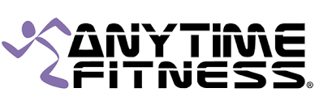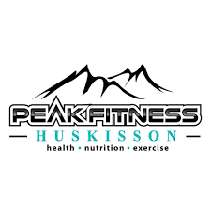
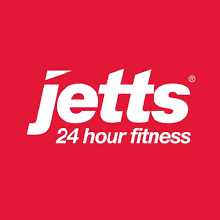

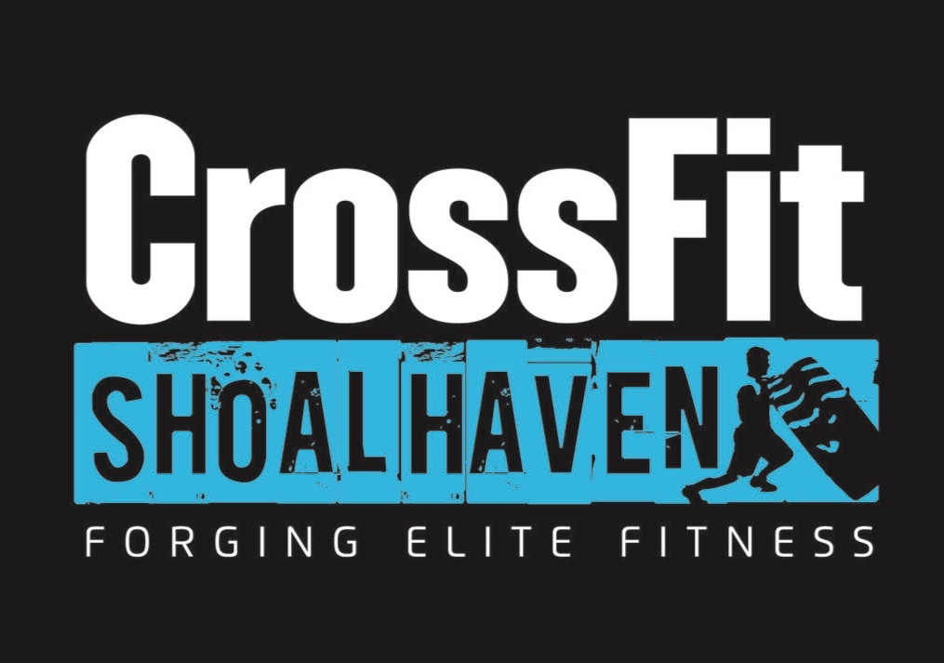

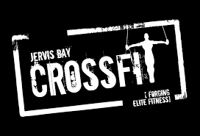

- If anyone has recently updated their logo, which creative route did they take? PEAK Fitness – retro

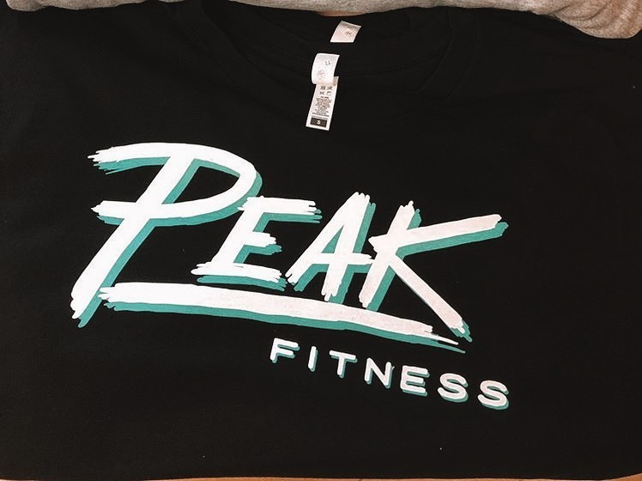

- Are there any design choices from the competition that you particularly like or dislike? I don’t like any of them.

6. Project Details

Style – Edgy, dynamic, smart, sassy, elegant but modern, sepia

Colour Preferences – I know that colour has a big role to play in maximising success. Colour is an important factor influencing the consumer buying decision process. It is not simply an afterthought when it comes to product packaging and company branding. I am aware that selecting colours that reflect the values of Renegade Fitness and preferences of the target audience. Traditional buyers, buyers on a budget and impulse buyers (from research) tend to see different ‘hues’ and ‘variants’ of blue as an indicator for purchasing. Blue is seen to be reliable, staid, professional, cool, novel and trustworthy. However, I am open to purple, white, and yellow - reflecting imagination, down-to-earth, and spirited. Given the examples above I don’t see a colour that is used more often as they are all different.

Font Preferences –

Specifics – I like sepia. The intelligence of a reverse R in Renegade Fitness Logo. Talks to my personality. Its left of centre, slightly quirky, unconventional, abstract.

Designs I am attracted to –

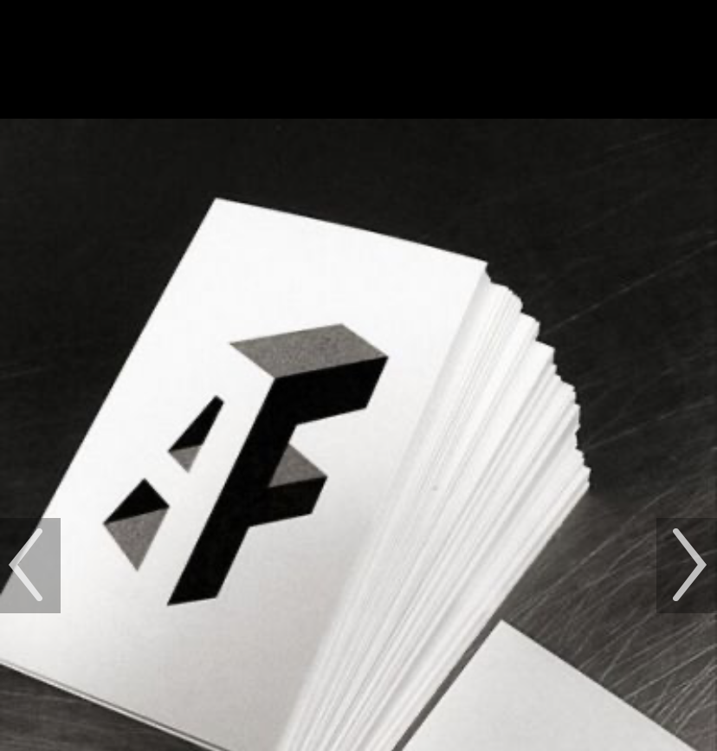

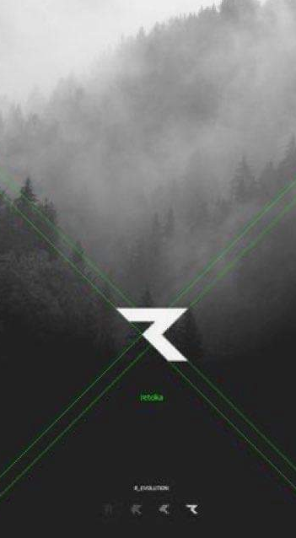


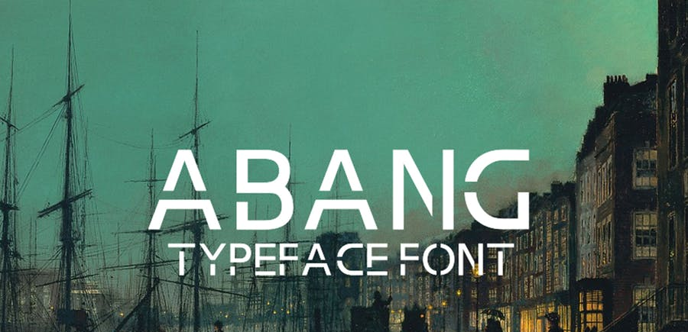

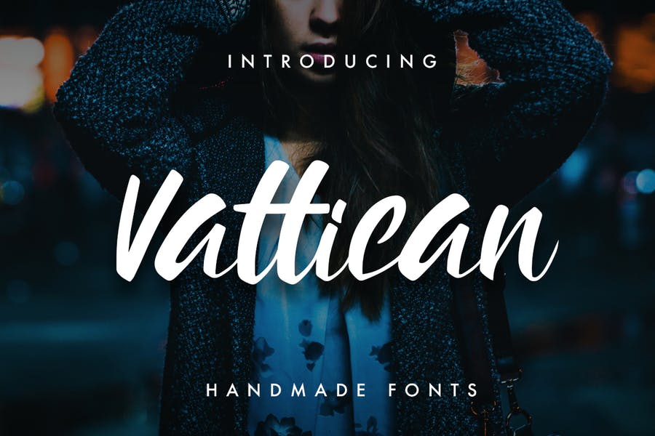

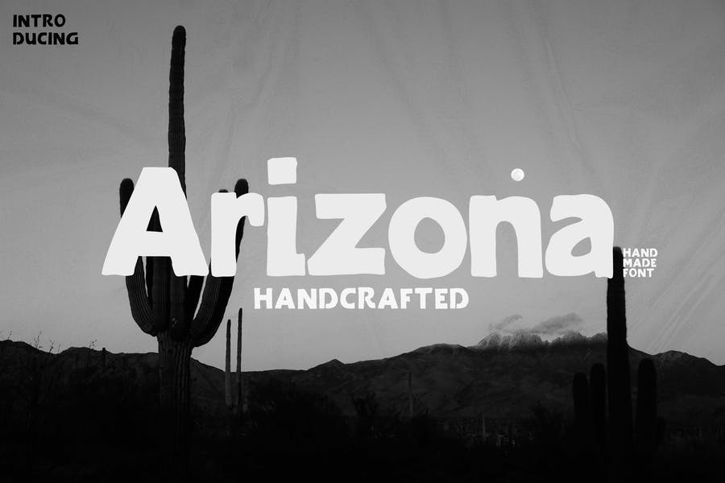

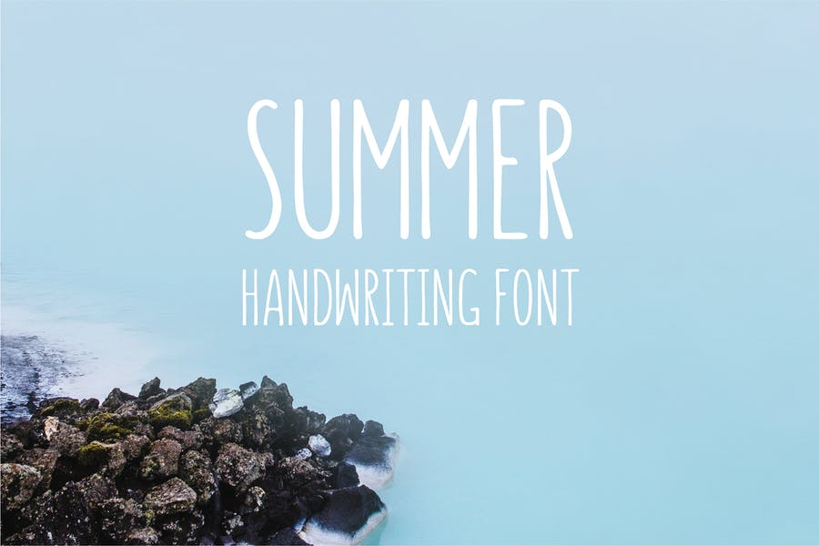

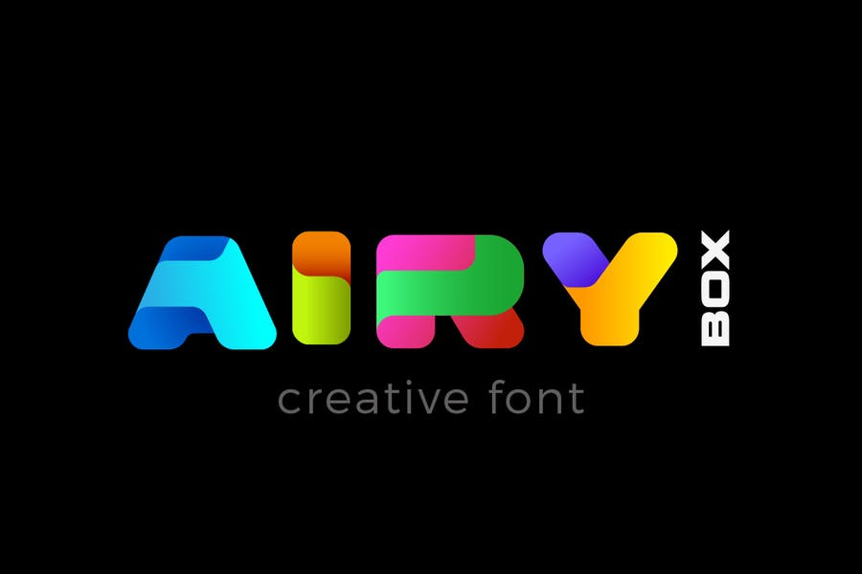

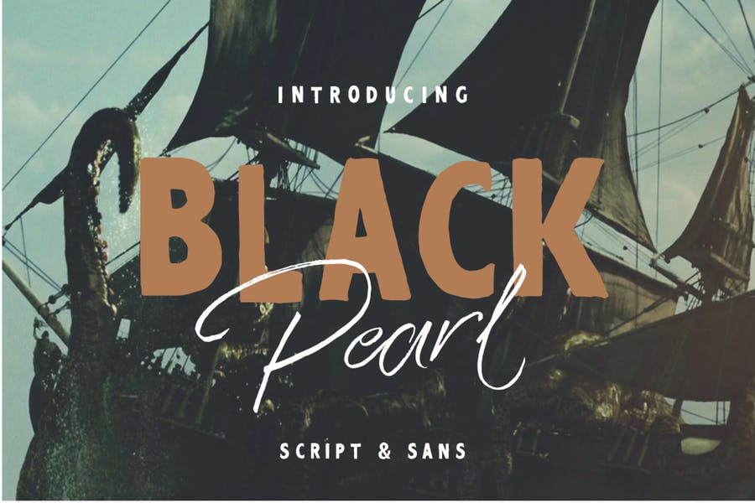

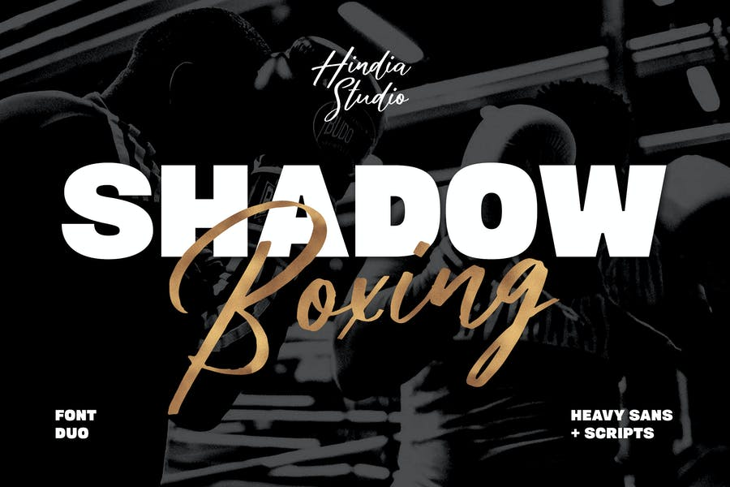

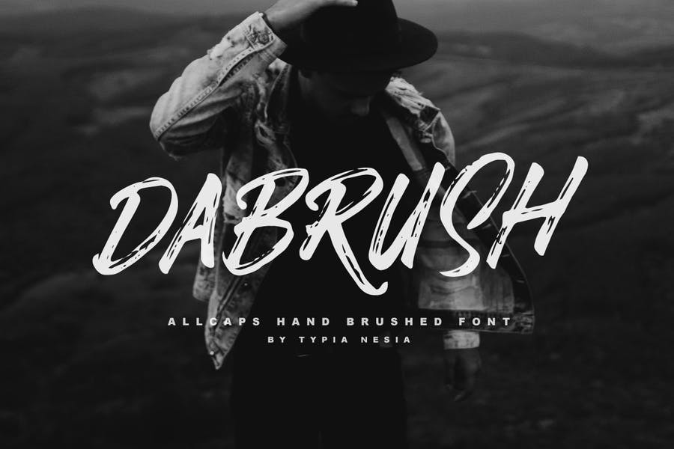

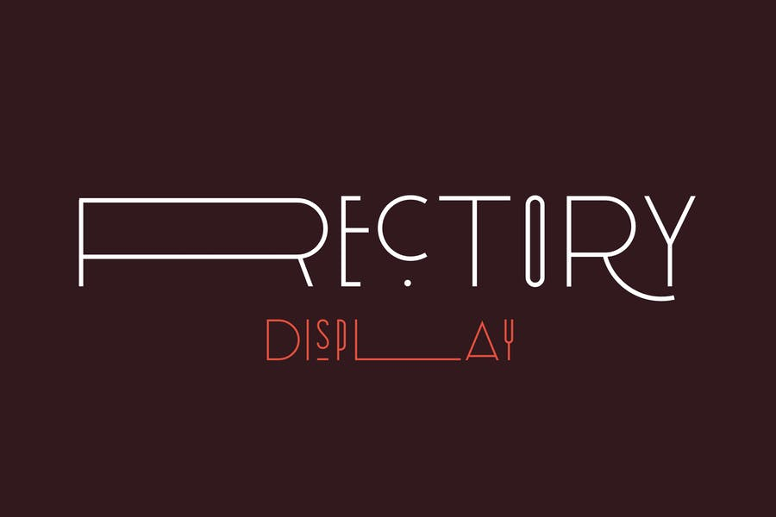

8. Deadlines and Budget

ASAP
? Budget.
I spent $100 USD last time on Upworks.

