Thank you for all of your submissions.
I like the effect of having:
- the piece of the puzzle that resembles a person running
- displaying the theme it Stands Up.
- Displacing the 3D theme
One more concept to explore is to add a silhouette of the actual product, and shows how realistic it is.
To see the actually product please see www.sportspop.com.au and make sure you watch the 10 second video.
Sports StandStar

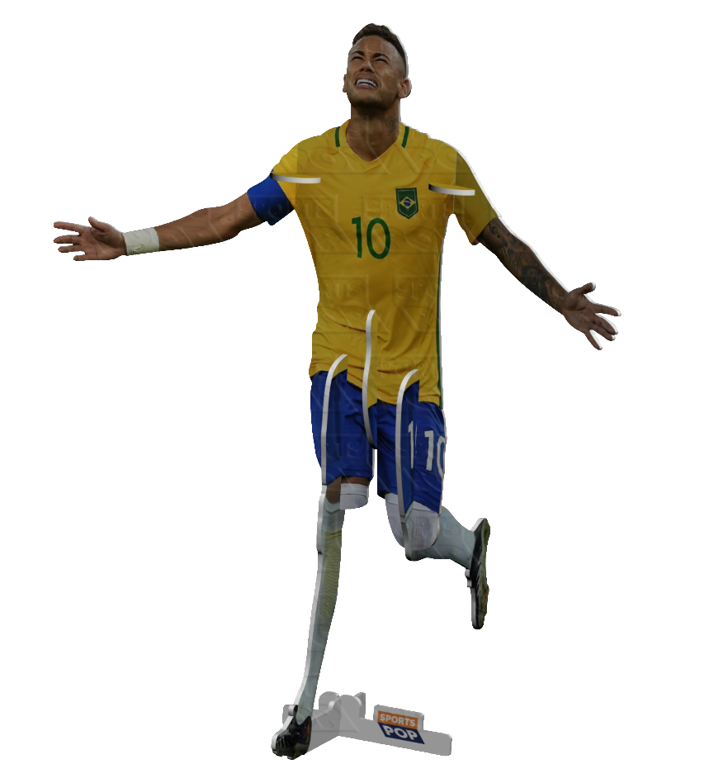
The Product for information purposes

For a new take on the concept it could look really cool to incorporate this image as a silhouette somewhere in the logo.
How would this work?
This silhouette of this player could be featured next to the Sport Standstars text
It could be a normal silhouette in blue
Or it could be cut up into puzzle pieces
- Option 1 See below (with the silhouette of the player blue )
- Or Option 1 (with the silhouette of the player blue ) with broken into puzzle pieces.
- Or Option 1 (with the silhouette of the player blue ) with broken into puzzle pieces (different puzzle style.

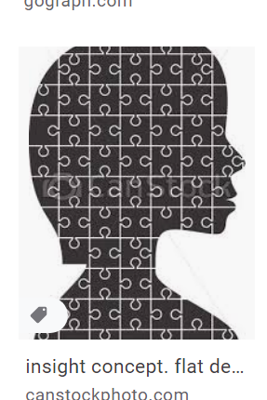

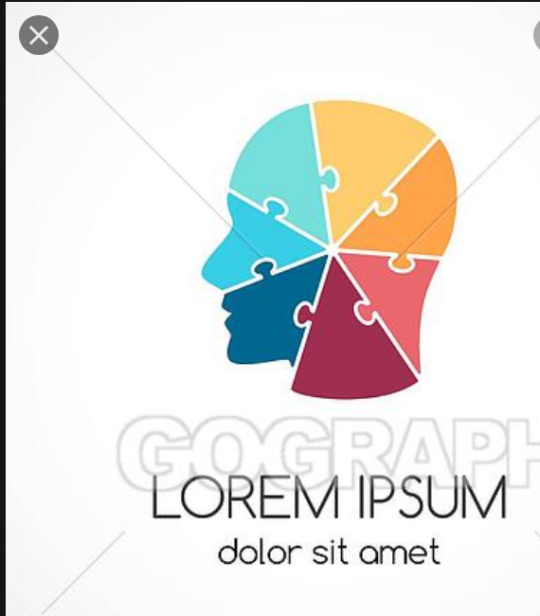
Option 1

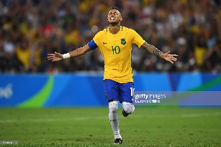

Option 2

Option 3

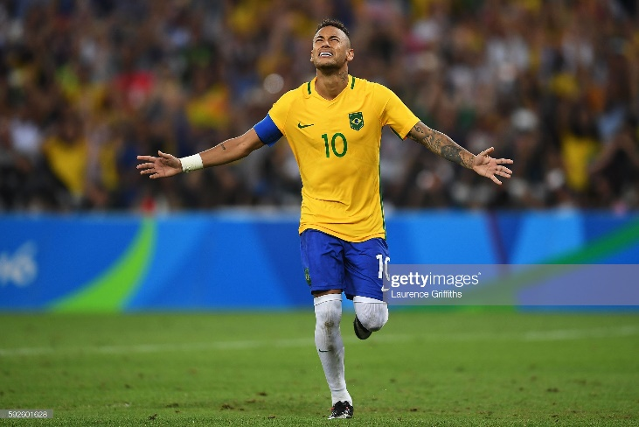
The original image
The original image
