Puzzle Idea 1

Make a the letters stand up somehow like Playstaion

.

Puzzle Idea 2

As the product is a puzzle.

One idea is to have a sports player but have it made out of coloured puzzle pieces, like a silhouette of the figurines (running, playing football etc…). See below - it’s a brain but made out of puzzles. You could do that but with the blue body like the below.
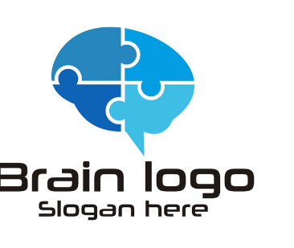


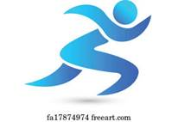

Puzzle Idea 3

As the product is a puzzle of a star that turns into the name Sports StandStar

One idea is to have a sports player but have it made out of coloured puzzle pieces, like a silhouette

