Sport Standstars Logo Brief
I would like to get a new logo.
The business is called Sport Standstars
- Sport – Singular
- Standstars - Plural
About
This is a fun 3d Puzzle that comes in the form of a card (10cm x 6.5 cms), all the pieces Pop Out out of the card frame to assemble a lifelike sports star.
They are fun, interactive, cool and will be targeted as a promotional toy for sponsors of major sporting teams around the world with the aim of engaging with fans and sponsors.
As an example picture McDonalds handing them out in happy meals or Bud Light giving out during an activation event.
Product Preview
As a preview for the product please see this video https://youtu.be/hKwc0x0i63g.
The Product
- Sold or given away as a promotional toy
- They come in the form of a plastic card card the size of a baseball card
- All the pieces components body parts are pressed out of the frame and assemble into a free standing 3D Sports Star.
We will be producing these for all sports NFL, MLB, NBA, Football/Cricket, Cricket, Skateboarding, Olympics.
- Primary Market
- The market is for kids above the age of about 6+ and
- Any sporting fan.
- Secondary Market
- There is also huge potentially to be a collector’s items similar to trading cards which could be marketed as adults.
So this has to be fun and kid friendly but edgy enough to appeal to the adults and teenagers around the world. I probably lean towards minamilist, but I am totally open to suggestions.
As adults and teenagers may express their love for a player or a team by collecting them.
It will be cool if somehow a user can get the idea that you build, assemble create the stars from a cards. Please see my old logo which was Sport Pop (Which Pops out)
Rebrand
- My original logo was Sports Pop, the re-brand, so if you can work with these colours it would be appreciated as it will be easier for me to update the communications.
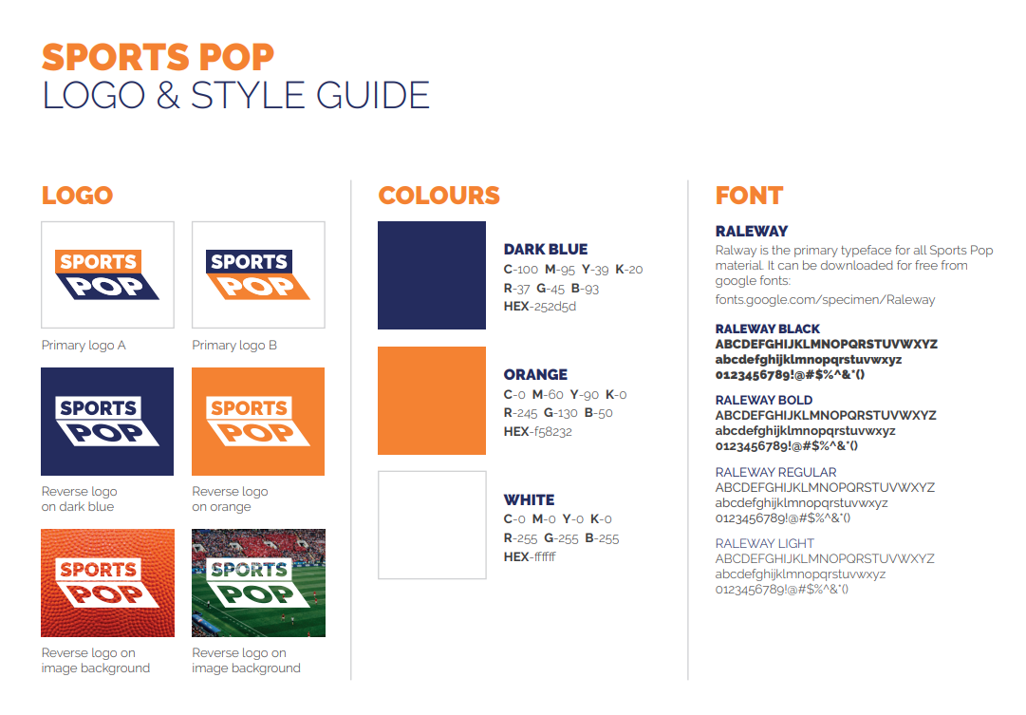
DO NOTS
There is a business out there called, Super Star Sports, they sell a different product, but I DO NOT want the logo to look like this.
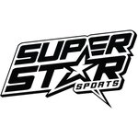
I also DO NOT want to look like FUNKO Pops.
We also need this to appeal to kids, boys, girls and adult fans.

