CFX Token Offering TEMPORARY White Paper
STRICTLY CONFIDENTIAL

Table Of Contents
Summary 4
Opportunity 4
Problem 4
Solution 4
Reason for ICO 4
HATS with CFX Sentiment Index on Blockchain 4
CFX Trading System 5
Market 7
Competition 7
Why us? 7
Signatures 7
CFX Token Offering (IEO) 8
Issuer Details 8
Issuance Details 10
General 10
CFX Token Description 10
Token Distribution 11
Overview 11
Caps 12
Whitelisting 12
Sales Process 13
KYC Process 14
Token Implementation 15
Overview 15
Token Implementation Details 15
Milestones & Lifecycle 16
Business Plan 18
Use of ICO Proceeds 18
Expectations 20

Marketing 21
Marketing Activities 21
Company 37
Management Team 37
Token Risk Factors 53

Summary

Opportunity

Problem

The world is disrupting in every sector, with deep changes that leave Investors and professional money managers with a big uncertainty that is reflected in the behavior of financial markets. There is need of points of reference, quality, fair communications, understanding and a solid approach to risk management.

Solution

CFX Quantum Ltd Introduces “Q-HATS”. Recent advances in technology, the blockchain, Artificial Intelligence, paired with state of the art pre-quantum chips, innovative concepts of dynamic allocation, have created the opportunity for CFX to create a new platform aimed at an easier approach of investing and trading, pooling the interest of professional traders and money managers together with final customers.
The aim is to avoid the pitfalls of this volatile markets, the manipulations of giant investors, and allow for an automatic constant optimization of risk and reward, stabilizing results and improving, not only performance, but mostly the confidence in investing.

THE EIGHT STEPS TO A GLOBAL FINANCIAL RAISE

- A very simple approach to moving money: a mobile and web application allows to create a new environment.
- The possibility to hold Crypto Assets including CFX Token, to switch Cryptocurrencies into the tied Exchange, learn with webinars and guides, and a continuous stream of market alerts, allows for flexibility and a guided path towards investing in the new world of blochchain with safe results.
- The link with a tier1 Forex Brokerage platform in cooperation with Swissquote Ltd UK, allows for lower transaction costs and efficient trading also in Fiat Market.
- CFX is constantly developing a system called HATS (Highly Advanced Trading System) based on Technical Analysis, Statistics, Artificial Intelligence, and Quantitative Analysis.
- The Innovation of HATS is that no single system or trader is giveng total confidence, but by allocating trades to several systems and traders the risk is lowered consistely and the potential performance boosted.
- The CFX “Sentiment Index” will be an exclusive of CFX Token holders. They will be allowed to forecast markets and contribute to the HATS system development, therefore gaining prizes for their ability.
- The disruptive “Q-HATS” evolution will allow shortly to give “near Zero risk” results by using a Pre Quantum-Chip in cooperation with Fujitsu and a University research centre, able to calculate instant trade opportunities.
- The Dream we hold in our hearts: “SURF Fund” - Social Universal Raise Fund. The ultimate way of investing and participating to the growth of underdeveloped countries and high social impact projects. After all the necessary authorizations will be launched with a unique method not only to give returns to investors but even to who is deeply in need for help.

How

How and why we differentiate from others?
The main concept is “a single system is short lived” so we work on hundreds of systems and a central engine that uses the best portfolio algoritms to constantly optimize the risk, shifting from one system to the other.
We do cooperate in a democratic way with several traders and algo creators anywhere, so no risk of falling due to our own stubbornnes.
CFX is developing CFX Sentiment Index a blockchain-based indicator that will add a unique, transparent, and reliable market indicator to HATS. The index will establish an understanding of people’s attitude towards financial market trends at any given moment, worldwide.
The alliance with primary providers of software platforms, liquidity, and money management allows CFX to give access to investors and trader to a comprehensive platform where they can follow markets, trade and invest with the safest parameters.
Q-HATS evolution is the most advanced development. The calculus potential of the “Quantum Annealer” is so impressive that we will be able to spot “instant triangular trades” with virtually zero risk, adding up small profits every day.

Reason for IEO

CFX has already developed products that wil be operative by the IEO launch.
With the IEO on LA TOKEN Exhange our token holders will provide the liquidity necessary for further steps of development and successful launch of our next-gen fintech product/services, to obtain primary licences and develop a global presence. We want to be near to our customers.

HATS with CFX Sentiment Index on Blockchain

CFX HATS is not a single trading system; instead, it is the sum of several different trading systems, each one with its own characteristics and specific risk/reward strengths, aming at diversification of portfolios not on single investments but on several intellingent Alpha seekers.
Added to this, CFX will insert the CFX Sentiment Index indicator housed on blockchain through its token owners.

Crowdsourced prediction platforms often demonstrate superior accuracy compared with the predictions of experts and pundits.

CFX Token holders will have special conditions for the HATS and Q-Hats products.
The remuneration of CFX is based on real results granted by HATS and Q-HATS at customer portfolios.
This offers tremendous opportunity for value creation in the long term, and, at the same time, lower entry barriers.



CFX HATS System

The System evolved from 30 years of experience of the founders and 4 years of testing, is an integration of:

• Big Data
• CFX Token Sentiment Index
• Artificial Intelligence systems that “learn by themselves” will increase efficiency and maintain drawdown risk to a minimum. Robots read trend signals and operative levels generated by the AI Engine and determine the best strategy to follow in real time.
• Autotraders: under continuous control and direction from expert traders, Robots buy and sell orders on the Stock, Currencies, and Commodities markets.


Q-HATS Evolution


• Pre-quantum evolution: the cooperation with Fujitsu, a University Team and a group of algotraders will allow us to exploit the best “light speed” technology to create risk free opportunities of arbitrage and “predictive allocation”.

TECHNICAL DESCRIPTION BY MONDAY

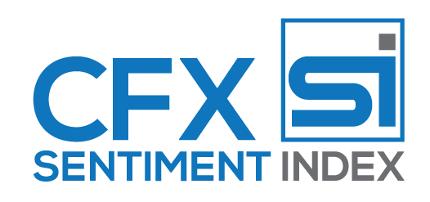
Sentiment Index Airdrop Reward for CFX Token

- CFX Token owners will insert their Sentiment on markets and economy using the App on their phones, toggling a scale on Up/Down prediction or answering questions.
- Every Token owner that contributes sentiment will receive an Airdrop in CFX Tokens with a pay per click feature. The best predictors will be ranked in a public wall and gain prizes in tokens and discounts on platform use.
- The Airdrop will be defined by the Board of directors over time considering the global economic and financial conditions of the company.

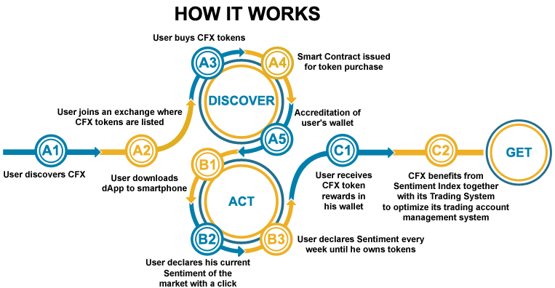

THE BURNING OF CFX TOKENS

Beside the Sentiment Airdrop, the CFX Token will be burned periodically.

Formula for CFX Token Burning:

- Calculation of the base amount.
- CFX Quantum Ltd, a company based in UK, is the company issuing CFX Tokens and allowing the customers the use of CFX Wallet and Exchange.
- CFX Quantum Ltd has bought from CFX Advanced LTd, Malta, all the development of HATS and Q-HATS, that will be used in the Crypto currencies world obtaining fees.
- CFX Quantum Ltd and has an exclusive agreement with CFX Finance Ltd UK, a Fiat Brokerage and Asset management company, to rent the systems for variable fees for usage in Forex, Commodities, indexes, Stock etc...
- The overall Net Turnover of CFX Quantum Ltd will be then calculated quarterly (i.e. the total of sales minus disconts, refunds, allowances and referral costs).
- The amount defined will be audited by BBKA.com

- Calculation and burning of CFX Tokens
- The amount of 10% of the overall turnover of CFX Quantum Ltd at point 4) will be used to buy tokens at current value and burn them.
- The burning will be shown in a specific page on cfxq.io

The overall CFX Token system is a Circle of sharing results!!
TEMPORARY GRAPHIC

Market Potential: the Millenials
The Millennials: young adults, very open to innovation and quite reluctant towards canonical institutions.
Total assets of Millennials In 2020 are expected to be twice as much as the of 2015 with estimates ranging from 19 to 24 USD trillions.
They will benefit from three significant growth elements:
- in an age range between 18 and 34, they are just facing the stage of strong asset growth, with the creation of massive liquidity.
- 54% of them have already planned or started their own business, now passing over the start-up phase and getting cash flow, available to be invested.
- They will benefit from the inheritance of the Baby Boomers generation.
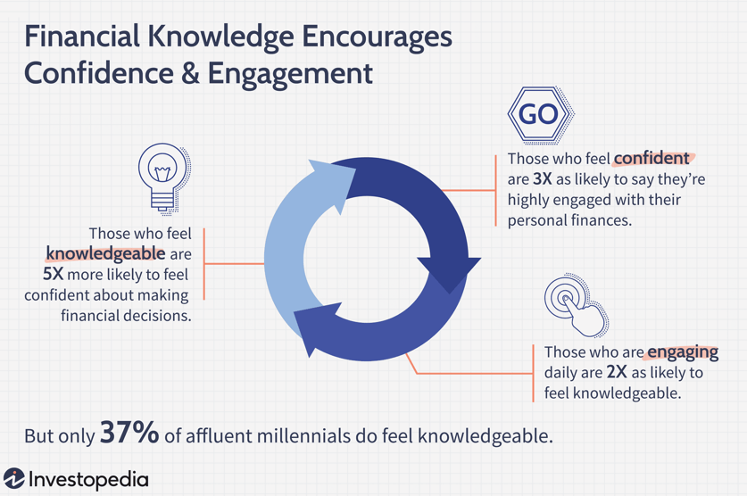
57% of Millennials would gladly change their banking service provider for a more technological solution, they are quite keen to mobile technology. They prefer being independent with freedom of choices wand less bureaucratic constraints.
Only a minority of Millennials feel they have sufficient knowledge in the financial field
Millennials are on two extremes, low risk and high technology.
CFX uses technology to reduce risk!

Market Potential: the Families

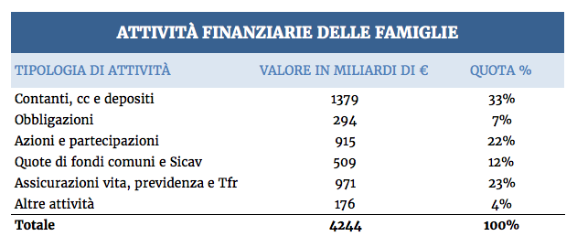
Significant volumes of liquidity are not invested by families, the need for alternative solutions is exploding.
As an example, out of the 4,200 billion of financial wealth owned in total by Italian families 1,379 billions are dormant on current accounts, with a high risk of imminent taxation.
Source: ABI research on data provided by Bank of Italy in 2017.

Market Potential: the Traders and Investors
The worldwide brokerage market shows impressive success stories, the natual base to develop CFX
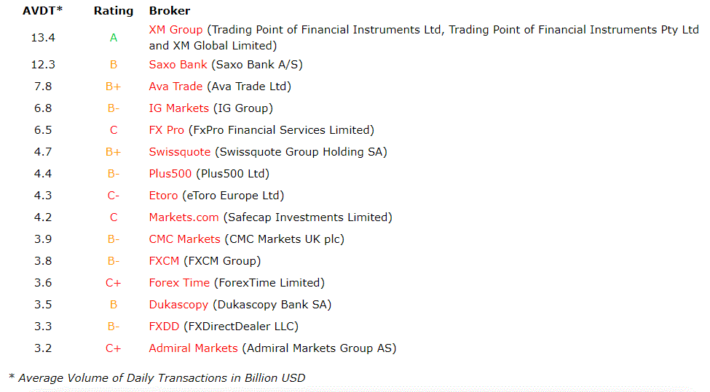
Social trading and copy trading are booming.
As an example E-Toro, from 2007 to 2019 reached 4.3 Billion of Dollars o daily exchanges, with 10 milion customers by innovating the sector.
Crypto Exchanges are also growing with impressive volumes up to one Billion per day.
CFX owns the two elements of success in brokerage industry:
Safety, and Innovation

ETF (Exchange Traded Fund) will represent by 2021 a 7 Trillion Dollar industry
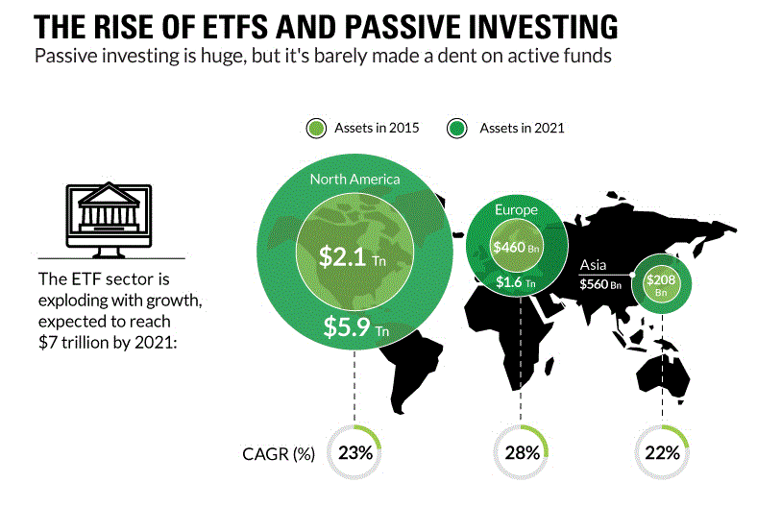
ETF will be the foundation for two products:
  - Roboadvisory
  - Tokenized Assets
Winning characteristics of ETFs:
They replicate indices such as investment funds with very low operating costs.
  - They cover almost the entire financial market.
  - They are extremely liquid and exchangeable in real time on the major stock exchanges; perfect for Roboadvisor.
The Robo-Advisory market is seen to grow up to 10% of the whole investment industry by 2020
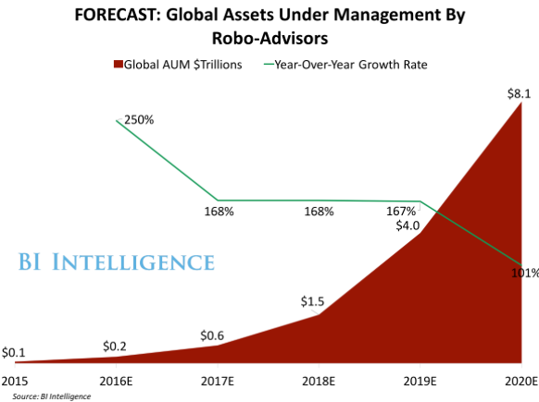
Transform the traditional asset management support systems through:
  - ease of use
  - low cost
  - technology’s appeal, which can also be enjoyed on mobile
Vanguard Personal Advisor Service and Schwab Intelligent Portfolio are the most important Robo-Advisors, with $ 47 Bn and $ 10.2 Bn of total Assets allocated by customers.
CFX is creating a new predictive ETF allocation system.

Competition

Competition could arrive from any Bank, Broker, Fund, Exchange or Financial Organization that provides products to investors.
By the way, the original mix of innovative technologies and methodologies allows for a “Shared trading and investing experience” that we believe is unique in the market at this moment.
Our aim is to reach in five years the level of Brand awareness of our project like “Revolut”, that is missing our investment side approach, or “E-Toro” that is oriented to more aggressive and self trading investors.
The main issues will be the quality that will take to word of mouth spreading and cost-effective marketing techniques that will be carried by ourselves and our highly specialized Partners (see in the partner pages).

Why us?

We are a team with proven experience:
On financial markets, historically capable of offering deep innovation, breakthrough systems, and an impressive rate of return based on knowledge, backtesting, vision, and willingness.
Marketing, due to the alliance with a strong network of professional merketers that completely support the project.
Technology with a strategic advisor board and a network of highly specialized partners.
Company Management, thanks to our Board members composed by highly respectable and efficient managers (see page)
The overall team experience on financial markets, marketing, technogies and company management is over 180 years.

Signatures

This whitepaper is not a prospectus or solicitation.

Investor Warning: Evaluate the full whitepaper before investing.

Issuer Warning: Civil liability attaches to the persons who table this summary.

Issuer: CFX ……………….. Ltd.

Declarations By The Persons Responsible For This Whitepaper
To the best of my knowledge, the information contained in this whitepaper is in accordance with the facts, and this whitepaper makes no omission likely to affect its import.

Name: Marco Mottana, CEO
Signature:_______________________________________________Date_________________
Name:

Signature:_______________________________________________Date_________________
Name: , CFO

Signature:_______________________________________________Date_________________

Token Offering (IEO)

Issuer Details

- Name: CFX Quantum Ltd.
- Registered address: …………………………………………………………………………………
- Registration number: UK 12727786
- Date of registration 8 July 2020
- Locations where issuer has been established for a period exceeding three years: None (new company).
- Directors exercising a determining role in issuer’s administration:
- Marco Mottana, ………………………………….
- Legal proceedings disclosure (any impacting issuer’s financial position): none
- Board of administration:
  - Marco Mottana, Via Crotto Rosa 6a, 22036 Erba Co, Italy, CEO
  - ……OTHERS……………………………………………………………………………………………
  - …………………………………………………………………………………………………
- CFX Technology Advisors Board:
  - ……DEFINE………………………………………….
  - ……………………………………………….
  - ……………………………………………….

The objects and powers set forth in this Article shall not be restrictively construed, but the widest interpretation shall be given thereto. None of the above-described objects and powers shall be deemed subsidiary or ancillary to any other object or power provided for above. The company shall have full power to exercise all or any of the powers, and to achieve or to endeavor to achieve all or any of the objects conferred by, and provided for, in any one or more of the above sub-Articles. Nothing in the foregoing shall be construed as empowering or enabling the company to carry out any activity or service which requires a license or other authorization, under any law in force in ……………….., without such a license or other appropriate authorization from the relevant competent authority, and the provisions of Article ……………………of the …………………….Act shall apply.

Issuance Details

General

- CFX Quantum Ltd is based in London UK
- CFX……………… will follow all procedures defined by…………………...
- CFX……………… will, make its first Token Offering of CFX Token trough LA TOKEN Exchange Platform.
- CFX……………… Token will guarantee its owners to be accepted as a mean of payment inside the CFX Group
- Owners of CFX ………… Token will have special dedicated services, discounts and offers not available to general public.
- Burning of tokens will be undertaken quarterly upon company results assessment.
- Taxes: TBD
- Development team: TBD
- Advisors: ……………………………….. is the technical advisor and this IEO.
- Legal opinion on CFX Token being a Utility Token……………………………………
- Service providers:
  - ………………………………………………………….TECH
  - Rakison International Consultants – Lawyer of long term experience based in London
  - ……………………………..– KYC and AML Compliance, state of the art personal data management
  - ATS – Referral and Viral Marketing Agency
  - ……………………………………………………………………
  - CFX Finance Ltd London, Appointed Representative of Pairstech Asset Management.
  - CFX Advanced Ltd, Malta. HATS Software development
  - Swissquote Ltd – Licenses of Brokerage with retail customers with Fiat accounts.
  - …………………………………. - Big Data and Financial Platform Expert
  - ………………………………….. – Advertising Agency

CFX Token Description

CFX Tokens will be issued as ERC20 Security Tokens on the Ethereum Platform and be compatible with the ERC20 interface.
- Consensus algorithm: Ethereum Proof-of-Work
- Protocol for transaction processing incentive mechanism and/or fees: Proof-of-Work
- Protocol description and benefits: The current transaction processing protocol for Ethereum is the Ethereum proof-of-work consensus algorithm. Ether miners use computers to solve mathematical puzzles and process transactions and, in return, they get a reward. The fees depend on how congested the blockchain is and what type of transaction is being processed. The Ethereum protocol is dominant in the ICO/IEO world. It has a huge and passionate development community. Getting an ERC20 token listed on a cryptocurrency exchange is easy. Wallet compatibility is also easy. Creating a wallet for an ERC20-compatible coin and then listing it on a cryptocurrency exchange is straightforward and easy.
- Ethereum transaction speed estimate: The Ethereum blockchain currently supports roughly 15 transactions per second. A transaction can take around 30 seconds up to several days. How long a transaction takes depends on the network congestion and GAS spent on the transaction.
- Smart contract underlying protocols, functionality, operational costs: Smart contracts are written in Solidity and deployed upon the Ethereum blockchain. To deploy a smart contract you have to pay GAS fees. To interact with a smart contract, a transaction has to be made.
- Smart contract embedded restrictions: None
- Smart contract voluntary withdrawal period: None
- Underlying protocol’s interoperability with other protocols: Ethereum smart contracts can access external data through trusted data feeds, called Oracles, that send information into the Smart Contract, and remove the need for Smart Contracts to directly access information outside their network, thus lightening their workload. Oracles are usually supplied by third parties and are authorized by the companies that use them.
- Oracles: None

Token Distribution

Overview

- Total to be issued: 500.000.000 million CFX
- Tokens Not For Sale (reserved)
  - 60.000.000 Company reserves (12.00 % of all CFX).
  - Founders: 100.000.000 CFX (20.00 % of all CFX) one-year Lockup gradual release
  - Management & Advisors 20.000.000. (3,85% of all CFX) one-year Lockup
  - Acquisition of CFX Development from CFX Advanced Ltd (early investors) 80.000.000 CFX (15.38% of all CFX) One year lockup Gradual release
  - Bounty strategic referral program managd by ATS Sharing: 100.000.000 (19.23 % of all CFX) gradual release one-year Lockup
  - Bounty for Sentiment Index and other promotions 20.000.000 of CFX Tokens (3.85 % of all CFX)
- Total Tokens for Sale (not reserved) 140.000.000 (26.92 % of all CFX)
= (40.000.000 Private Placement) + (100.000.000 IEO)
Tokens for sale in IEO = 100.000.000 CFX (19..23 % of all CFX; 71.42 % of CFX Tokens For Sale)
- Challenges/risks:
  - Competition from very established Groups with long history and credentials;
  - High tech disruptions may change market in an unforeseeable way.
- Challenges/risks mitigation: CFX’s Superior Trading System imparts to us unique advantages in relation to our potential competitors. CFX in the best position of any trading system technology company to patent, exploit, and scale any potentially valuable innovation that may appear on the technological horizon.
- Issuer’s wallets: Any ERC20-compatible wallet.
- Issuer’s wallets safeguards: The tokens will be held in a ……………………………….. multisigwallet. ……………………… will hold two signatures to ensure that no funds are taken out before the withdrawal period. A minimum of two of these signatures will be required by a Trezor or Nano Ledger wallet.
- Free transferability restrictions on token: Only whitelisted wallets can receive the CFX token with approval from CFX. This whitelisting functionality can be turned off by the CFX owners themselves. An Activator who has been given Activator Role by a CFX owner can whitelist wallet addresses to hold the token. An Activator could, for example, be a regulated centralized token exchange that wants to allow trading with the token.
- Free transferability restrictions on exchanges on which token may be traded: None
- Procedure for exercise of any right of pre-emption: None applicable
- Token delivery methods and time-limits: Instant transfer to contributor’s ETH address. Duration-dependent on network load, and subject to periods of congestion. Median time 2.5 minutes.
- Payment methods: ETH, BTC, EUR
- One (1) non-discounted CFX token = 0.05 EUR

Caps

- Hard cap: 140.000.000 CFX (private pre-sale + IEO); Soft cap: 20.000.000 (private pre-sale +IEO) CFX
- Investors will get their contribution back if soft cap is not reached.
- Refund timeline: 30 days
- Refund mechanism: ETH is sent to a refund-contract. Participants can then trigger a pull-function on the contract to claim back the ETH they invested from the same wallet that was used during the token sale. Participant transaction costs (GAS fees) are not covered by the refund.

Whitelisting

CFX Tokens will, by default, only be transferable to whitelisted wallets. The requirement for whitelisting can be turned off if the token is listed on a regulated centralized exchange or there is a change in regulations.

- A global boolean flag, isWhitelistActive, will be added to the contract storage. This flag can be flipped by the owner role and will allow enabling/disabling the whitelist checking for transfers.
- Each account will receive a whitelisted flag, which will indicate if the account is able to receive/send tokens. Every account is blacklisted by default.
- addToWhitelist(address) and removeFromWhitelist(address) functions will be added, which can set any account as whitelisted or blacklisted. These functions will only be accessible by the activator role.
- addToWhitelist(address[]) and removeFromWhitelist(address[]) functions will be added, which can set a group of accounts as whitelisted or blacklisted. They call the previous functions in a loop for the given array of addresses. These functions will only be accessible by the activator role.
- The transfer() function will be modified to respect the whitelist and the isWhitelistActive flag.
- An additional role, activator, will be added. This role will have the right to call the activate() function. The role will be given to the sale stage contract to begin with, and to any address that requires this privilege in the future.
- The function activate(address, amount) will be created. When called, this function will first whitelist an investor if not already whitelisted, then transfer the stated amount of tokens to the investor.

Additional processes can happen outside of the initial IEO workflow. For this purpose, CFX can manually whitelist and blacklist single or sets of addresses in the CFX token contract. At some point, it might become relevant to turn off the requirement for whitelisted accounts altogether, which is an additional function that the CFX token contract will contain.

Sales Process TO VERIFY WITH LA TOKEN

- An Investor will arrive at the Sale Dapp and verify his or her identity. Once all KYC and AML requirements are cleared, an investment receipt is issued for the Investor.
- The receipt is signed by the operator of the Sale Dapp and contains information for the Sale Contract to verify if a transaction is eligible for investment or not.
- The Investor sends an Ethereum transaction, including the receipt. The investment is forwarded to a CFX wallet.
- The sale contract calls the activate(address, amount) function on the CFX token contract, which first whitelists the account if it is not already whitelisted, and then transfers the appropriate amount of tokens from the account of the sale contract to the account of the investor.

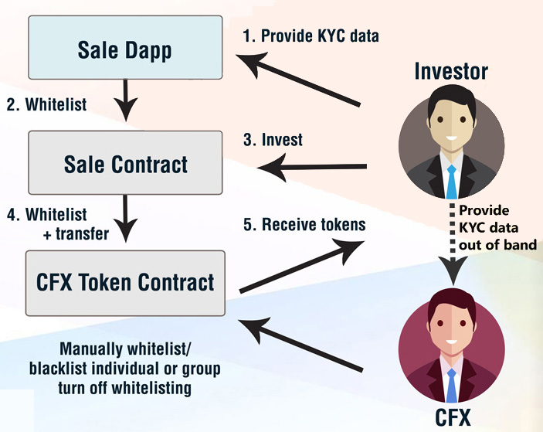

Investor categories to be targeted:

- HNWI Investors
- Institutional (Banks, Funds, Private Equity Management companies)
- Private informed investors who typically choose AIF (Alternative Investment Funds)
- Millennials

KYC Process TO VERIFY WITH LA TOKEN

      - User fills in personal details; these details are checked through an AML checklist provided by ComplyAdvantage.
      - User uploads passport; passport details are checked against personal details and the authenticity of the document is verified. This service is provided by OnFido. Upon passing all checks, the user is whitelisted and can proceed with the token purchase.

Token Implementation

Overview

- Smart contract auditors: ……………………………………………. TBD
- Base Token: The implementation will be based on the ERC20 contract provided by ………………………………………. on the master branch of their GitHub repository. These contracts are well-tested and reviewed, and have been successfully utilized in many production deployments without any incidents.
- Minting: NO minting functionality

Token Implementation Details UNDER REVISION

The CFX Token is an upgradable and mintable ERC20-compatible token. Token upgradability allows CFX to correct any possible bugs that are found over the token’s lifetime or switch to a newer standard without any downtime or outage while keeping the same contract address. While it has been difficult in the past to provide good upgradability for smart contracts, the Metropolis hard fork, deployed September 18th, 2017 introduced support for returndatasize in the delegatecall opcode. Using this, we can separate the implementation of the contract from the deployment address of the contract using the Solidity library function.

Good software engineering practices mandate an upgrade path for any deployed software and hardware. We are going to use an upgradable and mintable version of the ERC20. Making the token upgradable allows us to correct any possible bugs that could be found in the token’s lifetime or switch to newer standards without any downtime/outage while keeping the same contract address.

Privileged Conditions In Private Sale

This IEO is open to all investors who satisfy the issuer’s strict criteria for investments sophistication, portfolio diversification, risk profile and tolerance, and background and suitability check. It is also open to all known people, friends and parents of the Company’s staff.

All early investors may enjoy the possibility of privileged conditions offered by the company before the IEO takes place. All conditions are for limited quantities of Tokens, dependent in any moment on the total demand coming from the above-mentioned restricted target. Privileged condition starts with a % discount in respect to IEO value. The discount gets lower in direct proportion to the time left to approach IEO.

For more details, please contact………………………………..

Milestones & Lifecycle
CFX Issuance Roadmap Including Project Milestones

June 21, 2018 – Malta group formation:
CFX Holding Ltd. was constituted in Malta, and then created CFX Advanced Ltd. (“CFX”) and enrolled ICO/STO Financial Advisors, Legal Team and Blockchain advisors.

June 2018 - June 2020 CFX, HATS, Sentiment and Surf Development by CFX Advancec Ltd Malta.
Creation of the Logo and name “CFX”, and CFX “HATS”, and CFX “Sentiment Index”, The “Surf Fund”, and testing of HATS (Highly Advanced Trading System) technical, quantitative, and statistical analysis protocols which can be seen on www.cfxadvanced.com site.
Launch of CFX trademark and his concepts trough the direct participation and sponsorhipp of Malta Blockchain summits and Sigma Summit. Involvement of major players in the political, software, blockchain world, taking to more than 1000 contacts worldwide.
Important investments have been devoted to the projects from founders and friends and family early investors.

Sept 2019 -Jan 2020 – CFX development of Roboadvisory and brokerage concepts
By working with the Italian company Twice and Partners, a financial consultancy firm, former creator of the Twice Sim Spa (one of the first E-brokerage companies born in Europe, then sold to Banca Intesa group), the concepts of Roboadvisory 4.0 and the brokerage and exchange businesses “as a service base” for customer willing to use HATS system.

Feb 2020 -July 2020 – The development of Q-HATS concept, CFX Quantum Ltd is born.
The continuous development since 2019 with Smatxchange Ltd of London on technology research and strategies, led then to the Q-HATS concepts, exploiting the Fujitsu Digital Annealer capabilities and a university research group to add specialized algorithms for calculating Arbitrage positions.
This led to the creation of CFX Quantum Ltd in July together with the new CFX Token concept.

May 2020 -August 2020 – CFX Wallet and Exchange Development
CFX Finance Ltd of UK was formed and went further in the development of HATS by studying and involving partners. The agreements with Pairstech Asset Management and Swissquote were made to put HATS in practice in the Fiat world.
Was then developed the concept of a CFX Wallet and Exchange on Mobile with internal and external resources. The Wallet is a non custodial wallet tied to third party services and allows for Holding Of CFX Tokens and other main Cryptos such as BTC, ETH, LTC, USDC, USDT, BCH, XRP, DAI,LINK, MKR, DASH, BAT, ZRX, REP, OMG.
The wallet APP allows to buy Crypto from EUR, by using a Debit or Credit Card.
The wallet APP allows to exchange Crypto to Crypto between the above mentioned coins.
The wallet APP allows to send Crypto to other users or wallets.
The CFX Token can be used to lower the cost of transactions.

July 2020 – CFX Quantum Ltd to issue CFX Token on IEO with La Token
The last developments of project convinced the founders that the moment to issue the CFX Token had come.
CFX Quantum Ltd will hold all the rights and the outcomes of all the history of CFX group of companies, letting the public to be part of this development by giving exclusive features to the investors that allowed the company to surpass all the pitfalls and continue to succeffuslly develop such an outstanding project.

July 2020 – CFX Quantum Ltd to buy the assets of CFX Advanced Ltd.
CFX Quatum Ltd has defined to buy from CFX Advanced LTD of Malta, the CFX Logo and trademark with all his history and background, the HATS concept and development, trademark and software that the company has developed with important investments, the Q-Hats cocept predevelopment, the Roboadvisory 4.0 concept, the overall Business plan creation.
The agreed amount is a lump sum of 80.000.000 CFX Tokens with seven months lockup since listing, mainly going to remunerate early stage investors.
CFX Quantum Ltd will develop the Q-HATS evolution.
The HATS and Q-HATS systems will be given as an exclusive rental to CFX Finance Ltd for the development and sale of Trading Tools, Trading systems, Money management strategies for his institutional, Professional and Private Customers working with Fiat money.
HATS and Q-HATS Will be used by CFX Quantum Ltd for the development and sale of Trading Tools, Trading systems, Money management strategies for his institutional, Professional and Private Customers working with Crypto Assets.

May 2020 – August 2020 Private Placement Token Sale:
Reserved for ATS Ambassador Trading System Ltd UK, CFX Finance Ltd UK and first subscribers’ parents and friends, who met with top company management and booked CFX Tokens with favorable conditions as determined in such meetings.
- Tokens will be given to these investors in wallets to be created by ………………….

Until IEO Sale start date, CFX Quantum Ltd will continue to assign tokens to friends. There are friends waiting with a total capital of between 500.000 and 1.000.000 Euros to invest and they agree that these monies will be converted into tokens at the end of IEO.
All parties in this group know that all capital contributed will be converted into Tokens with an 66,66% bonus (="40% discount");

2020, Septemner 1 to 25 IEO Token Sale
100.000.000 CFX Tokens at a price of 0.05 Euro per token available for sale on La Token Exchange.

30 of September– CFX Token Assignments and Listing on La Token Exchnge
Within three working days from STO End, all Tokens subscribed and paid in STO and Private Sales will be assigned to their owner's wallets, according to KYC and AML requirements as defined by La Token.
The CFX Tokens will be immediately listed and traded.
The CFX Token will be available for sale and exchange also on the CFX Wallet/exchange app.

60-days or less after IEO End – Listed at other Exchanges
Upon successful IEO and deals with other major exchanges the company aims at multiple listings.

Looking forward

Use of IEO Proceeds
TEMPORARY SETUP TO BE DEFINED YET
"IEO Funds" = Total Monies Raised from Tokens Sold in Private Placement and IEO

IEO Funds Allocation by Percent – Details

% | Destination | Note
70% | Marketing | The main development will be on marketing effort to develop the Company brand and awareness, and the physical presence in different countries.
10% | Q-HATS development | To finance the “go to market” last stage after performance validation.
5% | Wallet/echange development | Continuous implementation of improvements.
8% | Investment in other companies | In order to develop the group structure.
5% | General Expenses | First year budget for Office Rent; Management & Employees Salary; Office; Travel; and minor expenses.
2% | Various not forecasted

Expectations

Forecast

In the next couple of years, we count on:

- Achieving authorizations for direct money management and creation of Surf Fund.
- Proving results of HATS and Q-HATS, in a clear and unquestionable way: official NAV of Funds managed with its directives, listed at major Stock Exchanges.
- Bring Sentiment Index to full efficacy, worldwide, with further utilization in Politics; Events; Surveys; Market research and more.

Project sustainability and scalability

The major expense over time is marketing, which is defined as a percentage of the revenues coming from the sale of tokens and the sale of products. The project sustains itself from a minimum of 1 million euro of tokens sold. That will give 4.0 million euros of investments possible, and a minimum return for the company of approximately 1 million euros per year. This is enough to ensure proper management and growth.

Marketing EVALUATE

Marketing Activities

To educate Partners and customers to fully understand the HATS and Q-HATS system, Sentiment Index, and Blockchain basics, the CFX marketing department will be focused on the following:

1. Web Advertising and Promotion: We'll engage a premier Web Marketing Agency, already operating in Europe, to manage a full Social Media Marketing campaign. The principal Social Media instruments that will be utilized include Social Network, Interactive Videos, Landing Pages, Group Activities, Social Events, and Prizes.

2. Customer Support Department: CFX will hire, train, and coordinate the activity of a highly professional customer support team that will use Salesforce CRM.

3. Referral marketing: Superior results generated by HATS will lead to referrals. We expect an average of 0,5 Customers referred x active customer.

4. PR: We'll select one of the most credible PR Agencies operating in the international field, with whom there will be a total focus in organizing a continuous series of PR Events in each Country where we'll operate.

Company

Management Team TO BE EVOLVED
The management team of CFX is composed of 4 people who will cover the major aspects of company creation and development, and then be supported by vice presidents and staff.

 | MARCO MOTTANA  Co-Founder of CFX, CryptoFXForinvest;  Fund Manager - Zenit; Money Mngt Head, BCCC  Mr. Mottana co-founded FORINVEST in 1987 as the first company to introduce Technical Analysis in Italy and is the co-founder of the first newsstand magazine entirely dedicated to it. He co-founded the initial SIAT and is the author of best-selling books on Technical Analysis.
……………………………………….
Co-founder of CFX,

Headshot to be supplied by CFX | RENATO AVANZINI  CFX CFX  IT professional with 30+ years industry experience in technology, security and finance. At the forefront of Internet introduction into Italy in the late 80's. Continuing today to lead and explore both in the international arena and in Italy.
………………………….
CFX Currency Trading System Manager

……………………………..
CFX Institutional Clientele Manager

Guarantee Committee
A group of key persons ………………………. and worldwide will suggest the board as per best practices and monitor the results.

External Key Consultants
Strategic Advisor: Virgilio Degiovanni
………………………………………………..
AML Consultant: ………………………………..

Financial & Auditor Advisors
T…………………………………………………

Token Risk Factors TO BE REVISED
Risk Factors Relating to Purchase, Sale, and Use of Tokens
Important note: the company expressly disclaims any and all responsibility for any direct or consequential loss or damage of any kind whatsoever arising directly or indirectly from: (i) reliance on any information contained the whitepaper and all associated materials, including this document, (ii) any error, omission or inaccuracy in any such information or (iii) any action resulting from such information.

By purchasing, owning, and using Tokens, you expressly acknowledge and assume the following risks:

General Suitability of Token Purchase
The purchase of tokens from the Company is only suitable for financially sophisticated persons who are capable of evaluating the merits and risks of such a purchase, or other persons who have been professionally advised with regard to token purchase, and who have sufficient financial resources to be able to bear any losses that may arise therefrom (which may be equal to the whole amount spent in connection with the token purchase). Such a purchase should not be seen as an investment or a financial asset.

Risk of Losing Access to Tokens Due to Loss of Private Key(s), Custodial Error or Purchaser Error
A private key, or a combination of private keys, is necessary to control and dispose of Tokens stored in your digital wallet or vault. Accordingly, loss of requisite private key(s) associated with your digital wallet or vault storing Tokens will result in loss of such Tokens. Moreover, any third party that gains access to such private key(s), including by gaining access to login credentials of a hosted wallet service you use, may be able to misappropriate your Tokens. Any errors or malfunctions caused by or otherwise related to the digital wallet or vault you choose to receive and store Tokens, including your failure to properly maintain or use such digital wallet or vault, may also result in the loss of your Tokens. Additionally, your failure to follow precisely the procedures set forth for buying and receiving Tokens, including, for instance, if you provide the wrong address for the Purchaser Address, or provides an address that is not ERC-20 compatible, may result in the loss of your Tokens.

Risks Associated with the Ethereum Protocol
Because Tokens and the Platform are based on the Ethereum protocol, any malfunction, breakdown or abandonment of the Ethereum protocol may have a material adverse effect on the Platform or Tokens. Moreover, advances in cryptography, or technical advances such as the development of quantum computing, could present risks to the Tokens and the Platform, including the utility of the Tokens for obtaining Services, by rendering ineffective the cryptographic consensus mechanism that underpins the Ethereum protocol.

Risk of Mining Attacks
As with other decentralized cryptographic tokens based on the Ethereum protocol, the Tokens are susceptible to attacks by miners in the course of validating Token transactions on the Ethereum blockchain, including, but not limited, to double-spend attacks, majority mining power attacks, and selfish-mining attacks. Any successful attacks present a risk to the Platform and the Tokens, including, but not limited to, accurate execution and recording of transactions involving Tokens.

Risk of Hacking and Security Weaknesses
Hackers or other malicious groups or organizations may attempt to interfere with the Platform or the Tokens in a variety of ways, including, but not limited to, malware attacks, denial of service attacks, consensus-based attacks, Sybil attacks, smurfing and spoofing. Furthermore, because the Platform is based on opensource software, there is a risk that a third party or a member of the Company team may intentionally or unintentionally introduce weaknesses into the core infrastructure of the Platform, which could negatively affect the Platform and the Tokens, including the utility of the Tokens for obtaining Services. Hackers or other malicious groups or organizations may also attempt to get access to private keys or other access credentials in the Wallet or any other wallet, vault, or other storage mechanism used to receive and hold Tokens. As a result, the Tokens may be lost forever.

Risks Associated with Markets for Tokens
The Tokens are intended to be used solely within the Platform, and Company will not support or otherwise facilitate any secondary trading or external valuation of Tokens. This restricts the contemplated avenues for using Tokens to the provision or receipt of Services, and could, therefore, create illiquidity risk with respect to the Tokens you own. Even if secondary trading of Tokens is facilitated by third-party exchanges, such exchanges may be relatively new and subject to little or no regulatory oversight, making them more susceptible to fraud or manipulation. Furthermore, to the extent that third-parties do ascribe an external exchange value to Tokens (e.g., as denominated in a digital or fiat currency), such value may be extremely volatile and diminish to zero.

Risk of Uninsured Losses
Unlike bank accounts or accounts at some other financial institutions, Tokens are uninsured unless you specifically obtain private insurance to insure them. Thus, in the event of loss or loss of utility value, there is no public insurer, such as the Federal Deposit Insurance Corporation, or private insurance arranged by Company, to offer recourse to you.

Risks Associated with Uncertain Regulations and Enforcement Actions
The regulatory status of the Tokens and distributed ledger technology is unclear or unsettled in many jurisdictions. It is difficult to predict how or whether regulatory agencies may apply existing regulation with respect to such technology and its applications, including the Platform and the Tokens. It is likewise difficult to predict how or whether legislatures or regulatory agencies may implement changes to law and regulation affecting distributed ledger technology and its applications, including the Platform and the Tokens. Regulatory actions could negatively impact the Platform and the Tokens in various ways, including, for purposes of illustration only, through a determination that the purchase, sale, and delivery of the Tokens constitutes unlawful activity or that the Tokens are a regulated instrument that requires registration or licensing of those instruments or some or all of the parties involved in the purchase, sale, and delivery thereof. The company may cease operations in a jurisdiction in the event that regulatory actions, or changes to law or regulation, make it illegal to operate in such jurisdiction, or commercially undesirable to obtain the necessary regulatory approval(s) to operate in such jurisdiction.

Risks Arising from Taxation
The tax characterization of Tokens is uncertain. You must seek your own tax advice in connection with purchasing Tokens, which may result in adverse tax consequences to you, including withholding taxes, income taxes and tax reporting requirements. In addition, the proceeds of the Token sale (which include any monies that purchaser has paid for the Tokens) may be taxable to the Company, which may adversely affect financial resources available to the Company, Company’s business and the Company's ability to achieve its business objectives.

Risk of Competing Platforms
It is possible that alternative Platforms could be established that utilize the same open source code and protocol underlying the Platform and attempt to facilitate services that are materially similar to the Services. The Platform may compete with these alternatives, which could negatively impact the Platform and Tokens, including the utility of the Tokens for obtaining Services.

Risk of Insufficient Interest in the Platform or Distributed Applications
It is possible that the Platform will not be used by a large number of individuals, companies and other entities or that there will be limited public interest in the creation and development of distributed Platforms (such as the Platform) more generally. Such a lack of use or interest could negatively impact the development of the Platform and therefore the potential utility of the Tokens, including the utility of the Tokens for obtaining Services.

Risks Associated with the Development and Maintenance of the Platform
The Platform is still under development and may undergo significant changes over time. Although Company intends for the Tokens and Platform to function as described in the Whitepaper, and intends to take commercially reasonable steps toward those ends, Company may have to make changes to the specifications of the Tokens or Platform for any number of legitimate reasons. Moreover, Company has no control over how other participants will use the Platform, what products or services will be offered through the Platform by third parties, or how third-party products and services will utilize Tokens (if at all). This could create the risk that the Tokens or Platform, as further developed and maintained, may not meet your expectations at the time of purchase. Furthermore, despite Company’s good faith efforts to develop and participate in the Platform, it is still possible that the Platform will experience malfunctions or otherwise fail to be adequately developed or maintained, which may negatively impact the Platform and Tokens, and the potential utility of the Tokens, including the utility of the Tokens for obtaining Services.

Risk of an Unfavorable Fluctuation of ETH, BTC or Other Coin Value If the value of ETH, BTC or other coins fluctuates unfavorably during or after the Token sale, the Company team may not be able to fund development, or may not be able to develop or maintain the Platform in the manner that itis intended. In addition to the usual market forces, there are several potential events which could exacerbate the risk of unfavorable fluctuation in the value of ETH, BTC or other coins, including another DAO-like attack on the Ethereum network, or significant security incidents or market irregularities at one or more of the major cryptocurrency exchanges.

Risk of Dissolution of the Company or Platform
It is possible that, due to any number of reasons, including, but not limited to, an unfavorable fluctuation in the value of ETH, BTC (or other cryptographic and fiat currencies), decrease in the Tokens’ utility (including their utility for obtaining Services), the failure of commercial relationships, or intellectual property ownership challenges, the Platform may no longer be viable to operate or the Company may dissolve.

Risks Arising from Lack of Governance Rights
Because Tokens confer no governance rights of any kind with respect to the Platform or the Company, all decisions involving the Company’s products or services within the Platform or the Company itself will be made by the Company at its sole discretion, including, but not limited to, decisions to discontinue its products or services in the Platform, to create and sell more Tokens for use in the Platform, or to sell or liquidate the Company. These decisions could adversely affect the Platform and the utility of any Tokens you own, including their utility for obtaining Services.

Regulatory Risks
The Company, and by extension the Platform, is subject to a variety of federal, state and international laws and regulations, including those with respect to privacy and data protection, consumer protection, data security, and others. These laws and regulations, and the interpretation or application of these laws and regulations could change. In addition, new laws or regulations affecting the Platform could be enacted, which could impact the utility of the Tokens in the Platform. Additionally, the Platform participants are subject to industry-specific laws and regulations or licensing requirements. If any of these parties fail to comply with any of these licensing requirements or other applicable laws or regulations, or if such laws and regulations or licensing requirements become more stringent or are otherwise expanded, it could adversely impact the Platform and the Tokens, including the Tokens’ utility for obtaining Services.

Also, changes in laws or regulations governing the Company's operations may adversely affect its business. Any change in the Company's tax status, or in taxation legislation in the United States or elsewhere, could affect the value of its financial holdings, its business and the Company's ability to achieve its business objective. Prospective purchasers are urged to consult their tax advisers with respect to their particular tax situations and the tax effects of the purchase of Tokens from the Company.

Operational Risks
The Company is a young company, and the growth of the team and its capabilities may take longer than expected to result in the intended usefulness for the Tokens. The Tokens are just one product in a highly competitive market, and broad adoption by other users and developments by technology partners may take longer than expected. The usefulness of the Tokens depends on the extent of widespread adoption of the offered technology by the marketplace.

Risk of Lack of Adoption
The success of the Platform, Services, and Tokens is dependent in large part on the adoption of the Platform, Services, and underlying technology by users. It is possible that users do not adopt or use the Platform. Such lack of use or interest could negatively impact the development of the Platform and therefore the potential utility of the Tokens, including the utility of the Tokens for obtaining Services.

Technology Risks
The Tokens are intended to represent a new capability on emerging technology that is not fully proven in use. As the technology matures, new capabilities may dramatically alter the usefulness of the Tokens or the ability to use or sell them. The functionality of the Tokens is complex, will require enhancements and product support over time, and full functionality may take longer than expected. The full functionality of the Tokens is not yet complete, and no assurance can be provided of such completion.

Unanticipated Risks
Cryptographic tokens such as the Tokens are a new and untested technology. In addition to the risks included in this document, there are other risks associated with your purchase, possession, and use of the Tokens, including unanticipated risks. Such risks may further materialize as unanticipated variations or combinations of the risks discussed in this document.

Forward-Looking Statements
The Company’s Token sale whitepaper and the documents attached thereto or associated wherewith contain forward-looking statements within the meaning of Section 27A of the Securities Act and Section 21E of the Exchange Act. These forward-looking statements are based on current expectations, estimates, and projections about our industry, Company management’s beliefs, and assumptions made by Company management. Words such as “anticipates,” “expects,” “intends,” “plans,” “believes,” “seeks,” “estimates,” and variations of such words and similar expressions are intended to identify such forward-looking statements. These statements are not guarantee of future performance and are subject to certain risks, uncertainties, and assumptions that are difficult to predict; therefore, actual results may differ materially from those expressed or forecasted in any forward-looking statements. The risks and uncertainties include those noted in “Risk Factors” above and in the exhibits. We undertake no obligation to update any forward-looking statements, whether as a result of new information, future events or otherwise, except to the extent that we are required to do so by law.

- END -

