4 Candy Label Brief

Brand – Scott Bros.

previous/current label designs:
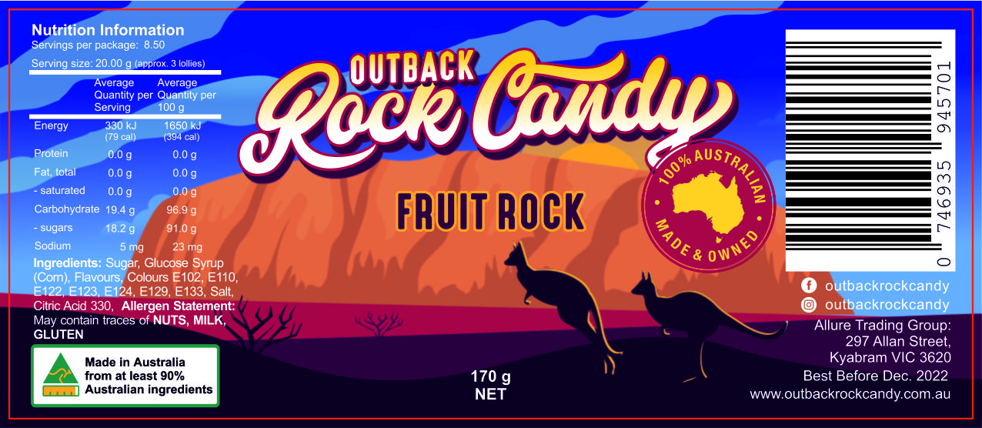

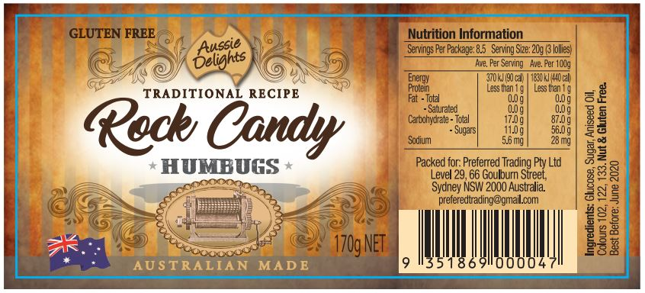

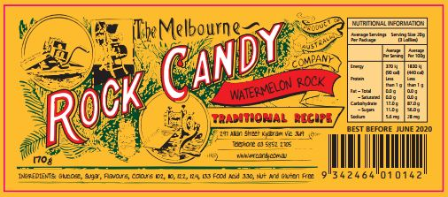

Four new labels: Tiny Tots, Watermelon Rock, Eucalyptus Drops, Bull’s Eyes (Peppermint), each 105x45mm finished size, need to supply high-resolution .ai, .eps, and .jpg, files of all labels, including separate images of background, text and any other aspect of the label.

Brand: Scott Bros. I have no current logo so you are welcome to include a logo design or interesting font that could be used as the logo

Details and accuracy very important!

I will supply all data needed for ingredients, nutritional label and unique barcode after I select a designer. For your mock ups, just put in something like the top one to fill the space the correct information will fill. The barcode must be the same size as the top/blue label.

Ideas:
- Old fashioned design
- Tiny Tots – randomly placed multi-coloured polka dots on a white background
- Watermelon Rock – pink/green stripes
- Eucalyptus Drops – little gum leaves
- Bull’s Eyes – red/white stripes

Design will be symmetrical like the top one – nutritional information and Australia label on the left and barcode and other contact info on the left.

Must have nostalgic old-fashioned look

Some design ideas I like:

Font/label shape?
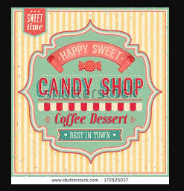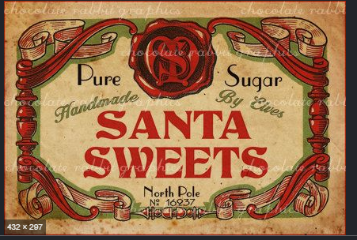

Font/Design style?
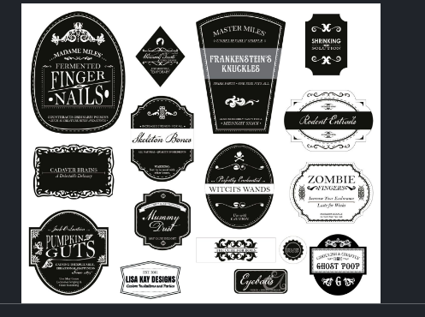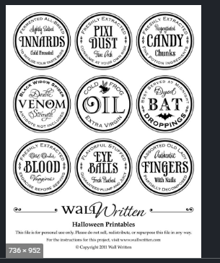

Stripe style/colours?
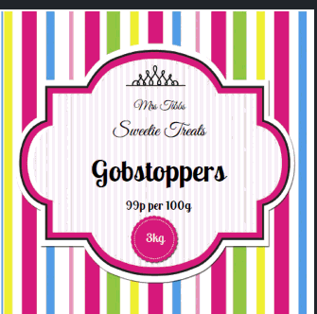

My communication preference is Skype once a designer is selected.

You must speak excellent English.

My time zone is Sydney Australia. I am on my computer every day.

I welcome questions if you are not sure you understand my requirements. I would rather you ask than waste time on incorrect design styles.

Photos of current jars. https://we.tl/t-8gO7NxNsQk

