Draft Website Content EPI Dose Trial
***The images/icons shown here are only for the basic idea of having icons present and WILL NOT BE INCLUDED IN THE FINAL PROJECT***
Homepage:
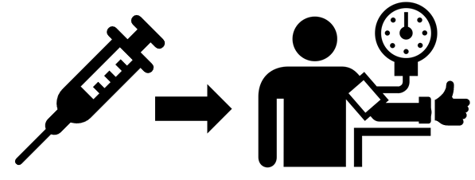
EPI Dose Trial
A study is taking place in the xxx ICUs to look at a medication called epinephrine that is commonly used for urgently increasing blood pressure. Epinephrine can quickly raise blood pressure in an emergency when the blood pressure is too low.
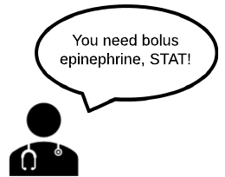
If the ICU team decides that a patient needs epinephrine for very low blood pressure, he/she may be enrolled in the EPI Dose Trial. Patients who are enrolled in the study will initially receive one of the two most commonly used doses of bolus epinephrine in order to quickly raise the blood pressure.
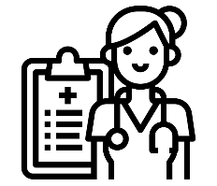
If enrolled, your child’s safety will continue to be the top priority, and he/she will receive all treatments he/she would otherwise get.


Because very low blood pressure is an emergency, your doctors and nurses need to focus on taking care of your child, so they will not discuss the study with you at the time the medication is needed. However, study personnel will discuss the study with you in further detail after your child is enrolled in the study. We are available at XXX-XXX-XXXX or XXXcxxxx to answer any questions.

If you do not wish your child to participate, you may opt out at any time before the medication is given, including now, by telling your bedside nurse that you do not wish to participate AND filling out this brief form. You can also click here for more information on opting out.

Links listed on the left of homepage:
-Low blood pressure

Very low blood pressure or “hypotension” is very rare, but it can be an emergency depending on how low the pressure goes, the age of the child and the clinical situation at the time. It is important to fix very low blood pressure rapidly because prolonged low blood pressure can cause damage to vital organs including the brain, heart and kidneys.

-Epinephrine
Epinephrine or “adrenaline” is a hormone that is naturally made by the human body which serves many functions. One function is to raise heart rate and blood pressure. Doctors also use epinephrine as a medication to raise blood pressure when someone’s blood pressure is very low. Risks of receiving epinephrine include blood pressure temporarily going too high, heart arrhythmias and damage to other organs. However, these risks are very rare and since low blood pressure is an emergency, epinephrine is used often in this situation.
For epinephrine drug information, click here.

-EPI Dose Trial Details
Why?
Very low blood pressure can be a medical emergency, and if not treated quickly can harm vital organs like the heart, brain and kidneys. In order find the best possible treatment for very low blood pressure, studies need to be done to give doctors information on what dose of epinephrine works best. Many different doses work well, but we need your help to find the best dose.
What we know:
From previous studies at BCH, we know that ICU doctors at BCH use many different initial doses of epinephrine boluses for very low blood pressure. Most often, doctors use doses between 0.5mcg/kg to 1mcg/kg as the initial dose and then adjust later doses based on the response of the blood pressure. Unfortunately, the existing information is not able to tell us what dose is best, but initial doses between 0.5 to 1 mcg/kg seemed to benefit patients similarly.
Who?
Patients hospitalized in the CICU (8 South), MICU (11 South) or MSICU (7 South) who are 25 years or younger are eligible to participate if their blood pressure becomes too low and the ICU team thinks a bolus of epinephrine will help.
How?
If a patient’s ICU team determines that they need a bolus of epinephrine for low blood pressure, the patient may be enrolled in the EPI Dose Trial immediately. Patients who need epinephrine will have a 50:50 chance of receiving EITHER 0.5 mcg/kg OR 1 mcg/kg as the initial dose. The effects on blood pressure and other patient information will be collected from the chart. No other interventions or participation is required.
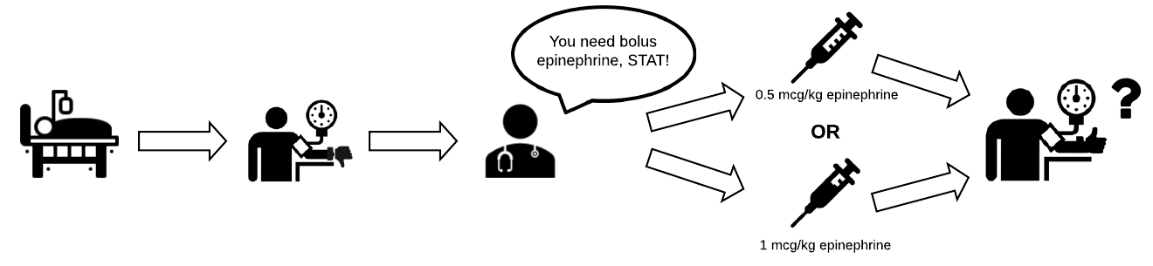Safety:
It is important to understand that patients enrolled in the EPI Dose Trial would have received epinephrine regardless of being in the study or not; the only difference is the chance of getting one dose or the other as opposed to your doctor choosing which dose to give. Also, the study only affects the first dose of epinephrine needed; if more epinephrine is needed, your doctor will decide how much to give. If your doctor is not satisfied with the increase in blood pressure after the first dose, he/she may give as much additional medication or adjust future doses as necessary.
Your child’s safety will continue to be the top priority.
For more detailed information on the EPI Dose Trial, click here. For more information on the risks and benefits of participating in the EPI Dose Trial, click here.
-Exception From Informed Consent and the EPI Dose Trial
Because very low blood pressure can be an emergency, the ICU team has to act very quickly to give treatments, including epinephrine. For many studies, we discuss participation with families beforehand to get their consent; however, in the case of an emergency, like very low blood pressure, this is often not possible. In these cases, the FDA allows for “Exception From Informed Consent” in which the patient participates in the study, and then the study is discussed with the family afterward.
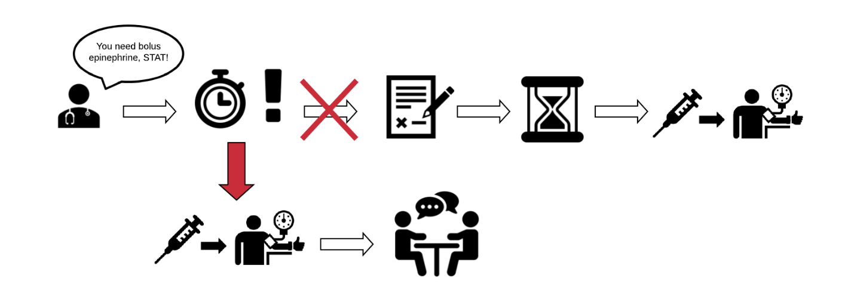
In these cases, we do our best to make families aware of the study beforehand and give them the option to “opt out”, if they do not want their child to participate. For the EPI Dose Trial, we have provided brochures to every family upon admission to the ICU, posted signs in each patient’s room, attempted to visit each family in person or by phone and created this website.
If you would like to OPT OUT, please fill out this brief form and tell your bedside nurse that you do not wish to participate. You can also click here for more information on opting out.
For more information on Exception From Informed Consent, click here.
For more information on how the EPI Dose Trial meets the requirements for Exception From Informed Consent, click here.
For more information on our approach to Exception From Informed Consent, click here.

-Opting Out
If you do not wish your child to participate, you may opt out at any time before the medication is given, including now. Your child be given an arm band that must be worn at all times when hospitalized at BCH. We will also provide signs that must remain on the patient’s bed and/or room door.

To OPT OUT, please fill out this brief form and tell your bedside nurse that you do not wish to participate.
OR
Call: XXX-XXX-XXXX and tell your bedside nurse that you do not wish to participate.
OR
Email: XXX@childrens.harvard.edu and tell your bedside nurse that you do not wish to participate.

-Results:
When available, the results from the EPI Dose Trial will be provided here.

-Previous Studies:
Our team recently reviewed 144 historical patients who received epinephrine for very low blood pressure in a BCH intensive care unit. We found information that helped us to design the EPI Dose Trial as safely as possible:
-Most commonly, doctors gave a first dose of 0.7 mcg/kg, and the average increase in systolic blood pressure of 31 mmHg (good response).
-Doctors used a wide variety of initial doses of epinephrine, most of which were between 0.3 and 2 mcg/kg.
-We were not able to find an association between the dose and the effect on blood pressure (for example, higher doses did not necessarily result in bigger raises in blood pressure).
-We also found that for a subset of patients, the first dose of epinephrine did not significantly raise their blood pressure, and they needed either more epinephrine or other interventions to help. Again, the initial dose did not appear to affect this, as these patients got similar doses to those of patients who had a good response.
Significance for the EPI Dose Trial:
- Doctors are using many different initial doses of epinephrine boluses for very low blood pressure.
- Existing data is not able to tell us what the best dose is.
- Initial doses between 0.5 to 1 mcg/kg seem to benefit patients similarly.
Link to full article: https://www.ncbi.nlm.nih.gov/pmc/articles/PMC6441975/

