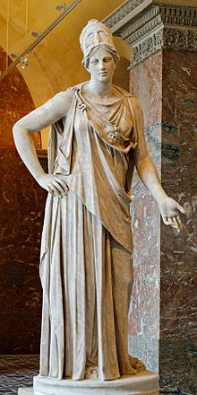

Athena is an ancient Greek goddess associated with wisdom, handicraft, and warfare. Athena was regarded as the patron and protectress of various cities across Greece, particularly the city of Athens, from which she most likely received her name. She's usually shown in art wearing a helmet and holding a spear. Her major symbols include the owl.
From her origin as an Aegean palace goddess, Athena was closely associated with the city. Her temples were usually located atop the fortified acropolis in the central part of the city. The Parthenon on the Athenian Acropolis is dedicated to her, She's also a warrior goddess, and was believed to lead soldiers into battle as Athena Promachos.
Athena was the patron goddess of heroic endeavour; she was believed to have aided the heroes Perseus, Heracles, Bellerophon, and Jason. Along with Aphrodite and Hera.
She plays an active role in the Iliad, in which she assists the Achaeans and, in the Odyssey. She is the divine counsellor to Odysseus.

Since the Renaissance, Athena has become an international symbol of wisdom, the arts, and classical learning.
Western artists and allegorists have often used Athena as a symbol of freedom and democracy.

