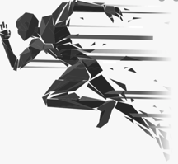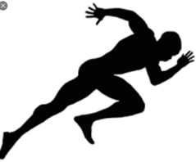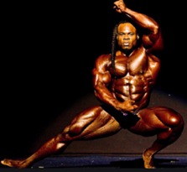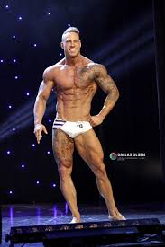

Thanks to GL Designs for creating this awesome logo. This is the perfect design. The only issue is the silhouette in the logo looks like an ice skater. If you look at the photos on top of this design, they all represent fitness. Can we please get creative, take the ice skater out and put the fitness silhouettes in.

1: If using the sprinter, then maybe some flesh breaking away from him like the logo G to the left of sprinter.

2: If using Kai Green, which is the man in the middle, please make him a silhouette

3: If using the fitness models, the 3 on the right. Maybe place the man and 1 female either side of the T

The current logo is awesome, it is exactly what I am looking for. We just need to play with the pictures around the T.

Thanks, I look forward to seeing what you can create and look forward to working with you guys for future projects

