PRECEDENTS
____________________________________________________________________
PERRY STREET COLLECTIVE
CASTLE ROCK 2020

____________________________________________________________________
JLA design
castle rock co
05.28.2020
LIVE WORK – MIXED USE
____________________________________________________________________

This is a somewhat similar project that Lyndsay Armstrong worked on several years ago. Mixed use spaces with restaurants and shops on the bottom floor and residential condominiums on the top floors. Reminds me of all of the houses tied in with commercial buildings in downtown Castle Rock and the desire to have a pedestrian friendly hub to bring the community together. These final drawings were done using Autocad and Archicad.

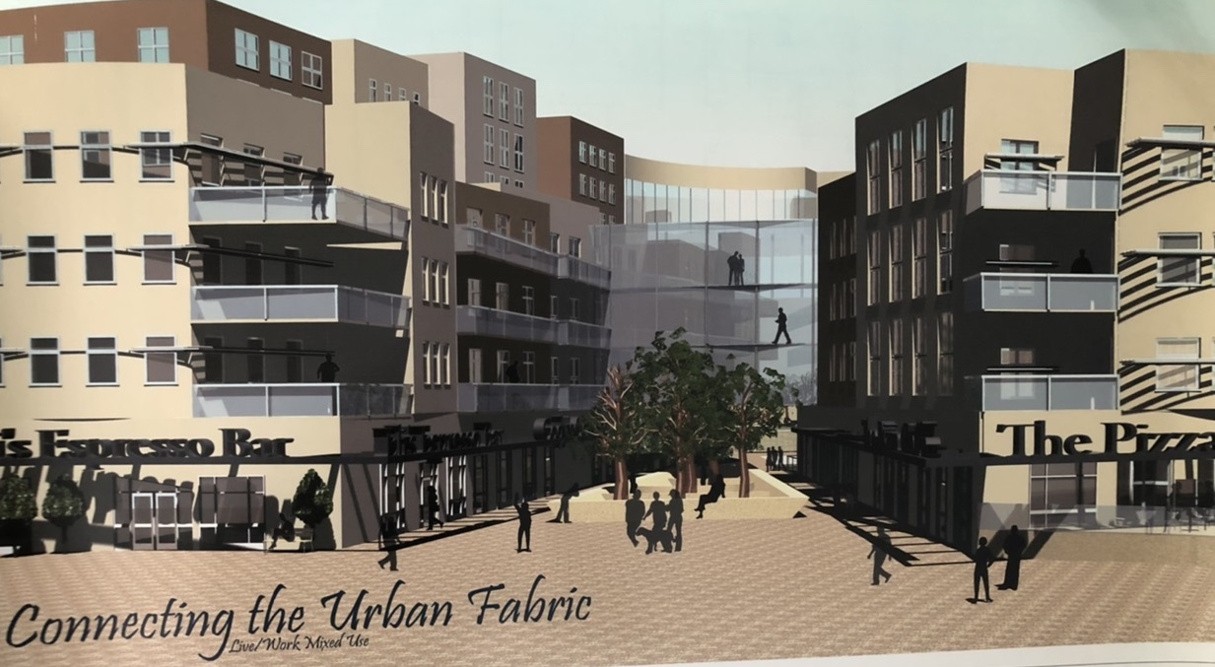

GOLDEN MILL
____________________________________________________________________
This project was not designed by JLA; it was done by Handprint Architecture in 2019 and is currently under construction. However it demonstrates several of the concepts that JLA would like to explore for the Perry street project. The Golden Mill will be a “Food Hall and Gathering Place for Golden Colorado.” The project aims to restore the old mill building, as well as add an additional structure, to create unique restaurant and bar spaces.

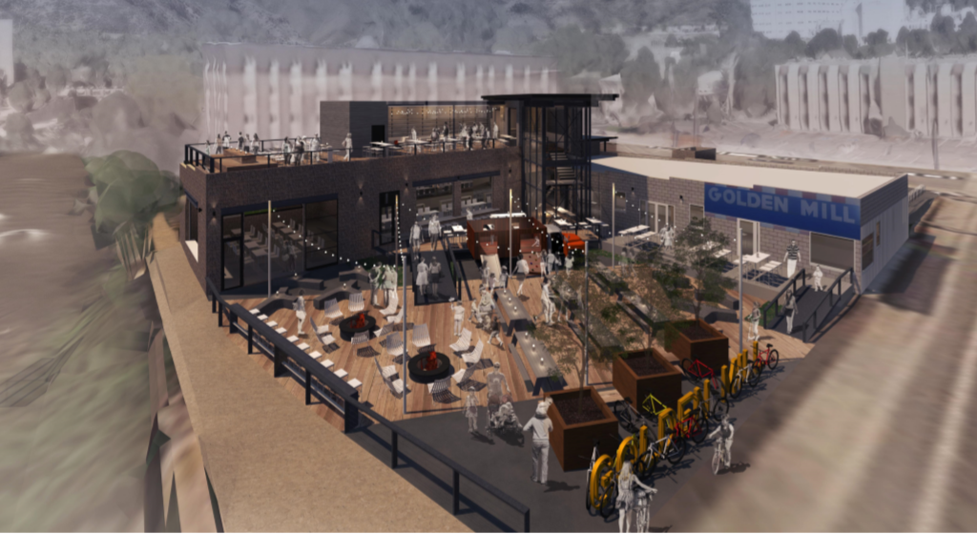

WILLIAMS RESIDENCE
____________________________________________________________________
Custom residential project completed by JLA in 2018, showing floor plans and 3D rendering done with Sketchup Pro and V-ray. These are the tools JLA design would use on this project.
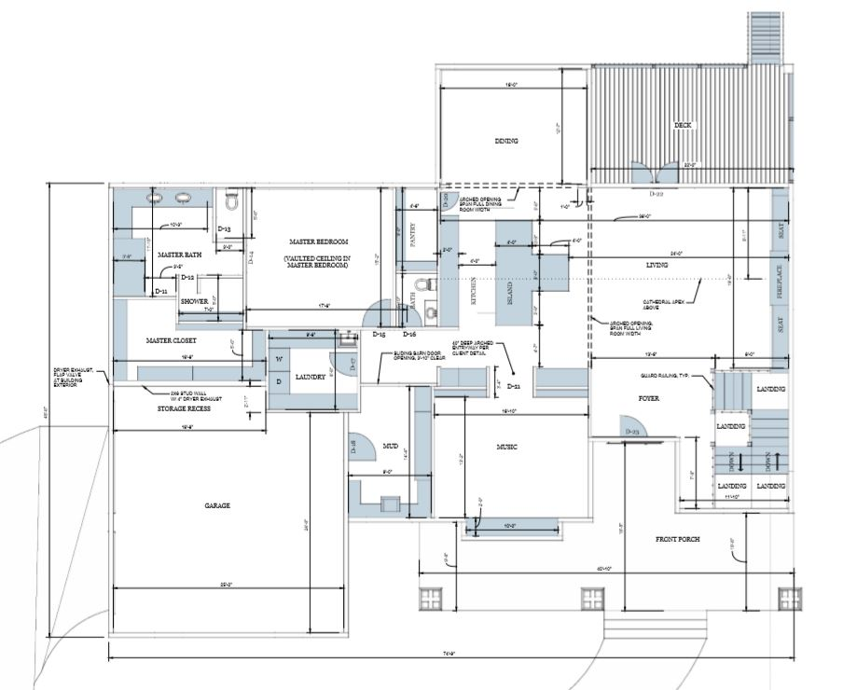
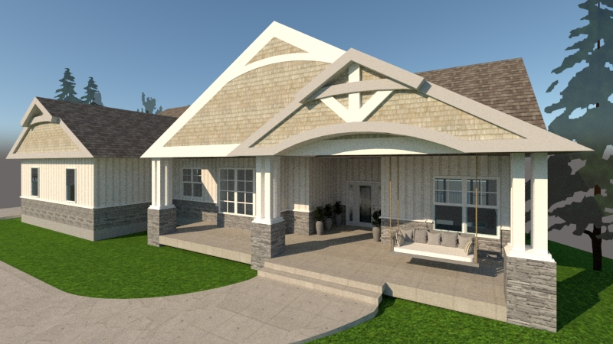
COURTYARD | PATIO
____________________________________________________________________________________
These are a few sketches of ideas for the 3 buildings and pavilion on Perry Street that we discussed this week. The first is the space underneath the pavilion where you had mentioned having lawn games during the summer. The second-the atrium space that would be part of FiDeli.

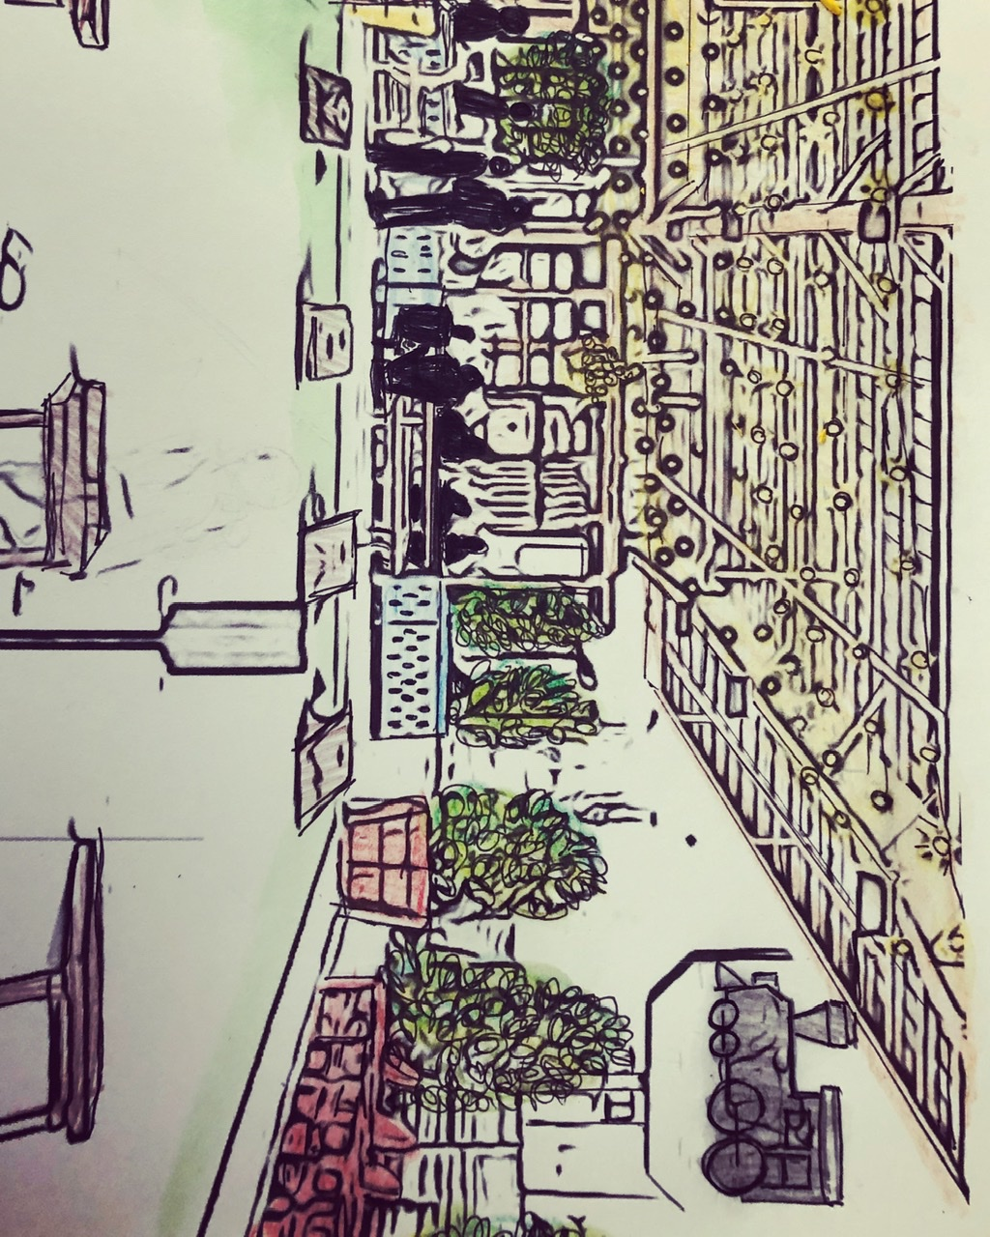
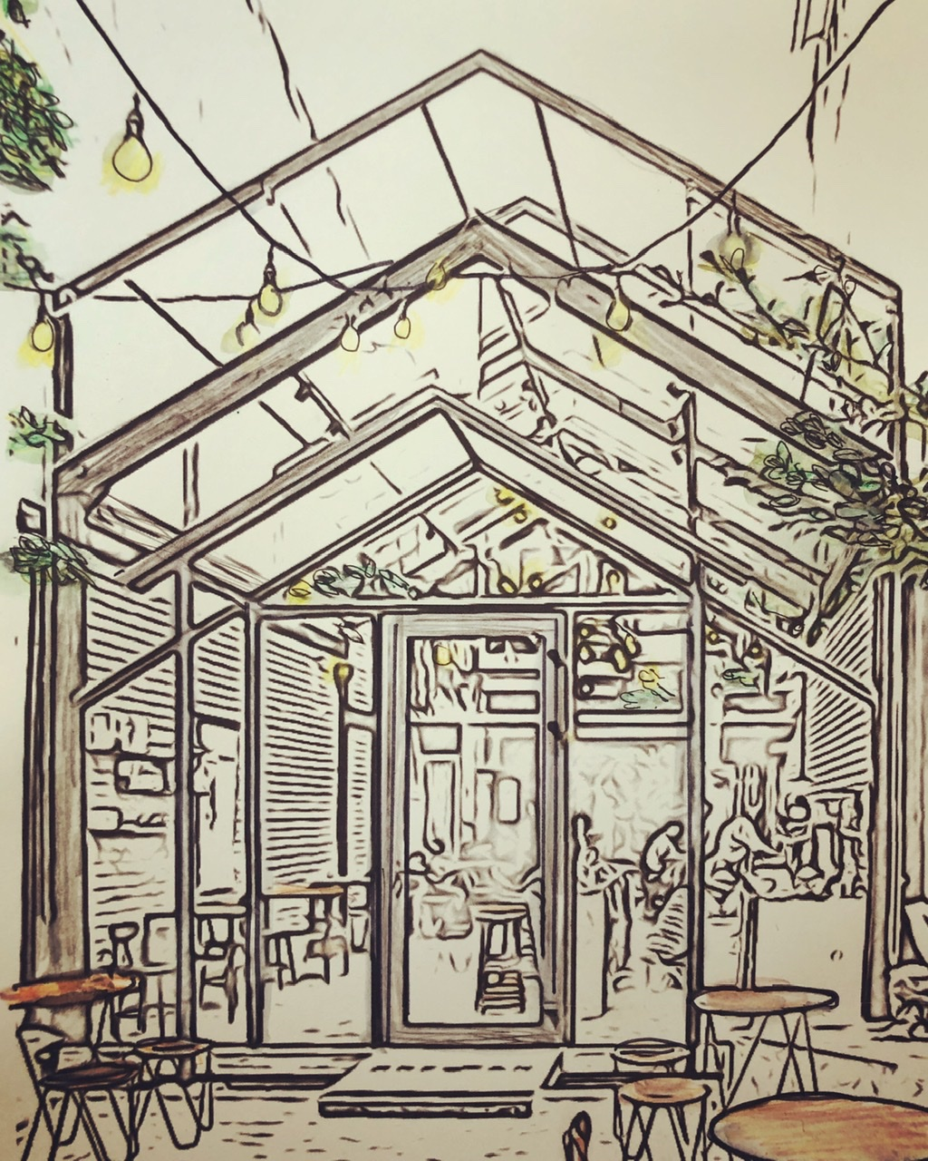

TAPROOM | WINE BAR
____________________________________________________________________________________
The third sketch is an idea for the taproom opening up to the pavilion space. The fourth-an idea for the wine bar opening up to the pavilion and the last is of the taproom opening up to the walkway, with the roll up doors that you had mentioned.

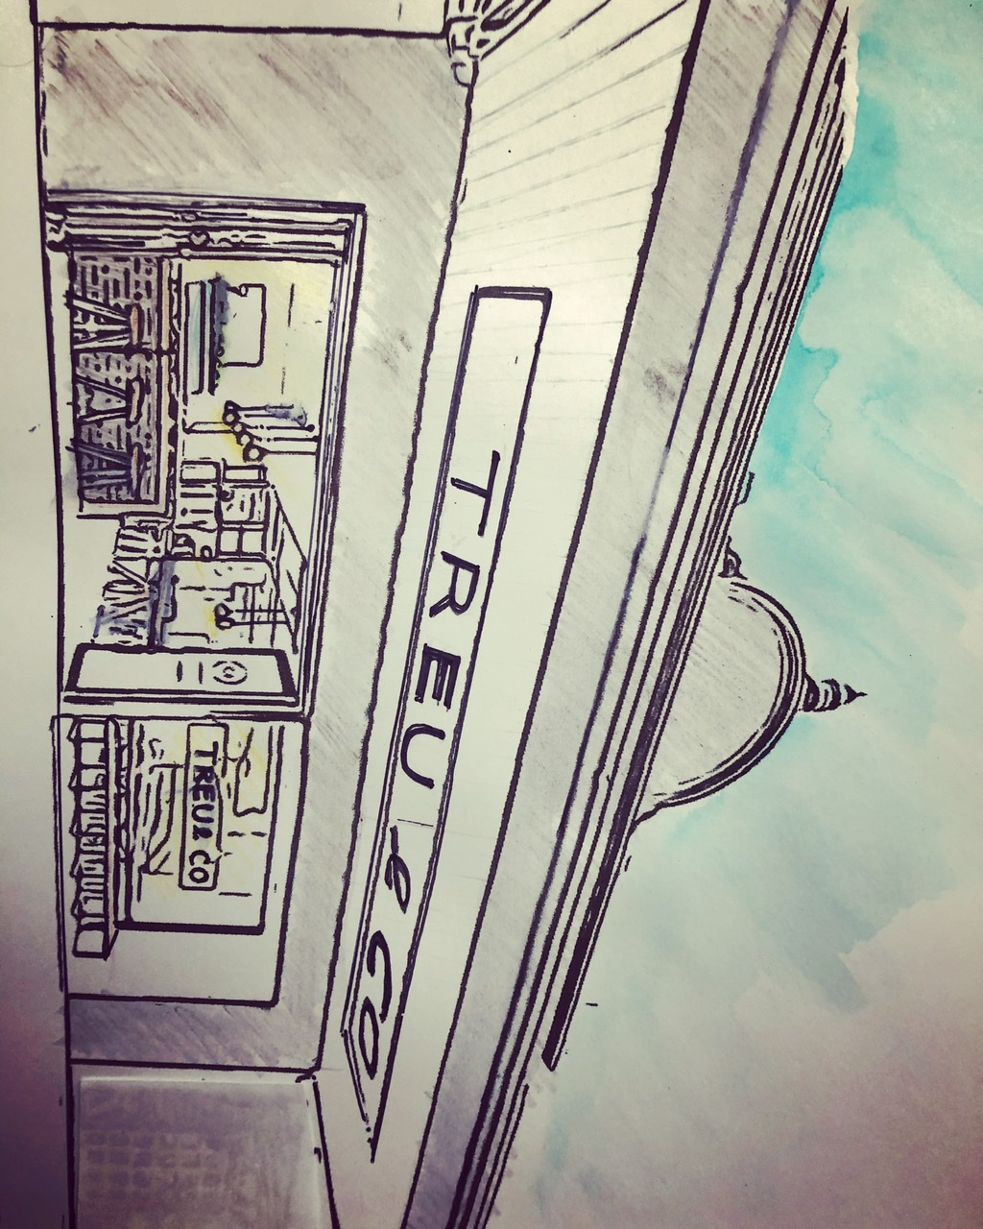

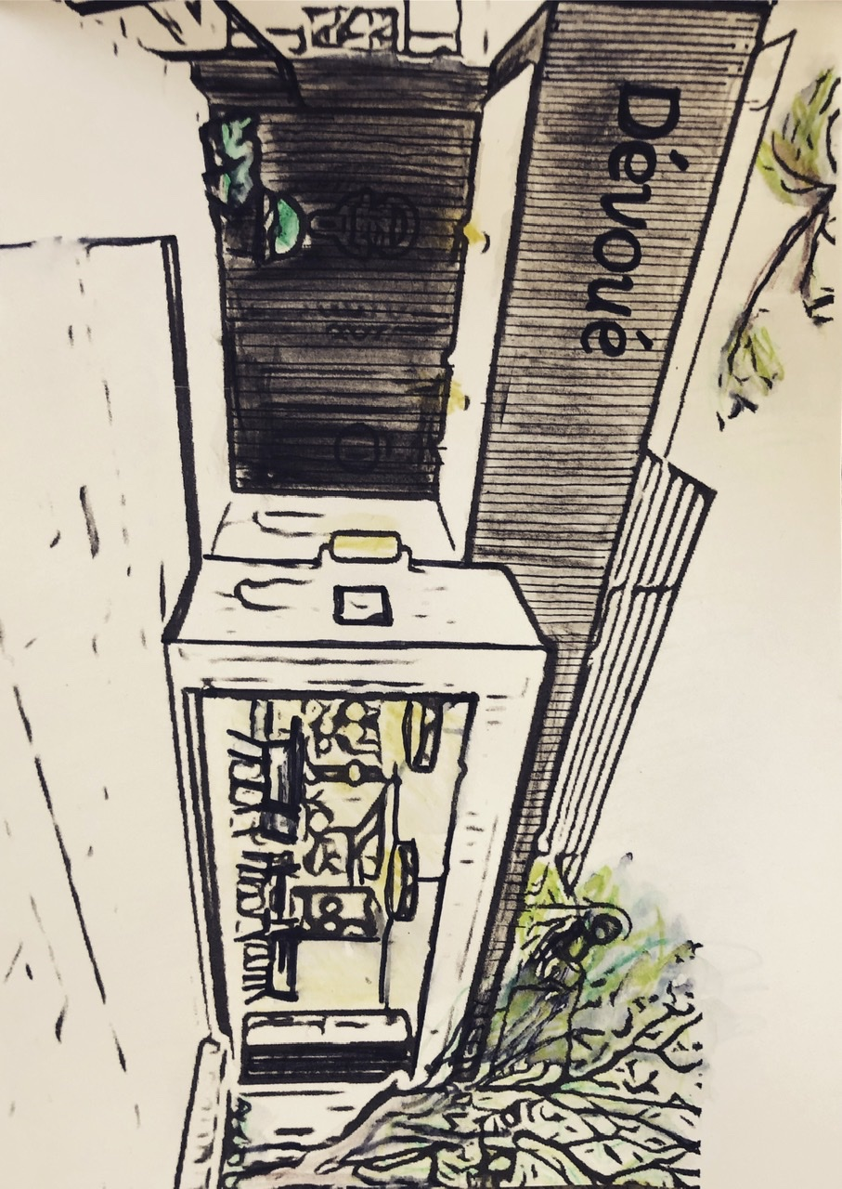

One style that you mentioned was New Orleans style. Even though New Orleans is eclectic, with many elements coming together, one influence that is consistent is French design. So we pictured using French themed elements for the inside of the wine bar.

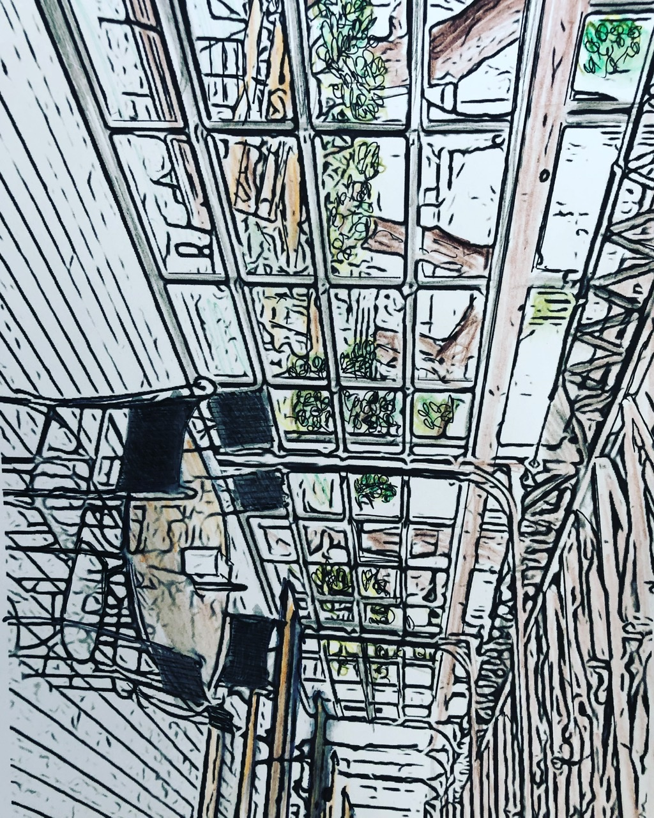

For the taproom, openness seemed to be important to accommodate as much seating as possible, so we envisioned the roll up doors on the west side, and an entrance similar to the wine bar on the north opening up to the pavilion to keep some continuity within the 3 buildings.

The name FiDeli seemed like a great theme to carry through the project (or faithfulness) so the wine bar and taproom have faithful (or devoted) in French and then in German in the renderings. These are precedent photos that reminded us of the project that we turned into sketches that we felt fit the site. At the same time, there are many more directions that we could go with everything and would love to hear any feedback on these ideas.

