ABOUT PAGE

About – this is a new page.

History. It will contain the program history with short videos of Angela and Rebecca describing the history.

Leadership. Same information as current page (updated).

Placeholder for Legal Entity. If we proceed with a non-profit structure, that information will be here.

Header and Main Navigation are the same on every page

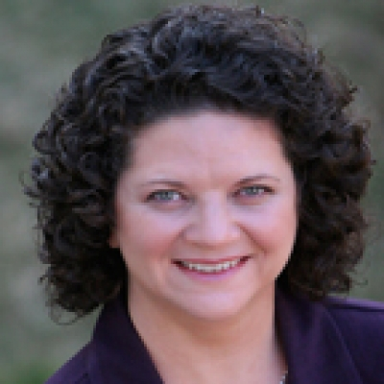



History

Leadership

Structure

Privacy Policy
Angela Packer McGhie, CG is a ProGen founder, past Program Administrator and continues to guide it by leading its board of directors.

Click here to hear Angela talk about the history of ProGen.

Rebecca Koford Whitman, CG, CGL is the Program Administrator and also serves on its Board of board of directors.

Click here to hear Rebecca share more the ProGen program.

Header and Main Navigation are the same on every page

Board of Directors
Angela Packard McGhie, CG

Rebecca Whitman Koford, CG, CGL

History

Leadership

Structure

Privacy Policy
Program Administrator
Rebecca Whitman Koford, CG, CGL

ProGen Administrator Role
Oversees the ProGen Study Program develops and posts curriculum facilitates networking, and organizes participants into study groups.

ProGen Mentor
Guides a ProGen study group by participating in monthly group discussions, providing expert guidance, and sharing comments on each topic. Each mentor is certified by the Board for Certification of Genealogists or the International Commission for the Accreditation of Professional Genealogists.

ProGen Coordinator
Manages a ProGen study group of ~25 members divided into three discussion groups by monitoring participation and reviewing assignments. Each coordinator is an alumni of ProGen Study Groups.

ProGen Discussion Leader
Moderates monthly discussions in a his/her own group of approximately eight study group members.

Pic here

Pic here

Pic here

Pic here

Volunteers

Events Coordinator
Lynn Parent

Secretary
Bobbie Johnson, CG

Waiting List Coordinator
Nicole LaRue, CG

Webmaster
Carla Cegielski

continued

Groups, coordinators and mentors can be listed here as current page. Two columns though

Groups, coordinators and mentors can be listed here as current page. Two columns though

History

Leadership

Structure

Privacy Policy

