PROTECT YOUR HOME FROM WILDFIRE – CREATE IGNITION RESISTANT SPACE

Learn more at
FIRESAFE HELENA WWW.TCFSWG.ORG

The best way to keep your home from burning is to
keep it from catching fire in the first place.
Learn more at
FIRESAFE HELENA WWW.TCFSWG.ORG

Your home… Your loss…
YOUR CHOICE!
PREPARE NOW!
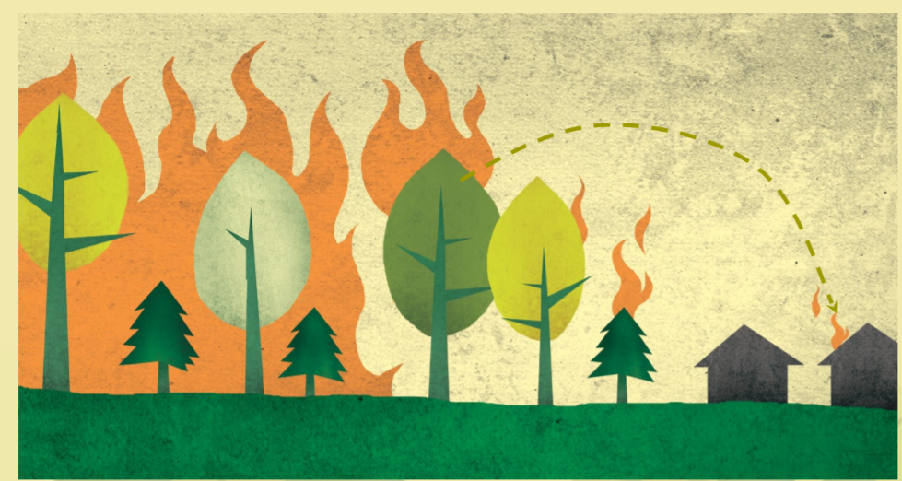
You Do Not Have to LIVE IN A FOREST to be in a WILDFIRE!

