Quick Reference Boom Sizes:
37 Meter – 120’ reach
38 Meter – 105’ reach
Rates:
$135.00 per hour for either truck
$2.50 per yard of concrete pumped through the truck
$35.00 per hour for a Laborer or Hoseman (if required)
We charge from port to port.
Overtime and Saturday Rates*:
$145.00 per hour for either truck
$40.00 per hour for Laborer or Hoseman (if required)

*Overtime rates are assessed for any hours over eight, or hours after 4:00 p.m. daily. The contractor is required to provide a safe area for the pump to set up and wash out. All towing will be at the contractor’s expense.

Cancellation Policy: The contractor/owner must call at least two (2) hours prior to scheduled concrete failure to do so will warrant minimum fee to be billed to the contractor/owner.

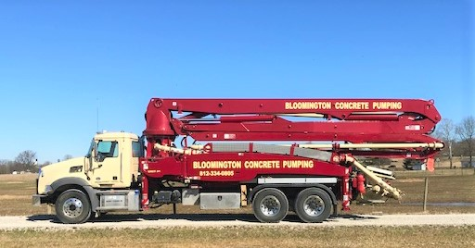

Bloomington

Concrete

Pumping

PH: (812) 334-0805
FX: (812) 334-3144

“Don’t Dump It, Pump It!”

Liebherr 37 Z4 XXT
- 120 foot Vertical reach
- Quick and easy set-up
- Powerful hydraulics for even and vibration free movements
- Reduced boom width for easy insertion in building openings
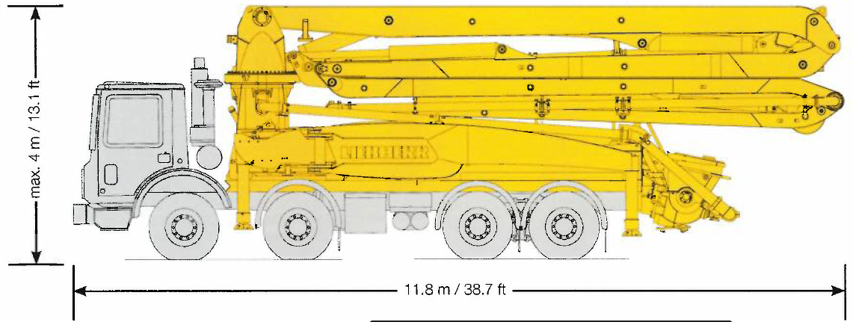

Putzmeister 38 Z Boom
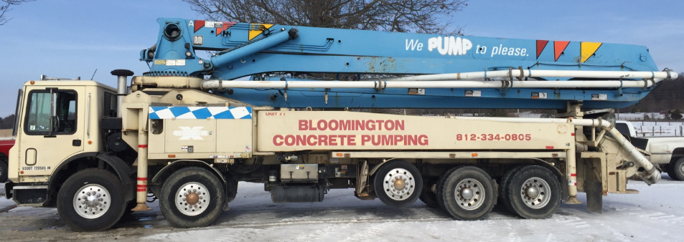
- 124 foot vertical reach
- Lightweight design
- Versatile 4-section Multi-Z boom Design
- Compact Outrigger Spread
- Free Flow Hydraulics

