Leo and Lyn Handcrafted Candles – Box Design Brief 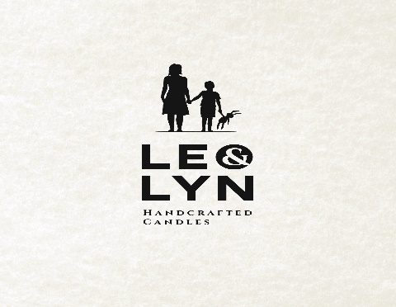

What is Leo and Lyn:
Leo and Lyn Luxury Handcrafted Candles is a new range of scented candles. The candles will be made with 80% soy and 20% paraffin wax for maximum scent whilst being kind to the environment.
L&L Candles will made in small batches and hand poured in Belfast, Northern Ireland using the finest ingredients.

What our candles will look like:
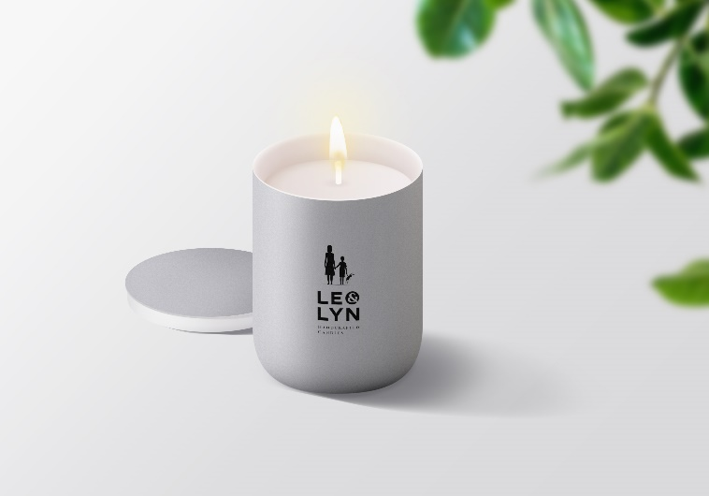
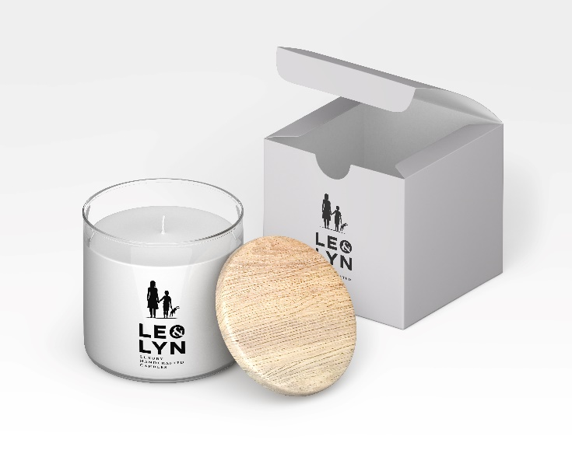

The above images are demonstration only and not the correct jar we will be using a Lucy jar (details below)

What jars are we using and dimensions:
We have chosen to use the Lucy jar (formerly known as the Karen jar)
Lucy Jar 30cl, height 93mm, diameter 81mm
Lucy Jar 30cl box dimensions, height 94mm, width 81mm, depth 81mm
This is a link to the site where we will purchase the jars:
https://www.continentalbottle.co.uk/cbproduct/karen-2/
This is a link to a website selling boxes for the jar (dimensions are here):
https://candle-shack.co.uk/collections/box-for-30cl/products/folding-box-for-30cl-jars-black

What do we want our packaging to look like:
Please think class, elegance and vibrance, with a touch of fun. We want our boxes to stand out while remaining elegant. We make luxury hand-poured candles and we name each scent creatively e.g. for Leather and Oudh scent we name that “Lounge Lizard” and for Fresh Laundry scent we call that “Cat’s Pyjamas” . That should give you a sense of our individuality. We want to look different and appeal to a high -end market. We don’t want to look like all the other “Spa” – looking candles. We would like the logo typeface to be black set in a white or cream square which sits cleanly in the centre of the front face of the box – not too big. For colour scheme please use tasteful colours – think Farrow and Ball blues and greens for example. The reverse face should have the text displayed clearly. We want to be inspired by you and will chose a box design that resonates with our brand.

Copy for reverse of box:

Leo and Lyn Candles are, each one, unique. We hand pour them with care, using the finest of ingredients, making them destined to fill your home with beautiful scents and a touch of elegance. Our candles are soy-based and made in small batches in Belfast, Northern Ireland.
We hope that you love your candle as much as we have loved making it.
Leo and Lyn

For best results place your candle upright on a flat, level and heat resistant surface. Always keep the wick upright and trim to about 5mm before lighting. Burn your candle for a minimum of 2 hours to create an even wax pool and a maximum of 4 hours to enjoy the fragrance. Keep free of any debris. Never leave a burning candle unattended, keep out of reach of children, pets and flammable materials. Do not burn near any draughts.

Burn time 40-45 hours approx.

Contains e220g/30cl of scented wax
www.leoandlyncandles.com

