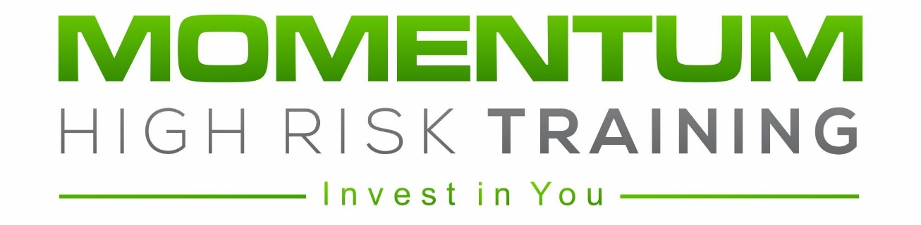

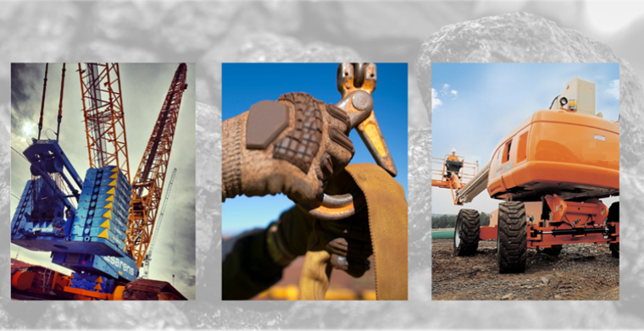

CAPABILITY
STATEMENT

- Company Details

Contact Details
Company Name | Momentum High Risk Training Pty Ltd
ABN | 62 631 030 021
CAN | 631 030 021
Telephone | 0484 001 205
Email | admin@momentumhrt.com.au
Website | www.momentumhrt.com.au
Office/Facility | 4 Presto Avenue, Mackay Harbour, QLD 4740
Contact | Jacqui Shields (Business Manager)
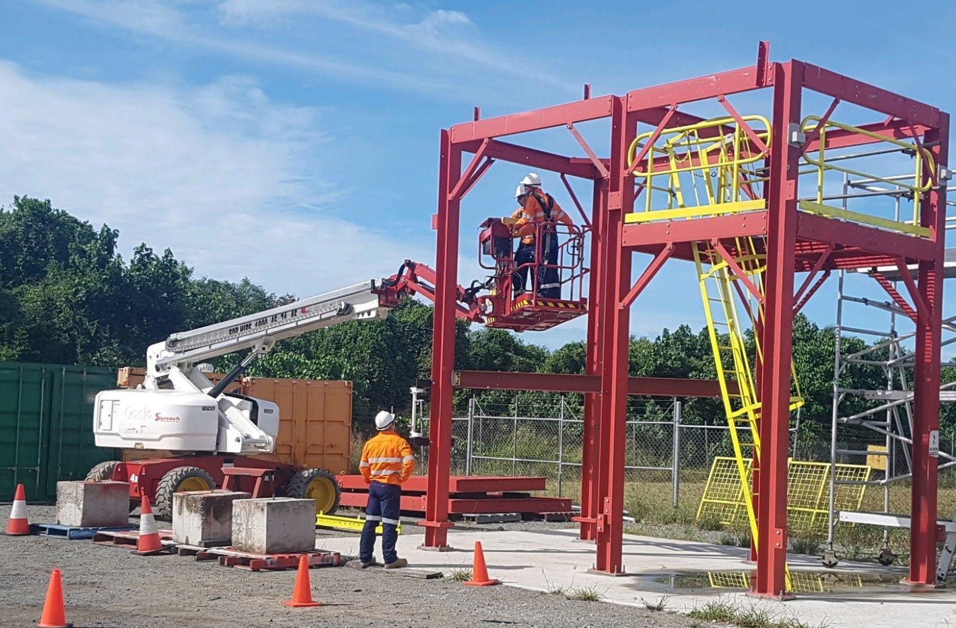

- About Us

Formed in 2019, Momentum High Risk Training (MHRT) was borne from a vision to deliver superior training and assessment services that strives to exceed the expectations of our customers.
Our goal is to connect great trainers with quality resources in a professional environment for our customers, ensuring a training experience above any other.
As specialists in the field of high risk training and assessment services, MHRT is well equipped to undertake a range of High Risk Work Licence (HRWL) services including:
- Forklift
- Elevating work platform (EWP)
- Dogging
- Basic rigging
- Intermediate rigging
- Non-slewing mobile crane
- Open crane
In addition to HRWL services, we provide a comprehensive range of Resource Infrastructure Industry (RII) courses including:
- Forklift
- Elevating work platform (EWP)
- Gantry/overhead crane
- Telescopic materials handler (telehandler)
- Vehicle loading crane (VLC)
- Dogging
- Conduct lifting operations
- Non-slewing mobile crane
- Work safely at heights
- Confined space

We have the expertise to undertake a range of supplementary services. These include large group training, training package design and development, Training Needs Analysis, providing advice on High Risk training requirements, Verification of Competency (VOC), familiarisation on machines/equipment plus other support services.
MHRT has a purpose-built facility at the Mackay Harbour which includes:
- comfortable modern training rooms with generous sized desks, large flat screen LED TV and soundproofing between rooms
- a custom-made structure that is utilised for basic rigging, intermediate rigging, elevating work platform and working at heights. The working at heights facility allows for the use of specific equipment such as inertia reels, dual hook ups, retractable lanyards, Gotcha Kits and to demonstrate the use of emergency release straps
This location at the Mackay Harbour provides an abundance of space to practice and learn in a controlled yet realistic work environment. This naturally influences the person to conduct a more thorough risk assessment, thus enforcing their understanding of risk management and appropriate control strategies.
As well as our own facility, MHRT can conduct most training on site – in town or a mine site.
We currently have three trainer/assessors plus a consultant to provide a range of training and support services. Our trainers are knowledgeable, experienced, and importantly, professional and respectful. All our trainers hold the required licences, competencies, and insurances to perform training and assessment services. We encourage continual learning and development through meetings, Professional Development activities and networking.
Not all trainers are the same - selecting the right kind of trainer is a crucial aspect of our business.

Momentum High Risk Training works in partnership with MyneSight (RTO No. 31900).
If you would like further information about our courses, our people or to make contact, please visit our website www.momentumhrt.com.au

- Key Personnel

Jacqui Shields – Director/Business Manager

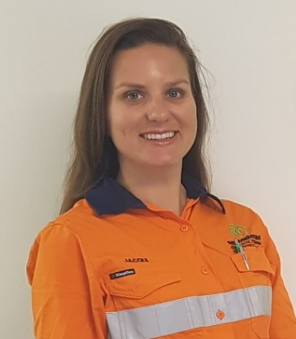
Key Responsibilities
Jacqui drives the overall direction of the business focusing on building relationships and networks within the industry.
Jacqui manages all aspects of administration, finances, legislative requirements, and marketing.
Personal Strengths
- Strong communication and interpersonal skills
- Always has time to invest in others
- Logical and systematic
- Good understanding of training required for mining, ports and civil industries
Qualifications
- Bachelor of Business (Griffith University)
- Graduate Certificate in Learning Technology (Griffith University)
- Graduate Diploma in Secondary Education (Griffith University)
- Diploma in OHS
- Certificate IV in TAE
Experience
Some of Jacqui’s recent experience in her 12 years in education and learning and development:
- Training Officer at Dalrymple Bay Coal Terminal
  - Seconded into Training Advisor position to coordinate the training requirements for Business Services/Business Improvement
- Training Coordinator at Rio Tinto’s Hail Creek Mine
  - Part of a team who designed a site-wide Training Needs Analysis and online document library
  - Managed the training requirements for the Maintenance and CHPP departments
- Trainer for SGS Australia
  - Part of a team who designed the initial 3-day Standard 11 course
  - Delivered generic induction training across Queensland
- Secondary school teacher for Education Queensland

Luke Shields – Director/Trainer Assessor
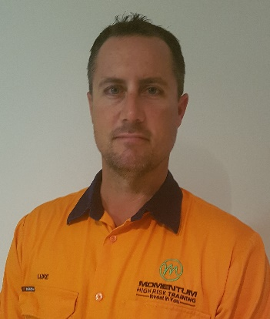
Key Responsibilities
Luke drives the overall direction of the business focusing on building relationships and networks within the industry.
Luke is a High Risk Work Licence Accredited Trainer/Assessor, performing training and assessment in classes LF, WP, DG, RB, CN and C0.
Personal Strengths
- Strong communication and interpersonal skills
- Can make the hard decisions and follow through with implementation
- Driven and strong willed yet people orientated
- Focused

Qualifications
- High Risk Work Licence – LF, WP, DG, RB, RI, CN, CT, C0
- WHSQ Accredited Trainer/Assessor – LF, WP, DG, RB, CN, C0
- Certificate IV in TAE
Experience
Some of Luke’s recent experience in his 18 years in mining, ports and civil construction including rigging, crane operating and learning and development:
- Trainer/High Risk Work Licence Trainer and Assessor at Momentum High Risk Training
- Training Coordinator/Trainer at Glencore’s Rolleston Mine
- Special Projects (Cranes and Rigging) at Ok Tedi Mine, PNG
  - Established a training department within the company
  - Designed and implemented a Training Needs Analysis
  - Coordinate large special projects in cranes and rigging
- Crane operator for McConnell Dowell (Hay Point Expansion – HPX)
  - Operated 750t Liebherr crawler crane

- Testimonials (online Business Reviews)
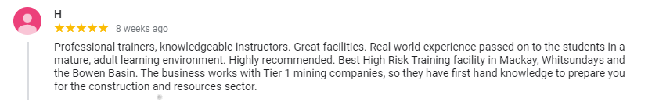
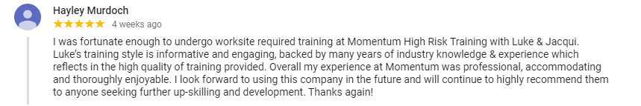



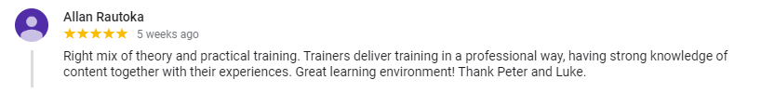

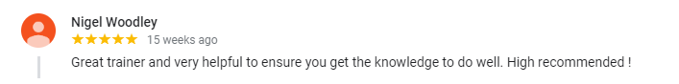

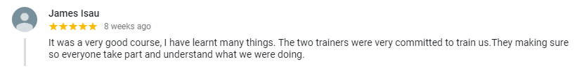

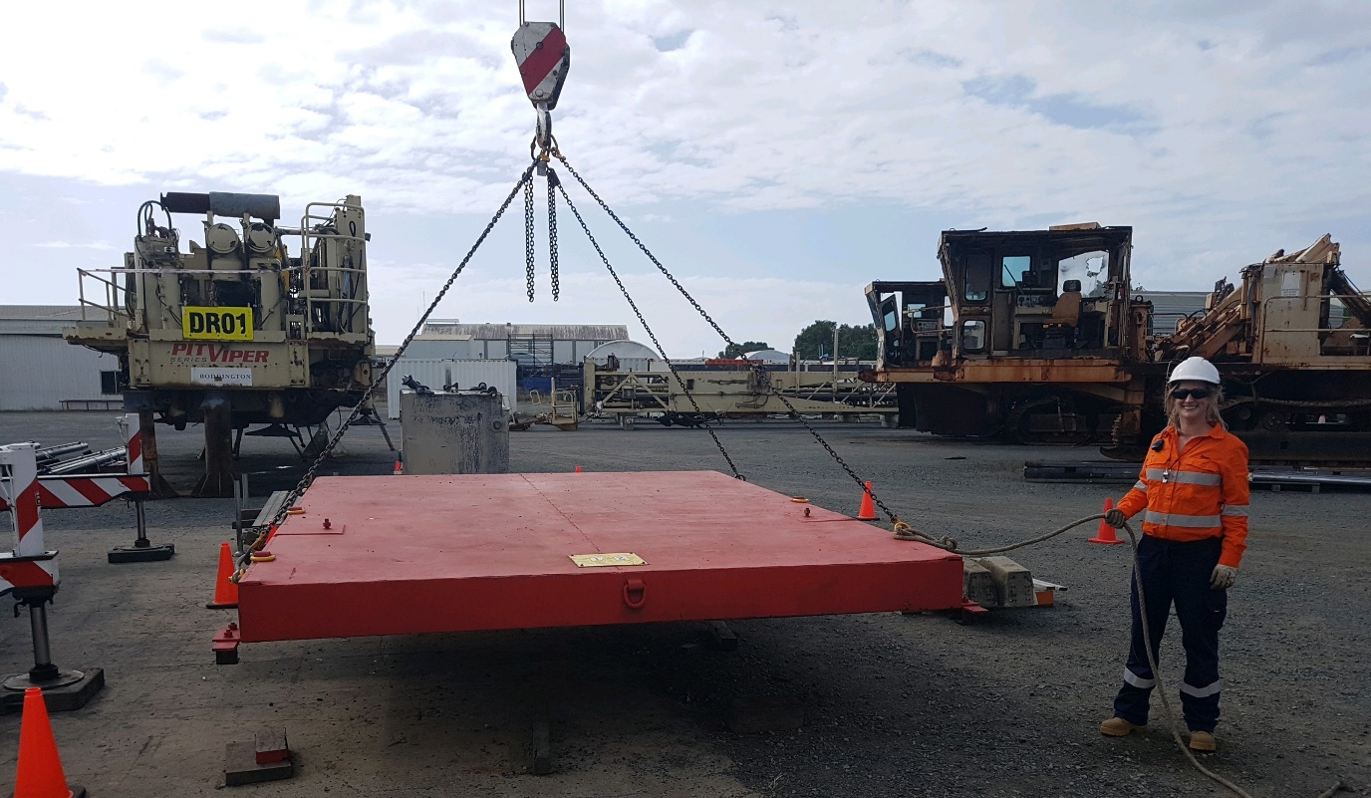
HRWL – Dogging course

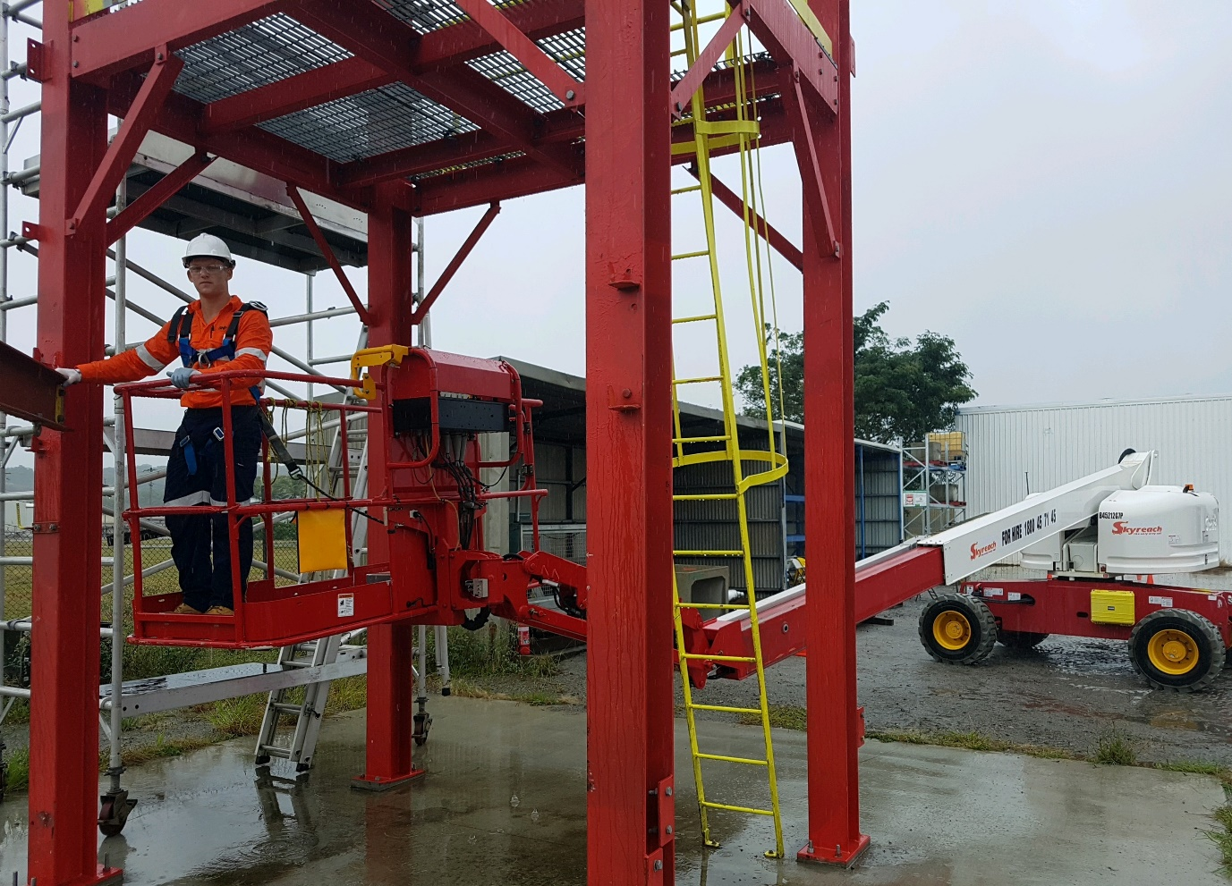
HRWL – EWP course

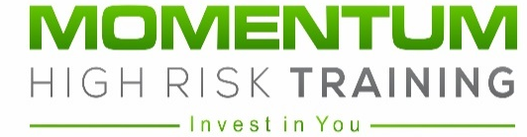


Phone: 0484 001 205
Email: admin@momentumhrt.com.au
Website: www.momentumhrt.com.au
Address: 4 Presto Avenue, Mackay Harbour, QLD, 4740

