Emilio’s Design Brief

Brand and Business Background
- We are two butchers purchasing an existing butcher shop under our new trading name ‘Emilio’s’.
- I’m a newly qualified butcher with an Australian background and a keen interest in innovation and sustainably raised produce. I completed a butchery apprenticeship with my business partner as a teacher and mentor.
- My partner is a third generation 20 year experienced butcher who moved to Australia from Italy 5 years ago.
- We specialise in offering meat sourced from smaller scale producers farming ethically and sustainably. Most animals that we process are pasture raised, this means they have lived their life with access to fresh outdoor pasture and are predominantly grass fed and free range. A number of our farms are also organic or biodynamic certified.
  - This is the primary identity of our business and one of the most important factors in appealing to our market. Most of the customers we will be serving are spending the extra money on this type of meat because they believe it’s the ethical way to consume meat.
- We intend to subtly celebrate our Italian influence through offering a number of specialty Italian products such as salami, prosciutto, Italian style sausages and Italian cuts of meat. This influence is not the focus of our identity, we don’t want to be labelled an Italian butcher, just to offer a service with traits we admire from the Italian style. It is however a point of difference in the market that we believe will be an attractive feature.
- The brand name comes from my partners father’s name. Emilio is important because he is the heritage of our skill an philosophy towards butchery. He taught my partner to butcher and that skill and knowledge was then passed on to me. The personality behind the name is not the focus, for us it is simply an elegant sounding name with some intrigue for the customer.

Brand Philosophy
- Our philosophy focuses on respecting the animals we process through a few ways:
  - Selling the whole animal and wasting nothing, bones and fat included.
  - Recommending less popular cuts and teaching customers the best way to cook them to celebrate all parts of the animal not just the ‘prime’ cuts.
  - Selling the animal at the optimal time and in the best condition possible. The animals we process are generally older than typical commercially raised ones and require dry aging to allow the muscles to tenderise and flavour to develop.
  - Acknowledging and praising the farmer who has worked hard to produce this animal to such a high standard.
  - Selling the meat in a way where it is the focus of the exchange – no performance, no arrogance, as little else aside the produce as possible.
- There is an element of minimalism to our approach in a few ways
  - In butchery there is a theory if you can complete a task in fewer actions or cuts then that’s the way you should do it.
  - There is beauty in the bareness and rawness of meat, it doesn’t need to be dressed up to be presented just well cut.
  - We don’t mess around with meat to provide a huge range of products – our offering is compact but meaningful, every cut in the display window is there for a reason and to serve a particular demand.
  - We work very cleanly and tidily and give a different image to the butcher stereotype.
Brand Identity
- Business and Industry
  - Emilio’s is a specialty butcher offering sustainably farmed produce expertly cut by artisan butchers.
- Competitors
  - There is growing competition in this segment of the market as operators identity customers heightened concern about where their food has come from and under what conditions it has been grown.
  - There has consistently been a number of small businesses targeting this market however larger retail and wholesale butchers are now also positioning themselves to attract conscientious consumers.
  - There is a limited number of producers operating under the parameters that we look for and with more competing businesses this means that often the same farmer’s animals are being sold across different shops.
- Differentiation
  - Craft
    - With generations of experience behind us we work at a high level of skill and precision and subtly flaunt this in our service. The standard practice of butchery in Australia in todays age is very limited in the skills it requires and this has resulted in a decline of skilled and passionate craftsmen. The service and product you receive from a butcher who takes great pride in their work is markedly different from the alternative.
  - Personal service
    - In running a small shop we have fewer customers and are able to develop more personal relationships with them and build strong loyalty. We take a much more friendly approach to serving customers to ease them and allow them to feel totally comfortable and trusting. We don’t want to grow our business to the point where we lose this close connection with the customer – we’re small and we’re happy with that.
  - Italian influence
    - Without overtly identifying as an Italian butcher we do feature many products and traits that people associate with Italian culture and cuisine. In my experience working with my partner Australian customers have been fascinated with his knowledge of Italian products and awestruck given the opportunity to try them. Italian customers living in Australia have also been a strong customer base of his as they find it hard to buy meat cut to their liking as they received it in Italy. Once these Italian customers find an Italian butcher working in Australia they quickly refer their friends and family.
  - Innovation
    - With two passionate butchers at the helm the ideas for new and interesting products are endless. We’re constantly trying new recipes and developing products that don’t just look good but also give the customer a truly satisfying experience in cooking, serving and eating it.
- Qualities and Values
  - Trustworthy, honest, friendly, fun, passionate.
  - Impressive, understated, genuine, traditional.
  - Minimal, high quality, clean, healthy.
- Customer/Target
  - Consumers conscious of where their meat is coming from – how was it raised, what has it eaten, has it been treated with chemicals, how was it slaughtered, what effect has its production had on the surrounding environment.
  - Consumers with an appreciation of fine service and artisan skill. A customer who isn’t just happy to wait a few extra minutes for a cut to be taken fresh from a whole body but actually enjoys watching it being expertly removed and trimmed with their best result at heart.
  - Italian customers searching for service and style they are familiar with from home. Whether the familiarity of an Italian speaking butcher or seeing particular products on offer from their region in Italy.
- Look and feel of Brand Identity
  - Stylish, cool, elegant, modern branding but traditional values, somewhat minimal.
  - We’re looking to have a clean and modern style to the branding as we don’t want to be attached to the old fashioned virtues of butchery and the shop’s previous owner. We’re considering a more modern and contemporary image than a typical butcher shop.
- Thematic colours
  - Dark green – Sacramento green, juniper green, British racing green, Phthalo green)
    - The branding shouldn’t necessarily be in this colour but it will be a colour featuring in the physical shop and in our uniforms.
- Where the branding will feature
  - The branding will appear primarily on an awning sign at the front entrance as well as a large canvas sign on the back of the building.
  - On price tickets pinned to fresh meat in display window
  - Price stickers on weighed packages of meat.
  - Labels on jars of bone broth, ready to eat food like curries, soups, pâté, terrine.
  - Cryovac packs of sausages sold in other retail outlets.
- Subtext
  - We would like a subtext of ‘Specialty Butcher’. We think this defines us well as we don’t want to align too closely to one niche and it leaves our options open for the future.
Do’s and Don’ts
- Do’s
  - Create a stylistic, elegant and simple logo design the conveys the essence of our brand – stylish, elegant, impressive yet understated and minimal.
  - Create a simple logo that is easy to read and recognisable.
- Don’ts
  - Focus on our Italian influence
  - Reference animal shapes or cuts of meat
  - Use a caricature of a person
Logos/shops I like

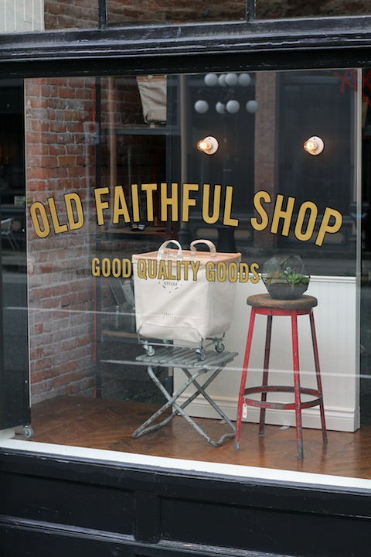
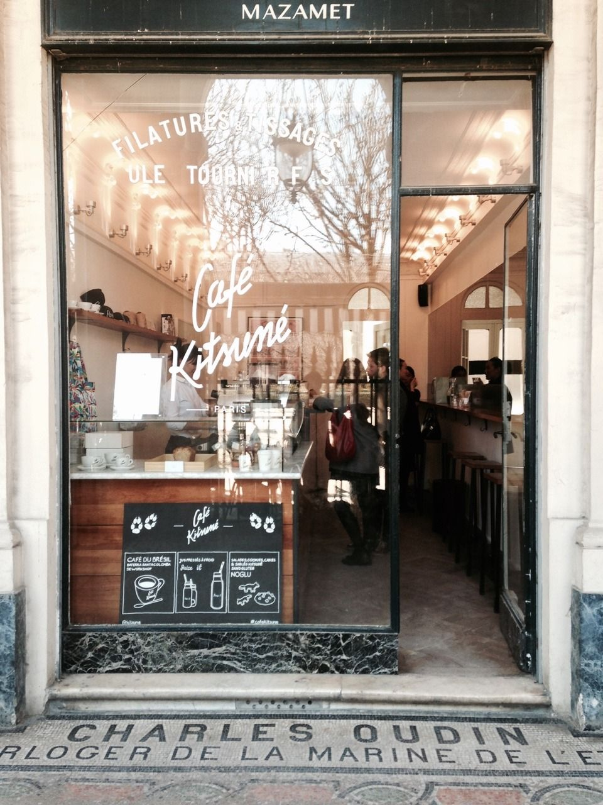

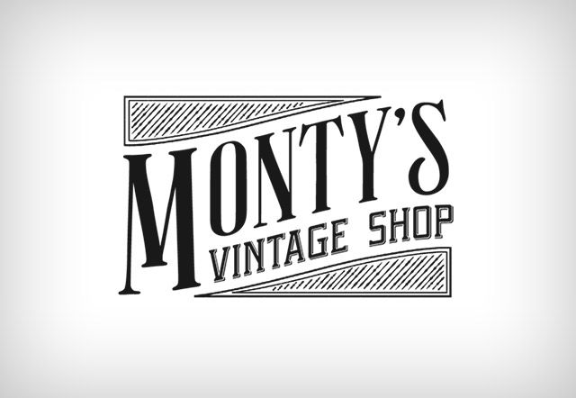
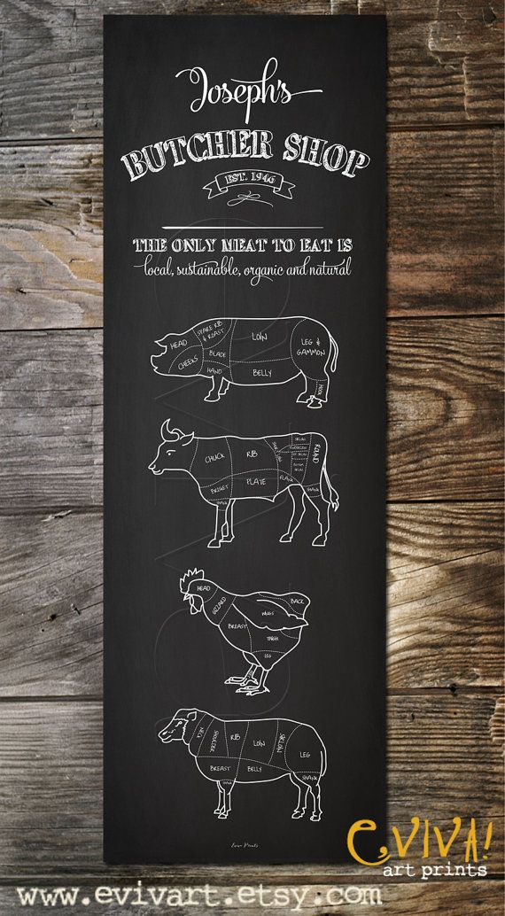
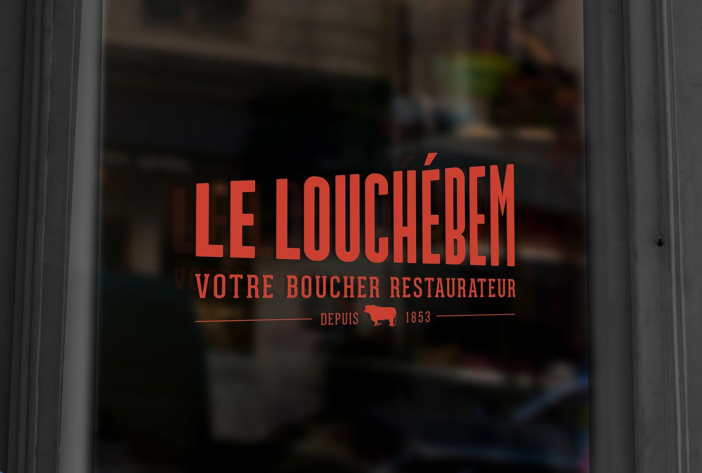

I particularly like aspects of this logo like its simplicity, resonance and boldness. I like the spacing and sizing ratio between the brand and the subtext.

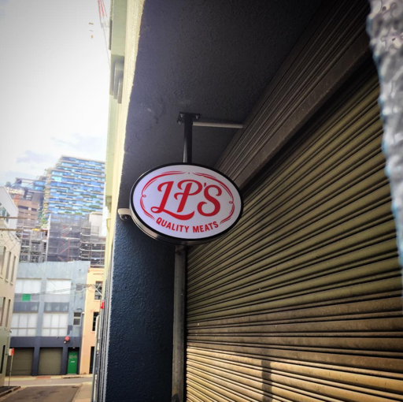
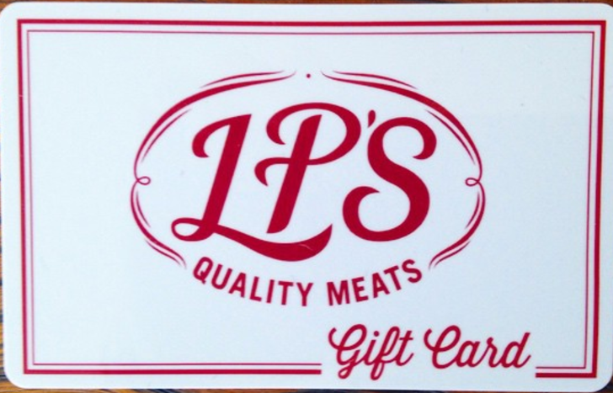

I like the font, boldness, sizing between brand and subtext, different font between brand and subtext. I really like this logo overall.

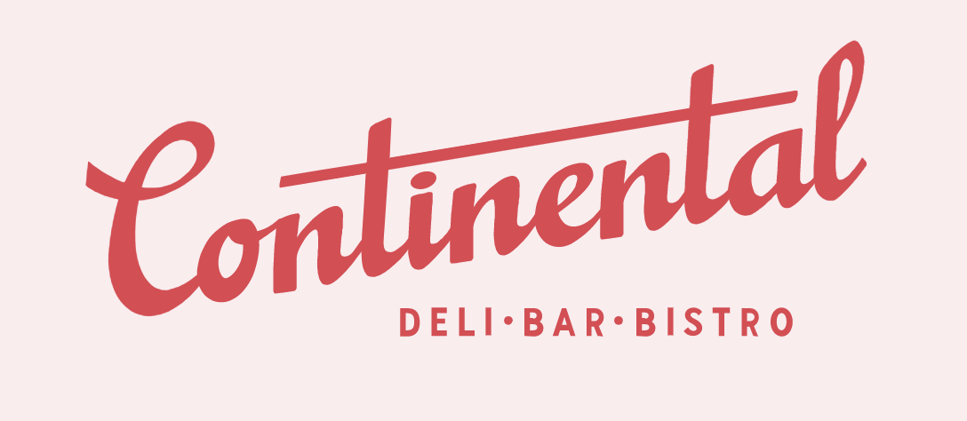

I like the font, boldness, angle of the logo, very stylistic but easy to read. The angle of the brand but overall squareness of the entire logo is cool. Another logo I really like.

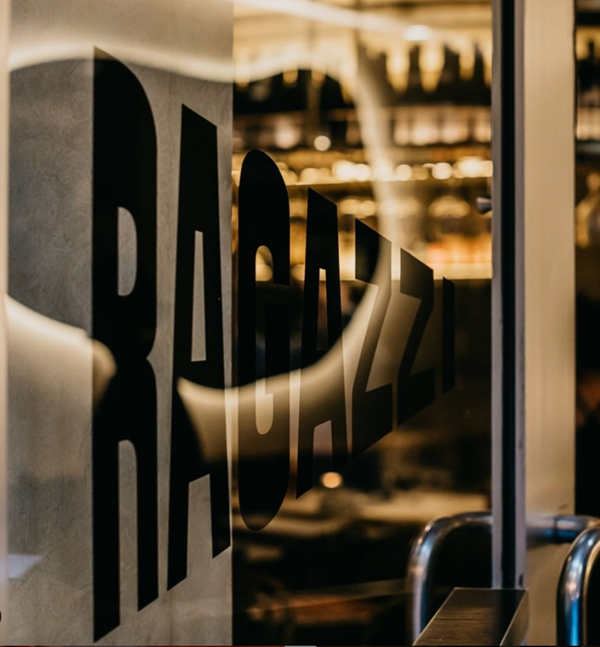
I like the boldness, angle, shape and font. Could be difficult to work with for labelling due to shape.

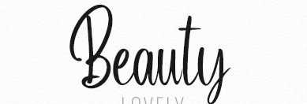
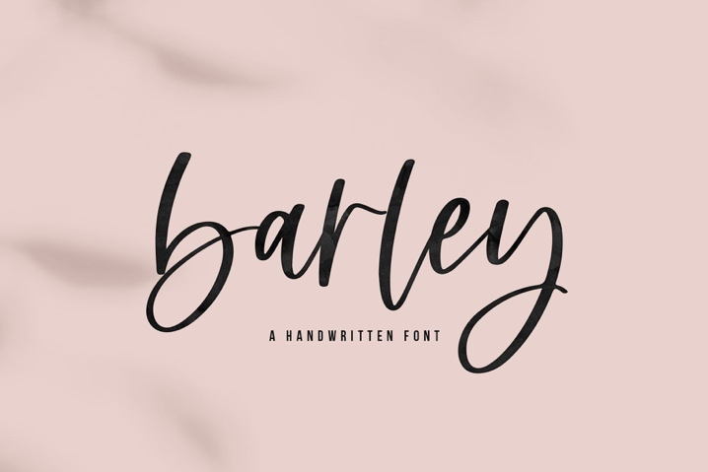
Fonts I like

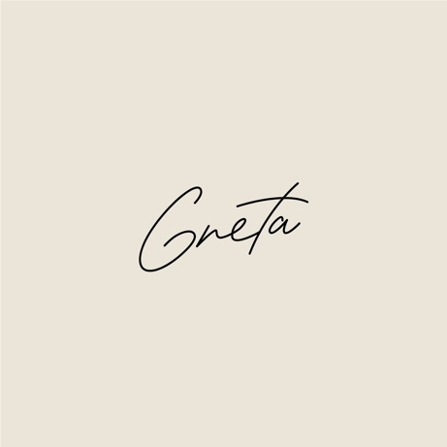

Important to note that the logo doesn’t have to be in cursive font. I would rather something that is cool, stylistic, readable and easily recognised.

