Summary
- The site includes the following pages. We expect design and coding for all of them with the content shown further below:
  - Home
  - Product
  - Crossbid
  - About
  - Contacts
  - Demo (the page has general graphics consistent with the other pages but for content it has only got a username and login form). The page will not be included in the main menu but we will point selected traffic to it
- For the above pages, we would like the design and coding also of the mobile views
- In general, we prefer the use of icons rather than photos
- Please use the logo supplied and a colour palette blue-black-white

Home
-First Section
A video of 40-50 seconds on the right
On the left a punching motto on two rows:
Embrace digital property management
Manage your assets, partners and projects in one place, from anywhere, with the power of technology

- Next Section
Features
- Task Management
  - Create and assign tasks to partners and colleagues
- Dashboard Views
  - Glance through planned and executed tasks to stay in control
- File and Communication Logs
  - Store all correspondence and files in one, easytofind and secure place
- Property Database
  - Log all your asset data and seemlessy share them with your partners
- Task Library
  - Use detailed task templatesto create new tasks in seconds
- Manage deadlines and productivity
Automatically mark overdue projects and receive alerts
-Next Section
Large logo of a laptop on the left
On the right:
Access your teams, partners and projects with Crossroad in real-time, from anywhere
Data are securely stored in the Cloud
Perfect innovation for remote working and dispersed teams
Built to manage and scale a flexible workforce

Move hand written notes, telephone conversations and long email exchanges in one, secure, auditable, and easily accessible place

Discover More (link to page “Product”)

-Next Section
Discover the power of Crossroad for your organization
One icon on the left with a laptop and the caption “Schedule a demo”. Let us show you how Crossroad can enhance your operations. Link to “Contacts”
Icon on the right with an email logo:
“Get a personalized quote”. Contact us to discuss your requirements and receive a competitive quote, inclusive of a free trial period.

- Next Section
Crossroad is an Enerinvest product.
Founded by Alex Coutlis and Mauro Terrinoni in London, Enerinvest is a leading SaaS technology provider focused on the financing and real sectors.
With 40 years of combined experience between them, Alex and Mauro have earned international experience in blue chip organizations in advisory, investment and management of properties and secured assets.
Discover more (Link to About)

- Footer
- Links to pages
- Contacts
- Legal (two pages underneath: Privacy Policy and Disclaimer)

Product
-- First section
Crossroad is a technology app that allows astute property owners (Funds, Banks, Corporates, State Entities) to manage and track tasks related to their assets for facility management, legal, sales, technical activities.
Key Benefits:
- Manage assets more efficiently,consolidate, track and easilyshare key information
- Increase assets under management with operational leverage
- Demonstrate to all stakeholders innovation and technological drive

- Next section
A new digital paradigm for property management
- All your work in one place
- Get real time updates from partners
- No more endless email chains

- Set and monitor task deadlines
- Improve collaboration and remote working
- Automate repetitive tasks

- Next section
Can we represent this graphic in some smart way?
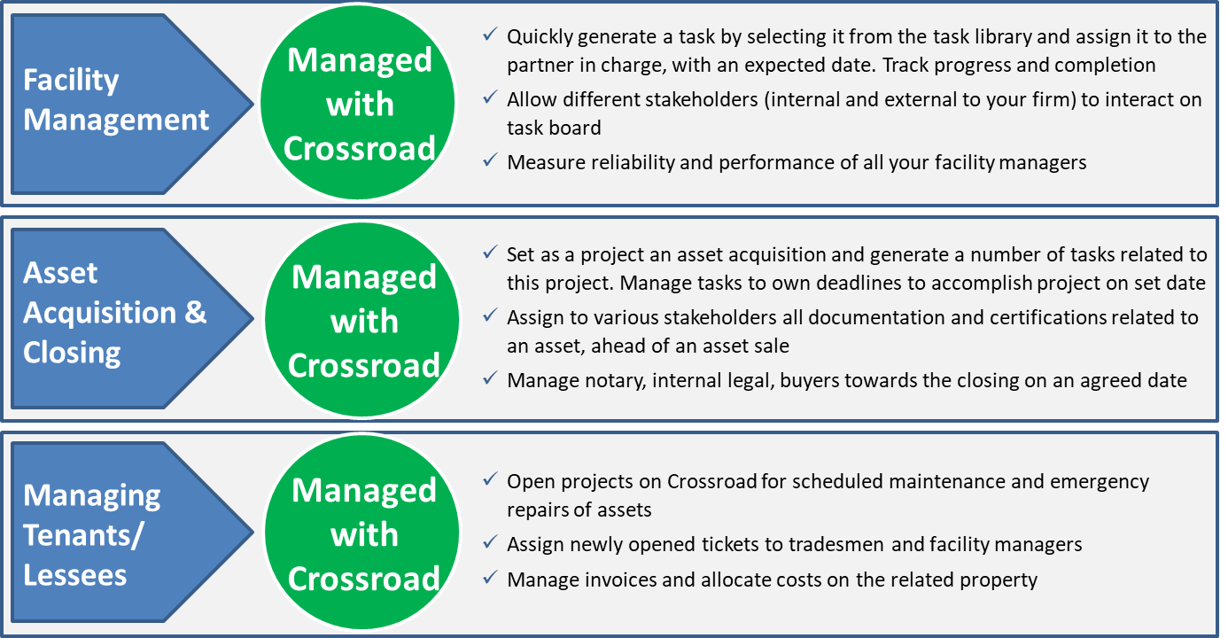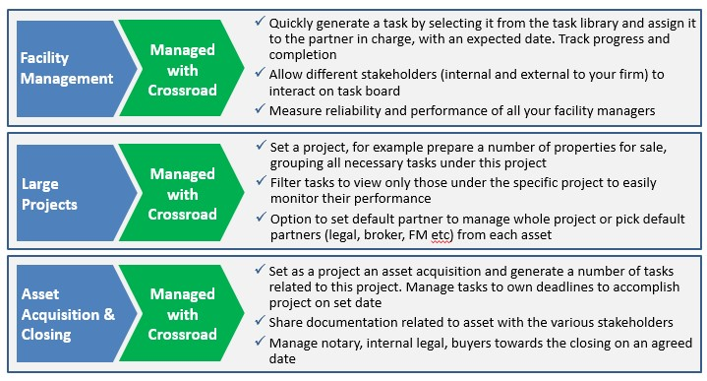
[more closely reflects what crossroad can do now]
Get in touch for a demo and a personalized quote (link to Contacts)

Crossbid
- First section
A large icon on the right depicting houses or buildings
Text on the left: Managing property sales with technology
Crossbid integrates sales channels for property owners, including direct sales via auctions and broker marketing

- Next section
Features
- Online Auctions
  - Easily set-up and run online competitive auctions
- Agent Integration
  - Allow for agents to register and invite clients to bid
- Financing Requests
  - Gather requests for financing and share them with financing partners
- Buy Now Option
  - In addition to real-time auctions, collect bids at fixed price
- Automated Workflow
  - All functions are automated and built to create a structured and efficient workflow
- Fully customizeable
  - Crossbid can be offered in white label and customized upon client’s specifications
---Next section
How online property auctions work

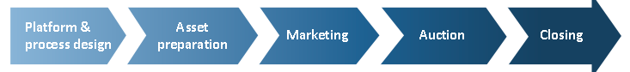

---Next Section

Snapshots of the platform

---Next Section
Request a demo or request quote (same as in the homepage)

About
- First section
Crossroad is a product invented and developed by Enerinvest, a London-based innovative software and advisory firm founded by Alex Coutlis and Mauro Terrinoni.
Alex and Mauro have a background in investment banking and principal investments, with a focus on distressed securities, real estate and loans. They have executed trades for hundreds of millions of dollars, as investors and advisors, in various European markets.
Alex and Mauro founded Enerinvest with the mission of leveraging technology to generate efficiency and control in traditional workstreams around asset management and property sales.

Alex and Mauro photos, contacts and link to Linkedin bios

Contacts
Please get in touch for a demo and a personalised quote using the form below or sending an email to team@enerinvest.com

Address:
Enerinvest (UK) Ltd
36-37 Albert Embankment
London SE1 7TL

Contact Form (please send results to team@enerinvest.com)
Name and Surname
Telephone:
Email:
Comment:

