5 Reasons You Suck At Hiring For Fit.

Hiring the wrong fit is painful, we are with you there.

Bad hires ruin your day, every day.

You want to make sure your next hire is the right one. You know what it’s like when you hire the wrong person – they aren’t productive, they don’t get along with others, there’s tension, you have to let them go, and you re-start the whole process over again.

Our goal is to help you stop this cycle. Here are 5 mistakes you are likely making.

- You have not defined the obstacles found in the job.
  - Every job has its challenges and you need to find someone who will deal with the challenges as a high performer would. Spending too much time in unstructured conversation or putting too much emphasis on selling the role can detract from this key insight. Define the top 2-5 obstacles and learn how the candidate has or would tackle them.

- You describe the job using words, not data.
  - Detail oriented means different things to different people. You only find out after you have hired someone that they are not detailed enough (or are too detailed!). The same can happen when we say a candidate needs to be proactive or risk oriented. You only find out later that you hired too much or too little. You used words and not numbers to define what you needed for the role.

- You assume knowledge and experience equals performance.
  - Just because someone’s resume says they are a strong manager does not mean they are one. And yet this is how you screen and rank your candidates. The best resumes rise to the top. But resumes are a terrible predictor of performance. Success at one company does not mean success in yours. Who are you overlooking that may be a better performer? (we have an idea below)

- You are biased and subjective in your assessment of others.
  - You get attracted to certain resumes and backgrounds. You make judgement calls on phone interviews. You do the same when you meet someone and during an interview. Very few recruitment processes have a way of OBJECTIVELY ranking and comparing candidates. As a result we end up picking someone we like as opposed to someone who will excel in the job.

- You think your “gut” makes good decisions.
  - “Gut” has more to do with how likeable someone is than how effective they will be. Effectiveness comes from a person’s ability to consistently behave in a manner that produces exceptional results. Do not make judgement calls on behaviours a candidate shows but may not be able to consistently repeat.

So how can you hire for fit?

Personality is the most significant predictor of both fit to the manager and performance in the role. It is also one of the most difficult things to assess without the use of an objective tool.

Most candidates behave a certain way in an interview, but it may be something that is difficult for them to sustain.

To start addressing the problem of hiring bad fits you need to add more objectivity to your process. Screen2Fit is a tool designed to define a benchmark of what personality is required in a role using data. Everyone gets on the same page of what success looks like.

From there each candidate completes a Pro.file personality survey within the Screen2Fit tool. Then they are compared equally to the benchmark and ranked objectively. All candidates are compared using the same personality dimensions.

You leverage specific data and our insight to find the best candidates … Your ability to consistently hire above average fits increases ... You achieve more.

Here are the results of a candidate compared to a job. The job is represented in red, the candidate is represented in black.
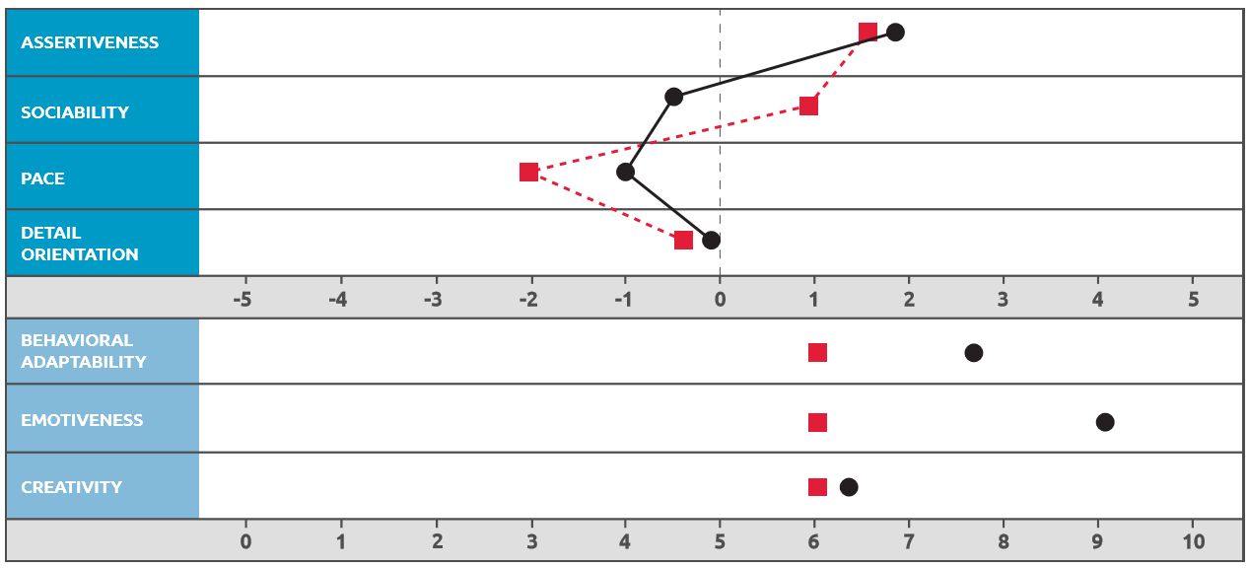

What’s next?

(Three boxes)
- Contact us to discuss your position
- Leverage our tools, process and insights throughout your process
- Welcome a great new team member and crush your goals

What Screen2Fit users are saying…

The process changes we have made in recruiting as a result of working with Concord’s Screen2Fit have been transformational. We went into the interviews with confidence which ultimately made it easier to select the right candidate for the roles. Thanks to your tools and assessments I have a stronger team!
VP, Oil & Gas Sector

We’ve had very good success over the past year and a half since I’ve been in this role with reducing our turnover from around 50% to less than 10%. I feel very strongly that much of that has to do with our practice of only hiring people who are a match for our benchmarks.
Recruiter, IT Sector

Screen2Fit allows us to identify those that don’t fit our benchmark early so we don’t spend time with those that don’t fit.
Owner, Auto Industry

email@concordconsulting.com
855 464 6688

