Our background:
Since its inception in 1998, Road Rules Driving School has strived to help drivers maintain their driving independence while leading safe and productive lives. Our motto “making drivers safe for life” drives our vision of helping drivers across industries and at all stages of our driving careers.
Road Rules started out working with school boards to deliver driver training to beginner drivers. Thousands of students have graduated from our ministry-approved curriculum throughout central Ontario. We are also ministry-approved to instruct defensive driving (DDC) and driver improvement courses (DIC), for drivers with speeding tickets, demerit points and at fault crashes.
Road Rules has also evolved to provide comprehensive driver rehabilitation to those who have lost, or are at risk of losing their license for medical reasons. This includes mobility issues requiring adaptive equipment, as well as traumatic crashes resulting in cognitive impairments and PTSD. We work with clients before the courts charged with impaired driving (alcohol, cannabis, opioids), road rage and stunt driving.
Founder Matthew Rivers started driving at an early age on his parent’s farm. Driving professionally and doing so safely is in his DNA. Matthew graduated from Lakefield College School, and obtained a degree in Business and Psychology from Bishop’s University. He is a certified in-car and in-class driving instructor and trainer.

Maintaining
driving independence,
while leading
safe and
productive
lives!

For more information:
www.roadrulesdrivingschool.ca
Call: 705-874-9220
mrivers@roadrulesdrivingschool.ca

IMPAIRED AWARE
A 1-DAY EDUCATIONAL COURSE FOR THOSE CHARGED WITH DRINKING AND DRIVING

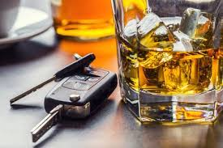

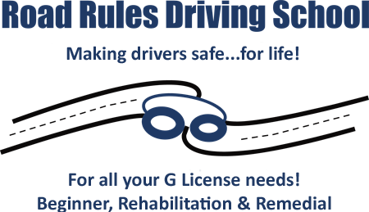
705-874-9220
www.roadrulesdrivingschool.ca
mrivers@roadrulesdrivingschool.ca

IMPAIRED AWARE…
A 1-day, 7-hour, intensive remedial measures course for those charged with being under the influence of alcohol.

Our goal is to equip our customers with knowledge and help them to avoid something devastating and/or irreversible from happening in the future.

During the course we will:
Look at how alcohol affects us from a physical standpoint:
- What is a serving of alcohol?
- Blood alcohol concentration (BAC) and the many factors that go into creating our individual BAC/level of intoxication; how much does it take to get us to 0.05/0.08; how long to wear off?
- Effects on different organs in the body including diabetes, cirrhosis etc.; effects on the brain/cognition at different levels of impairment

Count the costs including:
Financial: fines, programs fees, court costs, legal fees, insurance
Human impact: personal relationships, criminal record, job prospects, international travel, custody, physical injury

Help you gain a thorough understanding of the laws in Ontario & Canada (the Highway Traffic Act & Criminal Code of Canada)

Look at the psychology of addiction:
- Stages of change model (how to improve our habits)
- Define and explore neuroplasticity and the established science behind how we train and can retrain the brain

Reflective study based on what the night out looks like:
- Triggers and events leading up to the arrest
- Alternatives--what tangible things can we do differently moving forward?

Look at how genetics and role models influence our learned behaviours

COURSES ARE
ONE-ON-ONE.

OFFERED REMOTELY!



Course Cost: $775.00 + HST.

IMPAIRED
AWARE

