Map link:
https://www.google.com/maps?cid=7866700808481508930
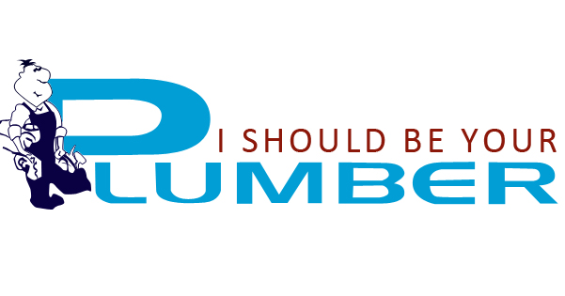

Contact Us

Plumbing & Gas Services
I Should Be Your Plumber is a family run business based in Muchea since 2004, we service Midland to Wannamal, Ellenbrook to Brigadoon, Joondalup and Wanneroo to Bullsbrook, Toodyay to Gingin , Chittering and surrounding areas of Bullsbrook, Brigadoon, Ellenbrook, Averley, Henley Brook, Millendon, Gingin, Bindoon, Wannamal, Chittering, Midland, Upper Swan, Belhus, Wanneroo, Wangara, Malaga and The Vines.
All of our plumbing and gas services are fully licensed, always on the go with vans that are well stocked for any plumbing situations. We offer a complete honest and reliable service, no call out fee, free quotes and professional advice. We believe in a duty of care to our customers.
At I Should Be Your Plumber no job is too big or too small regardless if it’s a complete bathroom, kitchen, laundry make over, new build or renovation. We are suppliers of quality tap ware and fixtures, agents for solar hot water and quality gas systems at an affordable price.
Market leaders in installation of Alternative Treatment Units – Aquarius, when only the best will do in nutrient retentive treatment products.
We have a wide range of products to suite any budget, the have the experience to get the job done and we come to you.
Free Call: 1800 655 335
Chris direct on: 0414 922 456
Email: office@ishouldbeyourplumber.com.au
Edit
- Quick Response
If you've had enough of tradespeople who never turn up when they say they will, call Chris at I Should Be Your Plumber.
READ MORE
- Payment Options
Electronic Transfer, Visa and Mastercard accepted, Debit Cards and EFTPOS facilities, Credit account to approved clients only, All accounts are
COD unless by prior arrangement
- View our Showroom
We handle all plumbing and gas installation including domestic and commercial.
READ MORE

About Us
Chris has been in the plumbing and gas industry since high school, his father Vince was a plumber and estimator. Chris has trained with reputable plumbers of his time and achieved apprentice of the year 2 years running, then taking out the “Apprentice of the Year” award for all trades during his apprenticeship.
A member of Master Plumbers  and an Enviro Plumber Chris maintains a high level of education and frequently refreshes his knowledge with current trends and regulations.
Originally from Perth, Duncraig, Chris Ellyard has been in the plumbing industry for over 30 years. Chris started his apprenticeship at 16, work for many reputable plumbing companies and was a foreman for Charter Plumbing on commercial sites for many years before starting out on his own in 1998.
As a family owned and operated business we are now proud to service the metro and country areas in the northern suburbs.
We provide a complete range of products services to suite our clients.
- Showroom – complete range of tap ware, sinks, bath and shower sets, toilets and showers – this is open by appointment
- Supply and install ATUs – Aquarius 0-3 Alternative Treatment Unit Specialists
- New Housing and Renovations
- Hot Water Units – gas and/or a selection of solar options
- All Gas installations including BBQ’s, Bayonets and Kitchen connections
- We carry a wide range of pumps, pressure vessels and parts.
So it doesn’t matter if you’ve created a leak large enough to turn your home into a swimming pool, you have blocked drains or you just want to renovate your bathroom, just give us a Quick Call and uncover the difference in our high quality plumbing offers!
Fast work does not mean bad service. We pride ourselves on minimising your disruption while work is being completed. We do not charge for unnecessary labour.
It’s actually law of nature. Plumbing troubles never show up at a handy time! To get more information our hotline is open 24 hours every day, seven days a week. Which means no waiting.At I Should Be Your Plumber, we are available 24 hours, 7 days a week – within the hour for emergencies!
Emergency plumbing repairs and services are our core business.We will fix your plumbing issue fast! 7 days a week 1800 655 335. Give us a Call Today!
Edit
- Contact Us
I Should Be Your Plumber
Free Call 1800 655 335
Chris: 0414 922 456
154 Davern Street, Muchea WA 6501
PO Box 205
Muchea WA 6501
Office@ishouldbeyourplumber.com.au
- Payment Options
We accept:
  - Electronic Transfer
  - Visa and Mastercard accepted
  - Debit Cards and EFTPOS facilities
  - Credit account to approved clients only
  - All accounts are COD unless by prior arrangement

- We give pensioner discounts
- 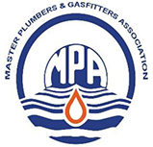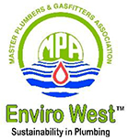

Services
At I Should Be Your Plumber we have a whole series of goods solutions specially designed for our clients.

Plumbing
- Set-up all pipework for new housing or renovations including compliance paperwork.
- Installation of tap ware and fixtures:
  - Taps
  - Sinks – Kitchen Bathroom and Laundry. BBQ areas
  - Toilets
  - Baths
  - Showers – cubical or screens
  - Installation of dishwashers and washing machines
We even install mirrors, towel rails and toilet roll holders
See our products page or in van catalogue
- Domestic & Commercial Installations
- Hot Water System installations, Repair & Maintenance
- Water Purification Systems – under sink filters
- Supply and installation of tank, house and bore pumps
- Supply and install septic systems – Alternative Treatment Units
- Sewer/Drain Cleaning and Installations
- Blocked drains, leaks, tap repairs and maintenance

Gas
- All gas pipework installations to kitchen, heaters, BBQ’s and Hot water Units
- Supply and install gas Hot Water Units
- Leak detection, gas line installation and repairs
- Gas appliance installation

Services:
- All Plumbing and Gas installations – Domestic and Commercial
- Renovations and New Housing
- Repairs and maintenance
- Supply and installation of Hot Water Units
- Supply and install pumps, domestic pressure pumps and sewerage sump pumps
- Approved Agent for Aquarius Waste Water Treatments Alternative Treatment Units
- Supply and installation of tap ware and fixturessee products page
Other than the general plumbing and gas installations, repairs and maintenance we also offer a great range of products we are agents for:
Hot Water – We offer competitive pricing on Solar and Gas hot water installations, maintenance and repairs all makes and models of solar and gas hot water systems throughout the northern suburbs and country areas. We are also approved Service Agents for Solargain and Solahart. We supply a great range of gas hot water systems from some of the world’s leading brands, including:
- Solargain – Solar and Gas
- Solahart– Solar
- We can also supply and install Rheem, Bosch and Rinnai
- Temperature controllers


Edit

Contact Us
I Should Be Your Plumber
Free Call 1800 655 335
Chris: 0414 922 456
154 Davern Street, Muchea WA 6501
PO Box 205
Muchea WA 6501
Office@ishouldbeyourplumber.com.au

Payment Options
We accept:
  - Electronic Transfer
  - Visa and Mastercard accepted
  - Debit Cards and EFTPOS facilities
  - Credit account to approved clients only
  - All accounts are COD unless by prior arrangement

We give pensioner discounts

Alternative Treatment Units

ATU’s – Alternative Treatment Units (septic systems)
I Should Be Your Plumber is the authorised service agent in this area to supply and install the Aquarius range of ATU’s. Aquarius Wastewater Management are a Western Australian company, the systems were developed and manufactured here in WA. It is Western Australian Department of Health approved, created for domestic house use and commercial applications. The internal system can be simply developed for use with business sites. A nutrient retentive system that leads to garden irrigation.
The wastewater (from the toilet, kitchen, bathroom and laundry) is treated to current Department of Health WA Standards that allows it to be used for irrigation in garden beds, orchards, etc., or disposal into leach drains, soak wells and aquasafe drains.
As the world turns its attention to ‘green’ technology and environmental issues the reuse of water becomes a major focus. We provide affordable, quality products that assist in the safe recycling of waste water and benefit Australia’s unique environment and diminishing water resources.
Aquarius Wastewater Management’s treatment technology is in the fore front of the water recycling industry. We invest heavily in research & development and work closely with specialists in the areas of aquatic microbiology and system design to constantly improve our product quality.
Irrigated Systems Include:
- Black Water Units (ATU)
- Grey Water Units (GWU)
- Retro fit to existing septics
- Suite both domestic and commercial applications
  - Residential homes
  - Hotels, Motels
  - Mining camps
  - Unit development
  - Caravan parks
  - Wineries
  - Recreational facilities
  - RTP (Relocatable Treatment Plant)
  - Commercial and Industrial Developments
- Let us take the pressure off you as we also do all the shire applications
Consider your health before choosing your septic system.
Chlorine treated septics are carcinogenic.
For more information please visit: www.aquariuswastewater.com.au
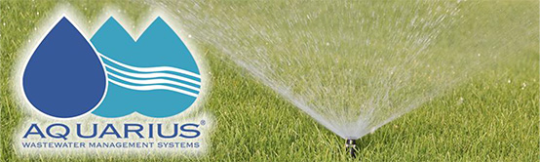
Authorized Agents Supported Links:
Solahart – www.solahart.com.au
Solargain – Hot Water Units and Solar Power Panels www.solargain.com.au
Aquarius Waste Water – www.aquariuswasterwater.com.au
Orange Pumps www.orangepumps.com
We are Water Wise Experts and Master Plumbers

Free Call 1800 655 335
Edit

Contact Us
I Should Be Your Plumber
Free Call 1800 655 335
Chris: 0414 922 456
154 Davern Street, Muchea WA 6501
PO Box 205
Muchea WA 6501
Office@ishouldbeyourplumber.com.au

Payment Options
We accept:
  - Electronic Transfer
  - Visa and Mastercard accepted
  - Debit Cards and EFTPOS facilities
  - Credit account to approved clients only
  - All accounts are COD unless by prior arrangement

We give pensioner discounts

Contact Us

Need Emergency Plumbing? Call us now!
Don’t wait – call or email now. Please leave your contact phone number.

Contact information
- Address
  - I Should Be Your Plumber
154 Davern Street
Muchea WA 6501
- Phone
  - (08) 9571 0590
  - 0414 922 456
- Email
  - office@ishouldbeyourplumber.com.au
Top of Form
Your Name (required)
Your Email (required)
Your Message
Bottom of Form
Edit

Contact Us
I Should Be Your Plumber
Free Call 1800 655 335
Chris: 0414 922 456
154 Davern Street, Muchea WA 6501
PO Box 205
Muchea WA 6501
Office@ishouldbeyourplumber.com.au

Payment Options
We accept:
  - Electronic Transfer
  - Visa and Mastercard accepted
  - Debit Cards and EFTPOS facilities
  - Credit account to approved clients only
  - All accounts are COD unless by prior arrangement

We give pensioner discounts

