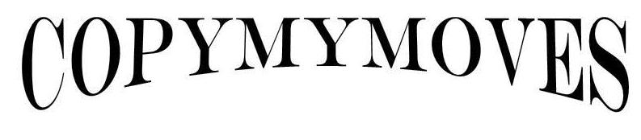

Fitness Pro
Copymymoves -fitness App Idea.
Two Business Logo.

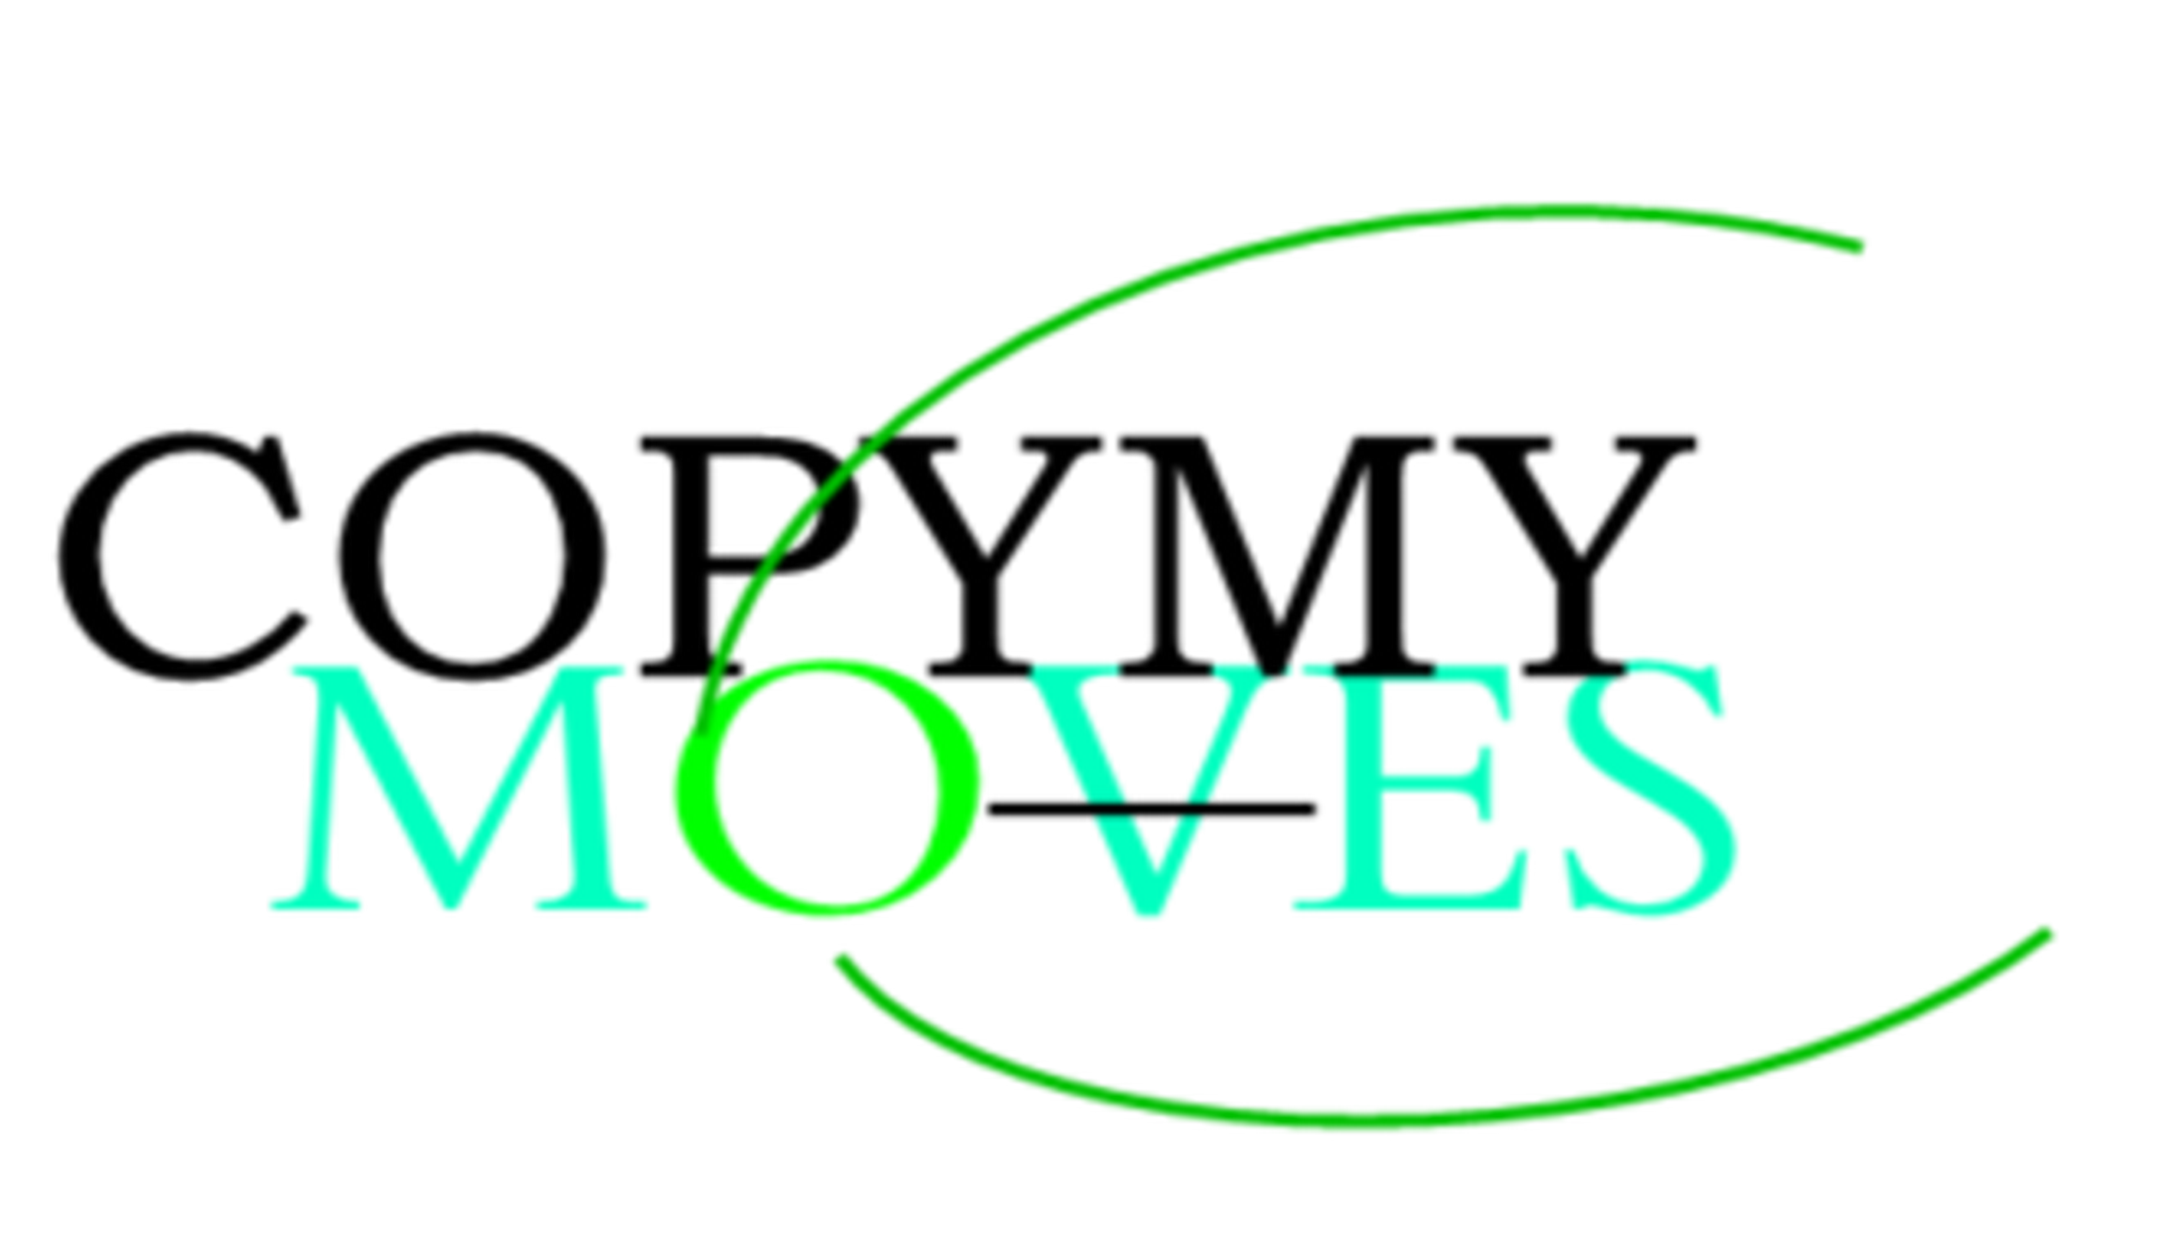
March2013 Ireland, the land of magic. Copymymoves was born. Copythe client moves. With the avatar.
The app is about fitness, I have a vision and that you can be part of it.
Let's change the world together!
- the 1st page is about copymymoves mission/ founder / value of the company.
I will attach all information on Page(A)
after the intro, Terms and conditions poly / data policy ( the client has to agree and Sign before continuing. Then comes the page ParQ
the ParQ is a questionnaire asking the client to know more about them!
ParQ features: the beginning: Create you’re personalized Avatar ( change cloths – if the choose no cloths, by default the avatar will have a pair of short- pant / hair/ eyes colour/ and select Body type: Ectomorph/ endomorph/ mesomorph or the client can select a mix body type.
Age select/ currant weight/ desired weight/ skin colour/ gender: male, female, Transgender, other.
Fitness goals: what the client desire how they are going to achieve it/ the measure they will take to achieve it or I don’t know option. The press continue / the app analyse all the data and create their personalise unique Avatar. That will look like the description they provided.
Page 2nd feature: they will see their fullBody avatar .
Next the client need to continue completing more information.
Stress level select/ nutrition habits select/ and nutrition habit desired select/ injuries select/ allergies select/ history of any health complication question to answer/ Gp ( their Doctor name and number, to fill in/ and a person to contact in case of an emergency. Fill-in answer).
Page 3rd The Main Page. This results will depends on the answer of E-Wallet (5)
CopyMyMoves-fitness Pro APP, Will analyse all the data and the app will suggest the best fitness program, nutrition plan, meditation advices to help them with stress/ and sleep hours they need to recover from after exercise/ base on their body type, fitness goal, and current stress level.
Main page Features: Keep in mind; the avatar changes form constantly, all deepend on the information the client put on the profile setting.
1- the Avatar
- the can look Happy
- or sad – reason why! Can tell the client all the reason for being that way and the solutions to make it better.
- Angry- Reason why! Can tell the client all the reason for being that way and the solutions to make it better.
- if the client gain weight, it will show on the avatar body.
- When the client looses weight the avatar will tell the client with a notification and it show o the avatar body.
2- fitness check the app call Fitvate and Better Me fitness app, I like their page layout, it might show you what type of page I’m looking for and the quality that hoping or expecting.
- Muscle 3d full body when select a muscle it will show you the best exercises to work that particular muscle and weight recommendation. Check the app called
- Fitness Equipments to target each muscle and best suggestion for each muscle.
- Exercises all exercise available to get someone i top shape and the option to add more custom exercises. Liked exercise option/ search for exercises option/ reminder option.
- Nutrition Plans ( Vegan option/ paleo diet Option/ Keto diet/ build their own pers meal plan.
- Wellness Suggestions , tips raising your energy level
3- social Media
- Instagram
- WhatsApp
- Pinterest
- Facebook
Feedback option
4- Music
- connect to Soundcloud.
- Connect to playlist Custom
- Connect to Spotify
5- E-wallet
- buy a 1to1 personal training session ( only for members on the country as the founder)
- Buy 1 sessions/ 45Minutes each/ 60€ each
- Buy 1sessions / 30 Minutes each/ 35€ each
App subscription ( 2 options)
- Buy one Month subscription 65€ app
- Buy one Year Subscription 780€ Share it with 10 people for the best deal 680€ for 12 months. App as well.
6- share it
on any social platform on the list
7- Picture Gallery
- before Pic
- after pic
8 – Deals & Offers
link to affiliated with other organization( copymymoves will put all fitness deals and offers on this page.
9 –Contacts
- Gps number and information
-- Friend or family to contact during an emergency
10- Testimonials
- Reviews
11- To do List
- Calendar bookings
- fitness goal planer
12- Chat On The app community
- a page where all the app members can chat if they open the portal and agree to it.
13- Profile settings
- account settings
14-Progress Tracker
15 – Connect Fit Device
-- Progression CHART.
- Junk food / sweet tracker (obviously the client need to log in what they eat each time.
Base on what they eat the Avatar will take shape/ increase weight or lose weight / change mood/ the client will know when they are doing something wrong or right base on how the avatar mood.
I this idea is yours to be part of something different, this idea is will donate for young and family who need help and support.

WELCOME TO CopyMyMoves-fitness Private Studio
OUR MISSION
CopyMyMoves an Ireland based company whose mission is to help you
complete your journey stronger, faster with confidence.
ABOUT COPYMYMOVES
CopyMyMoves-fitness Was created from and inspire by the Irish strength and power to conquer any challenges, in 2013 after wining a boxing tournament in the national stadium. Driven by the desire to make a difference in the sport industry, I won that knight because my hunger for success was bigger than my opponents. CopyMyMoves-fitness Private Studio , I decided to teach and coach people, how to improve their fitness components with all the experience I have under my belt. My Mission is to inspire and be inspired by the new young talents in need for an opportunity.
CopyMyMoves-fitness Private Studio – Your energy is what keep us moving and striving
for better and stronger united community. Fitness is the future & wellness is life.
- OUR FOUNDER
Born and raised in the Caribbean, I started boxing when I was 19 years of age.
I started fighting to learn how to defend myself from bullying and protect my mother.
I started winning all my amateur fights, travelling around the world, the idea of travelling and the famous side of being a fighter kind started to like a little bit. My ambition didn’t stop there, it grew aiming for the stars and bigger plans.
I always dreamed of owning my own cloth brand and my own fitness gym. All over the Caribbean.
My peaceful Land (Dominican Rep, gave me the qualities to rise and achieve many goals.. I believe- everything and anything is possible, once you have the right mindset and dedication to achieve it.
Coached by many of the biggest in Ireland- like: MickDowling / JayByrn/ Phill . All well-known figures in Ireland.
Now is time to share my knowledge.
OUR VALUES:
We value top quality products and will ensure you have an amazing
experience with CopyMyMoves Fitness. If not, write to us and we’ll make it right.
- GIVING BACK:
To help and support those in need in our communities.
15% of our earning will be used to help and support people in need in the Dominican Republic, Haiti and all the Caribbean. We support our young athletes with big dreams. Seeing them succeed is the best gift the world can give us all.
Good Luck to all who will take this challenge. Remember this is only the start, the winner will gain and extra bonus for completing this work. And chance to continue working with us.
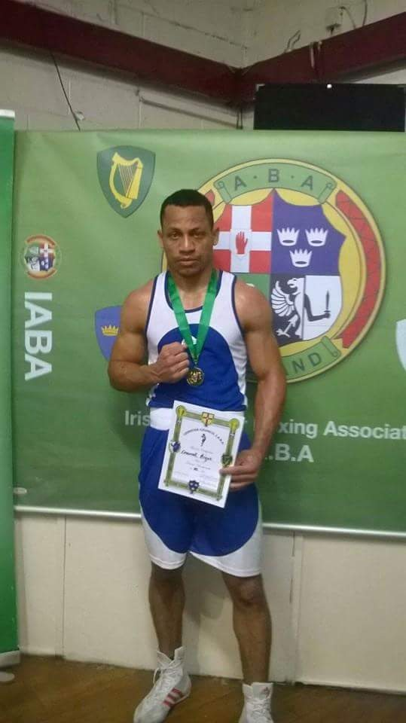

- You Can check the app call fitness Pal or better me fitness app
these fitness features and setting, is the style and standard I am looking for.

