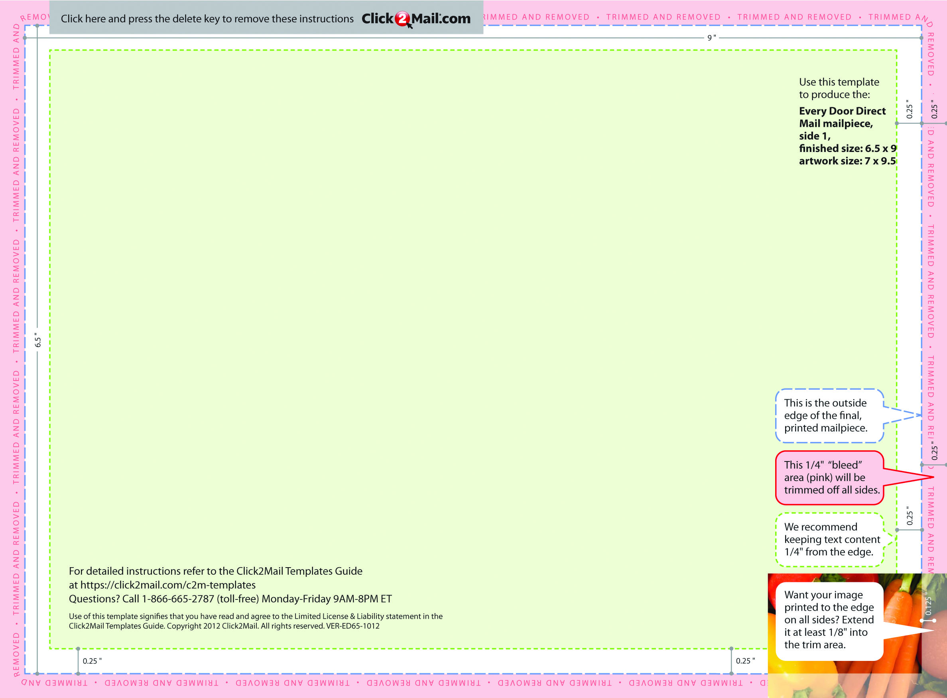
Placeholder text... Replace this placeholder text with text of your own.Use Click2Mail.com to print,
finish, post, and deliver your mailpieces quickly and economically. Click2Mail.com makes it easy to
design brilliant, full-color, affordable postal mail without permits, sorting, stamps, or trips to the
Post Office. How does it work? We use a network of strategically located, high-quality printers to print,
prep, and sort large volumes of mail daily. That network and our understanding of strict postal
requirements allows your mailpiece to receive optimal handling and delivery. You benefit from high
volume processing without setup fees or minimum quantities.
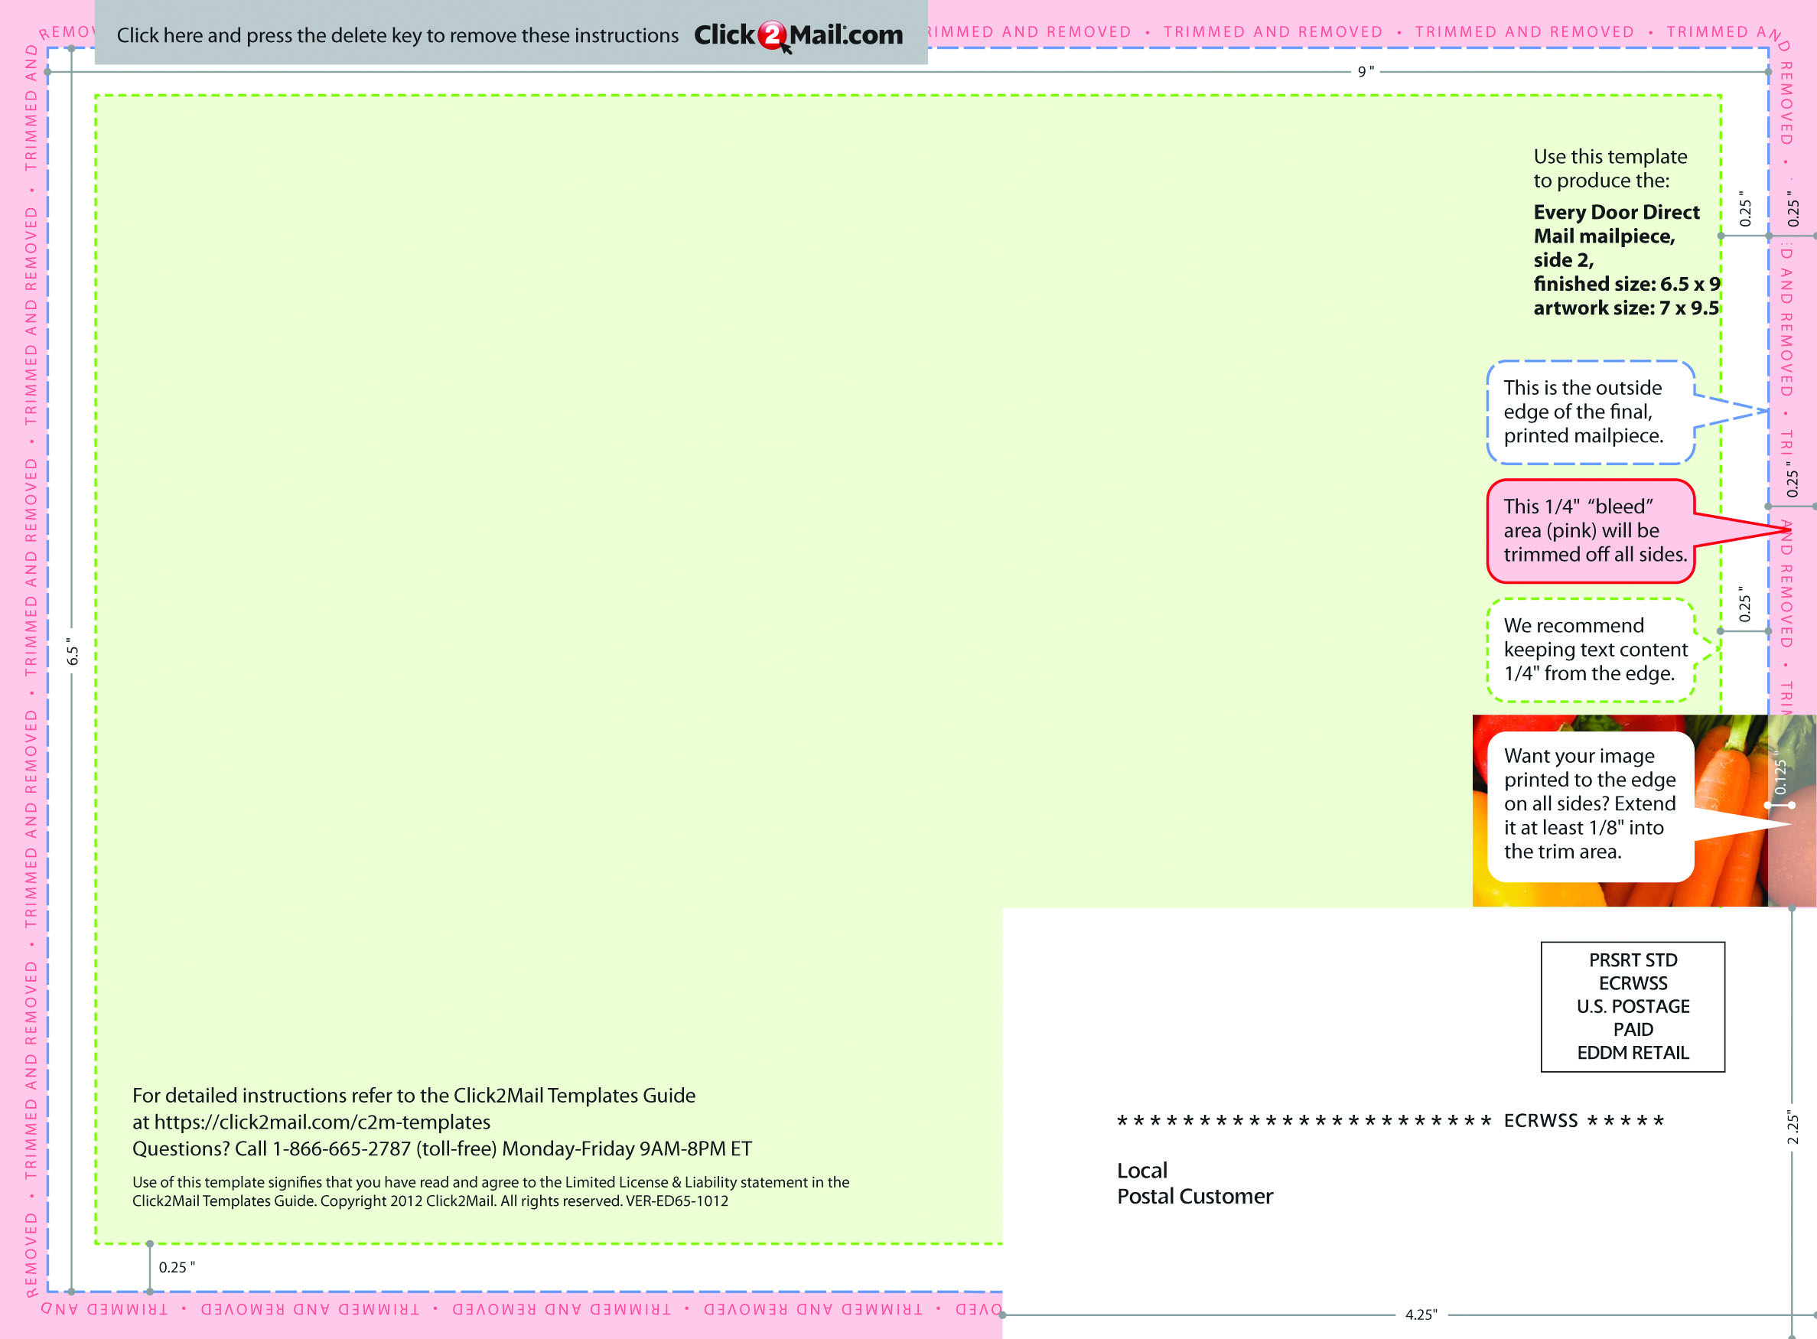
Placeholder text... Replace this placeholder text with text of your own.Use Click2Mail.com to print,
finish, post, and deliver your mailpieces quickly and economically. Click2Mail.com makes it easy to
design brilliant, full-color, affordable postal mail without permits, sorting, stamps, or trips to the
Post Office. How does it work? We use a network of strategically located, high-quality printers to print,
prep, and sort large volumes of mail daily. That network and our understanding of strict postal
requirements allows your mailpiece to receive optimal handling and delivery. You benefit from high
volume processing without setup fees or minimum quantities.

