
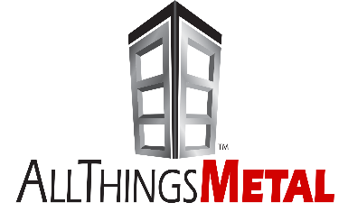
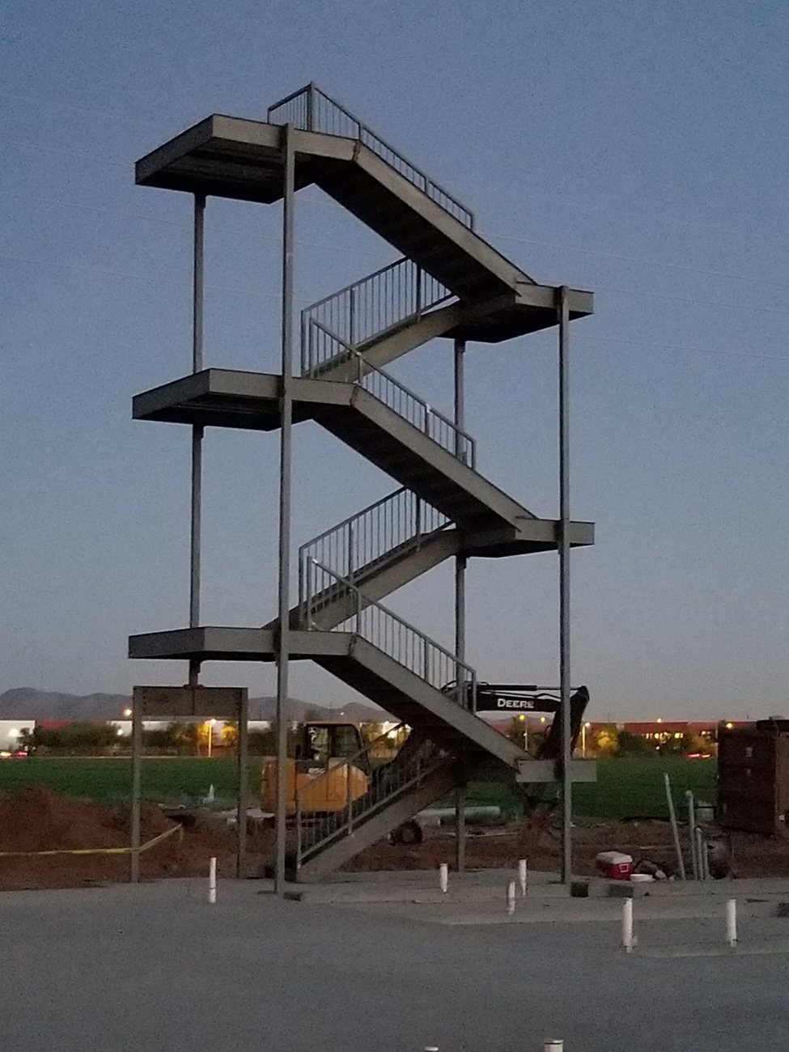
Your Solution Partner
Collaborate
-Pre-Construction Value Engineering
-Budgeting Assistance
Stairway to Success
Iron Strong Relationships
- Prior Success Foundation
-Zippered Relationships
Deliver
-Safely erect steel
-Blink and We Are Done
Evaluate
-Post Project Assessment
-Net Promoter Score
Implement
-Contact During Fabrication (75% Completed Before We Shop Up)
-3D Models Provided
Strategize
-Iron-Strong Expectations Meeting
-Smarter, Faster, Better (Coordinate to Maximize Prefabrication)
Discover
- Share our Steel Expertise (Best Practices)
-Identify Best Value Opportunities (What’s Best for the Project)

