Pic 1:
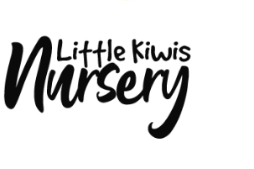
Chose this font, but not the size ratio. From this pic 1
The “Little Kiwis” should be more dominating standing out more that the word “nursery”.

Pic 2:
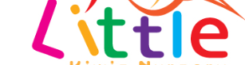

We need all the ‘i’ letters as well as the first “L” and “K” to fall in an angle, just like pic 2 above

Pic 3:
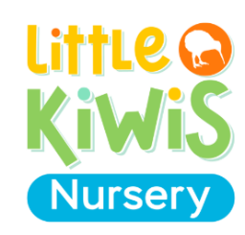
We need only the color code theme to be from this pic 3 for the fonts and the kiwi bird pic.

