Design Brief
We need banners that represent each practice - Competition, Energy, Public Policy, Strategy, Telecoms and Transport & Water for the welcome page of the practice management system for an economics consultancy based in 7 countries in the European Union. We are looking for a high impact isometric perspective design in two versions - dark and light theme . The design should use the organisation's colour palette. The final design should communicate fun, energy, imagination and flair.

Usage
The banners will be used in a welcome page similar to figure 1. The bulk of the image needs to on the right. The application will paint the 4 rectangular panels on top of the banner and the controls above the first panel on the left.

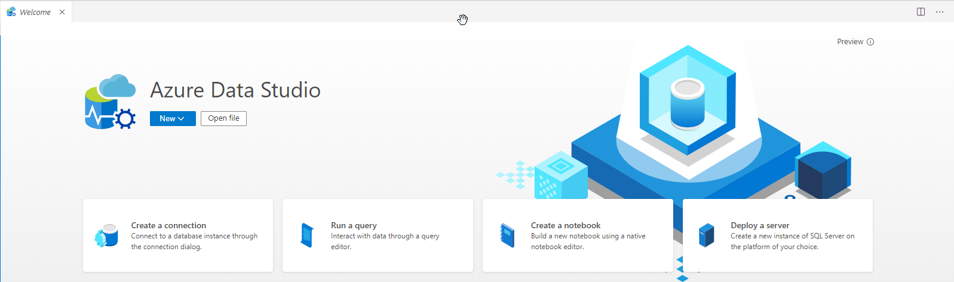
Figure 1 – Banner usage

Sizes and Colour
The dark theme uses 28,30,35 and the light theme has a white background.

The organisation’s colour palette has been uploaded as a separate document.

The banners should be 2560x600 pixels with the graphic elements shifted toward the right to leave a space on the left for application controls.

Isometric Perspective
We are looking a design in isometric perspective as illustrate by figure 2. In particular, each banner should incorporate a square similar to the one in the middle of the image with the charts.
Each square should be unique to each practice – Competition, Energy, Public Policy, Strategy, Telecoms and Transport & Water. Two additional banners are required for internal teams: Finance and Business Management Team.
With the exception of the squares for each practice the other elements can be the same for all banners.


Figure 2 – Isometric perspective

Using figure 2 as an example, the successful design would incorporate the following ideas.

- Workplace desk, with a monitor, keyboard and space for objects to reflect each of the practices/teams at the organisation.

- Dark theme should be the desk scene at night, utilising the dark theme colours. Because it’ll be at night, the monitor screen could have a soft glow to it.

- Monitor/keyboard on the righthand side of the banner, practice/team specific space more central, more open area on the left for buttons that will be overlaid within the app.

- Organisation logo on the monitor that we will be able to change to match the swish to ‘seasonal’ colours. Best solution is probably to have a version of the banner with the logo and one without.

- Objects should have block colours, similar to the SQL example. Objects can have more than one colour, like the charts, but colours should stay block – no gradients or patterns.

- The desk could have a few items on it, like a pencil holder or cup of coffee so the desk doesn’t look too bare and ‘corporate’ as organisation’s culture is young, fun and modern.

Practices
The organisation provides economic advice to Fortune 500 clients across six practice area. Each banner should have a square with graphic elements that represent each practice.

Without being prescriptive, we have provided some keywords that you might find helpful in identifying appropriate graphic elements.

Competition | Buildings, factory, court house, litigation, regulation
Energy | Power plant, wind turbine, solar panel, clean energy
Public Policy | Government, city, health care, people
Strategy | Puzzle, cogs and gears, target
Telecoms | Phone mast, map with connecting arches, satellite, communication
Transport & Water | Plane, train, bus, water droplet
BMT | Charts similar to square in figure 2
Finance | People, charts, bank, payroll

Figure 3 shows examples of squares with building and phone mast to illustrate the type of design we are looking for. These squares are used for illustration. They are very busy and complex – the successful design would simplify these to one or two key elements for each practice.
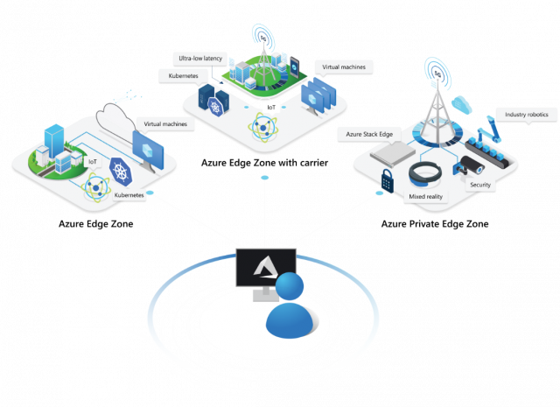

Figure 3 – Examples of practice squares

Images used here for illustration are copyrighted by Microsoft Corporation.

