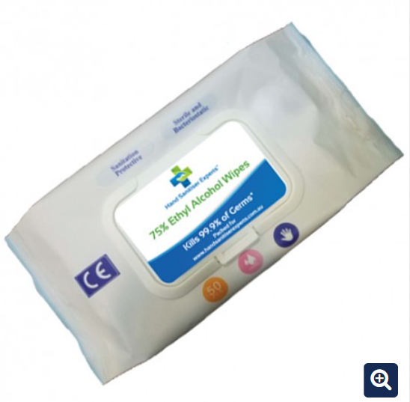

Antibacterial Wipes


500ml Hand Sanitiser (Pump Bottle)
75% Alcohol
Kills 99.9% of Germs
$12.95 + GST (minimum 24 units)

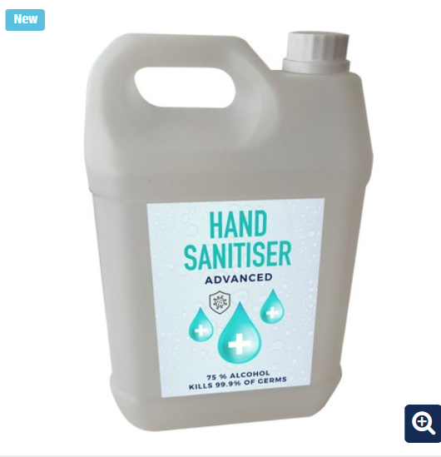
5 Litre Hand Sanitiser
75% Alcohol
Kills 99.9% of Germs
$109 + GST

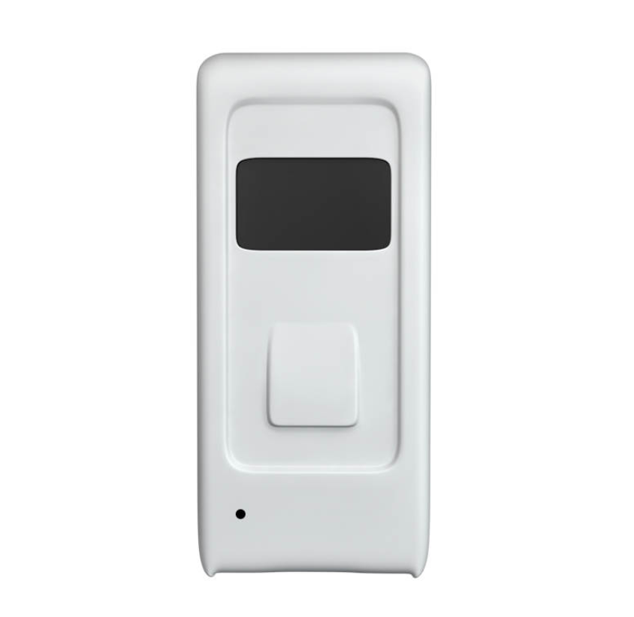
Wall Mounted Automatic Hand Sanitiser

$149 + GST

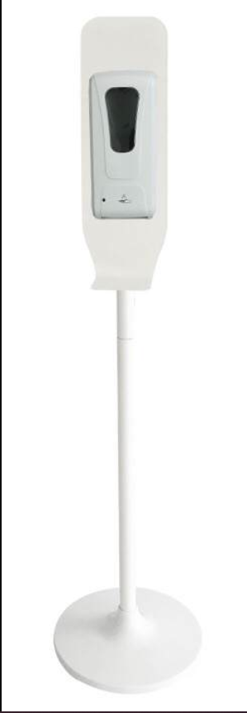
Floor Stand Hand Sanitiser Unit – Automatic
$399 + GST

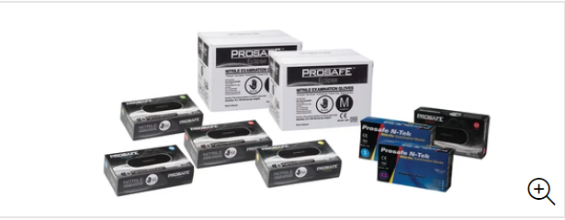
Nitrite Gloves
S/M/L/XL
Pk 100
$22.95

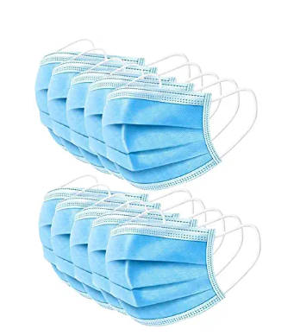
Anti-Dust Face Mask
3 Layer Anti Dust
$29.95
50 Pcs

This is our logo



