Think growth
Think new
Think evolution

A little simple but it conveys progress and moving up and has colours

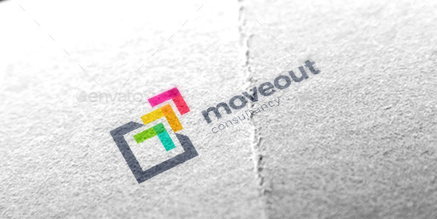

This shows fresh, innovation, creativity and is more memorable than a lot of logos
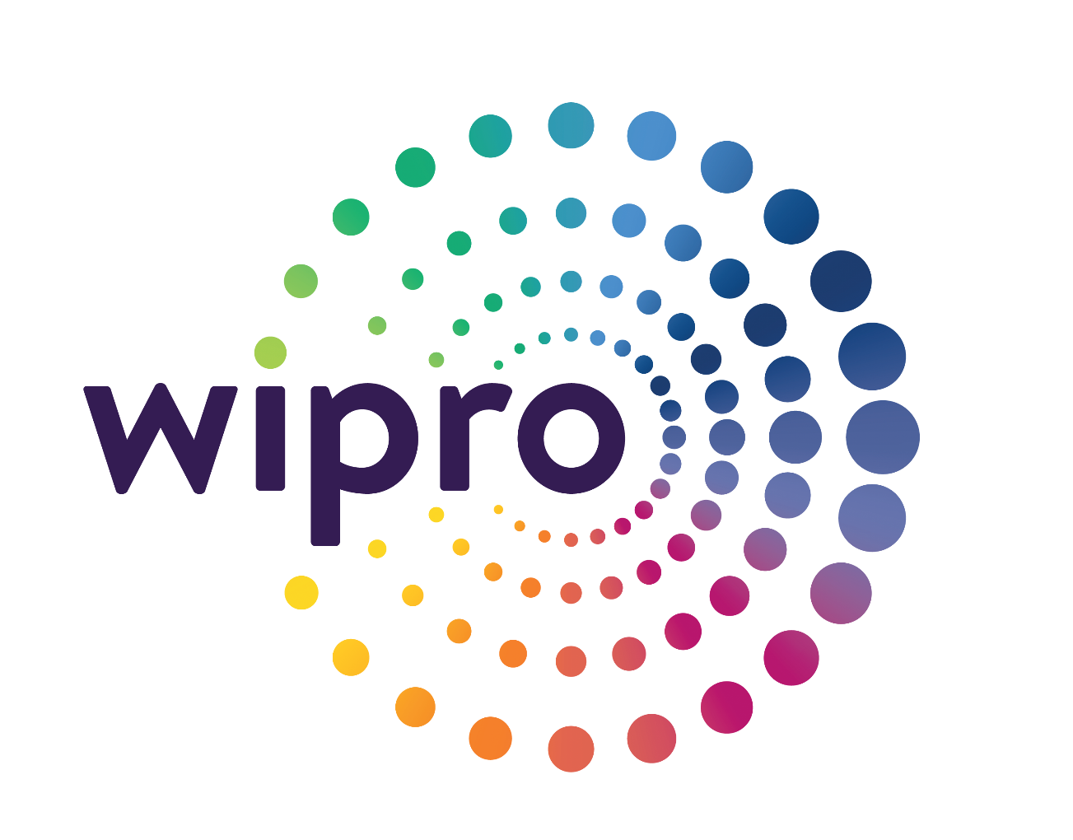

I like this. Needs more colour but I feel it shows growth, new things, innovation and is a bit tech oriented.



Same as above.



