Coffee Bean Roaster Logo & Coffee Bag Design

Company name - Red Hot Coffee Company or Red Hot Coffee Co or just Red Hot Coffee
This will be a wholesale coffee company selling coffee privately roasted coffee beans.

Design a logo and coffee bean bag to suit different coffee blend ranges.

Coffee Beans Packaging
Design a themed packaging that would suit out our blends/names of coffee. Our aim is all about providing people with the best start to their day by brewing them a perfect cup of coffee every morning coupled with outstanding customer service. We want to fire them up in the morning with our coffee so they can go out and conquer the day at work or home. https://www.cupajoes.com.au/ - retail business

Story Line/Style
We want to build a storyline and coffee product range around the type of meanings derived from the slang word “Red Hot”used in Australia
Red hot - Some definitions - please scroll right down in these definition pages.
https://www.urbandictionary.com/define.php?term=Redhot
https://www.dictionary.com/browse/red-hot
Please scroll all the way down to read the full description of definitions.

We want the vibe to be a naughty/badass/red hot positive vibe and relate to coffee. We need the logo and packaging design to suit. Our physical retail business is called “Cupa Joes - which is a red and white container that is a drive thru cafe.

We want our coffee bean range to have it’s own unique presence branding it “Red Hot Coffee” yet still allow the consumer to be able to make the connection between Cupa Joes and Red Hot Coffee. We want to make it fun for customers and bring out the bad/good in them lol.. Inspiring and motivating them for their day ahead. We want them to feel excited about being associated with terms of being red-hot to break some of the mundane routine of their daily lives and have a bit of a laugh and create a spark of much needed daily excitement.

Companies selling the coffee story and merchandise well
https://www.blackriflecoffee.com/
https://killercoffeeco.com.au/shop/

Please see attached initial descriptions of coffee blend range.

Below are some ideas to give you a vibe of idea around the blend.

Red Hot Coffee
Red Hot Blend -
This coffee is Dangerous - so why don’t you give it a red hot go!
This coffee can get you in trouble
When you have this coffee be careful what you’re doing because it’s red hot. “Make sure you don’t leave your fingerprints on the cup
Red hot for work
Aussie Coffee
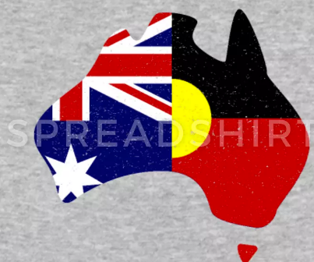

Red Hot Coffee
Bad Ass Blend - Bad Az Coffee

Bring out the Bad Ass in you - with this Bad az coffee. For those days when you want to take over the world this coffee will

Flavour - distinctively tough or powerful; so exceptional as to be intimidating.
Aussie Coffee
https://www.urbandictionary.com/define.php?term=Badass

Red Hot Coffee
Espressco-bar blend - Watch out this coffee can make you high -

Red Hot Coffee
Knockout Blend
https://www.urbandictionary.com/define.php?term=knock+out
Aussie Coffee

Red Hot Coffee
Caught Red handed Blend

Other blend names considered

Red Hot Coffee 
Five-O Blend
Dynamite Blend
Fully Sick Blend -
Shotgun Blend

Just to give you an ideas here are some descriptions of what some other businesses are doing with merchandising.

for a meeting at your safe space.
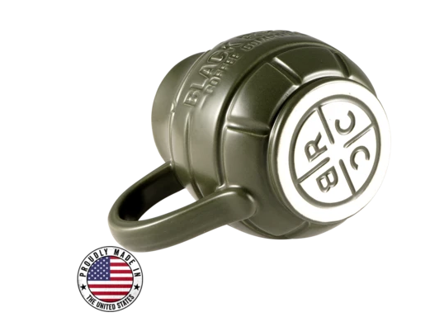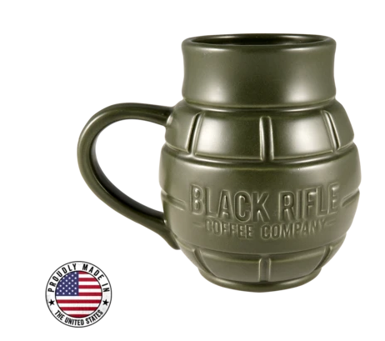

THE WORLD’S STRONGEST COFFEE
Death Wish Coffee, the world’s strongest coffee, is crafted with carefully selected, perfectly roasted coffee beans to produce a dark, bold, highly caffeinated coffee blend. Our coffee has double the strength of your average cup of coffee without being bitter or acidic. Be on the top of your game every day with the clarity and focus that comes with a strong cup of coffee.

Companies selling the coffee story and merchandise well

https://www.blackriflecoffee.com/

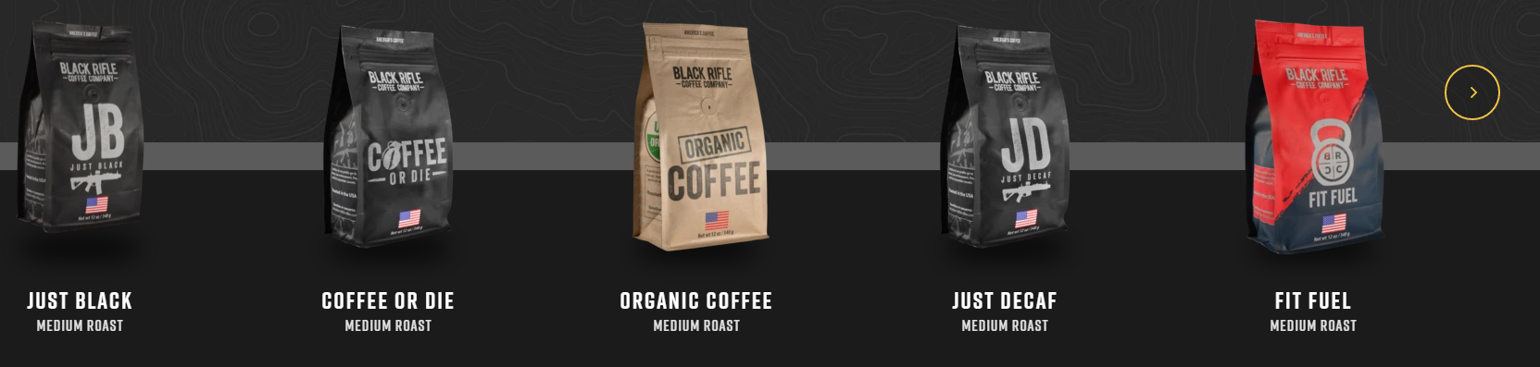

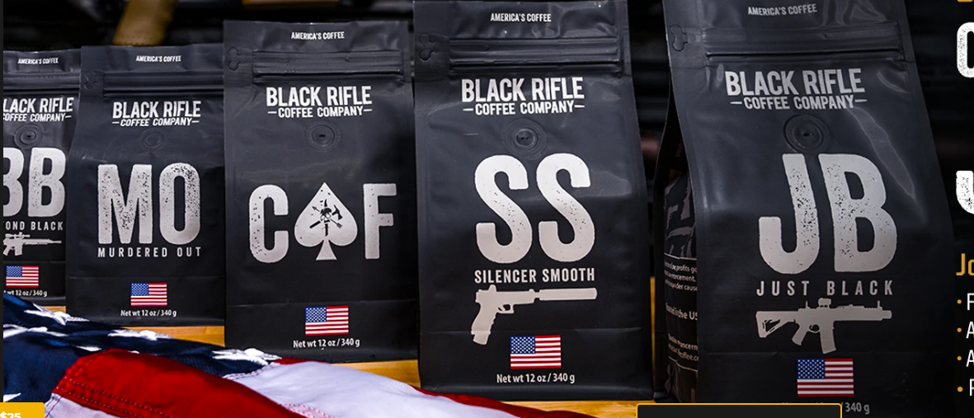

https://killercoffeeco.com.au/shop/
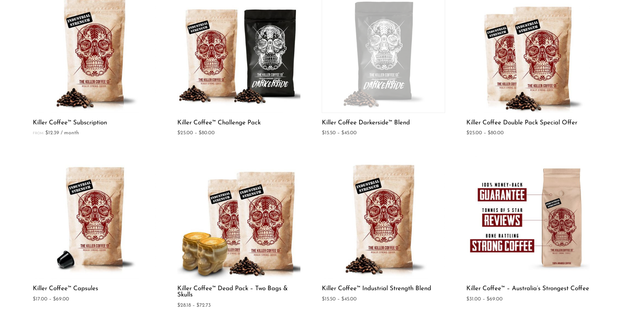
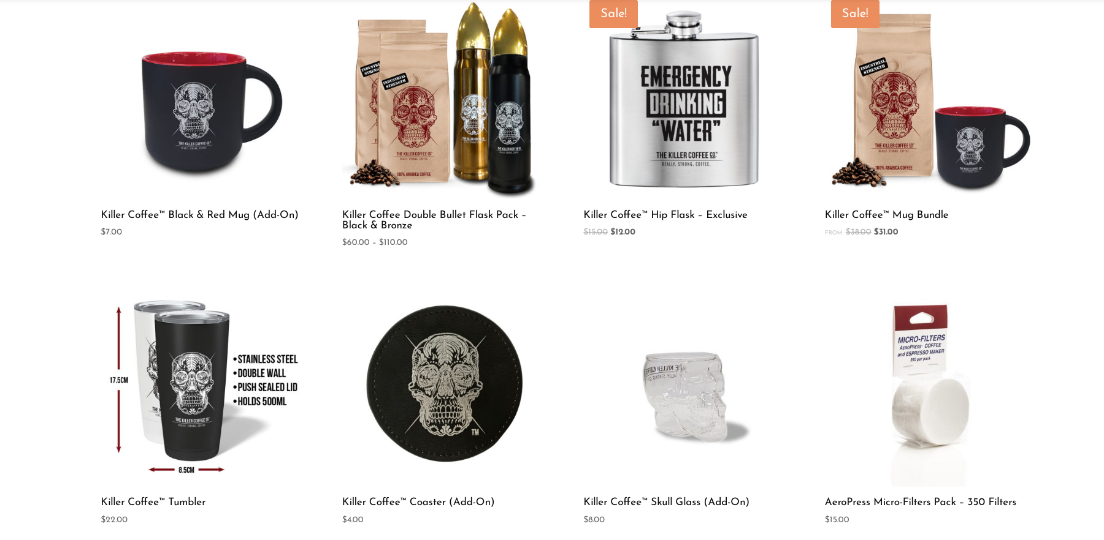

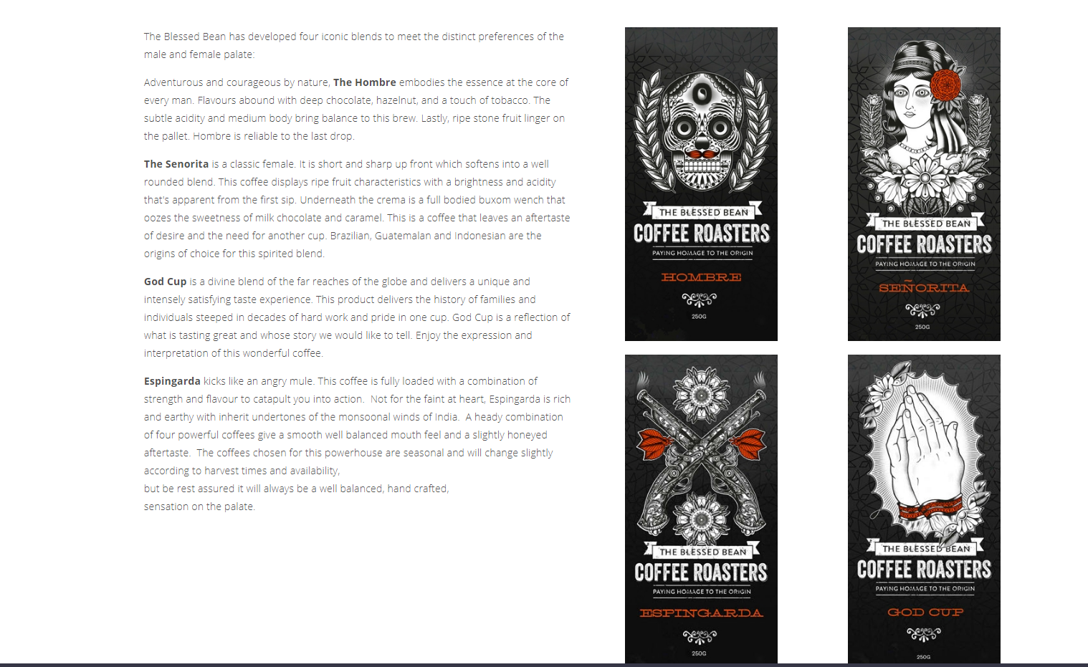
Merchandise to sell
Red hot coffee mugs
Grenade Cups
Apparell - Hoodies, Tshirt and hoodies

Merchandise ideas
https://www.blackriflecoffee.com/collections/mugs

https://www.cafepress.com/+skull-and-crossbones+mugs

https://www.google.com/search?safe=active&rlz=1C1GCEA_enAU852AU852&ei=2nOxXue8JNqc4-EP14i20AU&q=skull+and+crossbone+merchandise&oq=skull+and+crossbone+merc&gs_lcp=CgZwc3ktYWIQARgAMgUIIRCgATIFCCEQoAEyBQghEKABOgQIABBHOgQIABBDOgIIADoECAAQCjoICAAQFhAKEB46BggAEBYQHlCVFljtJ2D_OmgAcAJ4AIAB6QGIAdgIkgEFMC40LjKYAQCgAQGqAQdnd3Mtd2l6&sclient=psy-ab


