

Creative Brief – Thompson Institute brand

Project: Design a new Thompson Institute brand

Background
The Sunshine Coast Mind and Neuroscience – Thompson Institute has changed its name to the Thompson Institute (TI), following a decision by its Board. TI now needs a new brand to reflect its new name. The creative service required is to design a brand for TI that reflects it purpose, represents the Institute and is memorable to the public.

Essential inclusions

The new brand needs to incorporate:

- TI’s Vision: To be a world-renowned brain institute respected for our ground-breaking research and clinical excellence in mental health.

- TI’s Mission: Improve the lives of people suffering mental health conditions through scholarly research using the most advanced research and analytical methods, leading to scientific discoveries that transform clinical practice and health policy.

- TI’s Values (see attached poster for details)
  - Excellence
  - Togetherness
  - Making a difference
  - Wellbeing
  - Integrity

Opportunities
This is a chance to brand TI as a regional research and clinical centre with international impact. The previous name was considered too lengthy, which presented obstacles to brand use. With six words, the previous brand was cumbersome to reproduce in a way that left each word visible. This made it difficult for stakeholders and the public to remember the name in full. This rebranding exercise is an opportunity to develop a brand that is punchy, striking and more memorable.

Creative objectives
To create a brand that:

- Resonates with TI’s target audiences
- Inspires trust in TI as a research leader and centre of clinical excellence in brain health
- Raises awareness of TI’s mission
- Remains true to TI’s values
- Demonstrates our commitment to advocating for continuous improvement in mental health provision.

TI is different because we believe in:
- Rapid translation from research to community use – public benefit comes first
- Trailblazing – novel treatments, patient-centred model, system reform
- Anti-ivory tower – Steeped in its regional community, values lived experience and community capacity building
- Thinking globally, acting locally – research done in our local community is shared with the world
- Smart but caring – advocacy for patients/research participants using evidence of how to improve lives.

TI’s unique brand proposition is that all its offerings to the public – training, teaching, research trials and mental health services – are actively undertaking research to ensure best practice at the time of delivery. This means that the public can be assured that the quality of all offerings is constantly investigated to ensure optimum outcomes for users.

This provision of services in parallel with research is not available through any other mental health providers in Australia.

Communication Mix
The TI brand will used across a range of channels and collateral, including:
- TI website
- Media – traditional and social
- Posters, pull-up banners, flyers and merchandise (t-shirts, pens, lapel pins)
- Stationery – letterheads, business cards, signature blocks.
Priority projects
Development of the brand will need to be timely in order to apply it to the following within the next two months:
- Graduate Certificate in Mental Health and Neuroscience
- Expansion of clinical services
- Online education platform.

Target Audiences

Audience | What they need our logo to convey
TI funders:  Philanthropic/private organisations & individuals  USC  Federal Government  State Government  Local government | - Maintain the trust built among our funders  - Demonstrate stability, reliability, quality and compassion  - Evidence of improvement in those using TI’s services  - Best practice, latest research in use  - All findings available to community for public benefit
TI research/training participants | - Your commitment benefits yourself and the community  - Best practice, latest research in use  - All findings available to community for public benefit
TI students | - You chose the best post graduate course for cutting edge knowledge in brain health  - Best practice, latest research in use  - All findings available to community for public benefit
Alliance Members and partners | - Your commitment benefits yourself and the community  - Best practice, latest research in use  - All findings available to community for public benefit
Mental health sector  Peak bodies  National & local providers | - Having TI in a regional area offers great training and treatment opportunities to the local community and mental health patients  - Best practice, latest research in use  - All findings available to community for public benefit
National and international researchers | - An opportunity to share findings and build on existing work  - Partner with other researchers to extend scope of research and teaching

Additional Creative Advice - Logos in the research institute/mental health market

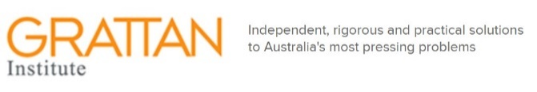
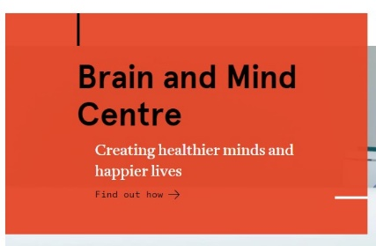

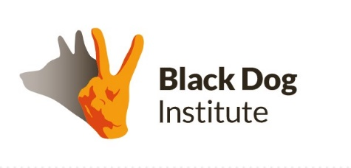
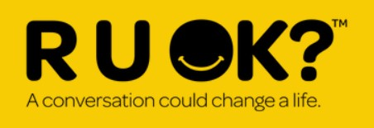



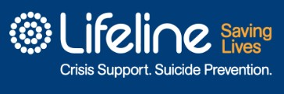

If TI was a car, it would be…

A Holden Colorado – a multi-purpose ute with lots of tools for different terrain, towing large objects, farm and city use. Ready to help all comers.



A Kluger – solid, reliable vehicle, featuring latest technology, room for everyone, but not too flashy.


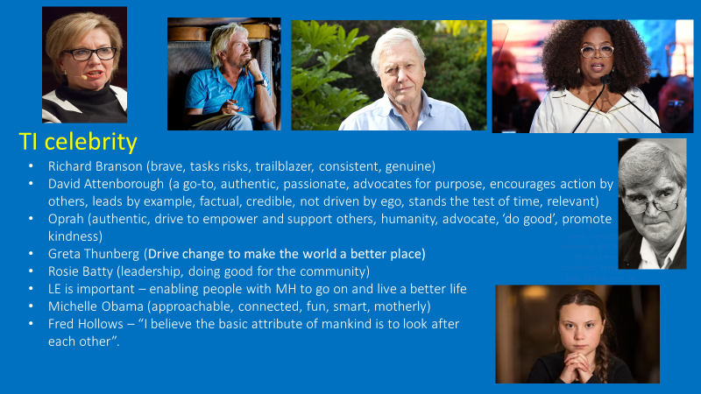
- LE = lived experience
- MH = mental health

