New Horizon Group
Logo (TBA)
Email
Phone
E |info@newhorizongroup.com.au
M | 0434-196-741|

Investor Report

Dual occ development

Prepared By:
Satish Alagasingar
New Horizon Group
ABN

Write two or three paragraphs summarising this document.

<Insert signature>
<Insert name>

<INSERT PHOTO>

Contents
PROPOSAL | 4
LOCATION | 4
PHOTOS | 5
FINANCIAL FEASIBILITY | 5
CASH FLOW ANALYSIS | 6
CAPITAL REQUIREMENTS | 7
SUBURB PROFILE | 8
COMPARABLE SALES DATA | 10
PLANNING INFORMATION | 13
TESTIMONIALS | 16
WHO ARE YOU? | 16
CONTACT | 20


Proposal

Project Goal:
Purchase an existing house on a block of land, obtain development approval to demolish existing house and build two townhouses (dual occupancy side by side)

Project Outcomes:
Project Type: 2 Townhouse Development
Total Project Costs: $1,900,000
Total Cash/Equity Required: $627,991
Indicative Project Net Profit: $250,093
Indicative Project Return: 40%

Project Location

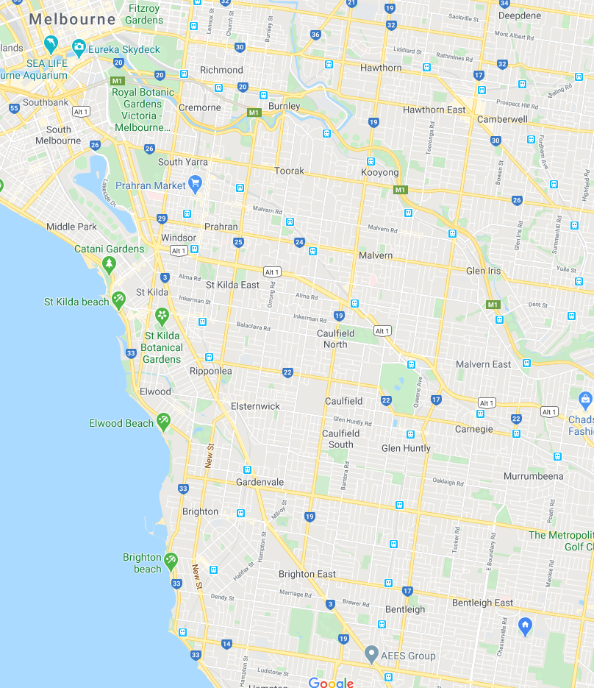

OVERVIEW

Include a brief description of the suburb.

Leafy and chosen as most livable suburb in Melbourne on many occasions. Has good mix of primary and secondary schools. Family friendly with growing demographic
Station : 1.4 KM

Freeway Access: 1.5 KM

Shopping Centre: 1 KM



Photos
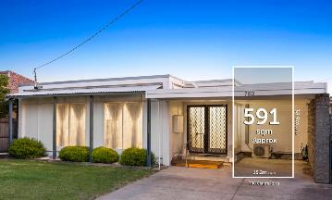
before
after



Location
Supermarket, Café

Hospital
Primary school
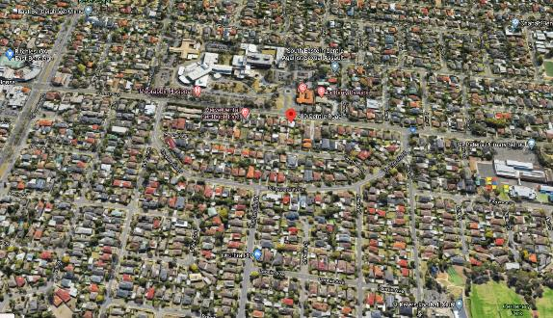
Feasibility Report
Acquisition and Build Costs
 | Amount | Finance
Land Purchase | $890,000 | 80% Residential
Legal Fees | $1500
Stamp Duty | $53,400
Development contributions | 0
Council, Water Rates | $2000
Loan fees | $2500
Contingency 6% | $53,400
Build Cost | $1,000,000
Title & Subdivision | $3000
Sales- Legal, Agency Cost | $40000
GST | $50,000
Holding Cost | $70,000
TOTAL COST OF PROJECT | 2,163,300
Sales income
 | Amount
Total sales of 2 unit | $2,400,000
Other income, rental | 0

Costs Summary Project Performance
Amount
Total costs
Total Bank finance
 | Amount
Net Profit | $236,000
Other income, rental

Capital Requirements

Capital Required - Time Line
Month | Description/Stage | Amount
April ‘16 |  | $
May ‘16 |  | $
June ‘16 |  | $
July ‘16 |  | $
August ‘16 |  | $
September ‘16 |  | $
October ‘16 |  | $
November ‘16 |  | $
December ‘16 |  | $
January ‘17 |  | $
February ‘17 |  | $
March ‘17 |  | $
April ‘17 |  | $
May ‘17 |  | $
June ‘17 |  | $
July ‘17 |  | $
TOTAL CASH REQUIRED |  | $240,072.00

Suburb Profile

<INSERT SUBURB PROFILE DETAILS & GRAPHS>

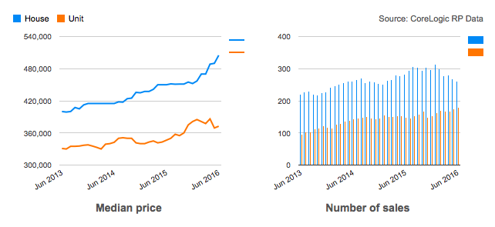
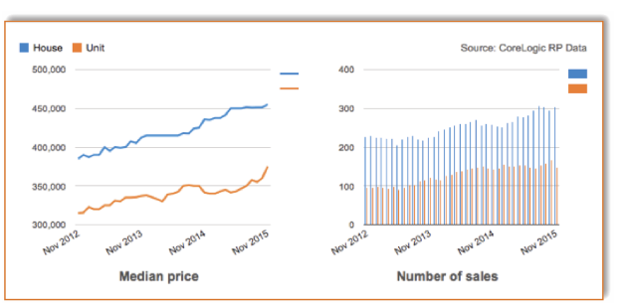

 | HOUSE | UNIT
Median price | $505,000 | $372,500
Quarterly growth | 6.09% | -1.32%
12-month growth | 11.91% | 6.43%
Average Annual Growth | 7.24% | 5.27%
Weekly median advertised rent | $360 | $300
Number of sales | 260 | 179
Gross rental yield | 3.71% | 4.19%
Day on market | 38.34 | 56.19

Insert relevant information here regarding the Suburb, profile statistics, demographics, infrastructure, and anything else unique.



AUCTION CLEARENCE
75%
DAYS ON MARKET
38
MARKET DATA
THREE BEDROOM HOUSE IN S………

SOLD THIS YEAR
260
MEDIAN HOUSE
$505K

*Source: data collected from Corelogic RP Data magazine

Comparable Sales Data

Planning Information

Ownership: | Private owners advertised at 850 – 900K
Property Address | , Bentleigh east
Street Frontage (m) | 15.24 m
Block depth (m) | 34m..
Land Area: | 585 sqm
Land | Flat / Sloping
Existing Buildings: | Building & single garage
Zoning: | NRZ
Comparable developments in street | 3
Council Constraints:
  Special Building Overlay | No
  Flood Zone | No
  Aboriginal Cultural sensitivity | Yes
  Bush Fire Prone area | No
  Sewer
  Easements
Easement at rear of block, favorable to development | 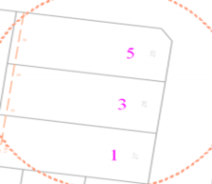
Sewer at rear of block | 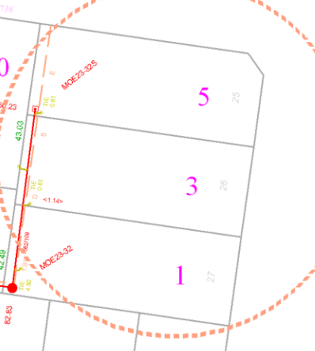
Watermain and tapping, side of property | 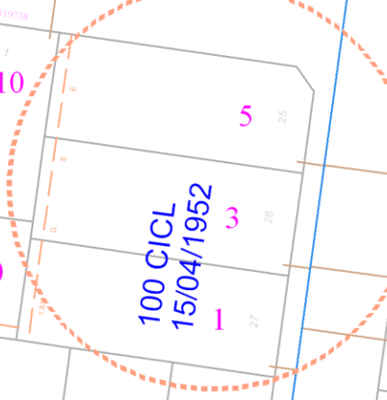
Gas main: running on opposite side of block | 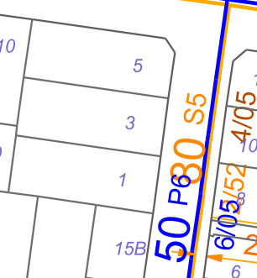
Power :
Vic roads, Fire hydrant | nil
Section 32 | Lawyer to check impediments on Titles prior to offer

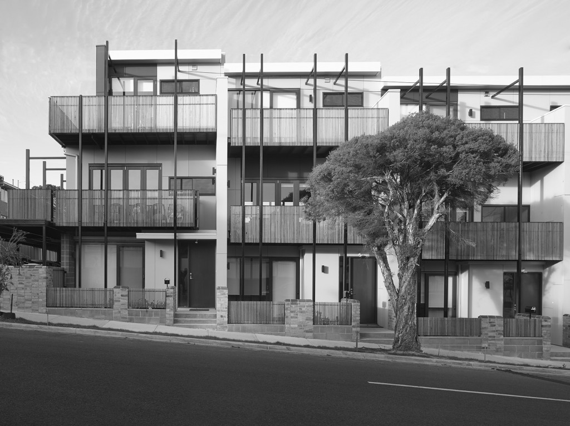
Testimonials


<NAME>
<TITLE>
<Insert testimonial here>

I’m ready for the next one!

CONGRUENCY

<satish alagasingar>
New Horizon group
New Horizon Group is a real estate development organization that operates within premier residential suburbs of Melbourne, projects are focused on sourcing and developing multiple dwellings. These projects offer investors the opportunity to obtain significant returns on investment.
Our team consists of experienced Town planners, specialized development professionals and we engage reputable builders with proven track record in area of operation. We research constantly in touch with market & examines demand of type of property and finishes required through constant liaison with real estate agents and site visits.

Insert a description of yourself, achievements and experience.
About Us
New Horizon Group is a boutique investment firm incorporated to deliver value through financial wealth by means of real-estate development, rent to hold with yields surpassing traditional 2-4% return pa. After projects renovating, undertaking subdivision, Townhouse development and delivering student accommodation project, New Horizon Group is seeking likeminded people to work with as funding partner on our next projects, which will be based predominantly in Melbourne and some small developments in premier suburbs of Geelong that are identified as Residential High-density Growth Zones.

Our Approach
Effective project management and precise communication at the right milestones is key to New Horizon Group’s successful project delivery approach. We will share our Property development knowledge, check lists & due diligence steps along the development cycle of this project. Project communications will be either through Skype, phone calls, 1 on 1 meetings, Trello Project activities and status visibility in real time to keep investors fully informed. Updates will take place as required during early phases but will be at least weekly during build phase.
The project will be structured under Joint venture agreement setting out terms of our relationship. Included in this will be the mechanism whereby we receive our share of the Joint venture by way of weekly advance of $500 +GST during the life of the project, with the balance at the end.
If more than one financing partner, a unit trust will need to be formed for the project, with each partners structure holding units in the unit trust. We would propose managing unit trust.
While it is not our preferred Option, we are also open to talking about idea of managing the project for a fee, with the financing partner(s) taking 100% of profit at end of the project.

our values
xxxxx
Annexures

Annexure 1:
Market Demand
Annexure 2:
Project Risks

<INSERT A PHOTO OF YOURSELF>

M | 0434-196-741

PHONE
Address |
P.O.BOX

ADDRESS
THANK YOU FOR
YOUR BUSINESS

EMAIL
E |info@newhorizongroup.com.au
W |www.newhorizongroup.com.au

