Rebel Streat Brand Identity Design Brief

Background: Rebel Streat is an exciting new casual dining experience being rolled across the UK and beyond.
Rebel Streat brings the most exciting street food operators to your local town centre / retail area and updates the traders every season with new fresh and exciting traders.
Rebel Streat is founded by Richard Johnson, author, journalist/TV presenter and the founder of the British Street Food Awards, European Street Food Awards and USA Street Food Awards.

The Brand Identity task: This has three components –
- A core logo and brand look which can be applied to physical dining locations including but not limited to interiors, furniture, trading kiosks or stands. Longer term this has to also work on food packaging and possibly media content such as T.V. etc.
- The Core Brand identity needs to be conceived of in terms of a space and or structure – with examples of what the experience of being in Rebel Streat would look and feel like.
- The Brand identity and application needs to be flexible enough to be adapted to fit differing physical location and fit-out challenges e.g. very different age and type of buildings. The identity and its application should not rely on overly expensive materials or finishes and as the name suggests should have an ‘edge’ or ‘attitude’ whilst remaining inclusive not ‘too cool for school’.
Target: This brand should appeal to adventurous eaters looking for novel and exciting dining experiences - whatever their age. These folks are less inclined towards unauthentic formulaic casual dining chains, they look for meaning and strong values in their consumption habits.
The target consumers are more likely to have been in higher education and be aware of the latest trends – young families, maybe, but they are not mum dad and the kids looking for a cheap burger.
Materials: See attached pitch deck and visual refences selected by our founder as guides to the sort of Brand Identity we are looking for. We want:
A logo and look
Examples of application to town centre / retail centre dining space
Examples applied to ready meal / convenience chilled food packaging

Rebel Streat is all about the life on the street. Our British street culture. Our ‘people’s’ architecture – from cul-de-sacs to sprawling high rises. Our pubs. Our graffiti. Our skies. Our country’s diverse outdoor life – and all the different cultures and communities. Our punk past, that’s due for a revival. Northern Soul. Rave. It all brings to mind the songs from my youth – Sounds From The Street, by the Jam, with that line “The USA has got the sea, but the British kids have got the street”.


Y NEWSLETTER

Like The Idea Of A Wall Of Fame…dedicated to local heroes – doctors, teachers, musicians etc.
This epic South Bronx block (below) is only unofficially dubbed the Wall of Fame. That’s too bad since it could benefit from landmark status; plans are afoot to raze this community beacon in favour of affordable housing. The wall’s pedigree is indisputable: Late Queens legend Iz the Wiz, Long Island’s Phetus and L.A.’s MSK crew represent a tiny fraction of the artists who’ve painted remarkable wild styles, fills, murals and messages across its bricks. The clock is ticking for you to see history before those bricks come crashing down.

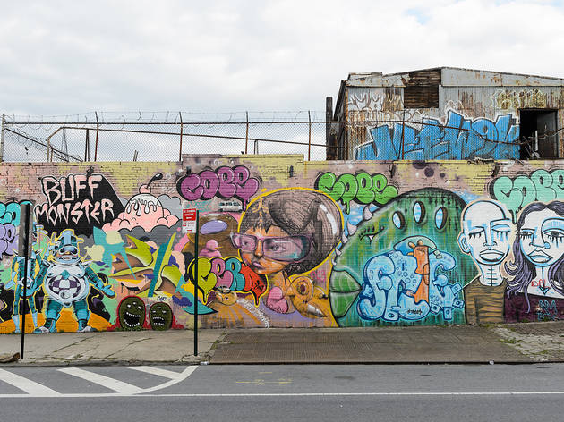




BECOME A P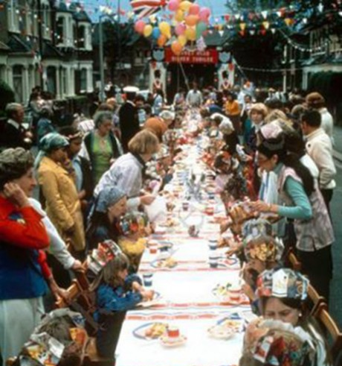ATRON



