Idea: image of an athlete made from a word cloud of sport terms.

Example:
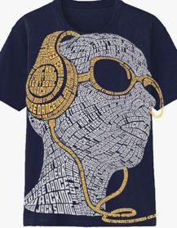

Idea: “R” over an “N” (to be more descriptive we could add “Reflexion Neuro-Fitness” in a circle around it). “R” over an “S” (to be more descriptive we could add “Reflexion Sports” in a semicircle or circle around it)

Example:
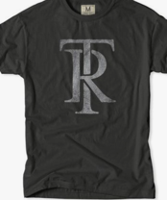

Idea: Pick a saying and write it out: Get Your Game in Gear – Train Your Brain, Real Athletes Train Their Brain, etc.

Example:
