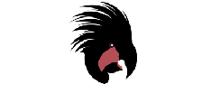
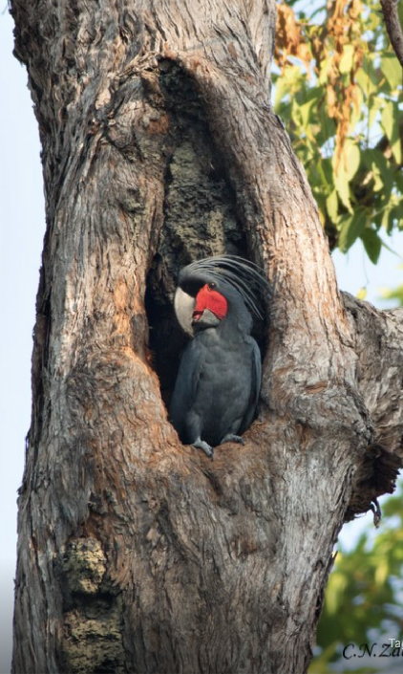
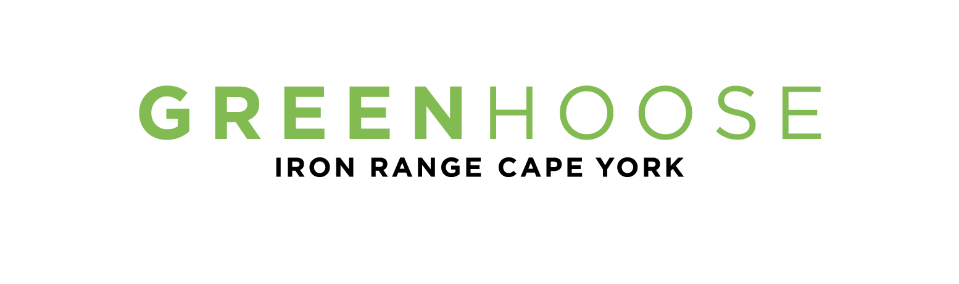
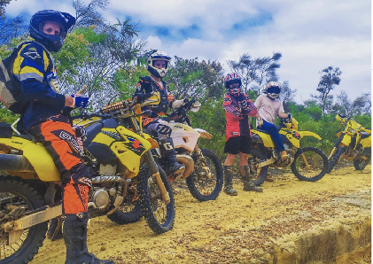
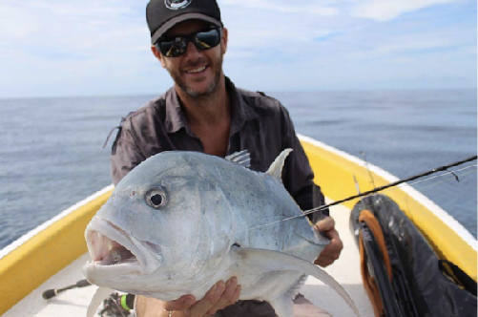
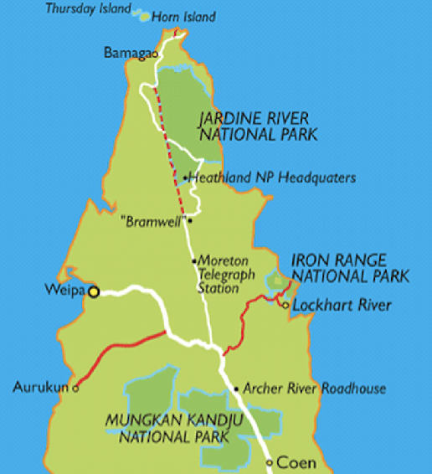
Accommodation,
Cafe & Tours www.greenhoose.com.au 07 4060 067

ww
Getting Here
By road
Iron Range is 100km’s off the Peninsula Development Road (PDR), 800kms north of Cairns. An incredibly beautiful and isolated area which can be reached, by road, during the dry season only.
Cape York Experience

Dirt Bike Tours
Experience a thrilling guided dirt bike tour on exclusive trails, the famous Frenchman’s track or 3 day ride to the Tip!
Fishing Charters / sightseeing
Fish unspoilt and secluded reef, estuaries and rivers to catch Mackerel, GT’s,Trout, Barra, Jacks. Or come snorkelling, sightseeing and beach combing!
www.capeyorkexperience.com
By air
Skytrans fly into Lockhart River from Cairns Monday to Friday. PH -1300 SKYTRANS

We would love you to stay…
(07) 4060 706
hello@greenhoose.com.au
www.greenhoose.com.au
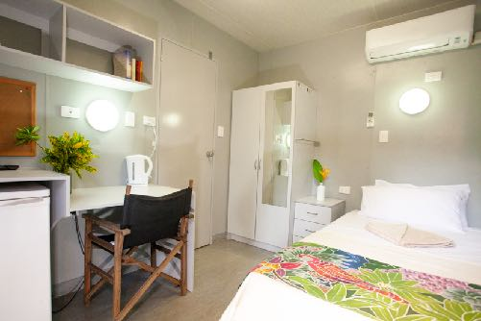
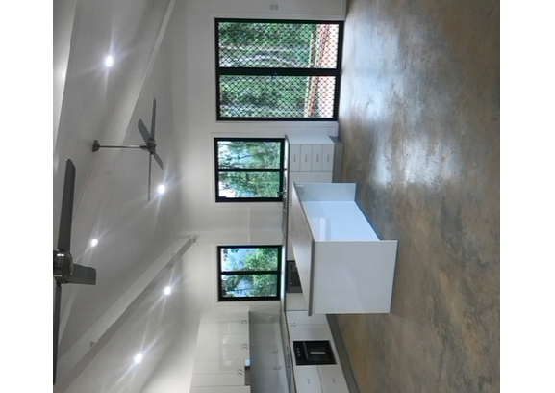
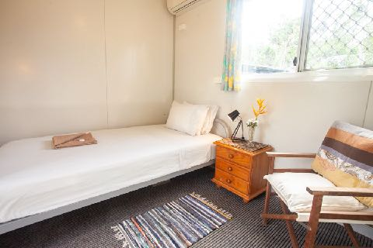
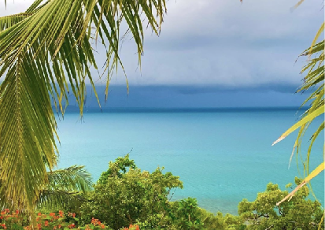
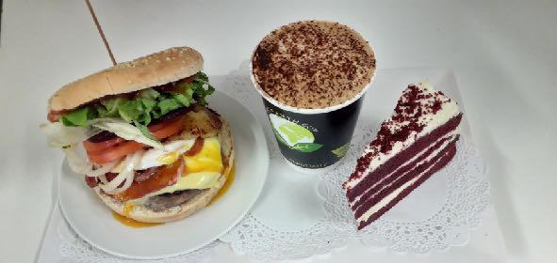
The Greenhoose
We are a friendly and family run accommodation, cafe and tour business. Sitting on 250 acres of rainforest bordered by the incredible Iron Range National Park

The Greenhoose has Ensuite rooms, family rooms, single rooms, and private VIP accomodation. Our beach house at Portland Roads is also available.
All have air conditioning and verandahs surrounded by beautiful gardens and scenery.
We also have a Cafe, Guest kitchen, free WIFI, BBQ area, fire pit, plenty of parking, walking tracks and plenty of info on how to get to the best spots.

The Area
Come visit Kutini Payamu (Iron range) N.P
World renowned for incredible rainforest, famous birdwatching, wildlife and rich in biodiversity.
Great Barrier Reef - it speaks for itself!
Portland Roads - a tiny but beautiful and historical beach community
Chili beach N.P - white sandy beach covered in palm trees over looking the Coral Sea.
As good as it gets!
Lockhart River Arts Centre - World famous for our local indigenous artists.
Lockhart River Aboriginal Community - Friendly and helpful indigenous community with General store, Health Care clinic, police station, Post office, bank ATM, mechanical workshop, fuel, Airport.

- native wildlife right on your doorstep.
Bush Walking tracks on 250 Acres of private landTake a walk along our bush tracks to see rare Cape York bird species or hike the rainforest track and marvel at the local flora and fauna.
ENSUITED
King single or double bed, TV, fridge, desk, verandah.
SINGLE ROOM
King single bed, fridge, shared bathroom and verandah.
Our Beach house - Portland Roads
Iron Range VIP Accommodation
Stay in our newly built 2 bedroom houses that are private, modern and have panoramic views over the rainforest and out towards the Iron Range.
Greenhoose Cafe
Enjoy a good barista coffee, delicious home made pizzas, burgers, cakes and snacks!
www.capeyorkexperience.com
Type to enter a caption.
Greenhoose Rooms

