Celebrating more than a Decade of Audinate 2006-2020

The Brief for the Designer

Exclusive staff T-shirt celebrating more than a decade of Audio-Visual Tech Company.

Staff belong to a well establish AV company within an industry associated with live music and major events where our technology and products have and are continuing to revolutionize how Audio is delivered at music festivals, conference rooms, churches, universities etc.

The thematic should involve networking, that is the thing that Audinate bought to gigs and events.

T-Shirt Front – Design around the theme of a Decade, band t-shirt style, Networking, Mixer Desks, Synthesizer, computer chips.

This T-shirt is for those who have been around 10 years plus – once we nail this we will look for a 5 year anniversary T-Shirt to be designed.

Looking for a design that is product and event based. Not a corporate look, no logo. Recognising/Celebrating the life of Audinate from inception small team working in a garage, countless hours refining Dante to accelerated growth and global expansion.

Example of events – this might also give some oversight into the company

Audinate a Decade
2006 – Dante is born
2008 – Dante Broadcasts Work Youth Day
2009 – Hyde Park summer in London. Oasis, Bruce Springsteen, The Killers, Neil Diamond… https://www.audinate.com/news/press-releases/xta-breaks-out-in-live-tours-with-audinates-dante-networking. This one was big, and way before we were ready for it. But, we was there and made it work 😉
2010 Winter Olympics – One of the biggest PA systems ever built https://www.audinate.com/news/press-releases/audinates-dante-a-winner-at-the-2010-vancouver-olympics. This one was really significant, it was the biggest network we had built, on the biggest stage we had operated.

2010 Wins EDN innovation award for best use of FPGA.
2010 Open European + US Offices
2010 DVS available online for the first time
2010 PCIe card launches
2011 Rednet launches, proving Dante has a role in the high end recording studio
2011 – NFL @ Wembley stadium

2015 – 2020 NFL Superbowl (Through ATK which is Michael Macdonald’s company – the consultant who helped us write our original business plan)
2017 Canal+ Factory goes Dante – huge broadcast facility in Paris all Dante networked.
2018 Coachella Festival – Dante is all over it
2018 Stagecoach Festival
2020 Dante comes home: https://restechtoday.com/dante/

Not sure if the above could translate into the back of the T-Shirt like a world tour gig list – would be interested to see how it would look.

Product photos attached for understanding only, can be creative on representation

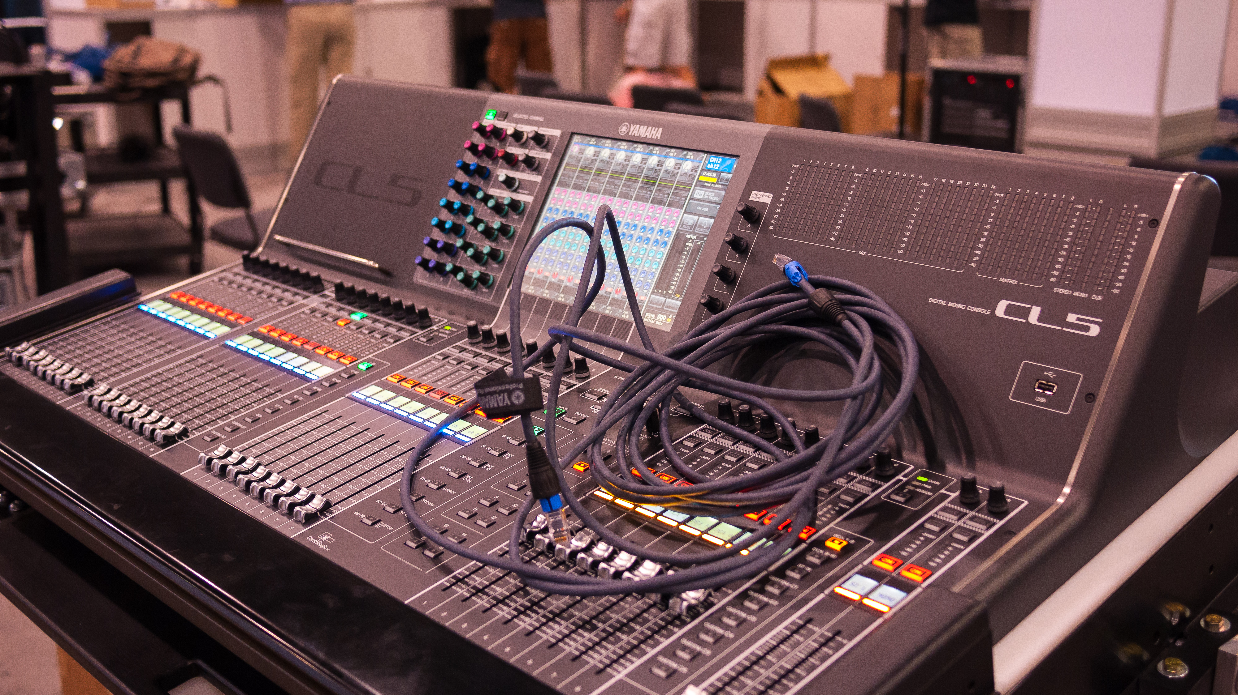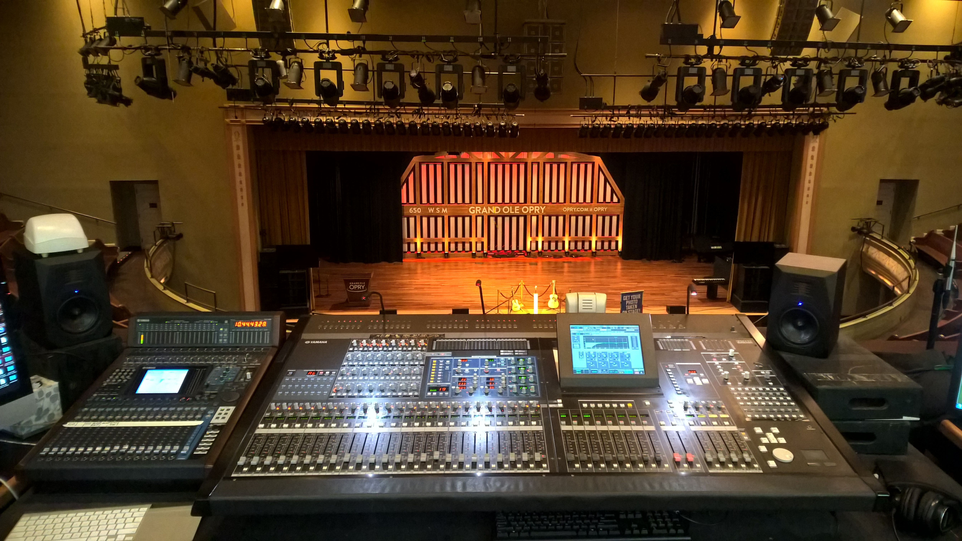


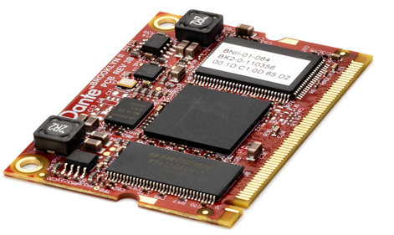
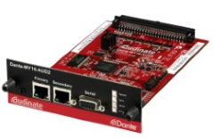
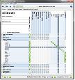
Chips
Cards
Modules
Software

Company Product

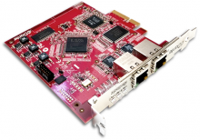

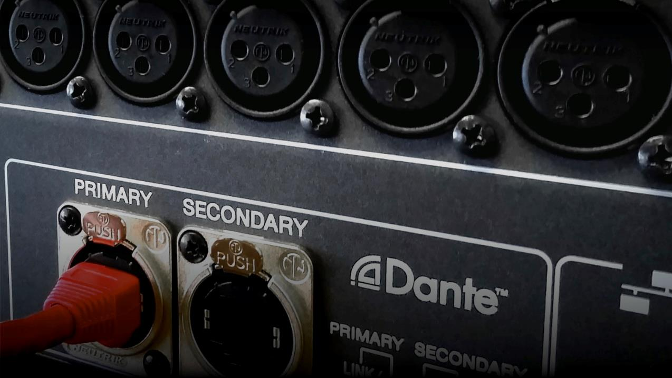
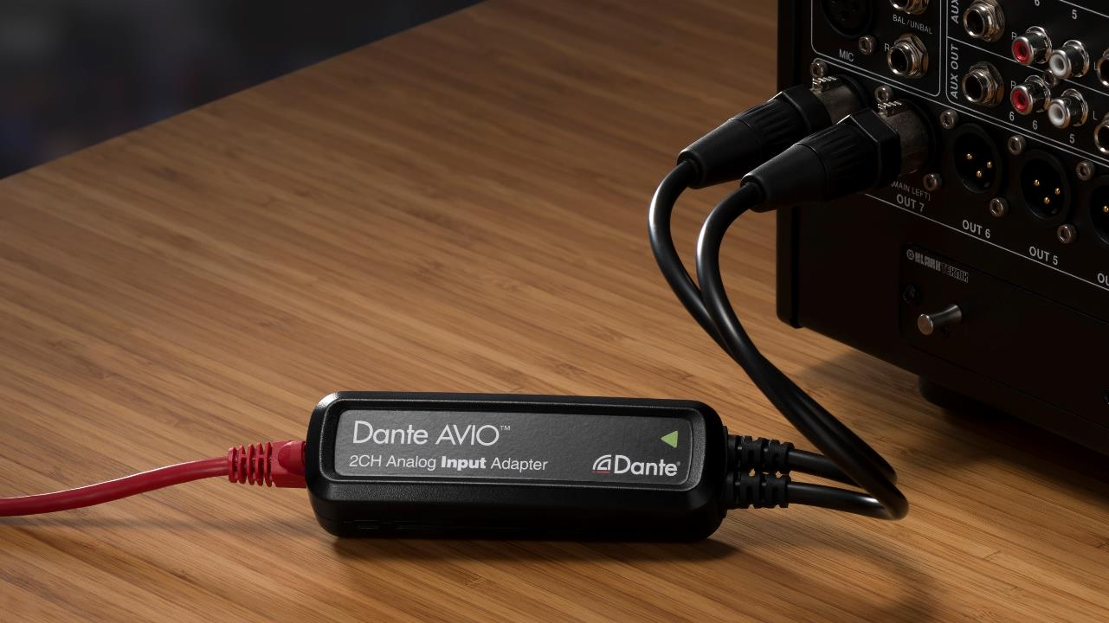
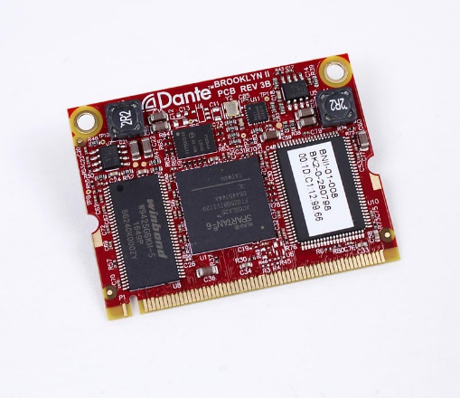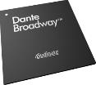
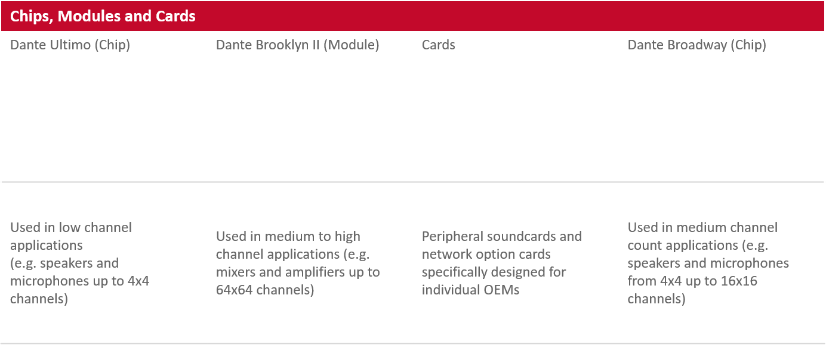


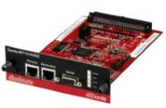
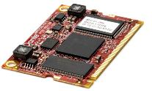

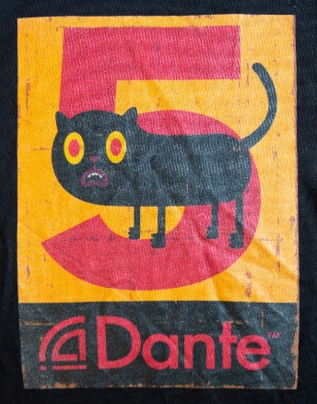
This is a loved designed that was produced some time ago coveted by those who were round at the time to receive but also those that weren’t

