Logo
Contact Us! (button linked to https://www.ltcreit.com/contact-us/)

Need Financing? We’ve got it.
Challenging times demand adaptive measures. We're constantly thinking outside of the REIT box to develop creative financing solutions.
Of course, we continue to offer our core NNN and JV structures. But, did you know we also offer a variety of structured finance products? These solutions provide a range of levers LTC can pull to help finance projects.

BENEFITS OF STRUCTURED FINANCE:
- Provide liquidity through releasing “trapped” equity in properties
- Bridge maturing loans while waiting for the market to return to normal
- Fund construction for shovel-ready projects
- Fund existing projects where other investors have backed away
- Provide an exit plan for equity investors who may have their own liquidity needs

PRODUCTS INCLUDE:
- Mezzanine
- Preferred Equity
- Bridge
- Construction Financing
- Unitranche Financing

DEAL PARAMETERS
Transaction Size: | $2 - $100 million
Property Types: | Independent Living, Assisted Living, Memory Care, Skilled Nursing
Locations: | Contiguous USA
Financing Types: | NNN, JV, Mezzanine, Bridge, Construction, Unitranche, Preferred Equity
Operators: | Regional, growth-oriented

ABOUT LTC:

180+ Investments | 27 States | 30 Operating Partners

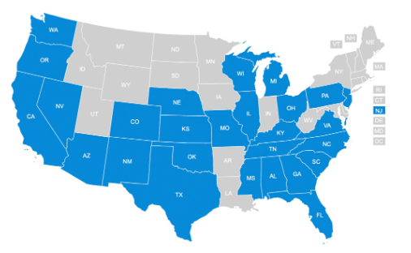
Shared success is based on partnership and alignment. Our business is about much more than real estate. It is about the operators who run the communities and the residents who call our buildings home.

We focus on building strong, long-term relationships and work to align interests ensuring that all businesses are supported to create the best outcomes for all.

Contact us today (button linked to https://www.ltcreit.com/contact-us/)

