
Logo / Icon Brief
Cordless You Can Count On

BACKGROUND INFORMATION
With a 90+ year passion for high-performance power tools, Festool makes life easier for professional tradespeople and helps them achieve perfect results faster that delight their clients.
Festool products are trusted by savvy tradies around the world for the tools’ innovation, health-focus, quality German-engineering, durability, relentless performance and the highly efficient ‘system’ design.

At Festool, we design our power tools…
- To solve problems - We create power tools that meet a need, streamline a process, or improve quality and efficiency.
- For the way work happens - From rough work to assembly, finishing and storage, we keep every function of the power tool in mind.
- With your comfort in mind - We limit the noise and vibration of our power tools, and carefully balance them to feel comfortable in your hands.
- To save time - Our power tools are easy to use and adjustments are easy with tools onboard and features, such as our FastFix® blade and bit changes, StickFix® hook and loop abrasives, and Plug-it quick change power cords.
- For quality, reliability and flawless execution - We measure quality in terms of microns and parts per million, to deliver parts that are 99.99% perfect!
- For healthier environments - Integrated dust extraction is designed into nearly every power tool we offer, keeping the work area cleaner and the air you breathe healthier.
- For portability - With our Systainer® system, you do not sacrifice quality for mobility. Systainers organize power tools and accessories and stack to create a mobile workshop.
- To work together - Our power tools feature an integrated system of design that allows them to work together more efficiently and effectively.

PRODUCT INFORMATION

Cordless Product Range
- Cordless impact drill
- Cordless percussion drills
- Cordless drills
- Cordless oscillator
- Cordless angle grinder
- Cordless freehand cutting system
- Cordless portable circular saws
- Cordless plunge-cut saw
- Cordless jigsaws
- Cordless sander
- Cordless hammer drills
- Cordless drywall screwdrivers

Applications
- Woodworking & joinery
- Carpentry & timber construction
- Painters
- Renovation & restoration
- Automotive

LOGO INFORMATION

Slogan
Cordless You Can Count On

Logo Style
Pictorial mark – Icon
The icon should not include the Festool Logo.
Icon to include a pic of a tool in action

Colours

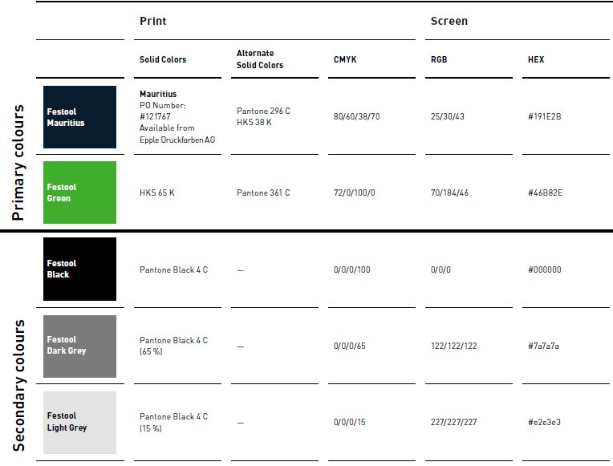

Product Examples
