I need icons for an AutoCAD Plug-in. There are 2 sizes allowed (32x32 and 16x16), I’ll put the requirements at the bottom of this document. Here’s a sample of AutoCAD icons:
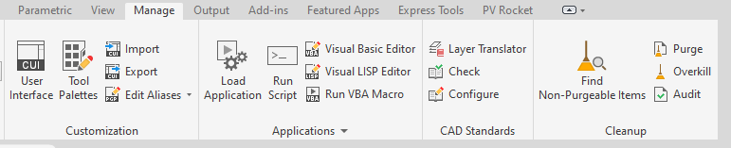
The plug-in I developed is used in the Solar Photovoltaic industry. You know, the black modules on the roof of houses that produce electricity. Icons might look like this, but not necessarily in color and not that detail:

Here’s all the icons I need at the moment:
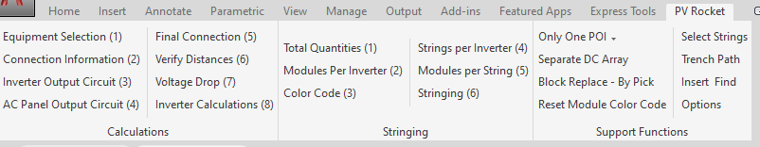
Two that are not yet shown are:
Help Videos
Account

In the examples, look at CUI Import, CUI Export, Visual Basic Editor, Visual Lisp Editor. I kind of see something similar for the (8) “Calculations” and the (6) “Stringing” commands. You can come up with one image, and use the initials to differentiate them.
The “Layer Translator” icon is an interesting idea for anything labeled “Stringing”. What we’re talking about is wiring, lots and lots of parallel wiring that all looks pretty much the same.
POI stands for “Point of Interconnection” where the array connects to the utility.
For the record, here’s what my PV Rocket logo looks like:


