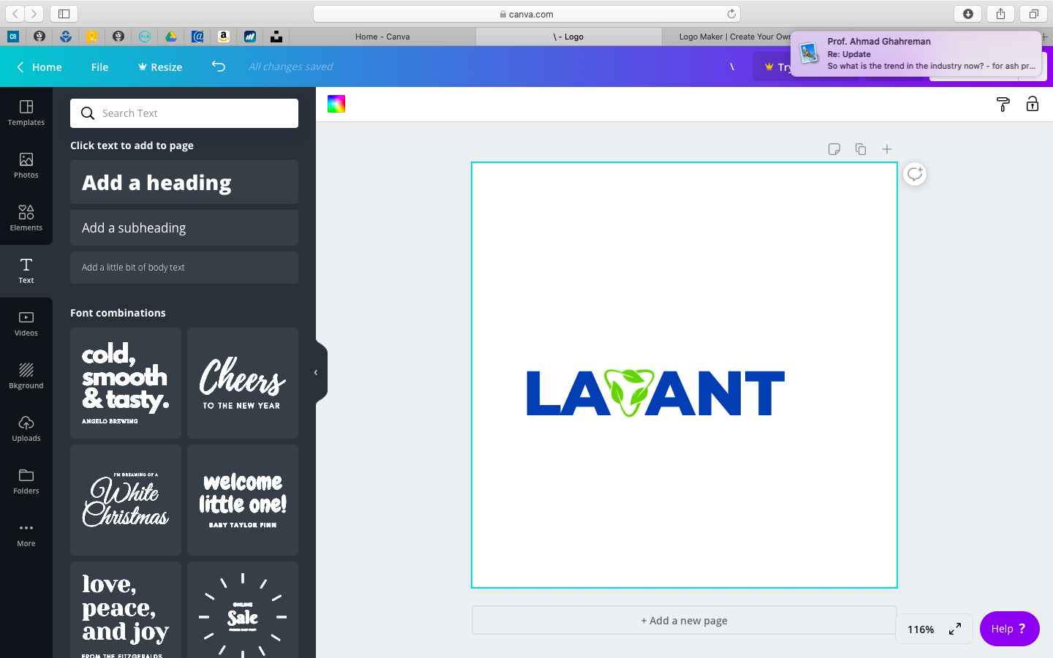Group
Beneficiation & Remediation Technologies

Group Inc.

Incorporate full - Legal name
Lavant Group Inc.

Required
  - Versions
    - Lavant (alone)
    - Lavant Group – tucked in somewhere (beside or under- does not need to be large.
    - Full version- Lavant Group Beneficiation and (or &) Remediation Technologies
  - Color specs will be required
  - All digital versions -png, eps, pdf…. Others.
  - Provide all Versions with Registered, and trademark

Please note:
  - We would like to soften the font. Representing earthly, but no overly environmental.
  - Ocean blue, but nothing a blue we cannot find anywhere.
  - We are open to some adjustment of the V, brown, bark triangle.
  - Option to alter leaves variety, one to water drop and one to prairie or forest
  - We are trying to not create to too tall or wide logo, stamp, signature. (difficult to fit anywhere)

