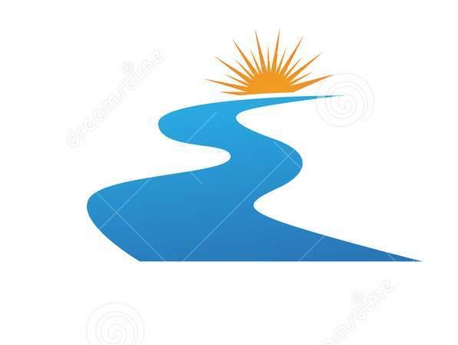
An ideas was to turn the white in this logo into a facial profile?
This river represents the Tamar River, which is where Tamar originates in our name.


We liked this as it represents the 3 arms to our business.

We like cubism, Picasso line drawings.

