Antique Joy-Rides Holland Saugatuck Grand Haven
AntiqueJoyRides.com Phone 248-705-4072
1929 Ford Model A Roadster
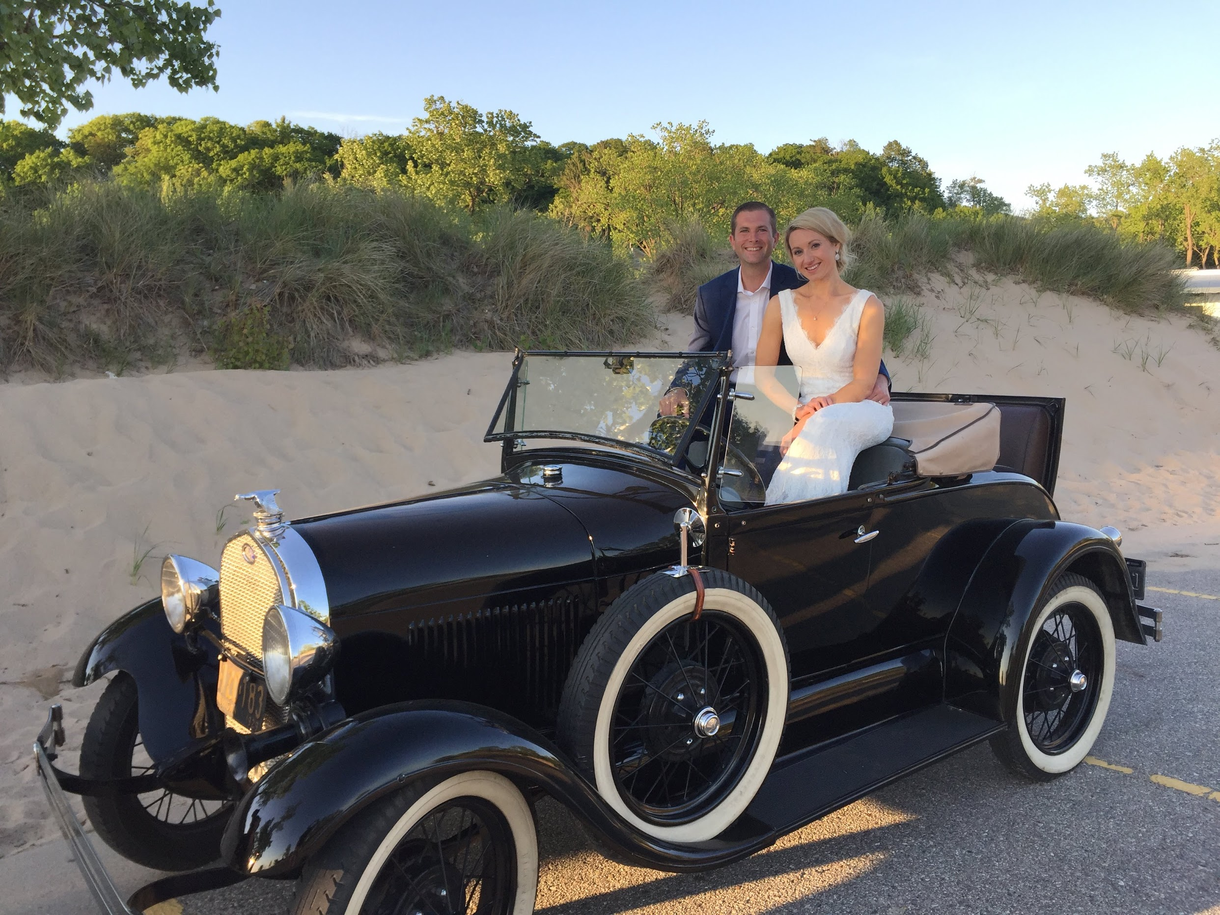
1931 Ford Model A Woody Huckster
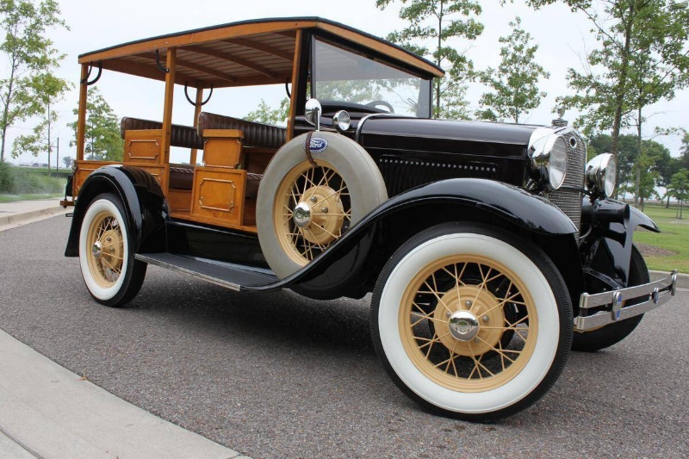
1930 Ford Model A Phaeton
