YOUR FREEDOM JOURNEY STARTS HERE
YOU CAN BUILD THIS 60 FT FAST OCEAN CRUISING CATAMARAN FOR UNDER $200,000
Simple and practical build methodology
Advanced aerodynamics with minimal fairing
Light, strong and stable and very fast
Superb upwind performance

Leonardo Da Vinci: Those who fall in love with practice without science are like a sailor who steers a ship without a helm or compass ….

Cruising on a sailing boat does wonders for your physical and mental health. It demands skill and courage and rewards the brave with joy and satisfaction. Below decks, a boat is comfort from the elements. Outside on a fresh morning all is speed, wind and journey. A boat safely anchored after a long passage is enchanted arriving. A space to sooth your senses with promises of discovery.

The traditional single hull boat is cramped and uncomfortable for cruising; it heels and pitches. When you are on a passage it is difficult to sleep, cook and eat except in benign conditions. And you probably need a crew.

The ancient Pacific solution of twin canoes offers speed and stability without the drag and weight of keel and ballast. A thoughtfully designed catamaran is the better cruising solution. With modern construction materials and building techniques, you can have it all: speed, space and stability and a reliable sailing boat.

Cruising long distances with just two people is safe, comfortable and easy on a catamaran. And at the end of the voyage, your catamaran can pass into a lagoon and anchor just off the beach. Your own cruising catamaran is an inspiring combination of craftmanship, naval architecture and science. Adventure and the freedom of the oceans can be yours.

So how can you build this boat? We have developed a simple building technique – everything is cut by computer-controlled milling (CNC). The shell formwork stays in place to add strength and is laminated over with epoxy and fibre glass in panels that one person can manage.

On this website you can buy the actual computer files (CNC files) that control the cutting machine. Everything is precise to better than a fraction of a millimeter. We will sell you a one-off license to use our CNC data files so you can mill everything from ribs to bulkheads and strongbacks. CNC milling machines can be found all over the world. CNC cutting services are inexpensive and precise. All your parts will click together like a child’s toy.

Read about this amazing boat and dream the possible.

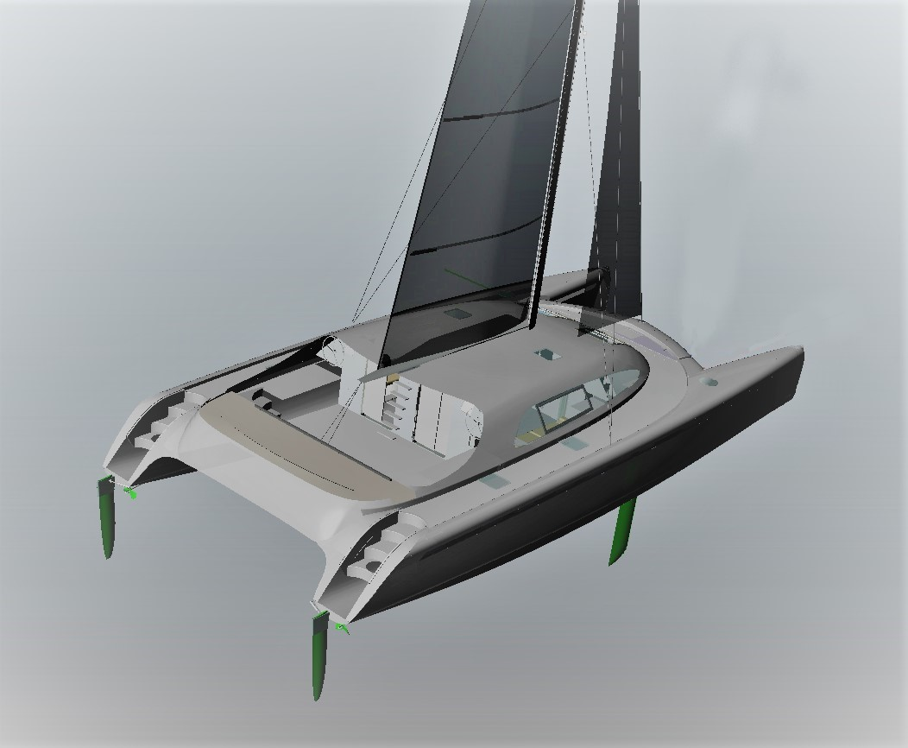

FIG 1. THE ARCHIMEDES 60
ARCHIMEDES 60 FEATURES

- Fast sixty-foot ocean cruising catamaran, easily handled by one person either from the cockpit or from the safety and comfort of an internal chart room with forward visibility

- Dedicated electric winch for mainsail halyard inside the main beam

- Self-tacking headsail

- Rotating carbon fibre wing mast

- Electric winches that can be controlled remotely for main sheet at the helm

- Sheltered cockpit helm stations

- Two huge main cabins with queen size beds – one in each hulls – midships to minimise motion

- Two 3 m long shower rooms with toilet, basin and washing machine

- Two forward cabins with bunks, two forward heads

- Easily tacked shallow forebody – elongated for wave piecing

- High bridge deck clearance to eliminate slamming in a seaway

- Massive solar array – 4.2 kW from eighteen 240 watt frameless panels

- Electric propulsion with high efficiency brushless DC motors

- Big engine rooms with access from electrically lifted transom steps or internal hatch

- Kick up foil rudders allow the stern to be beached

- Generous diesel (generator) and water tanks

- Separate galley forward of main salon

- Private chart room with all controls and remote helming forward of the main beam

- Wide decks all the way around the boat and a big level foredeck for sail management

- Self-launching twin anchors with winches under foredeck hatches

- X bows with medium buoyancy forebody to cut through waves and reduce pitching

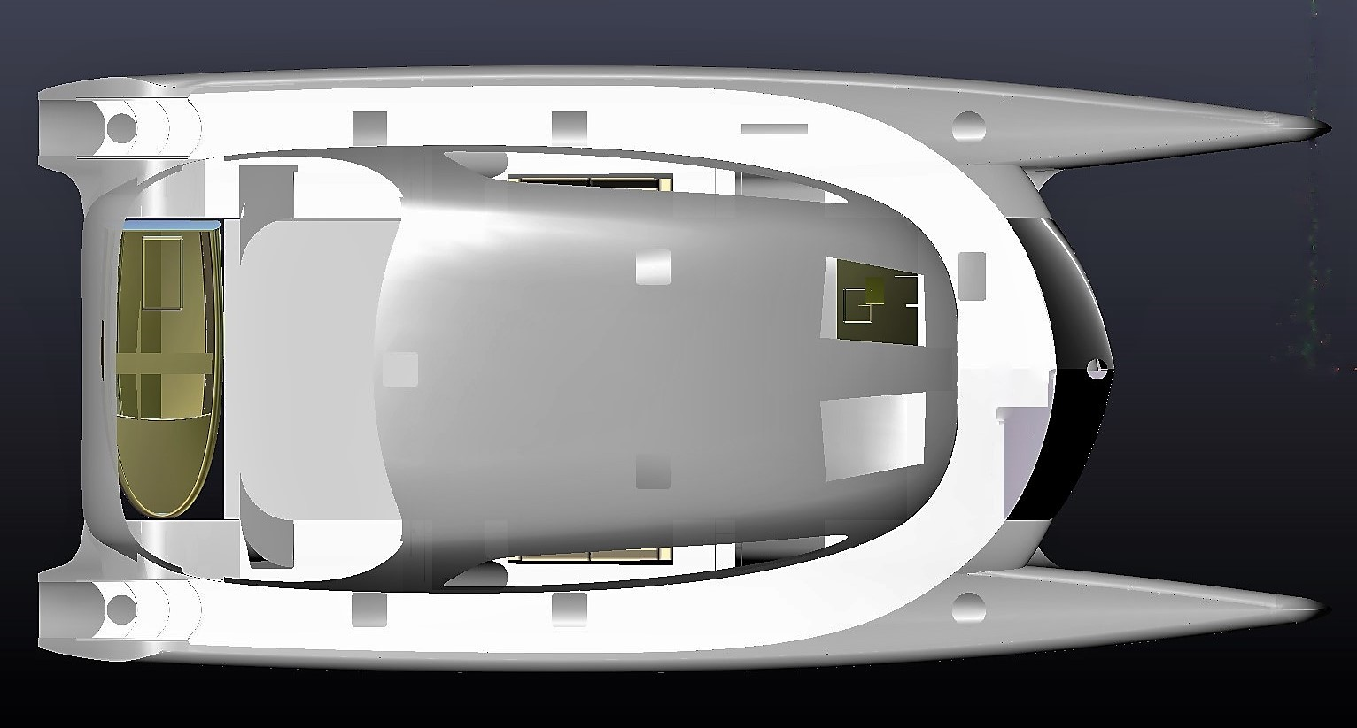

FIG 2. PLAN VIEW OF THE ARCHIMEDES 60

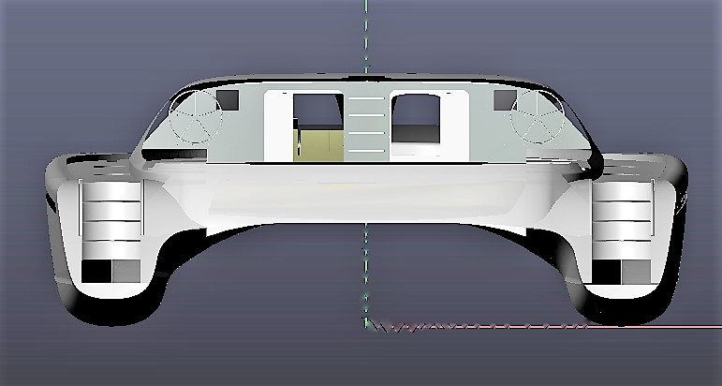

FIG 3. TRANSOM VIEW – THE STEPS LIFT UP WITH ELECTRIC LINEAR ACTUATORS

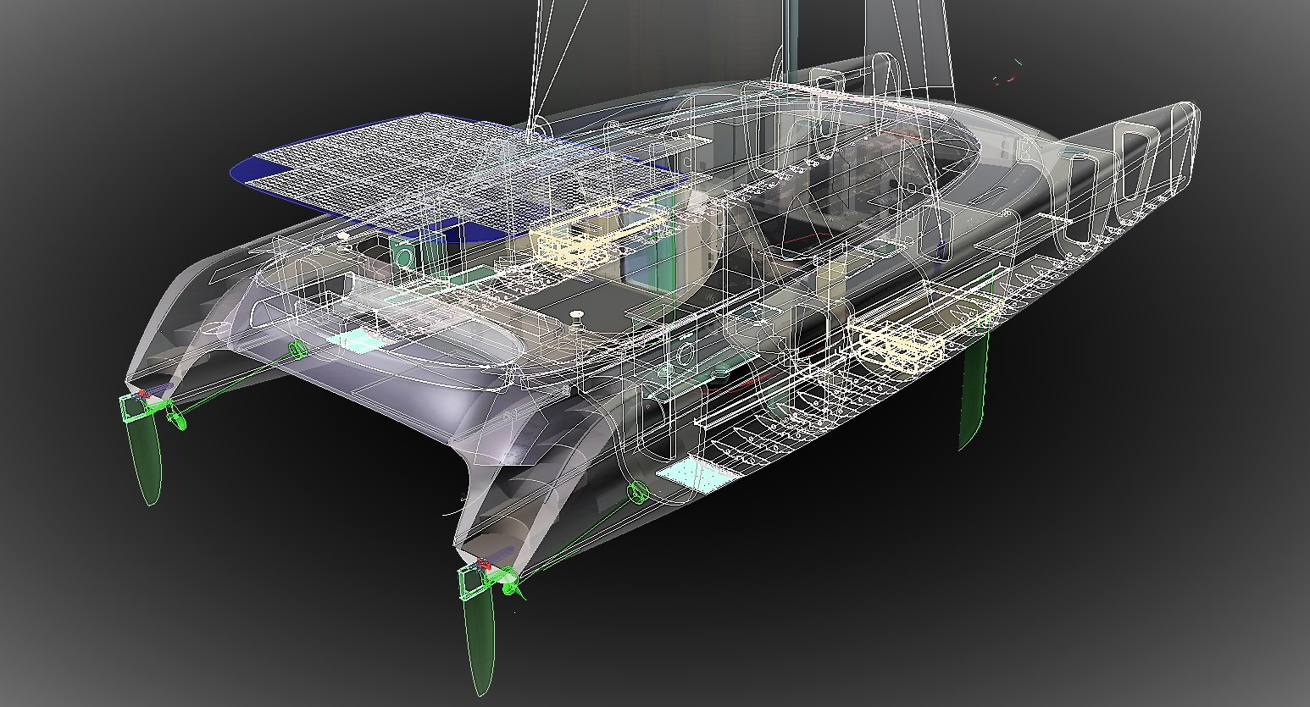

FIG 4. X-RAY VIEW HIGHLIGHTING HULL FLOOR RIBS AND BULKHEADS

HULLS
The hulls of the Archimedes 60 have been optimized to sail quickly upwind in light airs.
After thirty years of cruising, we know sailors often resort to motoring when there is not enough wind. We wanted a real sailing boat – one that uses the engine only as an auxiliary and for maneuvering.
In strong winds there is plenty of power in the wind. Speed and efficiency in a twenty-knot breeze is of secondary importance for a cruiser. The challenge is ghosting a catamaran upwind in a six knots breeze.
To achieve this light air objective, we refined every detail to make the boat slip quietly through air and water; everything has been shaped to minimise aero and hydrodynamic drag. To meet these objectives, the hulls of this beautiful sixty-footer have:
- Minimal wetted area to keep surface friction low – under 24 square metres
- Very low wave making resistance at speeds up to twelve knots - optimized prismatic coefficient
- Long and narrow shape - length to beam ratio 13.3
- An ideal midships profile - depth to width coefficient 2.9
- Hydrodynamically efficient centre boards and deep, kick up rudder foils – no fat fixed keels or undersized spade rudders as found on most production catamarans
- A novel feature to minimise pitch oscillation - increasing immersion causes the hull to sit back, offsetting the tendency to nosedive. Negative feedback damps longitudinal oscillation.
The hull design has been evolved using university developed resistance measuring software. After twenty-three iterations we got the slender body resistance at 10 knots down under 2,000 N – just 200 kg or 440 pounds. That’s easy for a 150 square meter gennaker (20 kPa x 100 sq. m)
Here is an underwater view of this amazing sixty-foot hull, the water line just kisses the bows, like a swan.
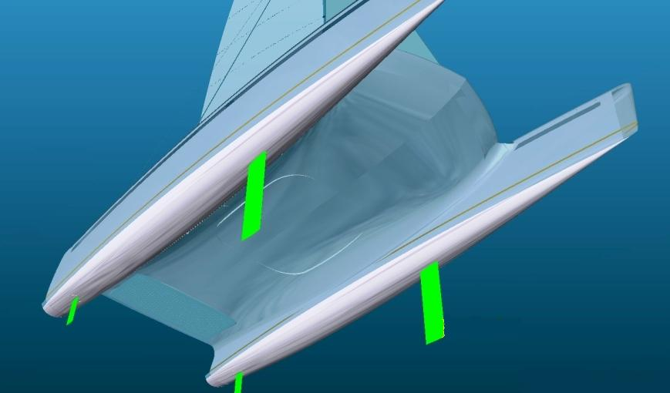

FIG 5. UNDERWATER VIEW OF THE 60 FT HULL AT FULL DISPLACEMENT
The hulls are light and strong. Vacuum bagged epoxy laminate skins with a 31 mm ply and foam core.
WING MAST
The mast is a twenty metre carbon fibre wing that rotates on a 90 ton Swedish spherical roller thrust bearing. This wing mast has innovations (patent pending) that significantly improve aerodynamic efficiency.
The shape has been engineered to match compression and buckling strength with aerodynamic performance. Many cross sections were analysed. The usual teardrop shape is not strong enough: a more rectangular shape is needed to resist buckling and increase second moment of area. Also, with a tear drop shape the air flow on the lee side where the mast meets the sail is not tangential except for a very narrow range of angle of attack. When the tear drop shape is over rotated there is a flow disturbing bump on the mast’s trailing edge.
There are several gurus in the aero/sailing design world whose work we greatly respect: architect Herreshoff the naval architect, C A Marchaj and Olympic champion Bethwaite. And Tom Speer who has written expertly about wing masts.
And their conclusion – a D shaped airfoil has the best lift over drag. In his University wind tunnel tests Marchaj demonstrated that you get double the lift over drag compared with a round section.
The problem is how to make the sail slide laterally so that its lee side is always flush with the trailing edge of the mast. Our design resolves this with an elegant new car design running in a wide track.
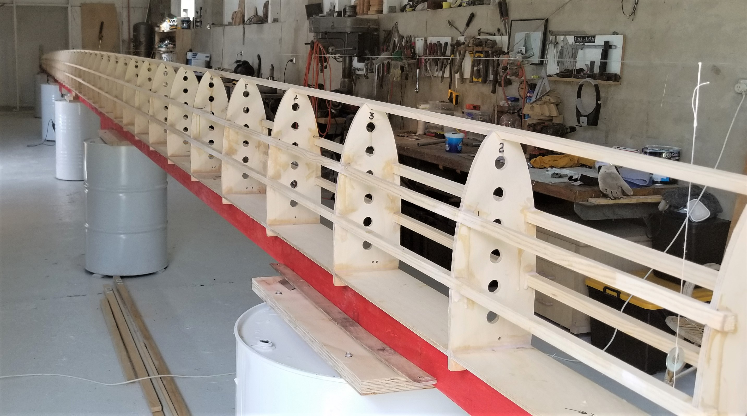

FIG 6. THE SKELETON OF THE WING MAST BEFORE 1.5 MM AIRCRAFT PLY IS WRAPPED OVER
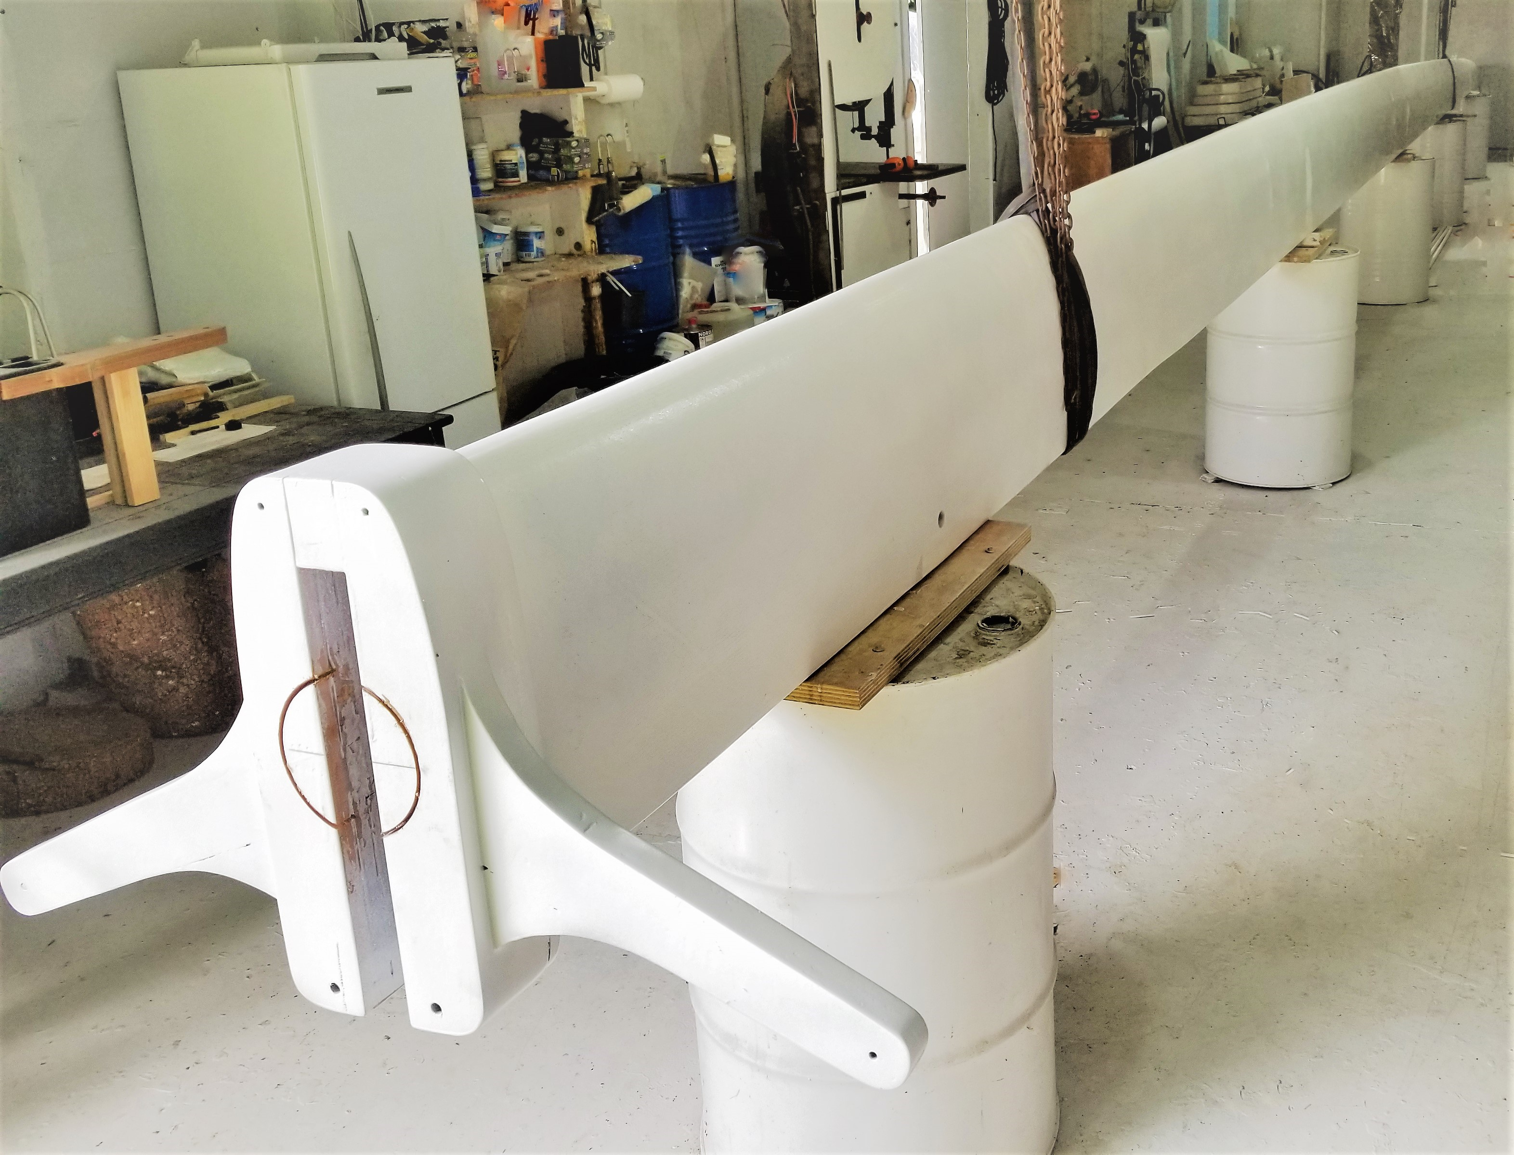

FIG 7. FINISHED CARBON WING MAST – ARMS FOR ROTATION – SIX HALYARD CONDUITS
CONSTRUCTION TECHNIQUE
We have developed a quick and easy method for building one off sandwich constructions: we bend ply over temporary CNC cut frames and hold it in place with epoxy and screws. This makes a very accurate shell over which we laminate epoxy and glass - or carbon. These are the steps in our method:
- Assemble temporary CNC cut frames on CNC notched strongbacks
- Fit stringers into notches in frames and secure them temporarily to frames
- Bend ply over the stringers and frames, glue and screw the sheets to the stringers and keelson
- Laminate over the ply shell with lateral, longitudinal and bi-axial glass
- Roll the hull over – deck side up
- Remove frames and glue foam between stringers
- Vacuum bag foam against the inner face of the ply shell
- Laminate inner face with lateral uniaxial, longitudinal uniaxial and biaxial glass
The resulting shapes are highly accurate and require little fairing.
The first step is to assemble temporary CNC cut frames on a CNC notched strong back. This part is fun and quick. Using an impact wrench and a box of M8 machine screws, you will have the complete shape ready in a day or two – it will feel like you have a boat already. Our CNC files contain all the cutting information for the frames, the strongbacks, the keelson spacer and many little joining pieces.
Below is a picture of the temporary frame skeleton. Notches in the frames guide the bending of the stringers. These stringers stay within the core after the temporary frames are removed. The stringers, which are the same thickness as the foam core, greatly enhance the shear strength of the core and stiffen the hull.
To bend the marine ply over the frames and stringers we use ratchet straps, epoxy glue and screws to secure the ply to the stringers to form a permanent shell. A big dividend is the ply also provides a stiff backing to the external epoxy glass laminate - the compression face. This greatly improves the short wave buckling and puncture strength of the outer face.

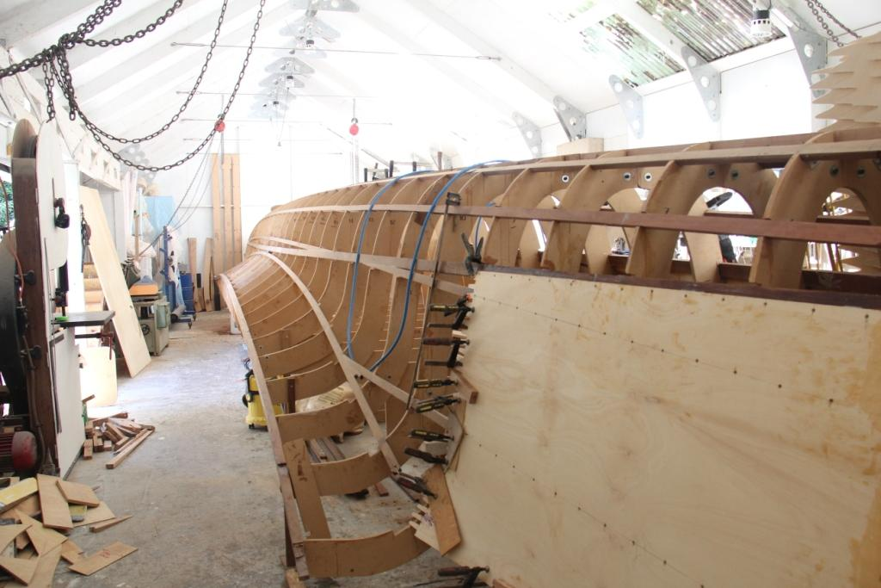

FIG 8. HULL STRINGERS NOTCHED INTO TEMPORARY FRAMES

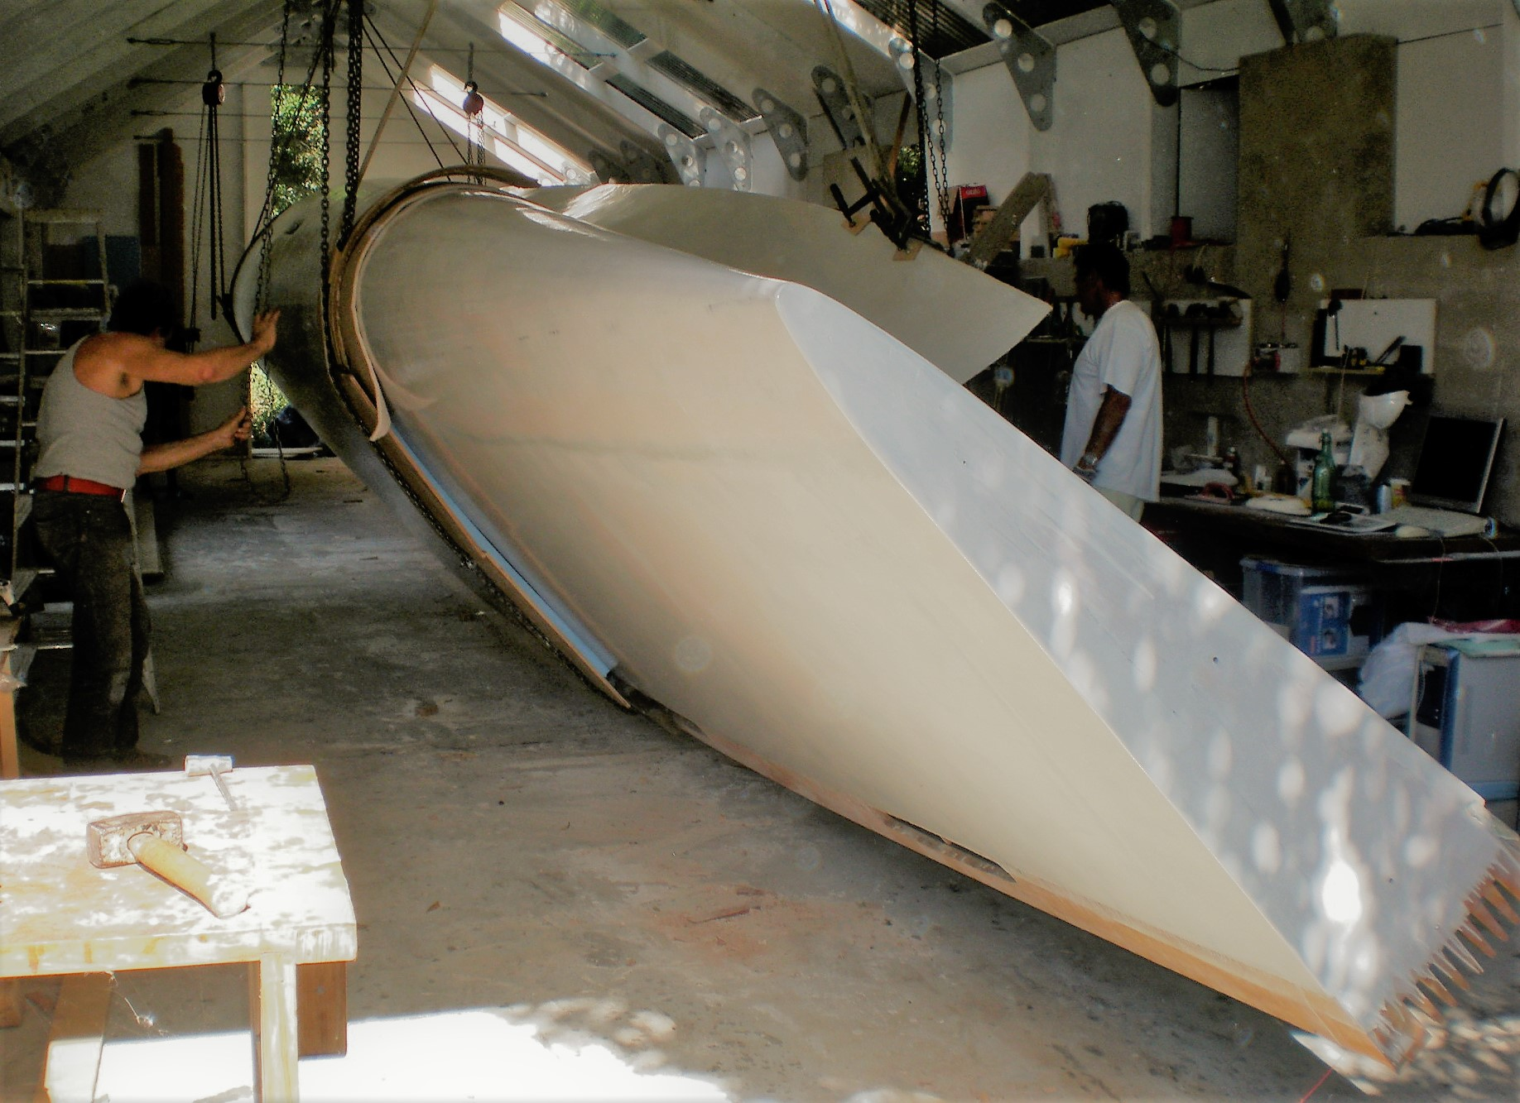

FIG 9. ROLLING THE HULL DECK SIDE UP TEMPORARY FRAMES ARE REMOVED LATER
BRIDGE DECK
The bridge deck is conveniently built up from several modules bonded together after assembly:
- The cabin roof – two mirrored halves
- The cross beams – bow, mast, mid and aft
- The salon floor module
- The cockpit floor module
- The galley and navigation floor

The cabin roof is a sandwich of outer laminate skin, ply shell, 35 mm foam and inner laminate skin
The shape is made from temporary frames and permanent stringers. 6 mm ply is bent over the frames and is screwed to the stringers. The outer face is then laminated with lateral, longitudinal and bi-axial layers of E-glass and epoxy.
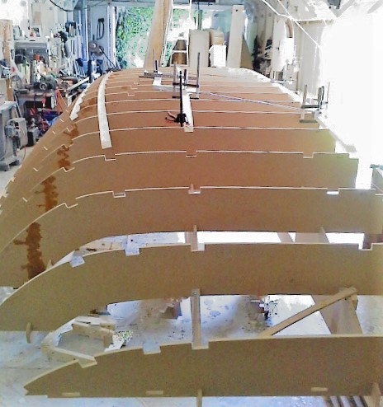

FIG 10. CABIN TOP FRAMES WITH PERMANENT STRINGERS BEING SLOTTED INTO NOTCHES

The assembly of frames and laminated shell is then rolled over. After removing the frames, the foam core is vacuumed in between the stringers Then the inside face is laminated with glass and epoxy.
SPECIFICATIONS

Builder you
Length overall 18.75 metres 61.5 feet
Beam 8.9 metres 29.2 feet
Draft, boards up 0.5 m 20 inches
Draft boards down 2.9 m 9.5 feet
Ratio beam to length 13.5
Headroom main cabin 1.92 m 6 foot 4 inches
Headroom in cabins 1.92m 6 foot 3 inches
Displacement – light ship 10.8 tonnes 23,760 pounds
Bridge deck clearance 1 m 3 foot 4 inches
Mast 20 m rotating wing, carbon and epoxy, NACA63015 section
Mainsail, fat head 106 sq. m 1141 sq. feet
Headsail, self-tacking 39 sq. m 420 sq. feet
Standing rigging Upper and lower side stays – UHMWP - Dyneema SK78
Galley L shaped bench, 1 cu m fridge (100 mm foam), stove, oven, dishwasher
Engines Twin 50 kW brushless DC motors with regeneration
Diesel generator 10 kVA
Diesel fuel for generator 200 litres
Water tanks Two x 400 litres
Holding tanks Twin 100 litres – one in each engine room
Solar array 4.2 kW
House batteries 24 volt 400 Ah lithium iron phosphate - >3000 cycles
Engine batteries Twin 96 volt 40 kWh lithium battery banks
Tender storage 4.2 x 1.8 m lowering platform/jetty/dive/ swimming platform

PRODUCTS

Product number AC601
Sample CNC file for hull ribs – one sheet in DWG format to test CNC - $250

Product number AC602
Sample CNC file for mast – one rib in DWG format - $250

Product number AC603
CNC files for temporary hull frames – includes ribs, keelson spacer, 18 m notched strongback
50 sheets ¾ inch ply - $20,000
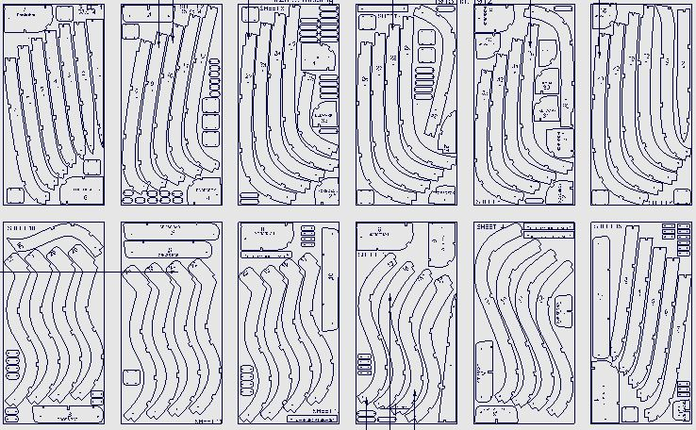

Product number AC604
CNC files for permanent bulkheads and floor frames - $15,000

Product number AC605
CNC files for bridge deck – DWG format files to cut 53 sheets ¾ inch ply - $20,000
Files include forms for cabin top, floor ribs, box beam bulkheads for four cross beams and hatches
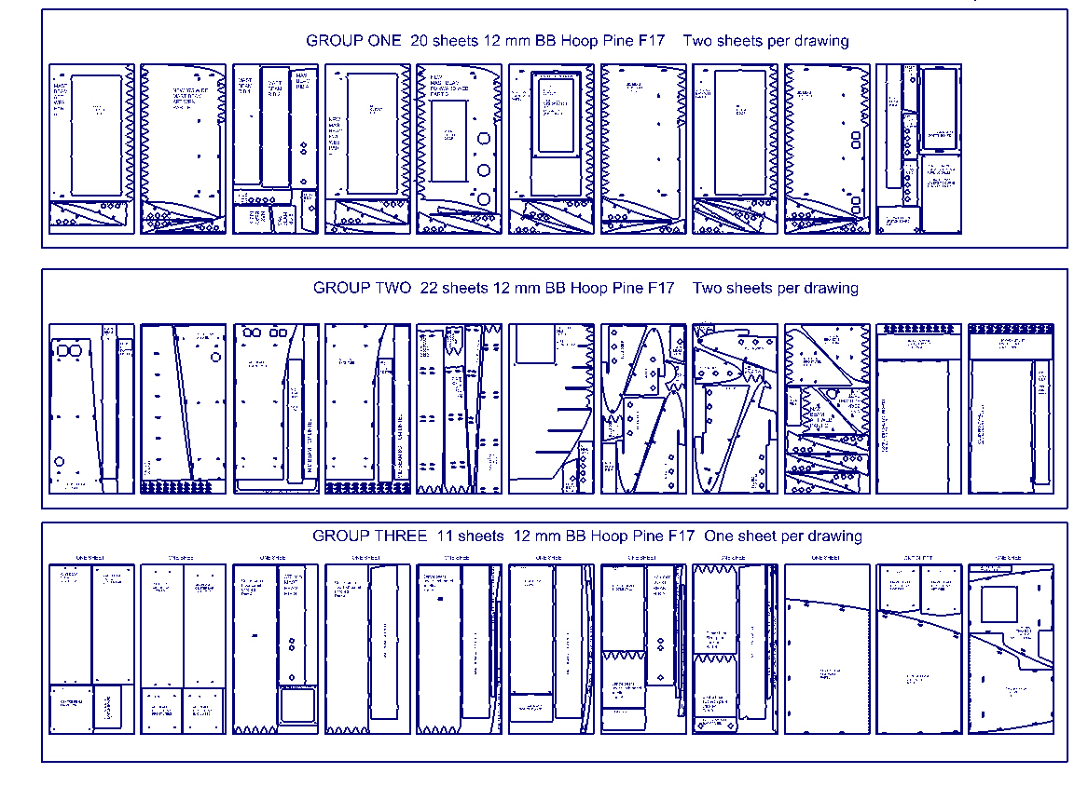
Product number AC606
CNC file for tapered wing mast – 40 ribs and backing plate in DWG format - $10,000
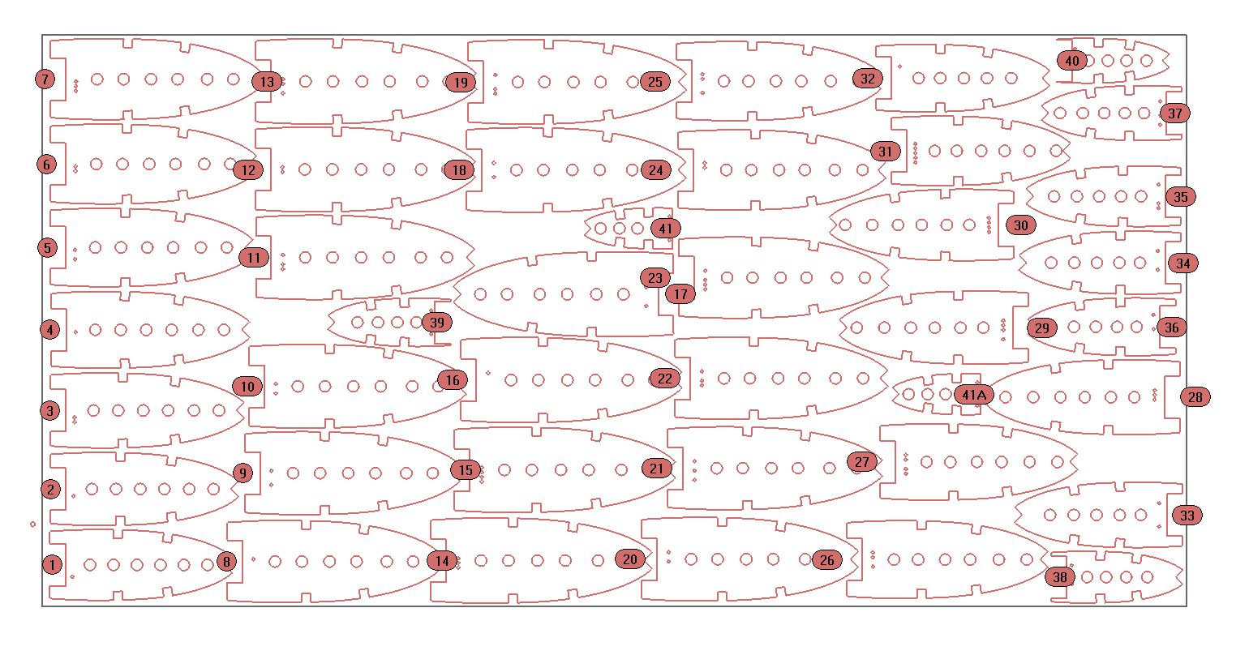
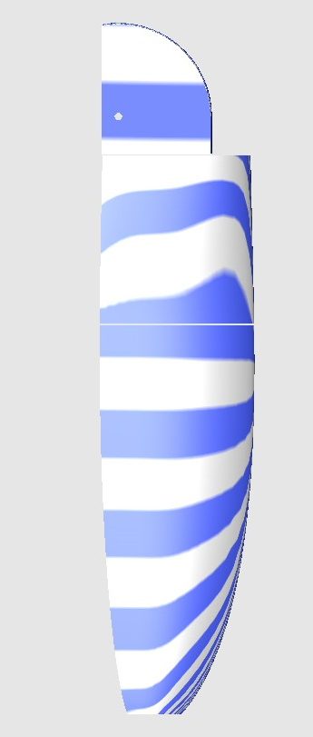
Product number AC607
3D CNC file to mill the female half molds for the carbon fibre
rudder foil - $2000

Product number AC608
Construction guide - $1000

Product number AC609
Budget spreadsheet - $1000

Product number AC6010
Weight analysis spreadsheet - $1000

Product number AC6011
Trim table spreadsheet - $1000

Product number AC6012
Electrical installation guide - $1000

Product number AC6013
Mast analysis spreadsheet - $4000
Complete structural analysis of the carbon fibre mast including buckling analysis, standing rigging loads, wind loading, weight and costing

