WHAT WE NEED:
We are looking to design a 24x36in landscape menu board for our new catering menu. Near this menu board will be pamphlets with the same catering menu. Detailed below is our catering menu and Wings Over branding. More information about our brand can be found at https://wingsover.com/.
MENU OFFERINGS:
All menu offerings must include pricing and calorie counts in the same size font. Placeholders can be used for calorie counts and any unknown pricing.
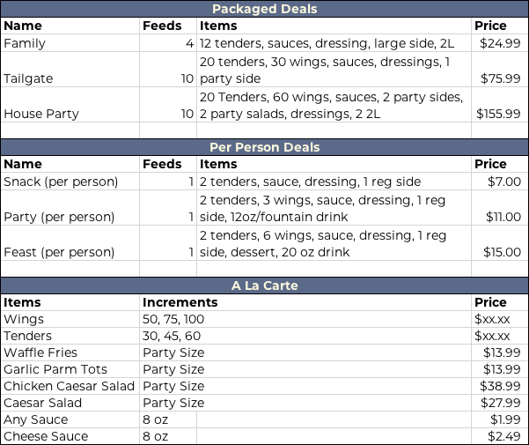
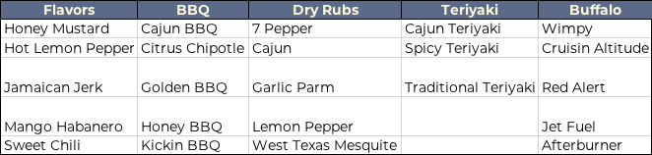
COLORS / FONTS:
- Font: Montserrat family
- Yellow - HEX: FFCE2D
- Gray - HEX: 636669
- Red - HEX: D43C2C
- Blue - HEX: 5D6B86
- White - HEX: FCF8DE
IMAGES:
Included are images of our tenders, wings and variety of offerings.

