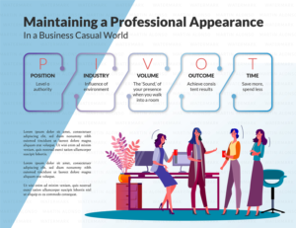

Steps in methodology

POSITION - Effecting your authority learn how to stand out with :
Interactive one on one meeting
Workshop step 1 of Levels
Who What Wear Worksheet

Discover your personal blueprint by
Industry--- How it influences your image : colour, body, style analysis
Workshop step 2 of Industry
Who What wear worksheet
Vibe ---- your energy field Create a difference when you walk in a room by
: Learning how to leverage your strengths
Use the elements of design to decode your style
Learn how to raise or lower your volume at will
Outcome---Empowerment Design your appearance through
: Workshop step 3 of Vibe and Colour
:WWW worksheet
: video series and digital lookboard
Time---- Save more, spend less Reap the benefits of having a strong foundation
Learn how to put outfits together quickly for any
Function
Workshop step 4 to put it all together

