Registration Page/JoinUs/Sign Up/Buy Today - Designer Pick One

Why work with us
- Change the way you view your Image
- Effective , long term results you can use repeatedly
- Learn how to present yourself professionally
- Achieve consistency in your appearance
- Raise your confidence to another level

Yes, I would like to attend.
Please tick the box that best reflects you:
- I feel like I’m outdated and fear I’m being overlooked for promotions
- I have regular virtual meetings and struggle with what’s presentable
- I tend to wear the same thing all the time
- I feel uncomfortable in dressing up because I don’t know what’s appropriate
- I struggle with being taken seriously at work

G LEStyle Consultant 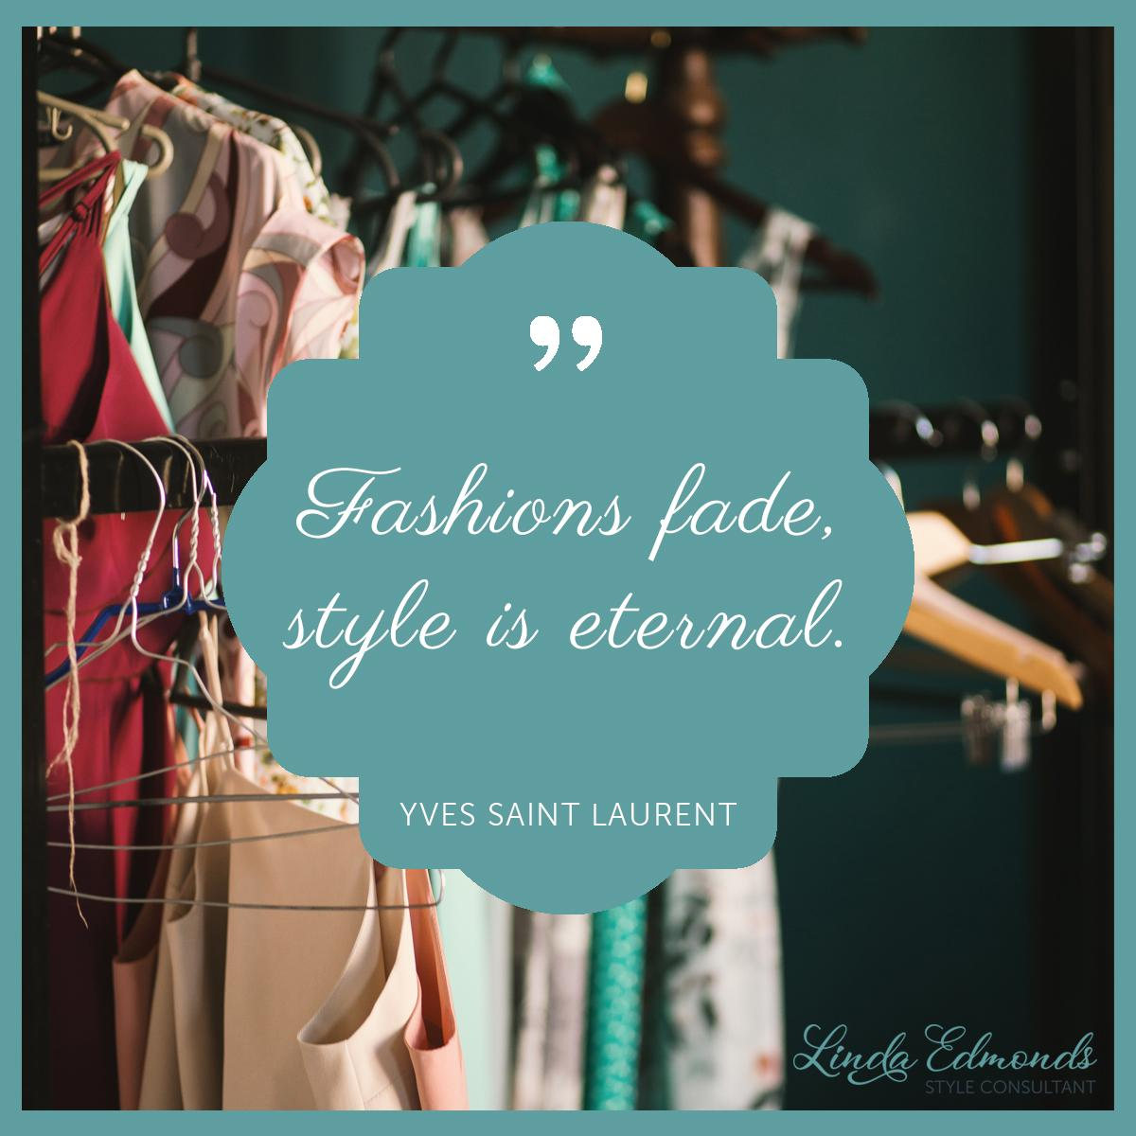
F LEStyle Consultant
In LEStyle Consultant
P LEStyle Consultant

Contact Details
linda@lestyleconsultant.com
www.lestyleconsultant.com

