The Pure Water Project

Purpose: Pure Domestic Water for all New Zealanders.

Thought Starter Logo ideas
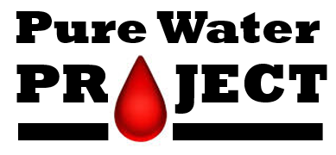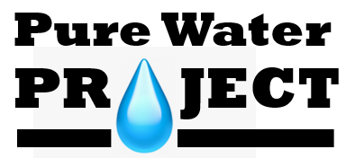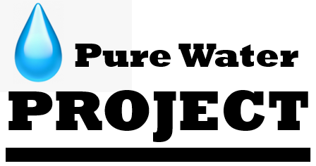
Try adding the word “The””.
Red [negative] or Blue [positive]
Related logo ideas for reference
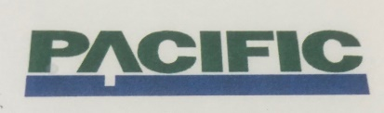 Forestry company: A & Tree? 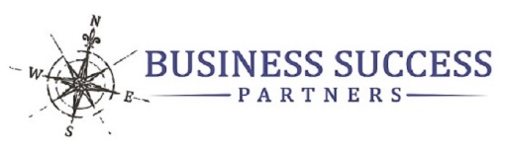

Simplicity and elegance is important for this market.
Curves vs sharp edges in form are in and align with flow of water and softness of skin/ hair.
Font and shapes, colour needs work. [agree … it was just to get something across in picture form rather than obtuse ideas …]

Target Market Segments
- Commercial
- Rural
- Health & Beauty – Residential Whole House
- Community Water Systems

The Pure Water Project - Brand Story
- Water – the foundation of life

- Pure – health & beauty

- Personal Safety – “Multi-barrier” to control the controllables!

- RED [BLUE is the opposite – negative or positive message?]
  - Suspended solids – colour, impurities
  - Hardness – damage pipes & appliances
  - Hardness – hair & skin
  - Hardness – spots on car, windows
  - Chlorine – poison & drinking water
  - Chlorine – poison & shower water and gas release
  - Germs – sickness
Background
Our background is in designing water treatment systems, but we realised there is a big gap in support for dealing with the contamination issues in town and bore supplies. We have kicked-off
The Pure Water Project to fix these problems and our water score process helps people understand how to do this.
The first step is assessing how safe your water is to drink and not just the bugs that make you sick immediately, but the range of chemicals that can cause illness over a long period of time. Did you know that around 34,000 people in New Zealand get sick every year from their drinking water, and around 800,000 people are at risk from drinking water that’s not regulated at all?
So, we are on a bit of a mission to fix that by supplying the most effective water purification system available for domestic use.
Now, the great thing about our purification process is, not only is your water is clean and safe to drink, but because we remove all the harmful minerals, it also tastes better, your fixtures and appliances last way longer, and you won’t end up with any spots on the car when you wash it, and by the way, (your other half will love this) with all the harsh minerals removed, pure water actually makes your skin and your hair softer. All these things improve your water score.

RDorey
29 Apr 2020

