· 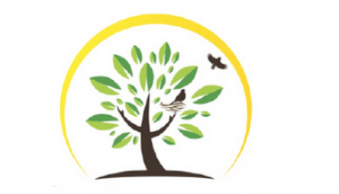 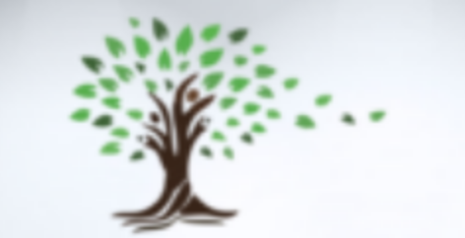
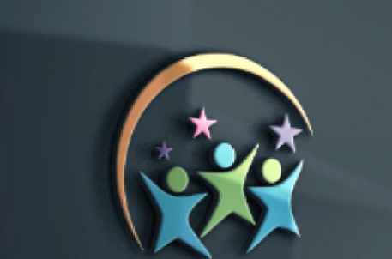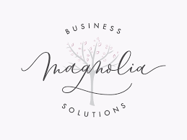
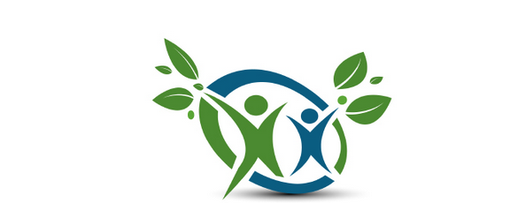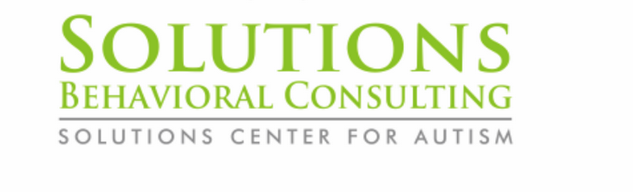
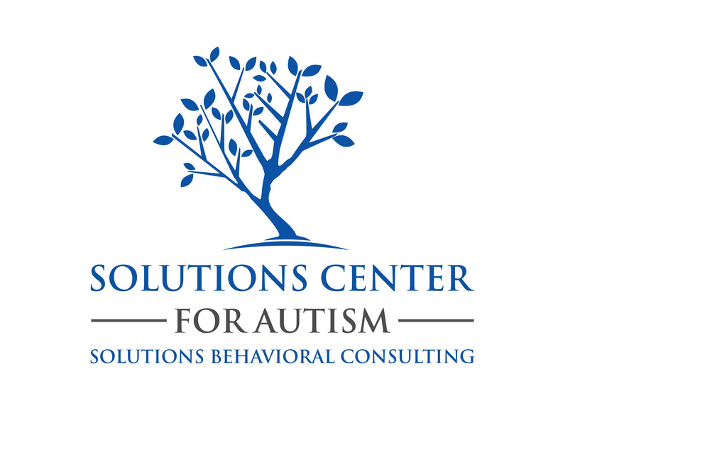

COMMENTS
- Logo features:
  - We like the three kids with the stars as a basis for the logo. We like the kids front and center and possibly adding a tree aspect in back or around (maybe like the magnolia logo above?)
  - The kids could possibly be reading aching for leaves on an outline of a tree in the background.
- Typeface: We like the typeface that shows SOLUTIONS and center for autism and behavioral consulting. The logo needs to stand alone as well. We also like the lines in the logo above that are next to the words -------For Autism-----------

- Trees: We like both green trees.
- Font: We like these fonts
- Colors: Earth tones - greens blues browns

