

LED Streetlights
Product Specification


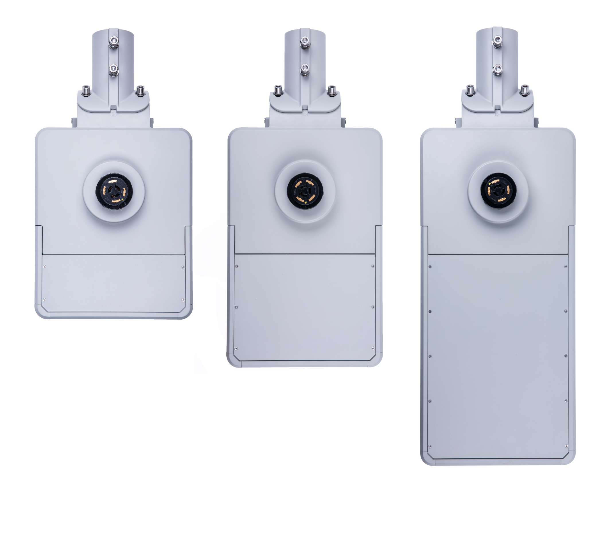

Important Notice
- To reduce the risk of electric shock, disconnect power supply before installation or servicing.
- This luminaire must be installed in accordance with the local electrical code. If you are not familiar with these codes and requirements, consult a qualified electrician.
- If NEMA photo control is installed refer to NEMA Receptacle section for instructions.
- If mounting bolts are completely removed in the field they should be hand threaded (prior to use of power tools) to ensure proper engagement of the thread when re-installing. Failure to pre-start threads may result in cross-threading or stripping of the bolts during reinstallation.
- The luminaire is designed for outdoor use only
- The light source contained in this luminaire shall only be replaced by the manufacturer or his service agent or a similarly qualified person.

ELECTRICAL RATINGS:

Model | Rated Voltage,  Vac | Frequency, Hz | Rated Current, Max. A | Rated Wattage,  W | Unit Type | Locations Use
TLXXX-YY-ZZ-U-V-T | 120-277 | 50/60 | 0.45 | 30-45 | Pole mounted | Wet
TLXXX-YY-ZZ-U-V-T | 120-277 | 50/60 | 0.65 | 45-65 | Pole mounted | Wet
TLXXX-YY-ZZ-U-V-T | 120-277 | 50/60 | 0.85 | 65-85 | Pole mounted | Wet
TLXXX-YY-ZZ-U-V-T | 120-277 | 50/60 | 1.10 | 85-110 | Pole mounted | Wet
TLXXX-YY-ZZ-U-V-T | 120-277 | 50/60 | 1.30 | 100-130 | Pole mounted | Wet
TLXXX-YY-ZZ-U-V-T | 120-277 | 50/60 | 1.60 | 125-165 | Pole mounted | Wet
TLXXX-YY-ZZ-U-V-T | 120-277 | 50/60 | 2.00 | 150-200 | Pole mounted | Wet
TLXXX-YY-ZZ-U-V-T | 120-277 | 50/60 | 2.50 | 200-250 | Pole mounted | Wet

NOMENCLATURE:

Example: | TL | 045 | 2M | CW | U | P | G
Group: | TL | XXX | YY | ZZ | U | V | T

Group | Description
TL | Series name;
XXX | Represent lamp wattage, may be any number, e.g. 045=45W;
YY | Represent the optics model number;
ZZ | Represent color temperature, may be CW - Cool White; NW - Neutral White; WW - Warm White; MW - Mesopic.
U | Represents input voltage is 120-277V;
V | Represents dimming function, may be P - Photocell; D - DALI; Z - 0-10V.
T | Represents lamp color, may be G - Gray; B- Black; W - White.

LIGHTING DISTRIBUTION TYPES:
Type II Medium

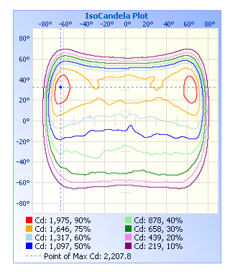

Type III Medium

Type IV Medium
TL043-YY-ZZ-U-D-T
PERFORMANCE CRITERIA - LED LUMINAIRE
VOLTAGE | Nominal luminaire input voltage range |  |  | 120-277 V
INPUT POWER | Nominal luminaire input power |  |  | 43 W
LUMEN OUTPUT | Min. luminaire lumen output
EFFICACY | Min. maintained luminaire efficacy at 3000K
POWER FACTOR | Min. power factor |  |  | 0.90
LUMEN MAINT. | Min. % of the initial output at 85,000 hours operation |  |  | L80=88,500 H
LMF | Min. Calculated Luminaire Maintenance Factor |  |  | 0.80
CHROMATICITY SHIFT | Max. LED chromaticity shift at 6,000 hours operation |  |  | ± 0.002 Duv
NOMINAL CCT | Nominal correlated color temperature |  |  | 3000K / 4000K
CRI | Color Rendering Index |  |  | >70
WEIGHT | Max. luminaire weight |  |  | 18.2 lbs.
SAIL AREA | Max. effective sail area |  |  | 0.80 ft²
TERMINAL BLOCK | 6-Way Screw Down Terminal Blocks |  |  | 6AWG-14AWG
PCR | Photoelectric Control Receptacle |  |  | Tool-less rotatable
MOUNTING SLIPFITTER | Top-entry | Side-entry | Integral tilt (-10° to +10°)
MOUNTING SLIPFITTER | Nominal pole size (NPS) |  |  | 1.25”/2”
OPTICAL DISTRIBUTION | Type II | Type III | Type IV | Type V
VIBRATION | ANSI C136.31 | Level 1 (normal) | Level 2 (bridge/overpass)
THERMAL ENVIRONMENT | Typical min. ambient temperature during operation |  |  | -30 °C
THERMAL ENVIRONMENT | Typical max. ambient temperature during operation |  |  | +50 °C
SURGE PROTECTION DEVICE | ANSI C136.2 | Basic  (6kV / 3kA) | Enhanced  (10kV / 5kA) | Elevated,  (20kV / 10kA)
CONTROL INTERFACE | None | ANSI C136.10,  3-pin | ANSI C136.41,  5-pin | ANSI C136.41,  7-pin
LED DRIVER | Not dimmable | Dimmable, 0-10V  (IEC 60929) |  | Dimmable, DALI  (IEC 62386)
CERTIFICATIONS - LED LUMINAIRE
SAFETY | UL 1598, UL 8750 |  |  | USL Certified
SAFETY | CSA C22.2 No. 250.0, CSA C22.2 No. 250.13 |  |  | CNL Certified
FCC | 47 CFR Part 15 Subpart B |  |  | FCC Certified
DIELECTRIC WITHSTAND AND ELECTRICAL TRANSIENT IMMUNITY | C136.2-2015: Clause 6, Clause 7, 7.1, 7.2, 7.3, 7.4 |  |  | Certified
INGRESS PROTECTION | Ingress protection |  |  | IP65
THD | Max. Total Harmonic Distortion (%) |  |  | 20
IMPACT TEST | Resistance to external mechanical impact test |  |  | IK08
SALINE MIST TEST | Salt spray test to ISO 9227 |  |  | 1,000 hours
PHOTOBIO. SAFETY | EN 62471 |  |  | Exempt group
PHOTOBIO. SAFETY | EN 62778 |  |  | Risk group 1
RoHS COMPLIANCE | European Directive 2011/65/EC |  |  | SGS Certified
MATERIAL - LED LUMINAIRE
OPTICAL MATERIAL | Optical lens material |  |  | UVC-Polycarbonate
HOUSING MATERIAL | Die-cast Aluminum alloy |  |  | 6063
FINISH | Polyester powder coating |  |  | Upon request

Photos for one-module luminaire: “TL043-YY-ZZ-U-D-T”

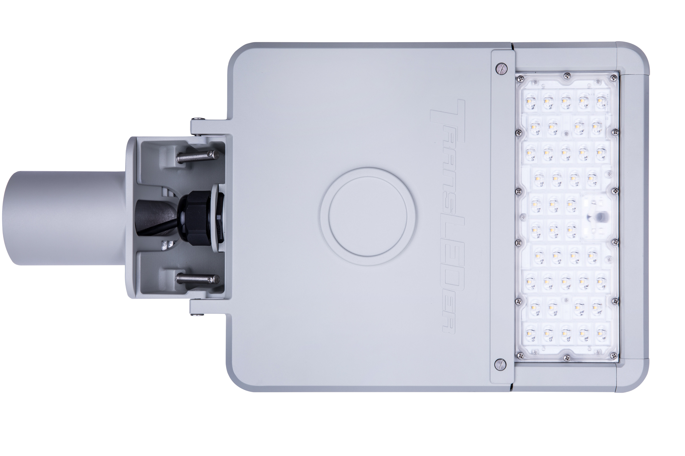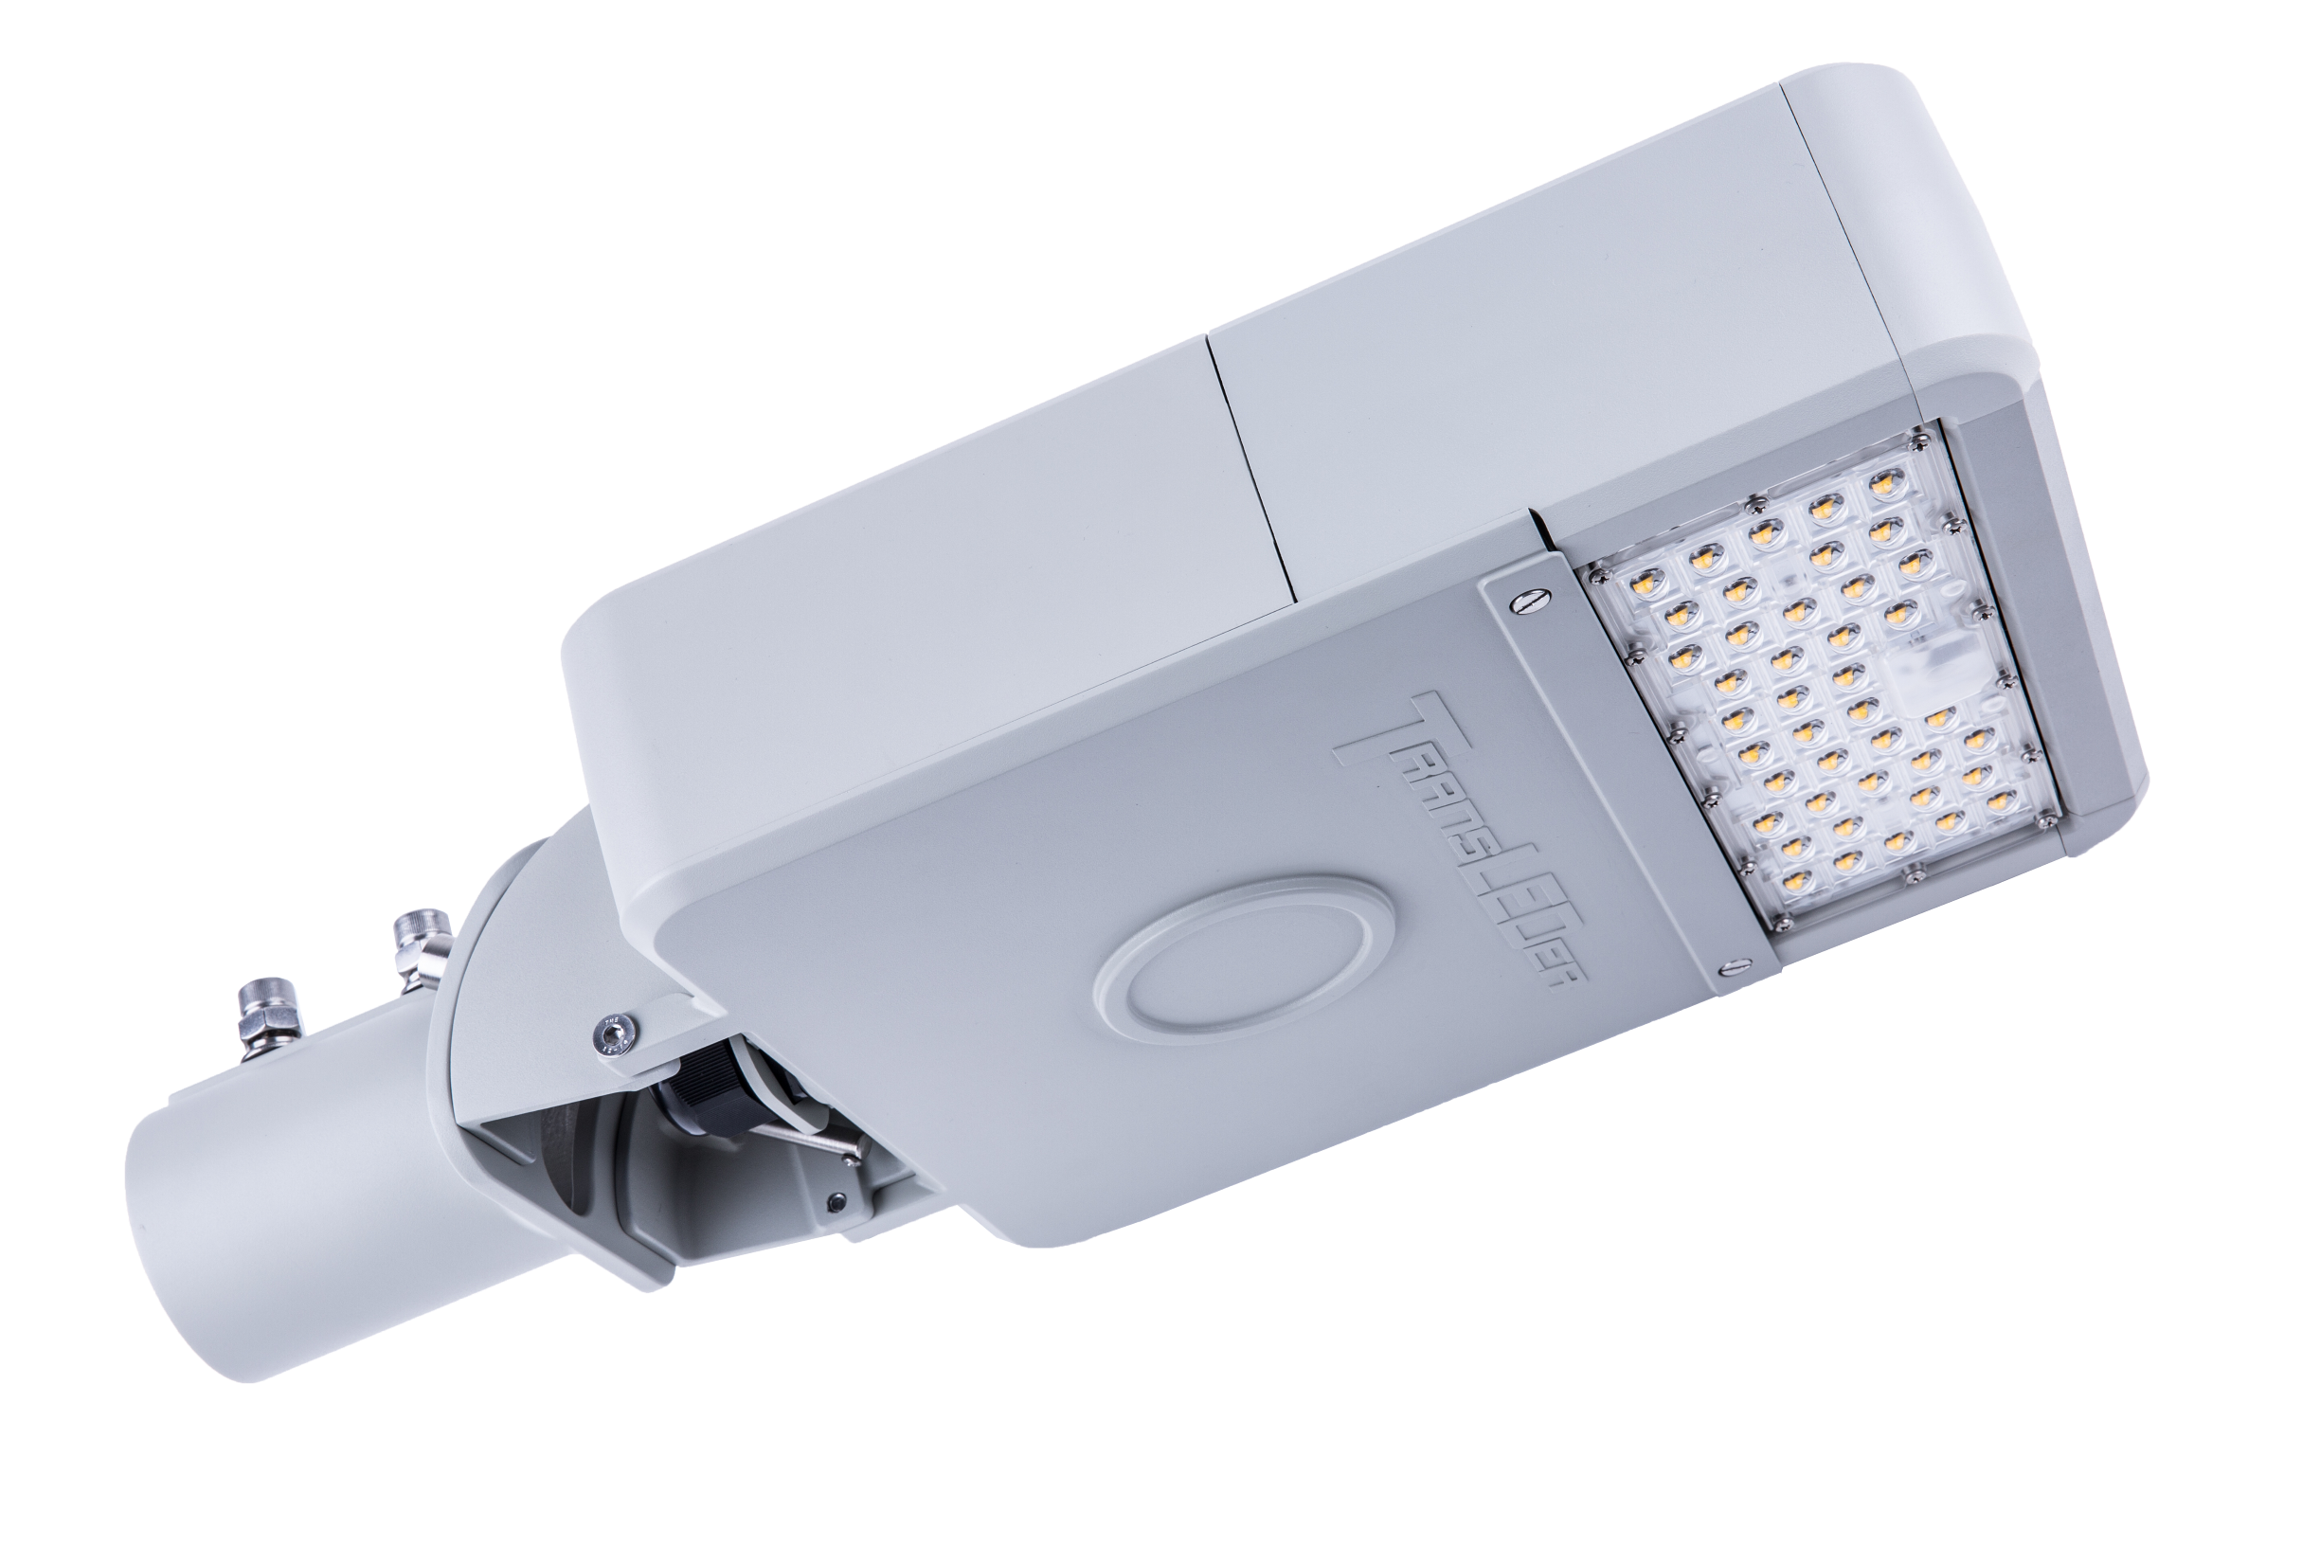

TL085-YY-ZZ-U-D-T
PERFORMANCE CRITERIA - LED LUMINAIRE
VOLTAGE | Nominal luminaire input voltage range |  |  | 120-277 V
INPUT POWER | Nominal luminaire input power
LUMEN OUTPUT | Min. luminaire lumen output
EFFICACY | Min. maintained luminaire efficacy at 3000K
POWER FACTOR | Min. power factor |  |  | 0.90
LUMEN MAINT. | Min. % of the initial output at 85,000 hours operation |  |  | L80=88,500 H
LMF | Min. Calculated Luminaire Maintenance Factor |  |  | 0.80
CHROMATICITY SHIFT | Max. LED chromaticity shift at 6,000 hours operation |  |  | ± 0.002 Duv
NOMINAL CCT | Nominal correlated color temperature |  |  | 3000K / 4000K
CRI | Color Rendering Index |  |  | >70
WEIGHT | Max. luminaire weight |  |  | 18.2 lbs.
SAIL AREA | Max. effective sail area |  |  | 0.80 ft²
TERMINAL BLOCK | 6-Way Screw Down Terminal Blocks |  |  | 6AWG-14AWG
PCR | Photoelectric Control Receptacle |  |  | Tool-less rotatable
OPTICAL DISTRIBUTION | Type II | Type III | Type IV | Type V
MOUNTING SLIPFITTER | Top-entry | Side-entry | Integral tilt (-10° to +10°)
MOUNTING SLIPFITTER | Nominal pole size (NPS) |  |  | 1.25”/2”
VIBRATION | ANSI C136.31 | Level 1 (normal) | Level 2 (bridge/overpass)
THERMAL ENVIRONMENT | Typical min. ambient temperature during operation |  |  | -30 °C
THERMAL ENVIRONMENT | Typical max. ambient temperature during operation |  |  | +50 °C
SURGE PROTECTION DEVICE | ANSI C136.2 | Basic  (6kV / 3kA) | Enhanced  (10kV / 5kA) | Elevated,  (20kV / 10kA)
CONTROL INTERFACE | None | ANSI C136.10,  3-pin | ANSI C136.41,  5-pin | ANSI C136.41,  7-pin
LED DRIVER | Not dimmable | Dimmable, 0-10V  (IEC 60929) |  | Dimmable, DALI  (IEC 62386)
CERTIFICATIONS - LED LUMINAIRE
SAFETY | UL 1598, UL 8750 |  |  | USL Certified
SAFETY | CSA C22.2 No. 250.0, CSA C22.2 No. 250.13 |  |  | CNL Certified
FCC | 47 CFR Part 15 Subpart B |  |  | FCC Certified
DIELECTRIC WITHSTAND AND ELECTRICAL TRANSIENT IMMUNITY | C136.2-2015: Clause 6, Clause 7, 7.1, 7.2, 7.3, 7.4 |  |  | Certified
INGRESS PROTECTION | Ingress protection |  |  | IP65
THD | Max. Total Harmonic Distortion (%) |  |  | 20
IMPACT TEST | Resistance to external mechanical impact test |  |  | IK08
SALINE MIST TEST | Salt spray test to ISO 9227 |  |  | 1,000 hours
PHOTOBIO. SAFETY | EN 62471 |  |  | Exempt group
PHOTOBIO. SAFETY | EN 62778 |  |  | Risk group 1
RoHS COMPLIANCE | European Directive 2011/65/EC |  |  | SGS Certified
MATERIAL - LED LUMINAIRE
OPTICAL MATERIAL | Optical lens material |  |  | UVC-Polycarbonate
HOUSING MATERIAL | Die-cast Aluminum alloy |  |  | 6063
FINISH | Polyester powder coating |  |  | Upon request
Photos for one-module luminaire: “TL085-YY-ZZ-U-D-T”

TL132-YY-ZZ-U-D-T
PERFORMANCE CRITERIA - LED LUMINAIRE
VOLTAGE | Nominal luminaire input voltage range |  |  |  | 120-277 V
INPUT POWER | Nominal luminaire input power
LUMEN OUTPUT | Min. luminaire lumen output
EFFICACY | Min. maintained luminaire efficacy at 3000K
POWER FACTOR | Min. power factor |  |  |  | 0.90
LUMEN MAINT. | Min. % of the initial output at 85,000 hours operation |  |  |  | L80=88,500 H
LMF | Min. Calculated Luminaire Maintenance Factor |  |  |  | 0.80
CHROMATICITY SHIFT | Max. LED chromaticity shift at 6,000 hours operation |  |  |  | ± 0.002 Duv
NOMINAL CCT | Nominal correlated color temperature |  |  |  | 3000K / 4000K
CRI | Color Rendering Index |  |  |  | >70
WEIGHT | Max. luminaire weight |  |  |  | 22.2 lbs.
SAIL AREA | Max. effective sail area |  |  |  | 0.93 ft²
TERMINAL BLOCK | 6-Way Screw Down Terminal Blocks |  |  |  | 6AWG-14AWG
PCR | Photoelectric Control Receptacle |  |  |  | Tool-less rotatable
OPTICAL DISTRIBUTION | Type II | Type III | Type IV |  | Type V
MOUNTING SLIPFITTER | Top-entry | Side-entry | Integral tilt (-10° to +10°)
MOUNTING SLIPFITTER | Nominal pole size (NPS) |  |  |  | 1.25”/2”
VIBRATION | ANSI C136.31 | Level 1 (normal) |  | Level 2 (bridge/overpass)
THERMAL ENVIRONMENT | Typical min. ambient temperature during operation |  |  |  | -30 °C
THERMAL ENVIRONMENT | Typical max. ambient temperature during operation |  |  |  | +50 °C
SURGE PROTECTION DEVICE | ANSI C136.2 | Basic  (6kV / 3kA) | Enhanced  (10kV / 5kA) |  | Elevated,  (20kV / 10kA)
CONTROL INTERFACE | None | ANSI C136.10,  3-pin | ANSI C136.41,  5-pin |  | ANSI C136.41,  7-pin
LED DRIVER | Not dimmable | Dimmable, 0-10V  (IEC 60929) |  |  | Dimmable, DALI  (IEC 62386)
CERTIFICATIONS - LED LUMINAIRE
SAFETY | UL 1598, UL 8750 |  |  |  | USL Certified
SAFETY | CSA C22.2 No. 250.0, CSA C22.2 No. 250.13 |  |  |  | CNL Certified
FCC | 47 CFR Part 15 Subpart B |  |  |  | FCC Certified
DIELECTRIC WITHSTAND AND ELECTRICAL TRANSIENT IMMUNITY | C136.2-2015: Clause 6, Clause 7, 7.1, 7.2, 7.3, 7.4 |  |  |  | Certified
INGRESS PROTECTION | Ingress protection |  |  |  | IP65
THD | Max. Total Harmonic Distortion (%) |  |  |  | 20
IMPACT TEST | Resistance to external mechanical impact test |  |  |  | IK08
SALINE MIST TEST | Salt spray test to ISO 9227 |  |  |  | 1,000 hours
PHOTOBIO. SAFETY | EN 62471 |  |  |  | Exempt group
PHOTOBIO. SAFETY | EN 62778 |  |  |  | Risk group 1
RoHS COMPLIANCE | European Directive 2011/65/EC |  |  |  | SGS Certified
MATERIAL - LED LUMINAIRE
OPTICAL MATERIAL | Optical lens material |  |  |  | UVC-Polycarbonate
HOUSING MATERIAL | Die-cast Aluminum alloy |  |  |  | 6063
FINISH | Polyester powder coating |  |  |  | Upon request
Photos for two-module luminaire: “TL132-YY-ZZ-U-D-T”

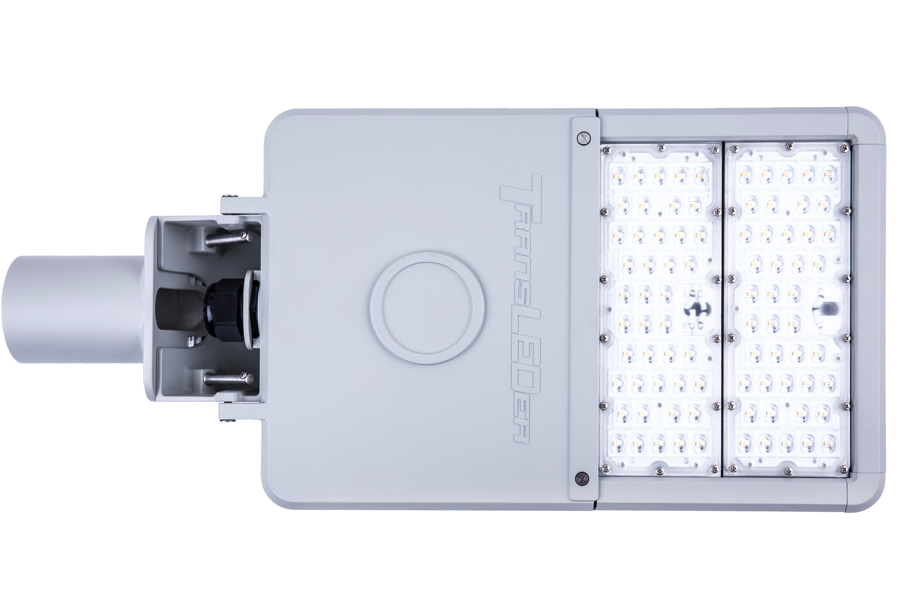
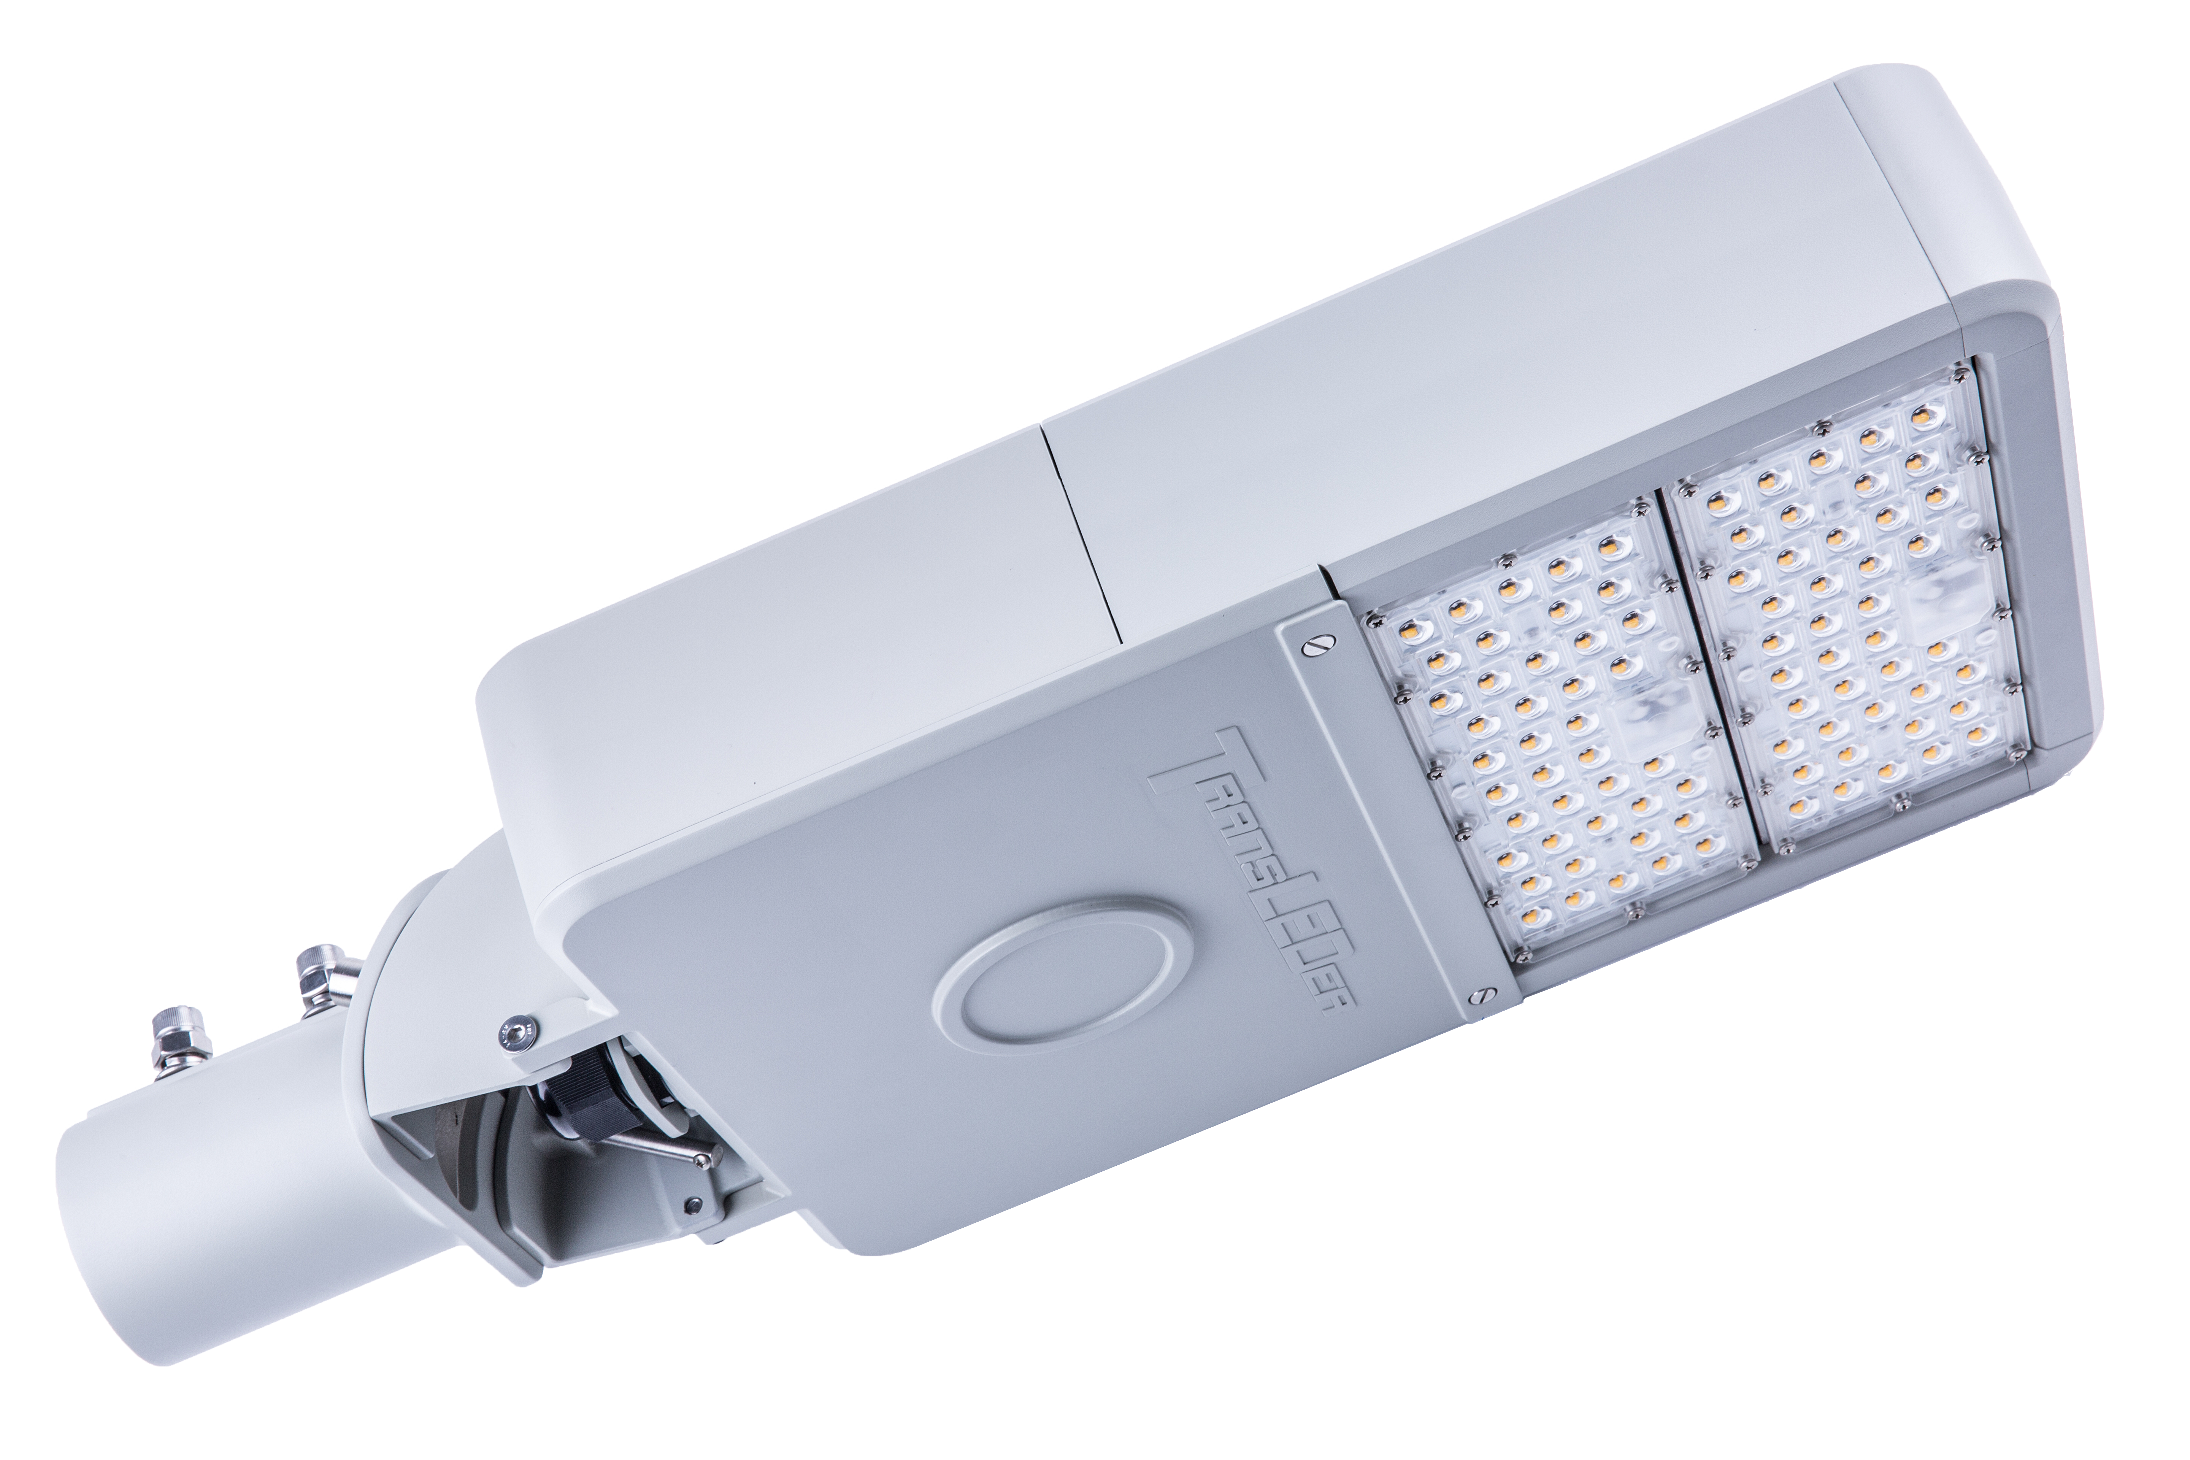

TL190-YY-ZZ-U-D-T
PERFORMANCE CRITERIA - LED LUMINAIRE
VOLTAGE | Nominal luminaire input voltage range |  |  |  | 120-277 V
INPUT POWER | Nominal luminaire input power
LUMEN OUTPUT | Min. luminaire lumen output
EFFICACY | Min. maintained luminaire efficacy at 3000K
POWER FACTOR | Min. power factor |  |  |  | 0.90
LUMEN MAINT. | Min. % of the initial output at 85,000 hours operation |  |  |  | L80=88,500 H
LMF | Min. Calculated Luminaire Maintenance Factor |  |  |  | 0.80
CHROMATICITY SHIFT | Max. LED chromaticity shift at 6,000 hours operation |  |  |  | ± 0.002 Duv
NOMINAL CCT | Nominal correlated color temperature |  |  |  | 3000K / 4000K
CRI | Color Rendering Index |  |  |  | >70
WEIGHT | Max. luminaire weight |  |  |  | 26.1 lbs.
SAIL AREA | Max. effective sail area |  |  |  | 1.07 ft²
TERMINAL BLOCK | 6-Way Screw Down Terminal Blocks |  |  |  | 6AWG-14AWG
PCR | Photoelectric Control Receptacle |  |  |  | Tool-less rotatable
OPTICAL DISTRIBUTION | Type II | Type III | Type IV |  | Type V
MOUNTING SLIPFITTER | Top-entry | Side-entry | Integral tilt (-10° to +10°)
MOUNTING SLIPFITTER | Nominal pole size (NPS) |  |  |  | 1.25”/2”
VIBRATION | ANSI C136.31 | Level 1 (normal) |  | Level 2 (bridge/overpass)
THERMAL ENVIRONMENT | Typical min. ambient temperature during operation |  |  |  | -30 °C
THERMAL ENVIRONMENT | Typical max. ambient temperature during operation |  |  |  | +50 °C
SURGE PROTECTION DEVICE | ANSI C136.2 | Basic  (6kV / 3kA) | Enhanced  (10kV / 5kA) |  | Elevated,  (20kV / 10kA)
CONTROL INTERFACE | None | ANSI C136.10,  3-pin | ANSI C136.41,  5-pin |  | ANSI C136.41,  7-pin
LED DRIVER | Not dimmable | Dimmable, 0-10V  (IEC 60929) |  |  | Dimmable, DALI  (IEC 62386)
CERTIFICATIONS - LED LUMINAIRE
SAFETY | UL 1598, UL 8750 |  |  |  | USL Certified
SAFETY | CSA C22.2 No. 250.0, CSA C22.2 No. 250.13 |  |  |  | CNL Certified
FCC | 47 CFR Part 15 Subpart B |  |  |  | FCC Certified
DIELECTRIC WITHSTAND AND ELECTRICAL TRANSIENT IMMUNITY | C136.2-2015: Clause 6, Clause 7, 7.1, 7.2, 7.3, 7.4 |  |  |  | Certified
INGRESS PROTECTION | Ingress protection |  |  |  | IP65
THD | Max. Total Harmonic Distortion (%) |  |  |  | 20
IMPACT TEST | Resistance to external mechanical impact test |  |  |  | IK08
SALINE MIST TEST | Salt spray test to ISO 9227 |  |  |  | 1,000 hours
PHOTOBIO. SAFETY | EN 62471 |  |  |  | Exempt group
PHOTOBIO. SAFETY | EN 62778 |  |  |  | Risk group 1
RoHS COMPLIANCE | European Directive 2011/65/EC |  |  |  | SGS Certified
MATERIAL - LED LUMINAIRE
OPTICAL MATERIAL | Optical lens material |  |  |  | UVC-Polycarbonate
HOUSING MATERIAL | Die-cast Aluminum alloy |  |  |  | 6063
FINISH | Polyester powder coating |  |  |  | Upon request

TL250-YY-ZZ-U-D-T
PERFORMANCE CRITERIA - LED LUMINAIRE
VOLTAGE | Nominal luminaire input voltage range |  |  |  | 120-277 V
INPUT POWER | Nominal luminaire input power
LUMEN OUTPUT | Min. luminaire lumen output
EFFICACY | Min. maintained luminaire efficacy at 3000K
POWER FACTOR | Min. power factor |  |  |  | 0.90
LUMEN MAINT. | Min. % of the initial output at 85,000 hours operation |  |  |  | L80=88,500 H
LMF | Min. Calculated Luminaire Maintenance Factor |  |  |  | 0.80
CHROMATICITY SHIFT | Max. LED chromaticity shift at 6,000 hours operation |  |  |  | ± 0.002 Duv
NOMINAL CCT | Nominal correlated color temperature |  |  |  | 3000K / 4000K
CRI | Color Rendering Index |  |  |  | >70
WEIGHT | Max. luminaire weight |  |  |  | 30.1 lbs.
SAIL AREA | Max. effective sail area |  |  |  | 1.19 ft²
TERMINAL BLOCK | 6-Way Screw Down Terminal Blocks |  |  |  | 6AWG-14AWG
PCR | Photoelectric Control Receptacle |  |  |  | Tool-less rotatable
OPTICAL DISTRIBUTION | Type II | Type III | Type IV |  | Type V
MOUNTING SLIPFITTER | Top-entry | Side-entry | Integral tilt (-10° to +10°)
MOUNTING SLIPFITTER | Nominal pole size (NPS) |  |  |  | 1.25”/2”
VIBRATION | ANSI C136.31 | Level 1 (normal) |  | Level 2 (bridge/overpass)
THERMAL ENVIRONMENT | Typical min. ambient temperature during operation |  |  |  | -30 °C
THERMAL ENVIRONMENT | Typical max. ambient temperature during operation |  |  |  | +50 °C
SURGE PROTECTION DEVICE | ANSI C136.2 | Basic  (6kV / 3kA) | Enhanced  (10kV / 5kA) |  | Elevated,  (20kV / 10kA)
CONTROL INTERFACE | None | ANSI C136.10,  3-pin | ANSI C136.41,  5-pin |  | ANSI C136.41,  7-pin
LED DRIVER | Not dimmable | Dimmable, 0-10V  (IEC 60929) |  |  | Dimmable, DALI  (IEC 62386)
CERTIFICATIONS - LED LUMINAIRE
SAFETY | UL 1598, UL 8750 |  |  |  | USL Certified
SAFETY | CSA C22.2 No. 250.0, CSA C22.2 No. 250.13 |  |  |  | CNL Certified
FCC | 47 CFR Part 15 Subpart B |  |  |  | FCC Certified
DIELECTRIC WITHSTAND AND ELECTRICAL TRANSIENT IMMUNITY | C136.2-2015: Clause 6, Clause 7, 7.1, 7.2, 7.3, 7.4 |  |  |  | Certified
INGRESS PROTECTION | Ingress protection |  |  |  | IP65
THD | Max. Total Harmonic Distortion (%) |  |  |  | 20
IMPACT TEST | Resistance to external mechanical impact test |  |  |  | IK08
SALINE MIST TEST | Salt spray test to ISO 9227 |  |  |  | 1,000 hours
PHOTOBIO. SAFETY | EN 62471 |  |  |  | Exempt group
PHOTOBIO. SAFETY | EN 62778 |  |  |  | Risk group 1
RoHS COMPLIANCE | European Directive 2011/65/EC |  |  |  | SGS Certified
MATERIAL - LED LUMINAIRE
OPTICAL MATERIAL | Optical lens material |  |  |  | UVC-Polycarbonate
HOUSING MATERIAL | Die-cast Aluminum alloy |  |  |  | 6063
FINISH | Polyester powder coating |  |  |  | Upon request

Photos for four-module luminaire: “TL250-YY-ZZ-U-D-T”

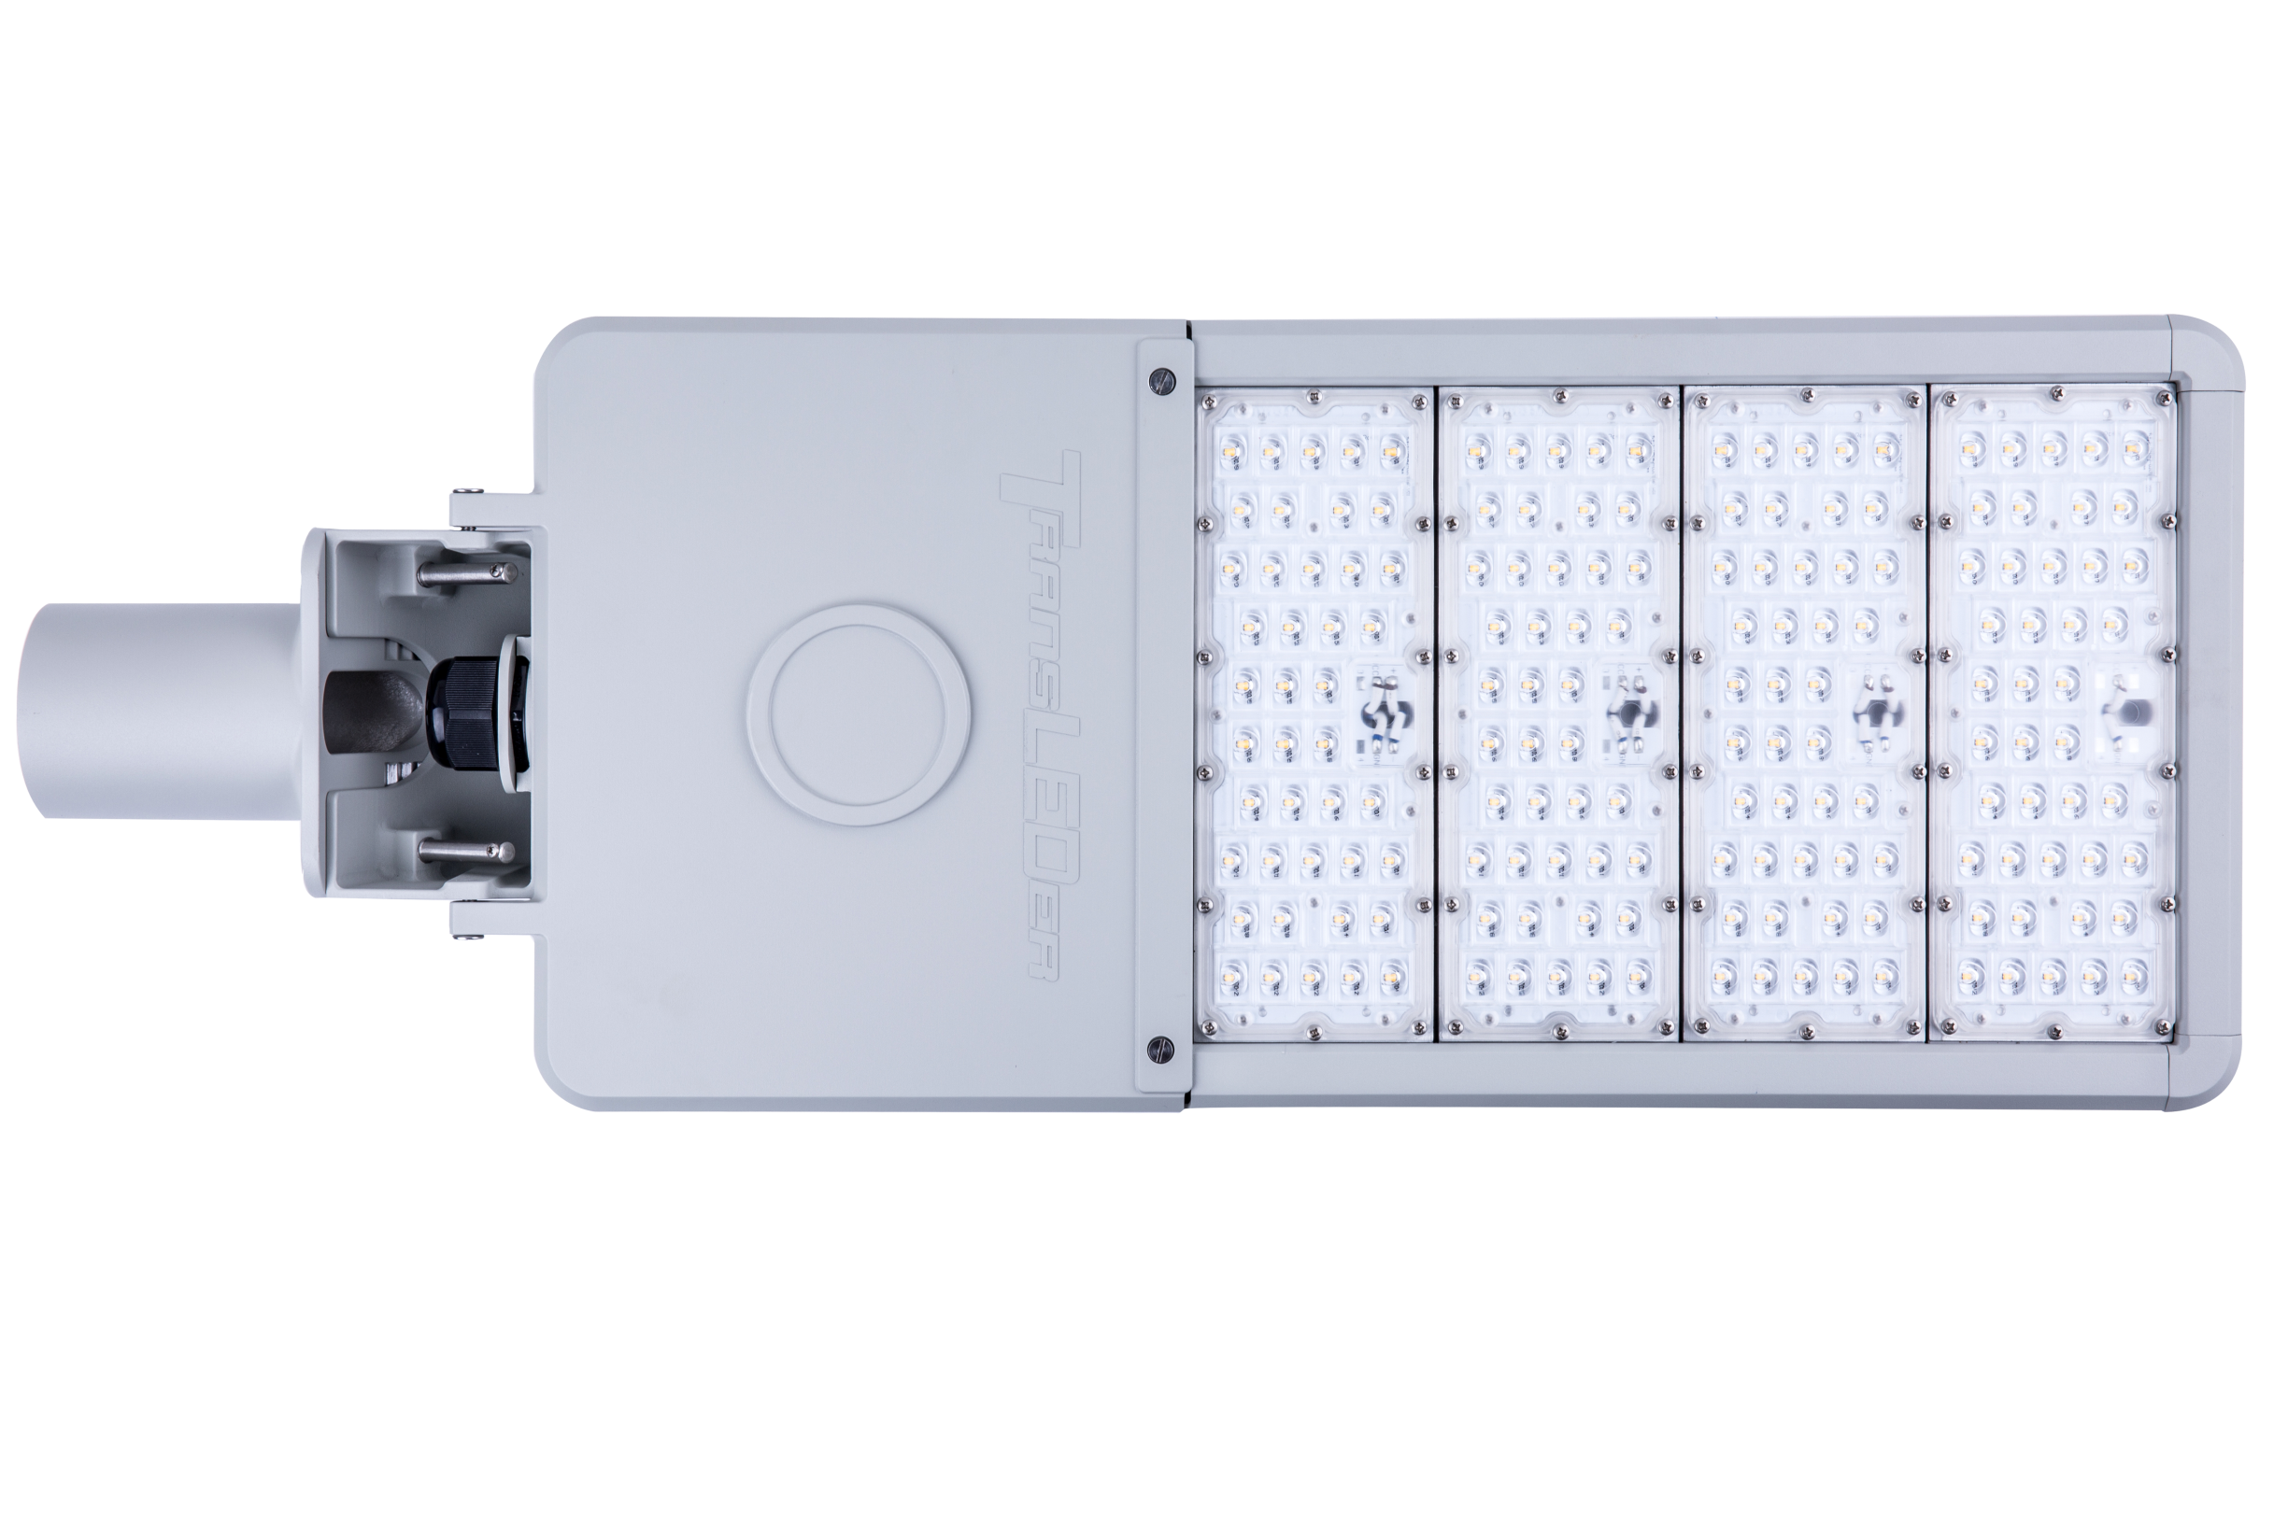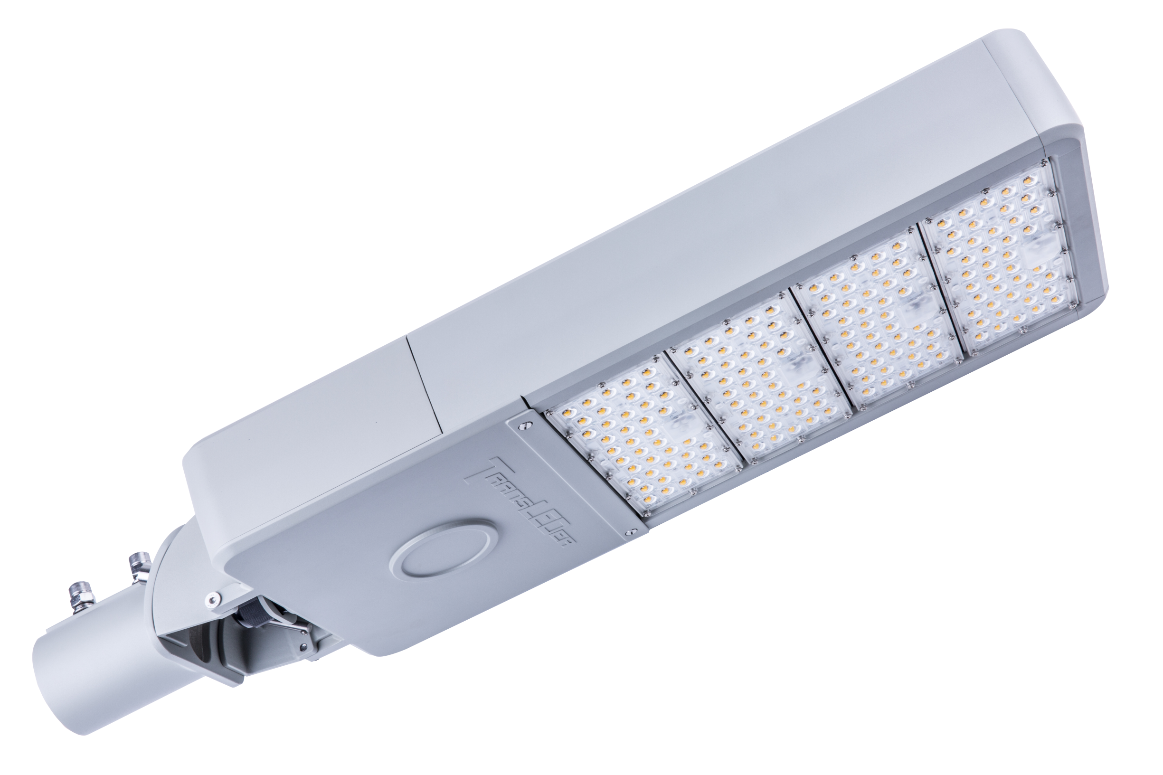

Weight and Dimension

Model | Module Quantity | Weight  (lbs.) | Dimension  (L x W x H)  (in) | Sailing Area  (ft²)
TL043-YY-ZZ-U-D-T | 1 | 18.2 | 21.5 x 11.4 x 5.3 | 0.80
TL085-YY-ZZ-U-D-T | 1 | 18.2 | 21.5 x 11.4 x 5.3 | 0.80
TL132-YY-ZZ-U-D-T | 2 | 22.2 | 25.1 x 11.4 x 5.3 | 0.93
TL190-YY-ZZ-U-D-T | 3 | 26.1 | 28.7 x 11.4 x 5.3 | 1.07
TL250-YY-ZZ-U-D-T | 4 | 30.1 | 32.4 x 11.4 x 5.3 | 1.19

Remark:
* Different color temperature is available upon request.
** For other pole diameters, a different mounting adaptor is required.

