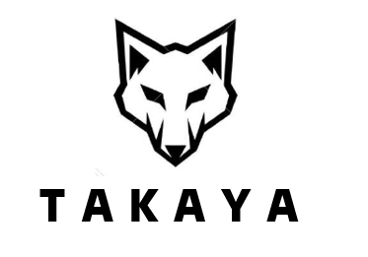



T A K A Y A




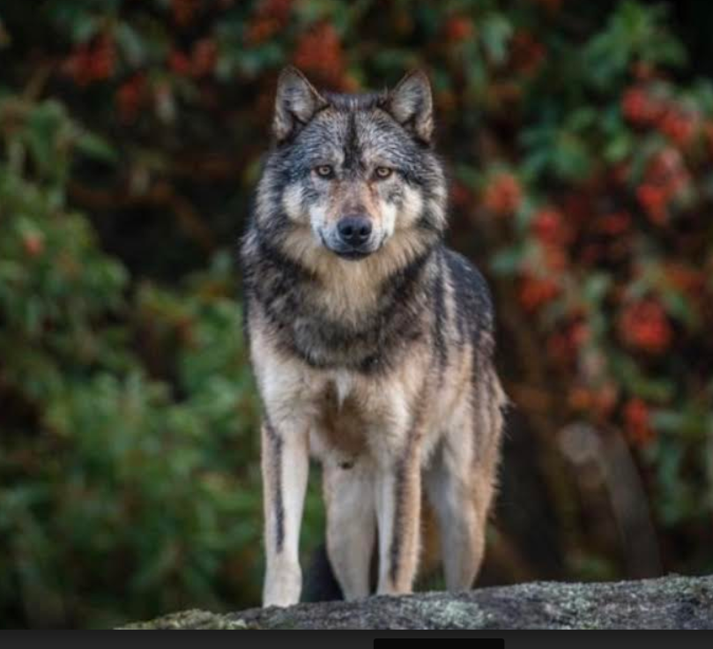
Meet my Spirit Animal, Takaya.

Takaya was a Grey Wolf who lived in Discovery Islands, British Columbia, Canada. When Takaya was about two years old, he ventured out to find his own turf prepare for a family of his own. Instead, he became socially distanced from other wolves as he swam to a small island group off the city of Victoria. Takaya lived on the Discovery Islands in British Columbia as a lone wolf until he was killed by hunter March 24, 2020.

Wolves are hunters (like Talent Acquisition professionals) and usually a pack animal. Takaya separated from his pack and was a "Lone Wolf" much like what I am doing as a consultant, and approaching the Talent Acquisition space differently, forging my own path in my career.

Talent Acquisition, my profession, is commonly abbreviated as “TA”, the beginning of the Lone Wolf’s name.

"Kaya” is Tagalog (Filipino) word which means capable, competent. “Kaya ko” in Tagalog means “Yes, I can do it!”.

Takaya, in one word, embodies my: upbringing, heritage, culture, personal journey and awakening, and my profession as a talent/people hunter.

