Gore Range Roofing Logo design.
3 Versions Required.
- Banner version – See gas Monkey #1 – Gore Range, Roofing - never fear, water stops here
- T-shirt version – Like Gas Monkey 2, 3, and your team 4 – must work in both positive and negative. not a monkey, but a gorilla. Happier, with a smile, but kind of like this style. See Happy Gorillas, 5,6. Words – Gas Monkey = Gore Range, Garage = Roofing.
- Billboard Version – Gorilla sitting/standing on a roof. Maybe holding a hammer, swatting at rain drops and/or snow flakes, like King kong 7,8,9. On house/roof 10. With Hammer 11. Include company name in base of house? Gore Range Roofing

Gas Monkey #1
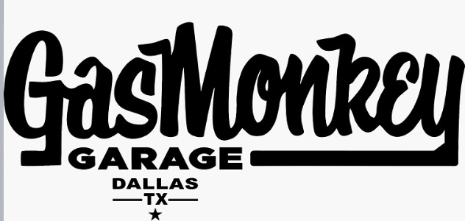

Gas Monkey 2,3 – Positive/negative, and Your team, 4.
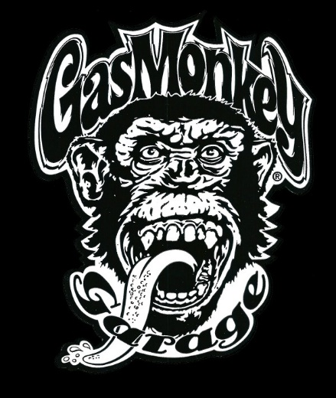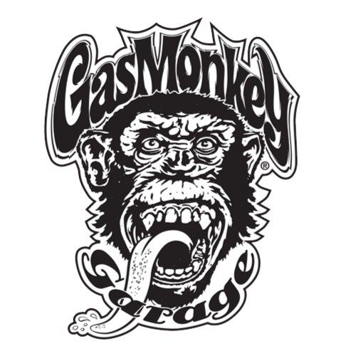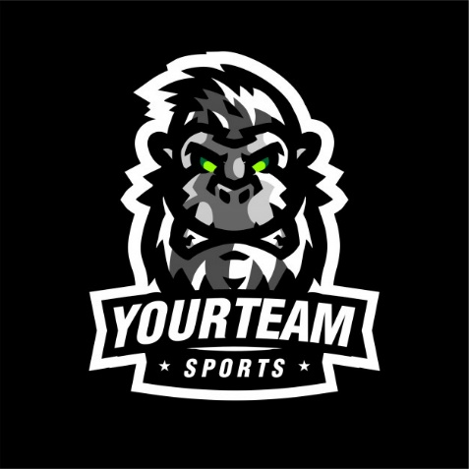

Happy Gorillas, 5,6
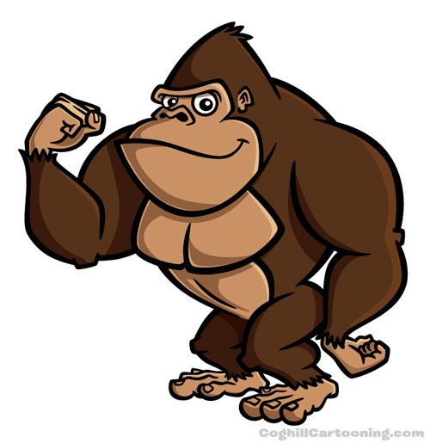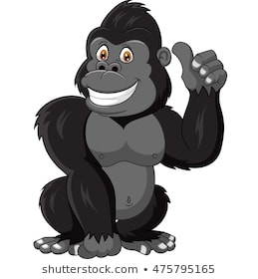
King Kong,7,8
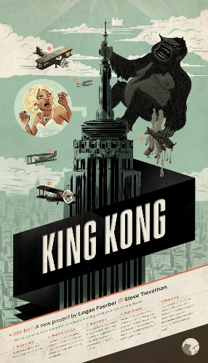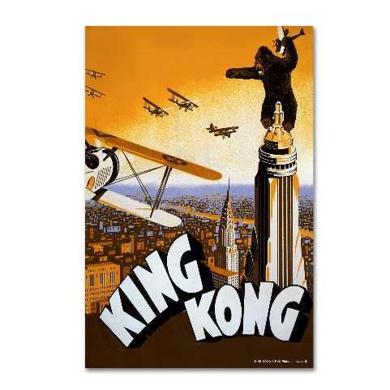
On a roof king kong 9
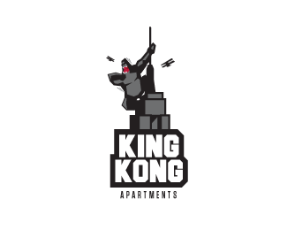

House Roof 10.
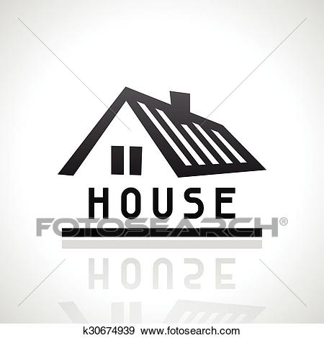

Hammer 11
