Instructions: | Design our Logo using color pallete shown below
Company Name: | EventView360
Company Website: | (In production) – www.eventview360.com
Company Overview: | A digital online hub for hosts, attendees, and sponsors to efficiently promote, find and sponsor Financial Services events (such as conferences, webinars, trainings, etc.)
Company Tagline: | Your View to “What’s Going On”
Color Palette |  |  | Color palette to use - could be a combo of a blue, green and grey for example this combo is nice  
Company Advertising: | This is the ad we use to promote our technology  “Tired of searching multiple site to find industry related events or missing out on events because you never received an invitation? When it comes to managing your calendars, let Eventview360’s search tools be your resource. We provide a comprehensive overview of the current happenings, so you never miss an important event again.”
Few notes: | I don’t want to concentrate on the 360 – this should not be front and center as it is an add on we needed since eventview.com was already taken. I also don’t want a location finder image because some of our events are virtual …  I want the logo clever but simple as I often times need to make the logo small for publication ads, etc and don’t want the logo to look distorted or hard to make out  And often times I need to have a one-color logo so needs to be able to go from color, to white, to dark (monotone) …  We are in the financial services industry so I need something professional and business-like but we are also an event technology, so I want to keep the spirit of the logo fresh and fun
Inspirations:
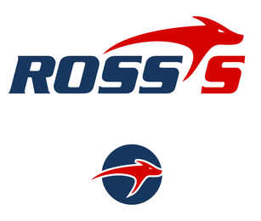 |  | I like the idea that this company has the logo incorporated but then can have a standalone logo that represents their brand

Very cute marketing package  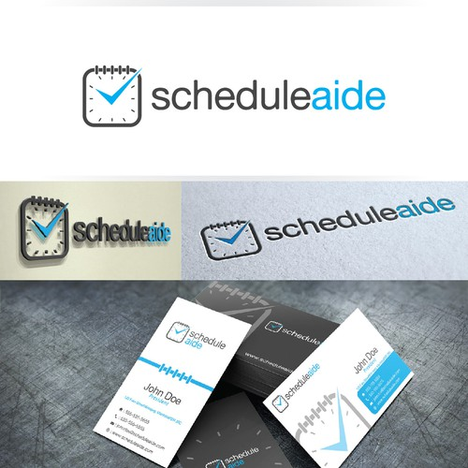 | Very Clean and clever logos I like    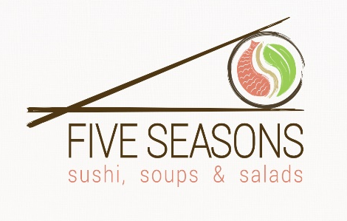  Cool how they incorporated the calendaar with the location find.  
Other logos I think are fun



To whimsical for us but super cute how they encorated what they due with their name
